HTML Examples

[« Previous](http://www.w3schools.com/html/html5_serversentevents.asp)

[Next Chapter »](http://www.w3schools.com/html/html_quiz.asp)

**HTML Basic**

[HTML document](http://www.w3schools.com/html/tryit.asp?filename=tryhtml_basic_document)  
[HTML headings](http://www.w3schools.com/html/tryit.asp?filename=tryhtml_basic_headings)  
[HTML paragraphs](http://www.w3schools.com/html/tryit.asp?filename=tryhtml_basic_paragraphs)  
[HTML links](http://www.w3schools.com/html/tryit.asp?filename=tryhtml_basic_link)  
[HTML images](http://www.w3schools.com/html/tryit.asp?filename=tryhtml_basic_img)

[Examples explained](http://www.w3schools.com/html/html_basic.asp)

**HTML Attributes**

[The title attribute](http://www.w3schools.com/html/tryit.asp?filename=tryhtml_attributes_title)  
[The href attribute](http://www.w3schools.com/html/tryit.asp?filename=tryhtml_attributes_link)  
[The width and height attributes](http://www.w3schools.com/html/tryit.asp?filename=tryhtml_attributes_img)  
[The alt attribute](http://www.w3schools.com/html/tryit.asp?filename=tryhtml_attributes_alt)  
[Attribute without quotes](http://www.w3schools.com/html/tryit.asp?filename=tryhtml_attributes_noquotes)  
[Attribute without quotes does not work](http://www.w3schools.com/html/tryit.asp?filename=tryhtml_attributes_error)

[Examples explained](http://www.w3schools.com/html/html_attributes.asp)

**HTML Headings**

[HTML headings](http://www.w3schools.com/html/tryit.asp?filename=tryhtml_headings)  
[HTML horizontal rules](http://www.w3schools.com/html/tryit.asp?filename=tryhtml_headings_hr)  
[HTML head](http://www.w3schools.com/html/tryit.asp?filename=tryhtml_headings_head)

[Examples explained](http://www.w3schools.com/html/html_headings.asp)

**HTML Paragraphs**

[HTML paragraphs](http://www.w3schools.com/html/tryit.asp?filename=tryhtml_paragraphs1)  
[More HTML paragraphs](http://www.w3schools.com/html/tryit.asp?filename=tryhtml_paragraphs2)  
[The use of line breaks in HTML](http://www.w3schools.com/html/tryit.asp?filename=tryhtml_paragraphs)  
[Poem problems (some problems with HTML formatting)](http://www.w3schools.com/html/tryit.asp?filename=tryhtml_poem)  
[How to control the line breaks and spaces with the <pre> tag](http://www.w3schools.com/html/tryit.asp?filename=tryhtml_pre)

[Examples explained](http://www.w3schools.com/html/html_paragraphs.asp)

**HTML Styles**

[HTML styles](http://www.w3schools.com/html/tryit.asp?filename=tryhtml_styles_intro)  
[HTML background color](http://www.w3schools.com/html/tryit.asp?filename=tryhtml_styles_background-color)  
[HTML text color](http://www.w3schools.com/html/tryit.asp?filename=tryhtml_styles_color)  
[HTML text font](http://www.w3schools.com/html/tryit.asp?filename=tryhtml_styles_font-family)  
[HTML text size](http://www.w3schools.com/html/tryit.asp?filename=tryhtml_styles_font-size)  
[HTML text alignment](http://www.w3schools.com/html/tryit.asp?filename=tryhtml_styles_text-align)

[Examples explained](http://www.w3schools.com/html/html_styles.asp)

**HTML Text Formatting**

[Bold formatting using the <b> element](http://www.w3schools.com/html/tryit.asp?filename=tryhtml_formatting_b)  
[Strong formatting using the <strong> element](http://www.w3schools.com/html/tryit.asp?filename=tryhtml_formatting_strong)  
[Italic formatting using the <i> element](http://www.w3schools.com/html/tryit.asp?filename=tryhtml_formatting_i)  
[Emphasized formatting using the <em> element](http://www.w3schools.com/html/tryit.asp?filename=tryhtml_formatting_em)  
[Small formatting using the <small> element](http://www.w3schools.com/html/tryit.asp?filename=tryhtml_formatting_small)  
[Marked formatting using the <mark> element](http://www.w3schools.com/html/tryit.asp?filename=tryhtml_formatting_mark)  
[Marked deleted using the <del> element](http://www.w3schools.com/html/tryit.asp?filename=tryhtml_formatting_del)  
[Marked inserted using the <ins> element](http://www.w3schools.com/html/tryit.asp?filename=tryhtml_formatting_ins)  
[Marked deleted and inserted using <del> and <ins>](http://www.w3schools.com/html/tryit.asp?filename=tryhtml_formatting_del_ins)  
[Subscript formatting using the <sub> element](http://www.w3schools.com/html/tryit.asp?filename=tryhtml_formatting_sub)  
[Superscript formatting using the <sup> element](http://www.w3schools.com/html/tryit.asp?filename=tryhtml_formatting_sup)

[Examples explained](http://www.w3schools.com/html/html_formatting.asp)

**HTML Quotations and Citations**

[Formatting short quotations with the <q> element.](http://www.w3schools.com/html/tryit.asp?filename=tryhtml_formatting_q)  
[Formatting quoted sections with the <blockquote> element.](http://www.w3schools.com/html/tryit.asp?filename=tryhtml_formatting_blockquote)  
[Formatting document author/owner information with the <address> element](http://www.w3schools.com/html/tryit.asp?filename=tryhtml_formatting_address)  
[Formatting abbreviations and acronyms the <abbr> element](http://www.w3schools.com/html/tryit.asp?filename=tryhtml_formatting_abbr)  
[Formatting work title with the <cite> element](http://www.w3schools.com/html/tryit.asp?filename=tryhtml_formatting_cite)  
[Formatting text direction with the <bdo> element](http://www.w3schools.com/html/tryit.asp?filename=tryhtml_formatting_bdo)

[Examples explained](http://www.w3schools.com/html/html_quotation_elements.asp)

**HTML Computercode Elements**

[Keyboard input formatting using the <kbd> element](http://www.w3schools.com/html/tryit.asp?filename=tryhtml_formatting_kbd)  
[Computer output formatting using the <samp> element](http://www.w3schools.com/html/tryit.asp?filename=tryhtml_formatting_samp)  
[Programming code formatting using the <code> element](http://www.w3schools.com/html/tryit.asp?filename=tryhtml_formatting_code)  
[Programming code formatting preserving whitespace and line-breaks](http://www.w3schools.com/html/tryit.asp?filename=tryhtml_formatting_codepre)  
[Variable formatting using the <var> element](http://www.w3schools.com/html/tryit.asp?filename=tryhtml_formatting_var)

[Examples explained](http://www.w3schools.com/html/html_computercode_elements.asp)

**HTML Comments**

[Hidden comments](http://www.w3schools.com/html/tryit.asp?filename=tryhtml_comment)  
[Conditional comments](http://www.w3schools.com/html/tryit.asp?filename=tryhtml_ie_conditional)  
[Comments for debugging](http://www.w3schools.com/html/tryit.asp?filename=tryhtml_comment_out)

[Examples explained](http://www.w3schools.com/html/html_comments.asp)

**HTML CSS**

[HTML with inline CSS](http://www.w3schools.com/html/tryit.asp?filename=tryhtml_css_inline)  
[HTML with internal CSS](http://www.w3schools.com/html/tryit.asp?filename=tryhtml_css_internal)  
[HTML with external CSS](http://www.w3schools.com/html/tryit.asp?filename=tryhtml_css_external)  
[HTML with CSS fonts](http://www.w3schools.com/html/tryit.asp?filename=tryhtml_css_fonts)  
[HTML with CSS using the id attribute](http://www.w3schools.com/html/tryit.asp?filename=tryhtml_css_id)  
[HTML with CSS using the class attribute](http://www.w3schools.com/html/tryit.asp?filename=tryhtml_css_class)  
[HTML and CSS borders](http://www.w3schools.com/html/tryit.asp?filename=tryhtml_css_borders)  
[HTML and CSS padding](http://www.w3schools.com/html/tryit.asp?filename=tryhtml_css_padding)  
[HTML and CSS margin](http://www.w3schools.com/html/tryit.asp?filename=tryhtml_css_margin)  
[HTML and CSS full demo](http://www.w3schools.com/html/tryit.asp?filename=tryhtml_css_full)

[Examples explained](http://www.w3schools.com/html/html_css.asp)

**HTML Links**

[Linking, using an absolute URL](http://www.w3schools.com/html/tryit.asp?filename=tryhtml_links_w3schools)  
[Linking, using a relative URL](http://www.w3schools.com/html/tryit.asp?filename=tryhtml_links)  
[Changing the color of links](http://www.w3schools.com/html/tryit.asp?filename=tryhtml_links_colors)  
[Removing the underline from links](http://www.w3schools.com/html/tryit.asp?filename=tryhtml_links_noline)  
[Changing the target of a link](http://www.w3schools.com/html/tryit.asp?filename=tryhtml_links_target)  
[An image as a link](http://www.w3schools.com/html/tryit.asp?filename=tryhtml_links_image)  
[Creating a bookmark link](http://www.w3schools.com/html/tryit.asp?filename=tryhtml_links_bookmark)  
[A link that breaks out of a frame](http://www.w3schools.com/html/tryit.asp?filename=tryhtml_links_target_top)  
[A mailto link](http://www.w3schools.com/html/tryit.asp?filename=tryhtml_links_mailto)  
[A mailto link with subject](http://www.w3schools.com/html/tryit.asp?filename=tryhtml_links_mailto_subject)

[Examples explained](http://www.w3schools.com/html/html_links.asp)

**HTML Images**

[The Mountain](http://www.w3schools.com/html/tryit.asp?filename=tryhtml_images_mountain)  
[An image height and width using attributes](http://www.w3schools.com/html/tryit.asp?filename=tryhtml_images_attributes)  
[An image height and width using CSS](http://www.w3schools.com/html/tryit.asp?filename=tryhtml_images_size)  
[An image height and width using both](http://www.w3schools.com/html/tryit.asp?filename=tryhtml_images_style)  
[An image in another folder](http://www.w3schools.com/html/tryit.asp?filename=tryhtml_images_folder)  
[An image with a broken link](http://www.w3schools.com/html/tryit.asp?filename=tryhtml_images_wrong)  
[An image on another server](http://www.w3schools.com/html/tryit.asp?filename=tryhtml_images_w3schools)  
[Using an image as a link](http://www.w3schools.com/html/tryit.asp?filename=tryhtml_images_link)  
[A moving image](http://www.w3schools.com/html/tryit.asp?filename=tryhtml_images_hackman)  
[An image map with clickable regions](http://www.w3schools.com/html/tryit.asp?filename=tryhtml_images_map)  
[A floating image](http://www.w3schools.com/html/tryit.asp?filename=tryhtml_images_float)

[Examples explained](http://www.w3schools.com/html/html_images.asp)

**HTML Tables**

[Basic HTML tables](http://www.w3schools.com/html/tryit.asp?filename=tryhtml_table_basic)  
[A table with borders](http://www.w3schools.com/html/tryit.asp?filename=tryhtml_table_border)  
[A table with collapsed borders](http://www.w3schools.com/html/tryit.asp?filename=tryhtml_table_collapse)  
[A table with cell padding](http://www.w3schools.com/html/tryit.asp?filename=tryhtml_table_cellpadding)  
[A table with headings](http://www.w3schools.com/html/tryit.asp?filename=tryhtml_table_headings)  
[A table with left-aligned headings](http://www.w3schools.com/html/tryit.asp?filename=tryhtml_table_headings_left)  
[Horizontal/Vertical table headings](http://www.w3schools.com/html/tryit.asp?filename=tryhtml_table_headers)  
[A table with a caption](http://www.w3schools.com/html/tryit.asp?filename=tryhtml_tables2)  
[Table cells that span more than one column](http://www.w3schools.com/html/tryit.asp?filename=tryhtml_table_colspan)  
[Table cells that span more than one row](http://www.w3schools.com/html/tryit.asp?filename=tryhtml_table_rowspan)  
[A table with cell spacing](http://www.w3schools.com/html/tryit.asp?filename=tryhtml_table_cellspacing)  
[A table with HTML tags inside](http://www.w3schools.com/html/tryit.asp?filename=tryhtml_table_elements)  
[Tables with different style using id I](http://www.w3schools.com/html/tryit.asp?filename=tryhtml_table_id1)  
[Tables with different style using id II](http://www.w3schools.com/html/tryit.asp?filename=tryhtml_table_id2)  
[Tables with different style using class I](http://www.w3schools.com/html/tryit.asp?filename=tryhtml_table_class1)  
[Tables with different style using class II](http://www.w3schools.com/html/tryit.asp?filename=tryhtml_table_class2)

[Examples explained](http://www.w3schools.com/html/html_tables.asp)

**HTML Lists**

[An unordered list (default)](http://www.w3schools.com/html/tryit.asp?filename=tryhtml_lists_unordered)  
[An unordered list with disc bullets](http://www.w3schools.com/html/tryit.asp?filename=tryhtml_lists_unordered_disc)  
[An unordered list with circle bullets](http://www.w3schools.com/html/tryit.asp?filename=tryhtml_lists_unordered_circle)  
[An unordered list with square bullets](http://www.w3schools.com/html/tryit.asp?filename=tryhtml_lists_unordered_square)  
[An unordered list without bullets](http://www.w3schools.com/html/tryit.asp?filename=tryhtml_lists_unordered_none)  
[An ordered list (default)](http://www.w3schools.com/html/tryit.asp?filename=tryhtml_lists_ordered)  
[An ordered list with numbers](http://www.w3schools.com/html/tryit.asp?filename=tryhtml_lists_ordered_numbers)  
[An ordered list with letters](http://www.w3schools.com/html/tryit.asp?filename=tryhtml_lists_ordered_ucase)  
[An ordered list with lowercase letters](http://www.w3schools.com/html/tryit.asp?filename=tryhtml_lists_ordered_lcase)  
[An ordered list with roman numbers](http://www.w3schools.com/html/tryit.asp?filename=tryhtml_lists_ordered_roman_ucase)  
[An ordered list with lowercase roman numbers](http://www.w3schools.com/html/tryit.asp?filename=tryhtml_lists_ordered_roman_lcase)  
[A description list](http://www.w3schools.com/html/tryit.asp?filename=tryhtml_lists_description)  
[A nested list I](http://www.w3schools.com/html/tryit.asp?filename=tryhtml_lists_nested)  
[A nested list II](http://www.w3schools.com/html/tryit.asp?filename=tryhtml_lists_nested2)  
[A horizontal list](http://www.w3schools.com/html/tryit.asp?filename=tryhtml_lists_horizontal)  
[A horizontal list menu](http://www.w3schools.com/html/tryit.asp?filename=tryhtml_lists_menu)

[Examples explained](http://www.w3schools.com/html/html_lists.asp)

**HTML Block and inline elements**

[Styling <div> elements](http://www.w3schools.com/html/tryit.asp?filename=tryhtml_div_capitals)  
[Styling<span> elements](http://www.w3schools.com/html/tryit.asp?filename=tryhtml_span_red)

[Examples explained](http://www.w3schools.com/html/html_blocks.asp)

**HTML Classes**

[Classing <div> elements I](http://www.w3schools.com/html/tryit.asp?filename=tryhtml_classes_london)  
[Classing<div> elements II](http://www.w3schools.com/html/tryit.asp?filename=tryhtml_classes_capitals)  
[Classing <span> elements](http://www.w3schools.com/html/tryit.asp?filename=tryhtml_classes_span)

[Examples explained](http://www.w3schools.com/html/html_classes.asp)

**HTML Layout**

[Layout using <div> elements](http://www.w3schools.com/html/tryit.asp?filename=tryhtml_layout_divs)  
[Layout using semantic elements](http://www.w3schools.com/html/tryit.asp?filename=tryhtml_layout_semantic)  
[Layout using <table> elements](http://www.w3schools.com/html/tryit.asp?filename=tryhtml_layout_tables)

[Examples explained](http://www.w3schools.com/html/html_layout.asp)

**HTML IFrame**

[Inline frame (a frame inside an HTML page)](http://www.w3schools.com/html/tryit.asp?filename=tryhtml_iframe)

[Examples explained](http://www.w3schools.com/html/html_iframe.asp)

**HTML head Elements**

[A valid HTML document with no <html><body, and <head>](http://www.w3schools.com/html/tryit.asp?filename=tryhtml_head_none)  
[A valid HTML document with no <head> element](http://www.w3schools.com/html/tryit.asp?filename=tryhtml_head_no_head)  
[The <title> element defines the document title](http://www.w3schools.com/html/tryit.asp?filename=tryhtml_head_title)  
[The <style> element contains style information](http://www.w3schools.com/html/tryit.asp?filename=tryhtml_head_style)  
[The <link> element defines a relationship to an external resource](http://www.w3schools.com/html/tryit.asp?filename=tryhtml_head_link)  
[The <meta> element defines special meta information](http://www.w3schools.com/html/tryit.asp?filename=tryhtml_head_meta)  
[The <script> element defines client-side JavaScripts](http://www.w3schools.com/html/tryit.asp?filename=tryhtml_head_script)  
[The <base> element defines the base URL for all URLs](http://www.w3schools.com/html/tryit.asp?filename=tryhtml_head_base)

[Examples explained](http://www.w3schools.com/html/html_head.asp)

**HTML Scripts**

[Insert a script](http://www.w3schools.com/html/tryit.asp?filename=tryhtml_script)  
[Use of the <noscript> tag](http://www.w3schools.com/html/tryit.asp?filename=tryhtml_noscript)

[Examples explained](http://www.w3schools.com/html/html_scripts.asp)

**HTML Forms**

[Form with text input](http://www.w3schools.com/html/tryit.asp?filename=tryhtml_form_text)  
[Form with radio button input](http://www.w3schools.com/html/tryit.asp?filename=tryhtml_form_radio)  
[Form with text fields and a submit button](http://www.w3schools.com/html/tryit.asp?filename=tryhtml_form_submit)  
[Form with a text fields without a name attribute](http://www.w3schools.com/html/tryit.asp?filename=tryhtml_form_submit_id)  
[Grouping Form Data](http://www.w3schools.com/html/tryit.asp?filename=tryhtml_form_legend)  
[Send e-mail from a form](http://www.w3schools.com/html/tryit.asp?filename=tryhtml_form_mail)

[Examples explained](http://www.w3schools.com/html/html_forms.asp)

**HTML Form Elements**

[A simple drop-down list](http://www.w3schools.com/html/tryit.asp?filename=tryhtml_elem_select)  
[A drop-down list with a pre-selected value](http://www.w3schools.com/html/tryit.asp?filename=tryhtml_elem_select_pre)  
[A textarea (a multi-line text input field)](http://www.w3schools.com/html/tryit.asp?filename=tryhtml_elem_textarea)  
[An input button](http://www.w3schools.com/html/tryit.asp?filename=tryhtml_elem_button)  
[Using the <datalist> Element](http://www.w3schools.com/html/tryit.asp?filename=tryhtml_elem_datalist)[Using the <keygen> Element](http://www.w3schools.com/html/tryit.asp?filename=tryhtml_elem_keygen)[Using the <output> Element](http://www.w3schools.com/html/tryit.asp?filename=tryhtml_elem_output)

[Examples explained](http://www.w3schools.com/html/html_form_elements.asp)

**HTML Input Types**

[Input type text](http://www.w3schools.com/html/tryit.asp?filename=tryhtml_input_text)  
[Input type password](http://www.w3schools.com/html/tryit.asp?filename=tryhtml_input_password)  
[Input type radio](http://www.w3schools.com/html/tryit.asp?filename=tryhtml_input_radio)  
[Input type checkbox](http://www.w3schools.com/html/tryit.asp?filename=tryhtml_input_checkbox)  
[Input type button](http://www.w3schools.com/html/tryit.asp?filename=tryhtml_input_button)  
[Input type number - with restrictions](http://www.w3schools.com/html/tryit.asp?filename=tryhtml_input_number)[Input type number - with steps](http://www.w3schools.com/html/tryit.asp?filename=tryhtml_input_number_step)[Input type date - with date picker](http://www.w3schools.com/html/tryit.asp?filename=tryhtml_input_date)[Input type date - with restrictions](http://www.w3schools.com/html/tryit.asp?filename=tryhtml_input_date_max_min)[Input type color - with color picker](http://www.w3schools.com/html/tryit.asp?filename=tryhtml_input_color)[Input type range](http://www.w3schools.com/html/tryit.asp?filename=tryhtml_input_range)[Input type month](http://www.w3schools.com/html/tryit.asp?filename=tryhtml_input_month)[Input type week](http://www.w3schools.com/html/tryit.asp?filename=tryhtml_input_week)[Input type time](http://www.w3schools.com/html/tryit.asp?filename=tryhtml_input_time)[Input type datetime](http://www.w3schools.com/html/tryit.asp?filename=tryhtml_input_datetime)[Input type datetime-local](http://www.w3schools.com/html/tryit.asp?filename=tryhtml_input_datetime-local)[Input type email](http://www.w3schools.com/html/tryit.asp?filename=tryhtml_input_email)[Input type search](http://www.w3schools.com/html/tryit.asp?filename=tryhtml_input_search)[Input type tel](http://www.w3schools.com/html/tryit.asp?filename=tryhtml_input_tel)[Input type url](http://www.w3schools.com/html/tryit.asp?filename=tryhtml_input_url)

[Examples explained](http://www.w3schools.com/html/html_form_input_types.asp)

**HTML Input Attributes**

[The autocomplete attribute](http://www.w3schools.com/html/tryit.asp?filename=tryhtml5_input_autocomplete)[The novalidate attribute](http://www.w3schools.com/html/tryit.asp?filename=tryhtml5_form_novalidate)[The autofocus_attribute](http://www.w3schools.com/html/tryit.asp?filename=tryhtml5_input_autofocus)[The form attribute](http://www.w3schools.com/html/tryit.asp?filename=tryhtml5_input_form)[The formaction attribute](http://www.w3schools.com/html/tryit.asp?filename=tryhtml5_input_formaction)[The formenctype attribute](http://www.w3schools.com/html/tryit.asp?filename=tryhtml5_input_formenctype)[The formmethod attribute](http://www.w3schools.com/html/tryit.asp?filename=tryhtml5_input_formmethod)[The formnovalidate attribute](http://www.w3schools.com/html/tryit.asp?filename=tryhtml5_input_formnovalidate)[The formtarget attribute](http://www.w3schools.com/html/tryit.asp?filename=tryhtml5_input_formtarget)[The height and width attributes](http://www.w3schools.com/html/tryit.asp?filename=tryhtml5_input_height_width)[The list attribute](http://www.w3schools.com/html/tryit.asp?filename=tryhtml5_input_list)[The min and max attributes](http://www.w3schools.com/html/tryit.asp?filename=tryhtml5_input_max_min)[The multiple attribute](http://www.w3schools.com/html/tryit.asp?filename=tryhtml5_input_multiple)[The pattern attribute](http://www.w3schools.com/html/tryit.asp?filename=tryhtml5_input_pattern)[The placeholder attribute](http://www.w3schools.com/html/tryit.asp?filename=tryhtml5_input_placeholder)[The required attribute](http://www.w3schools.com/html/tryit.asp?filename=tryhtml5_input_required)[The step attribute](http://www.w3schools.com/html/tryit.asp?filename=tryhtml5_input_step)

[Examples explained](http://www.w3schools.com/html/html_form_attributes.asp)

**HTML5 Canvas**

[Draw on the canvas with JavaScript](http://www.w3schools.com/html/tryit.asp?filename=tryhtml5_canvas_first)[Draw a line with lineTo()](http://www.w3schools.com/html/tryit.asp?filename=tryhtml5_canvas_tut_path)[Draw a circle with arc()](http://www.w3schools.com/html/tryit.asp?filename=tryhtml5_canvas_tut_path2)[Draw a text with fillText()](http://www.w3schools.com/html/tryit.asp?filename=tryhtml5_canvas_tut_text)[Draw a text with strokeText()](http://www.w3schools.com/html/tryit.asp?filename=tryhtml5_canvas_tut_text2)[Draw a linear gradient](http://www.w3schools.com/html/tryit.asp?filename=tryhtml5_canvas_tut_grad)[Draw a circular gradient](http://www.w3schools.com/html/tryit.asp?filename=tryhtml5_canvas_tut_grad2)[Draw an image with drawImage()](http://www.w3schools.com/html/tryit.asp?filename=tryhtml5_canvas_tut_img)

[Examples explained](http://www.w3schools.com/html/html5_canvas.asp)

**HTML5 SVG**

[SVG Circle](http://www.w3schools.com/html/tryit.asp?filename=tryhtml_svg_circle)[SVG Rectangle](http://www.w3schools.com/html/tryit.asp?filename=tryhtml_svg_rect)[SVG Rounded Rectangle](http://www.w3schools.com/html/tryit.asp?filename=tryhtml_svg_rect_round)[SVG Star](http://www.w3schools.com/html/tryit.asp?filename=tryhtml_svg_star)[SVG Logo](http://www.w3schools.com/html/tryit.asp?filename=tryhtml_svg_logo)

[Examples explained](http://www.w3schools.com/html/html5_svg.asp)

**HTML5 Media**

[Play Bunny](http://www.w3schools.com/html/tryit.asp?filename=tryhtml5_video)  
[Play bear video with controls](http://www.w3schools.com/html/tryit.asp?filename=tryhtml5_video_all)  
[Play bear video with autoplay](http://www.w3schools.com/html/tryit.asp?filename=tryhtml5_video_autoplay)  
[Play Horse sound with controls](http://www.w3schools.com/html/tryit.asp?filename=tryhtml5_audio_all)

[Examples explained](http://www.w3schools.com/html/html_media.asp)

**HTML5 Geolocation**

[Get geolocation coordinates](http://www.w3schools.com/html/tryit.asp?filename=tryhtml5_geolocation)  
[Handle geolocation errors](http://www.w3schools.com/html/tryit.asp?filename=tryhtml5_geolocation_error)  
[Get geolocation with a map](http://www.w3schools.com/html/tryit.asp?filename=tryhtml5_geolocation_map)  
[Get geolocation with Google map script](http://www.w3schools.com/html/tryit.asp?filename=tryhtml5_geolocation_map_script)  
[Get geolocation and watch the position](http://www.w3schools.com/html/tryit.asp?filename=tryhtml5_geolocation_watchposition)

[Examples explained](http://www.w3schools.com/html/html5_geolocation.asp)

**HTML5 Local Storage**

[Store a name permanentely](http://www.w3schools.com/html/tryit.asp?filename=tryhtml5_webstorage_local)  
[Store a counter permanently](http://www.w3schools.com/html/tryit.asp?filename=tryhtml5_webstorage_local_clickcount)  
[Store a counter for one session](http://www.w3schools.com/html/tryit.asp?filename=tryhtml5_webstorage_session)

[Examples explained](http://www.w3schools.com/html/html5_webstorage.asp)

**More HTML5 Examples**

[HTML5 drag and drop](http://www.w3schools.com/html/tryit.asp?filename=tryhtml5_draganddrop)  
[HTML5 application cache](http://www.w3schools.com/html/tryit.asp?filename=tryhtml5_html_manifest)  
[HTML5 web workers](http://www.w3schools.com/html/tryit.asp?filename=tryhtml5_webworker)  
[HTML5 server sent events](http://www.w3schools.com/html/tryit.asp?filename=tryhtml5_sse)

[« Previous](http://www.w3schools.com/html/html5_serversentevents.asp)

[Next Chapter »](http://www.w3schools.com/html/html_quiz.asp)

**HTML Basic**

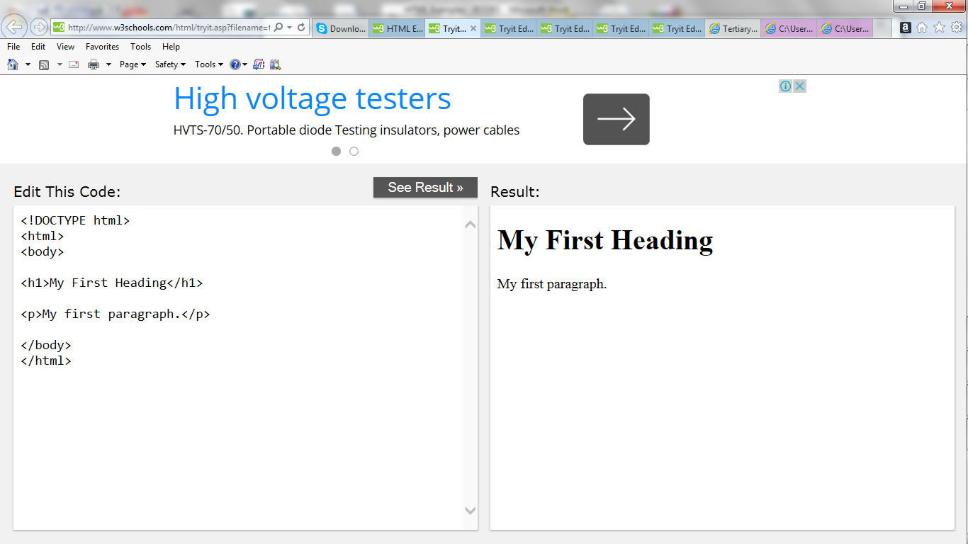

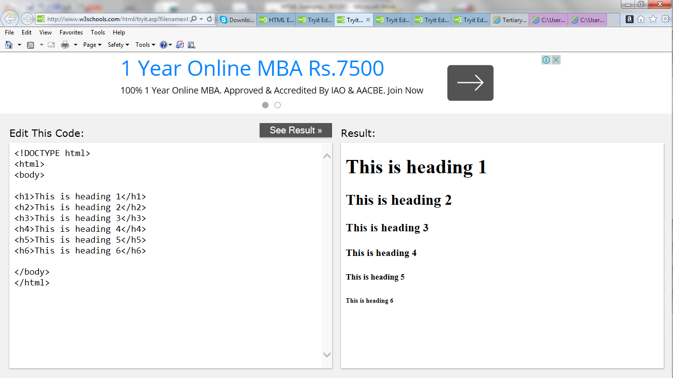

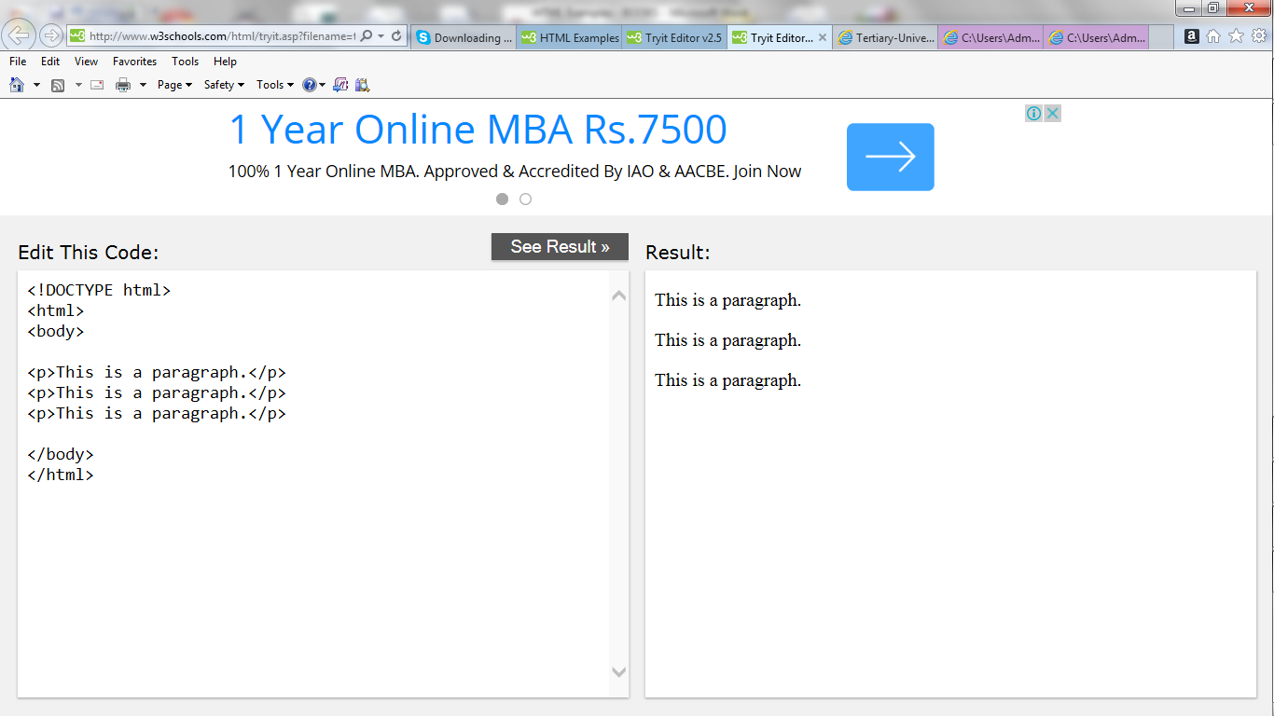

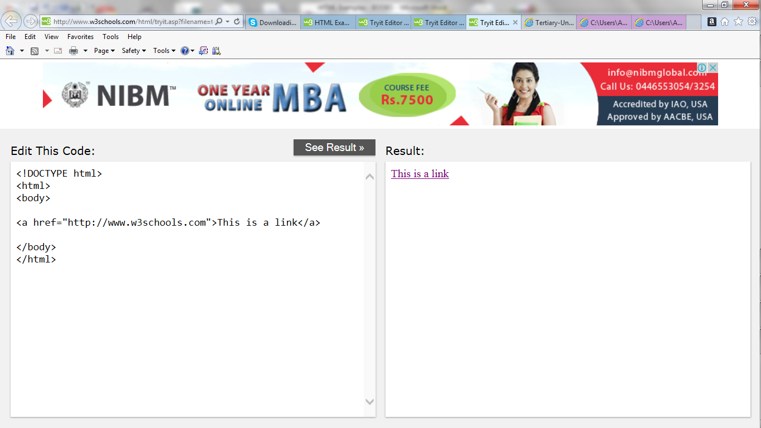

**HTML Attributes**

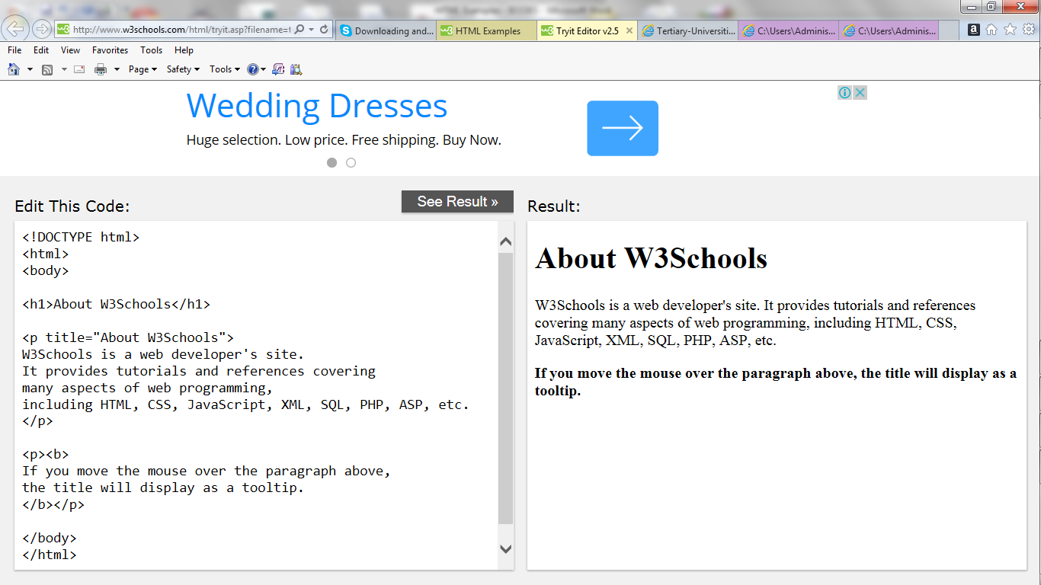

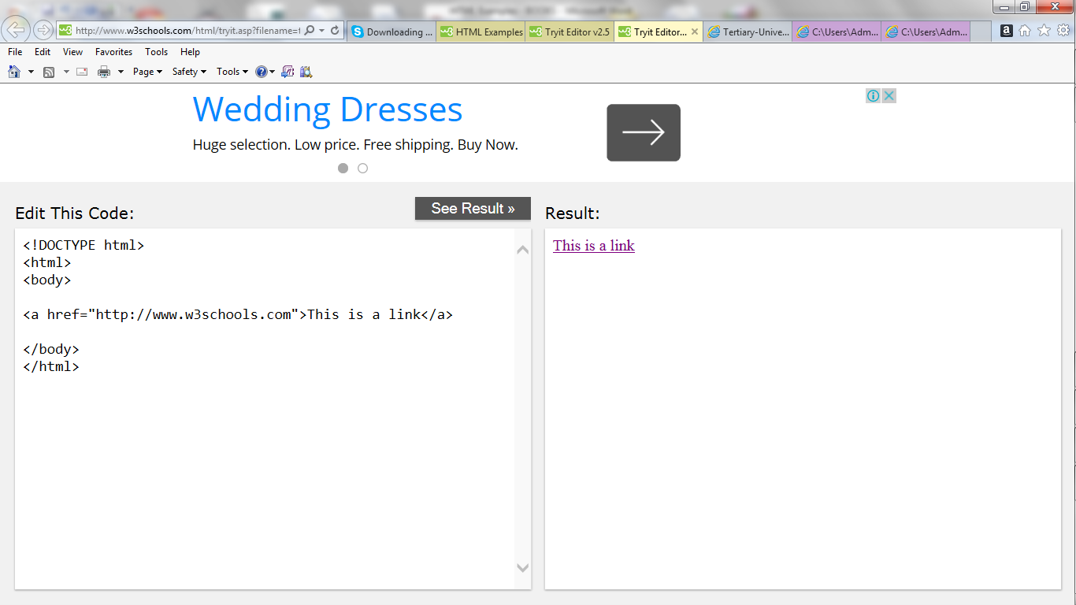

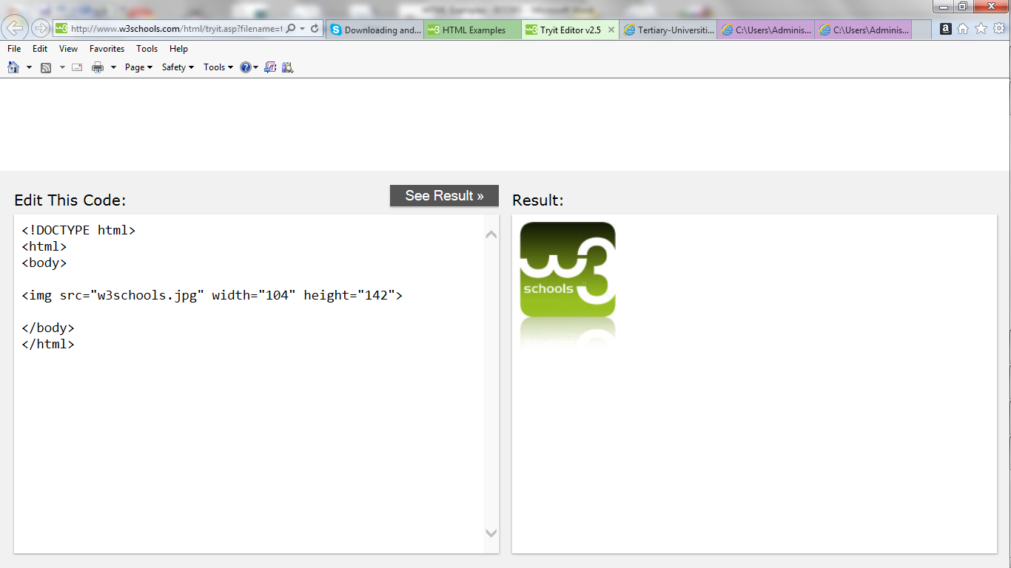

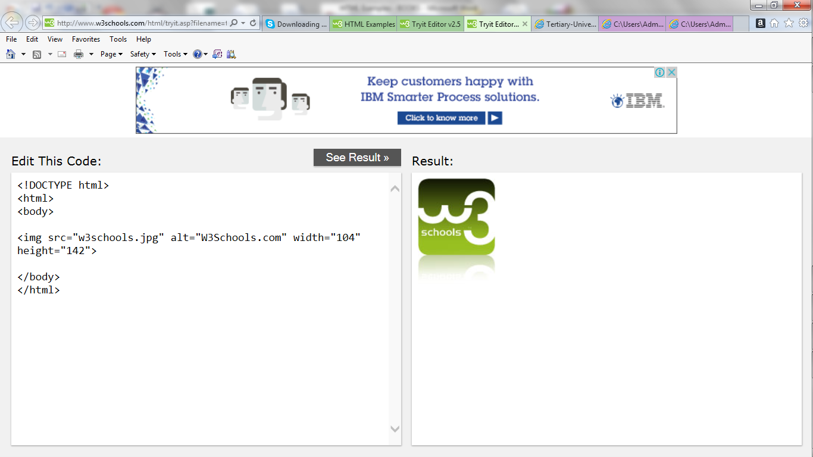

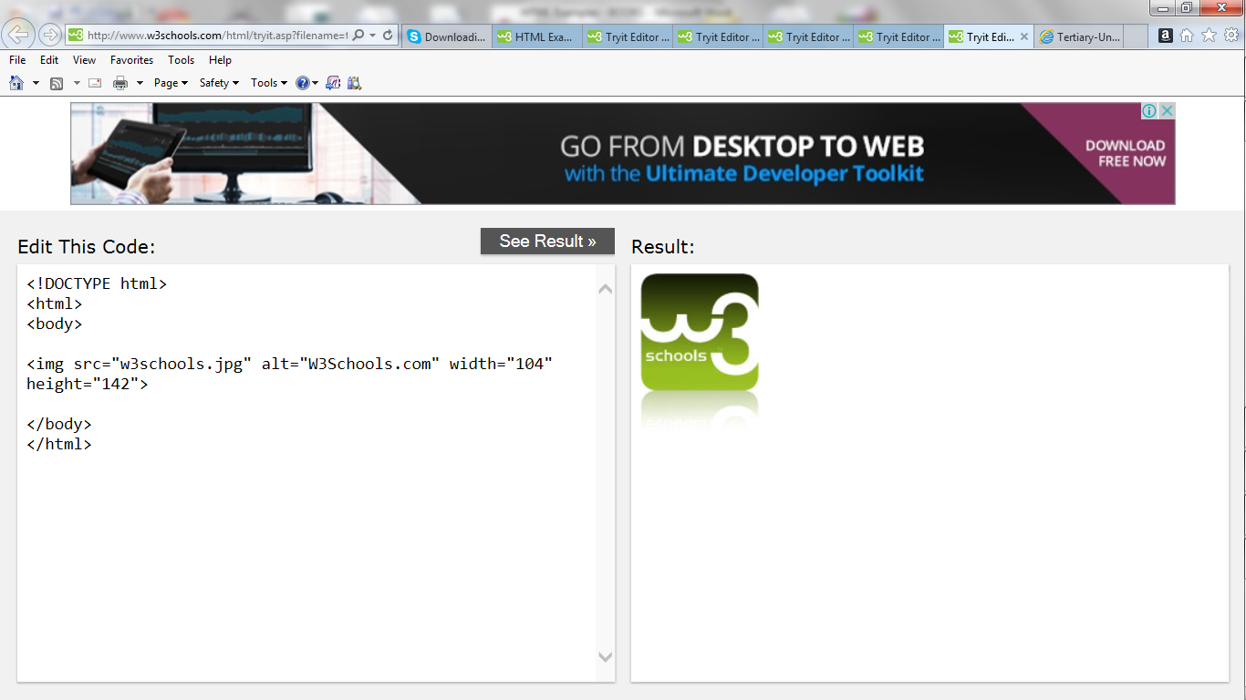

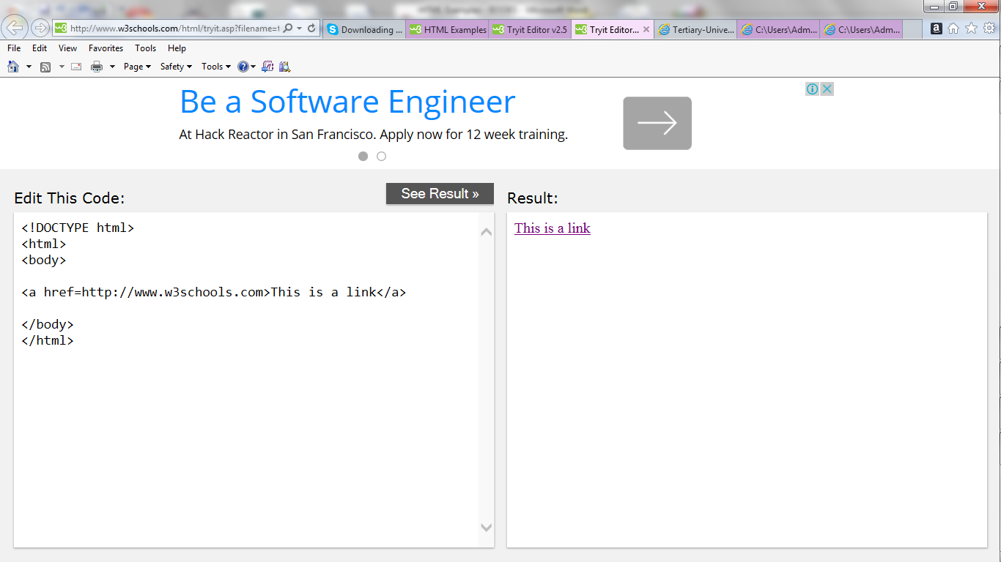

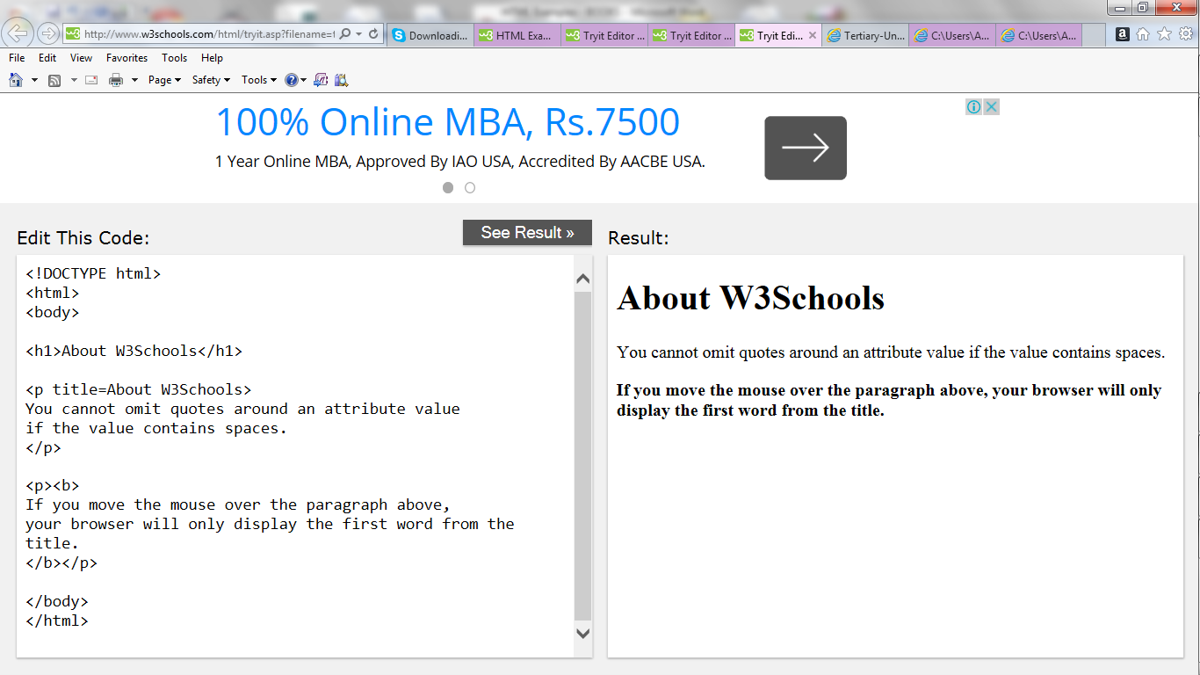

**HTML Headings**

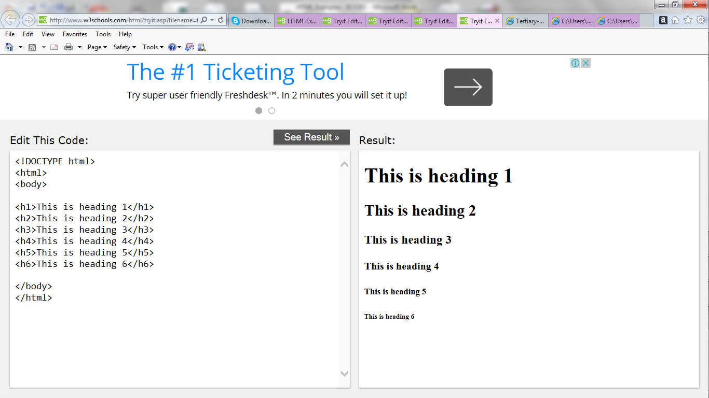

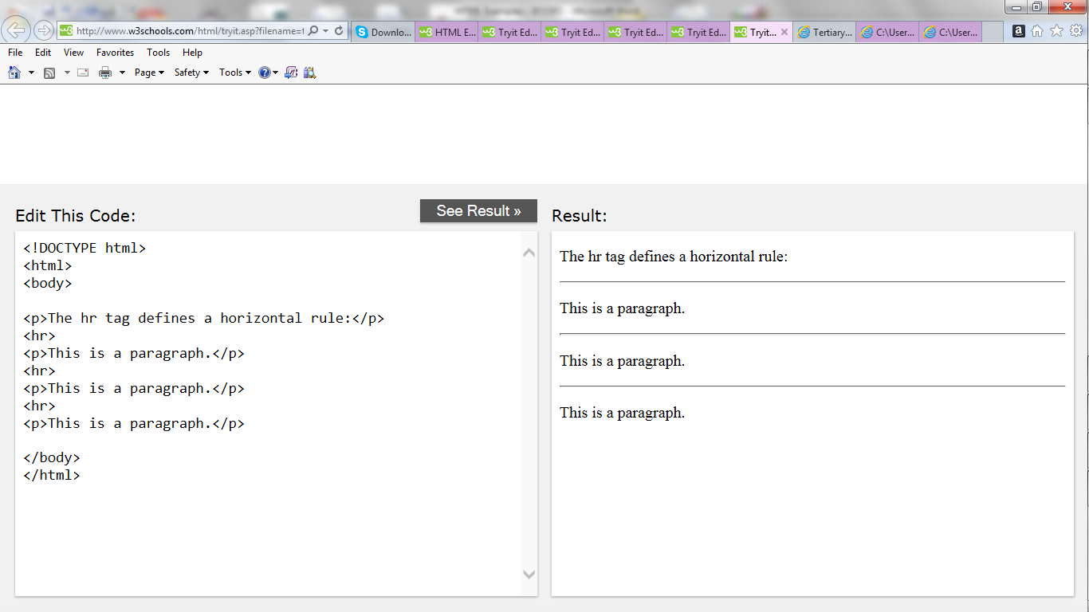

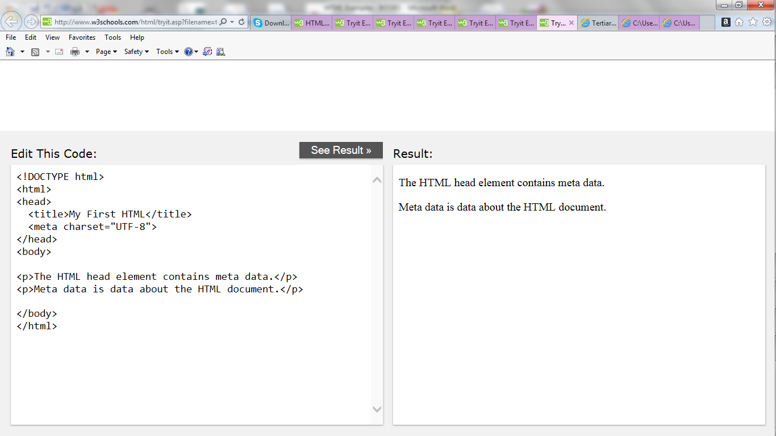

**HTML Paragraphs**

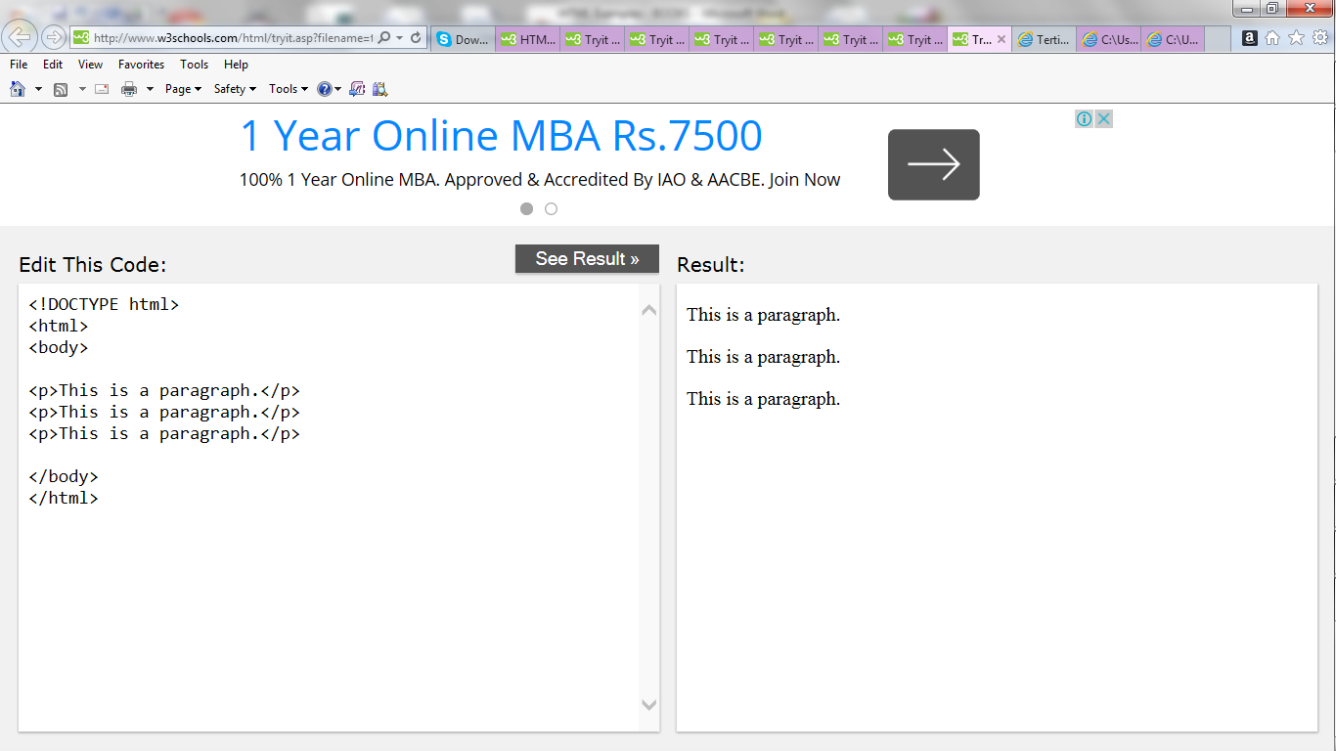

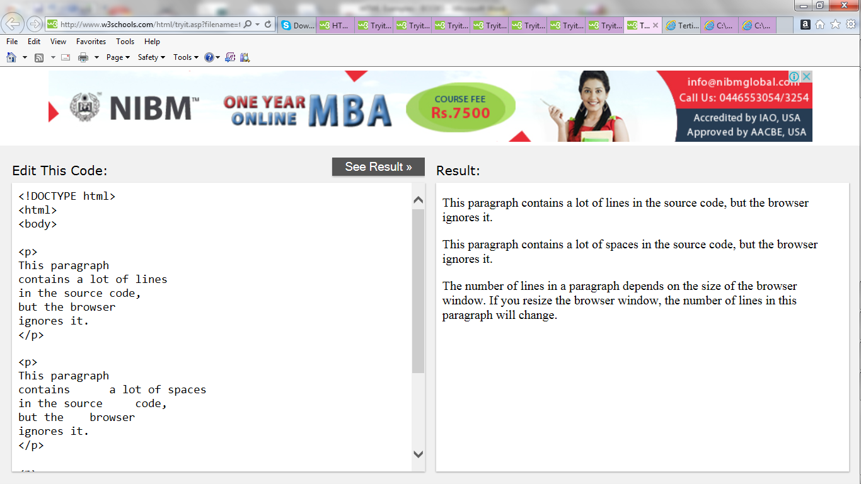

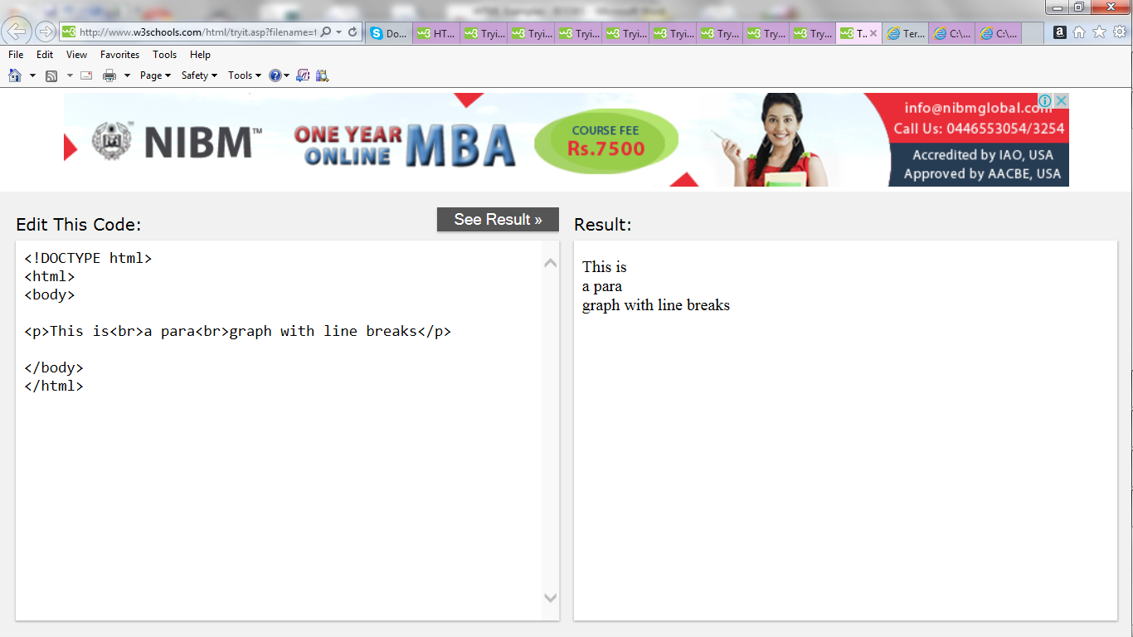

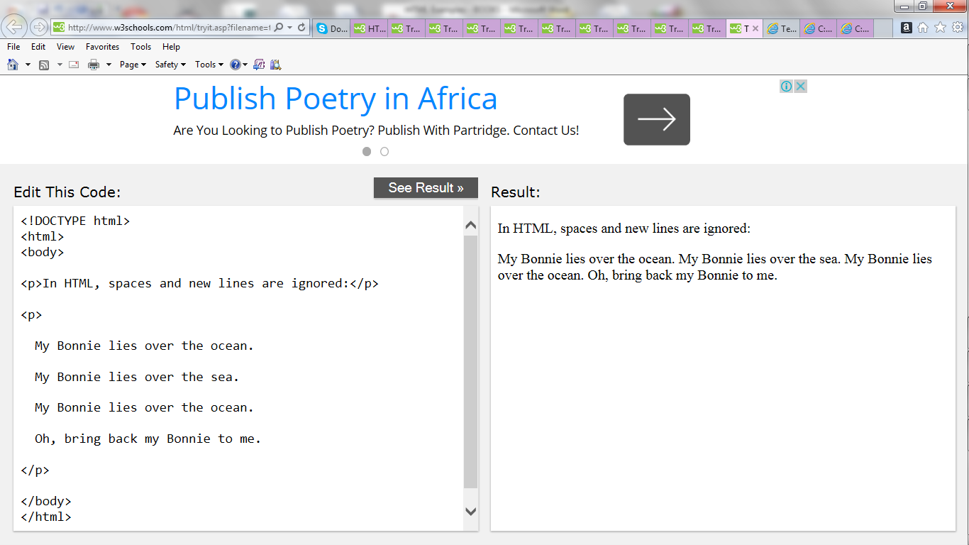

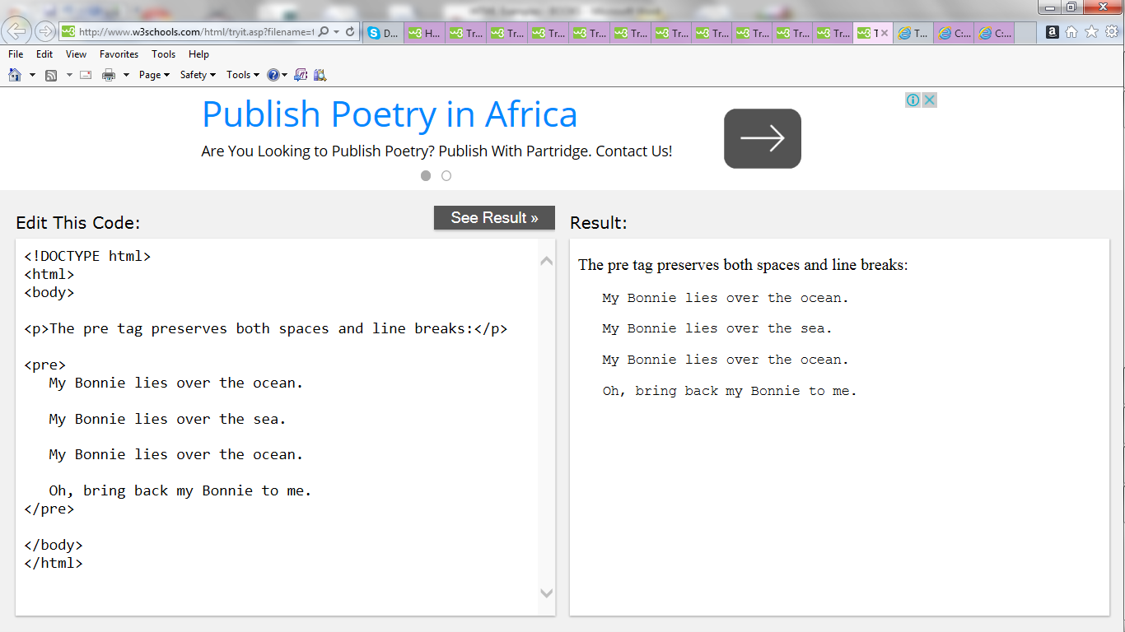

**HTML Styles**

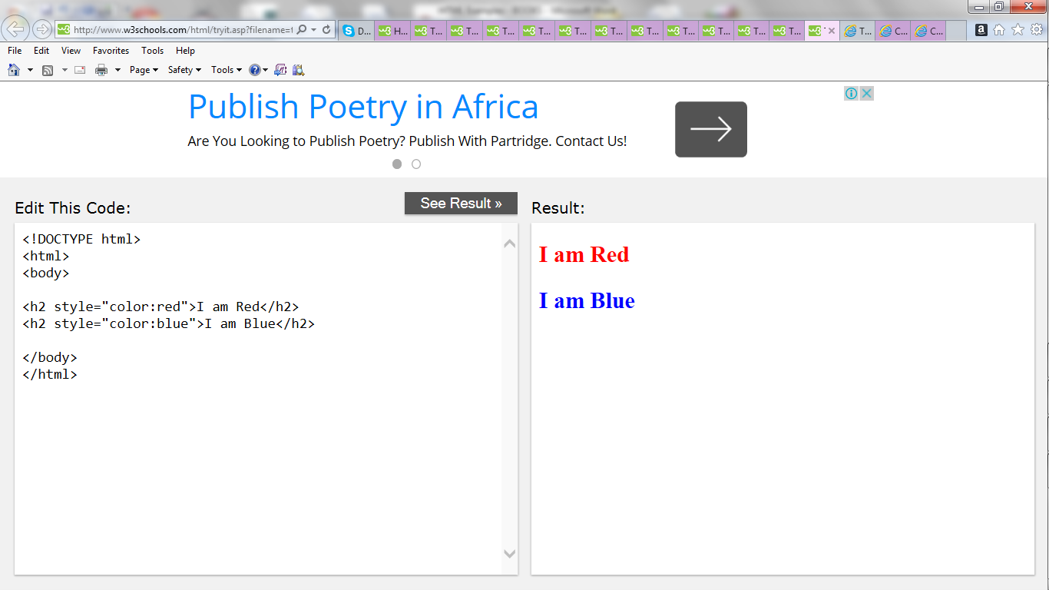

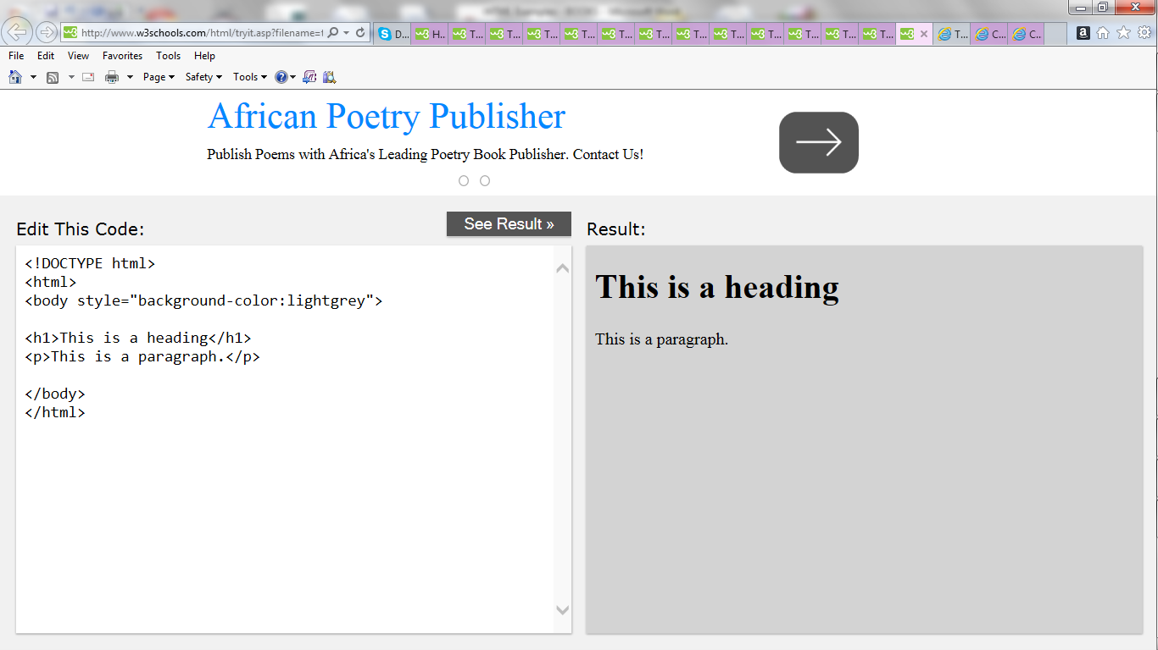

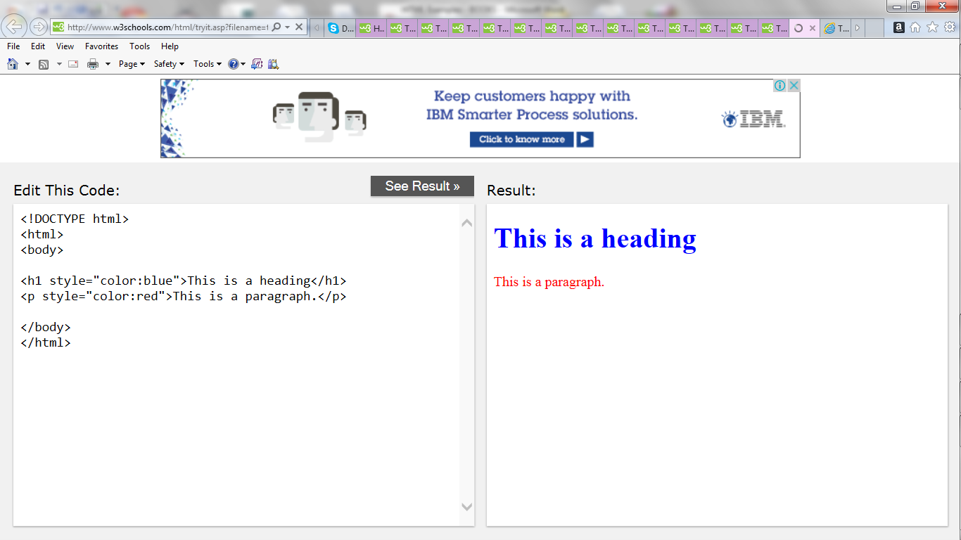

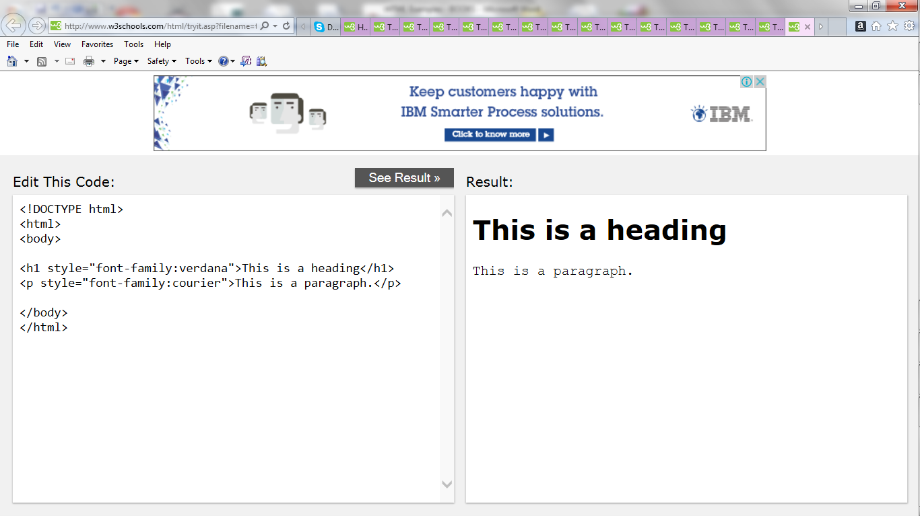

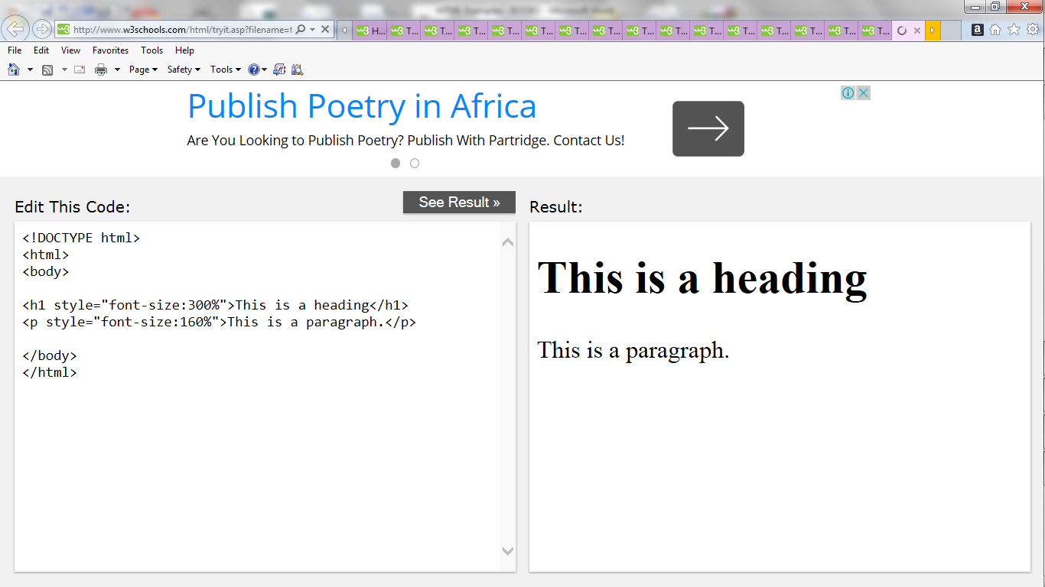

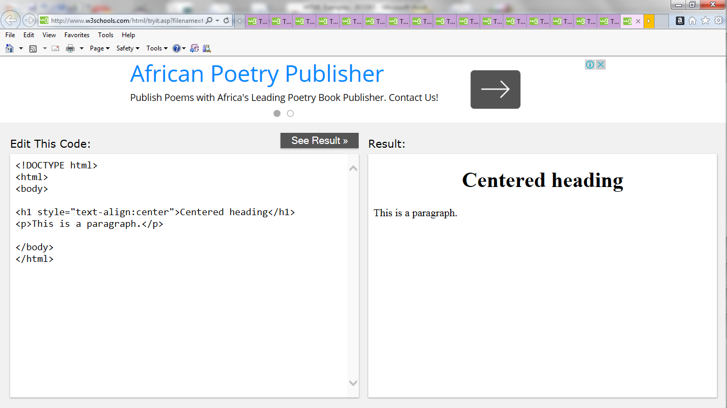

**HTML Text Formatting**

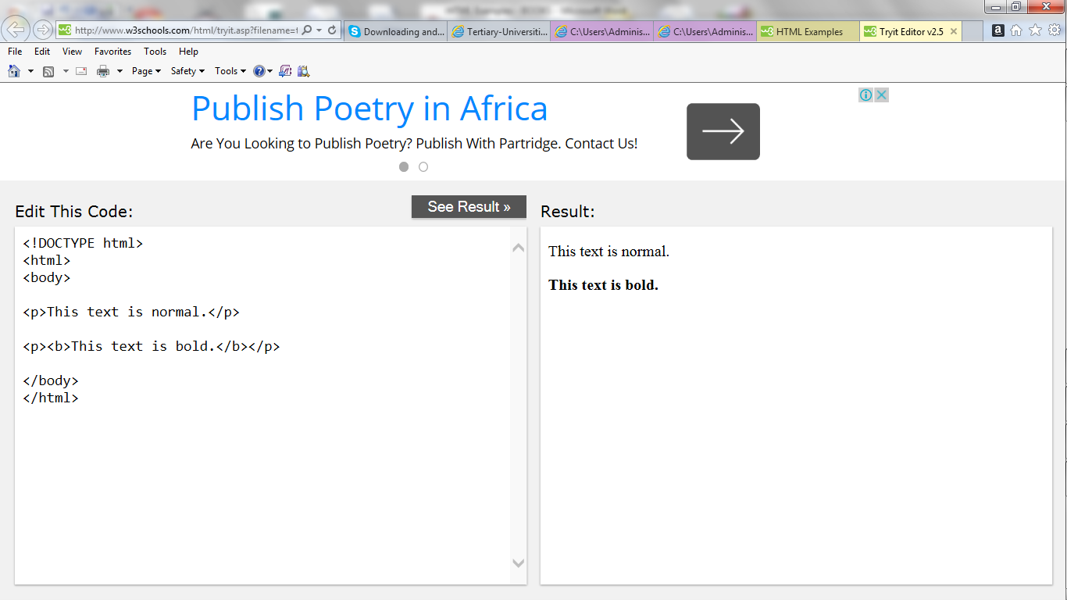

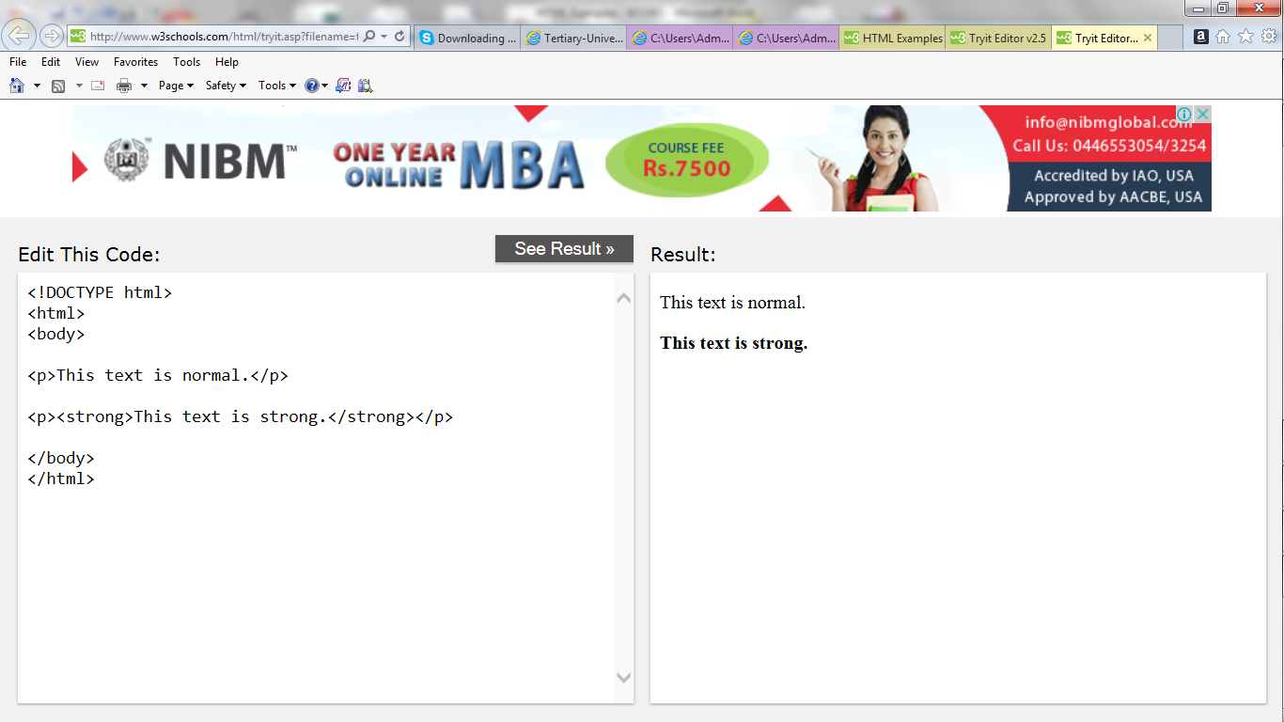

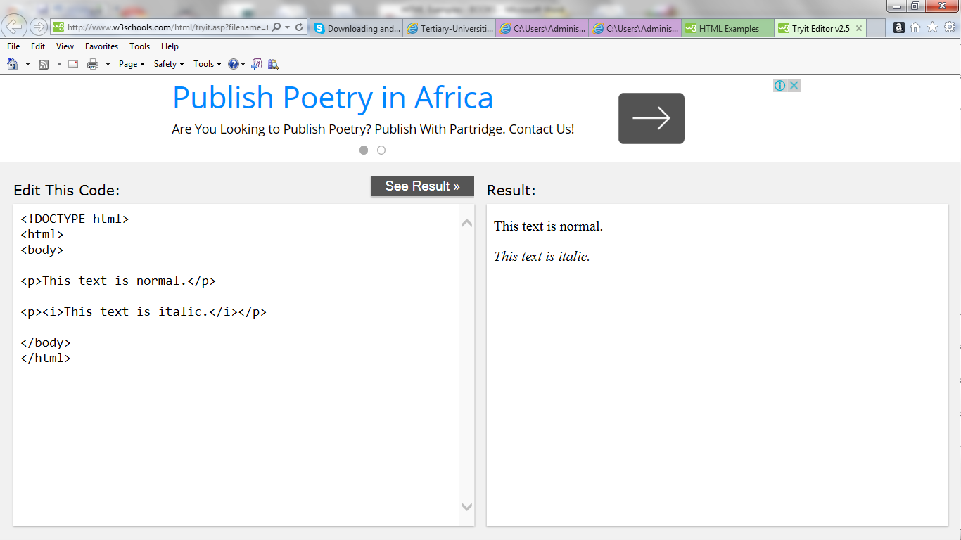

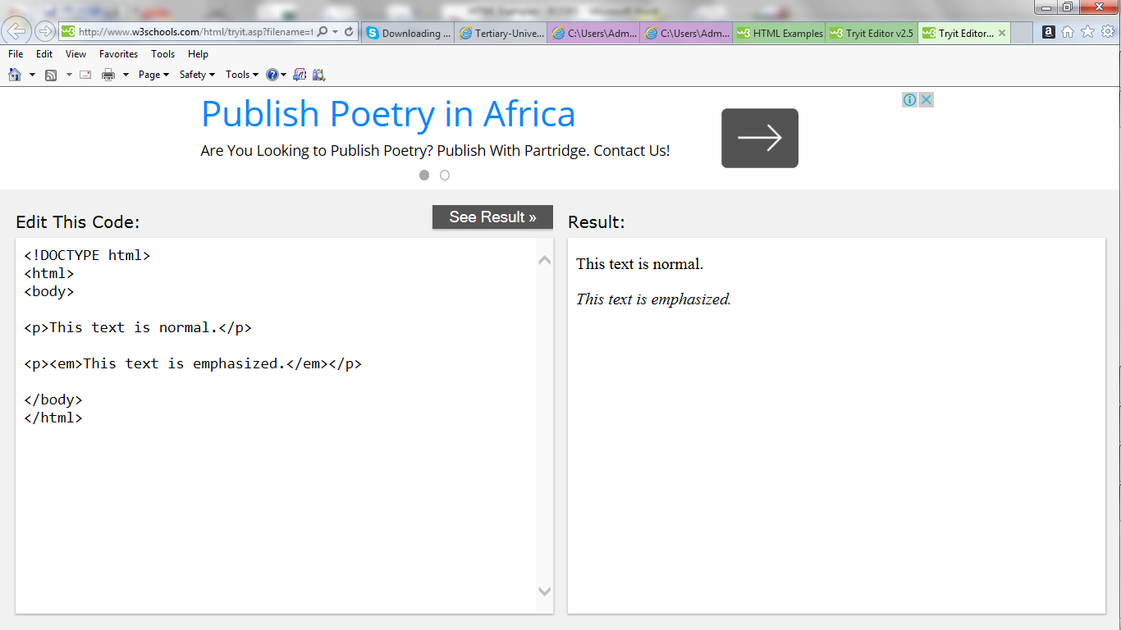

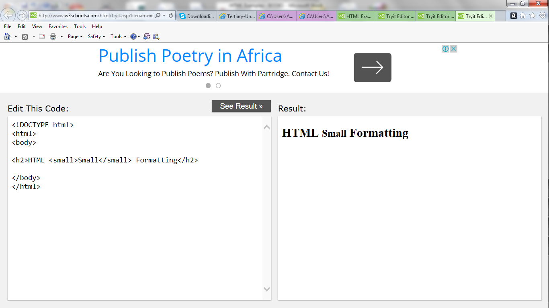

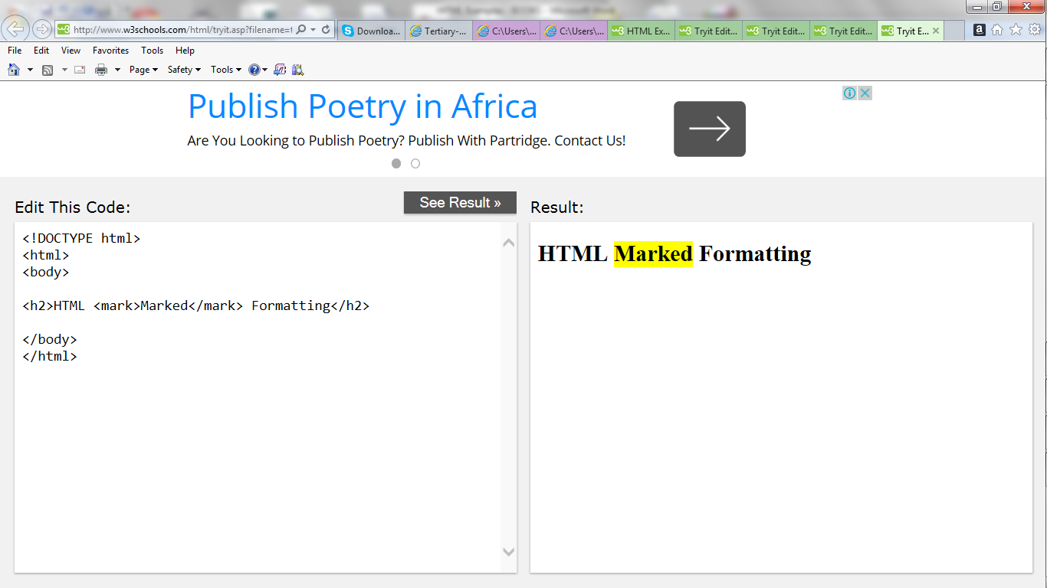

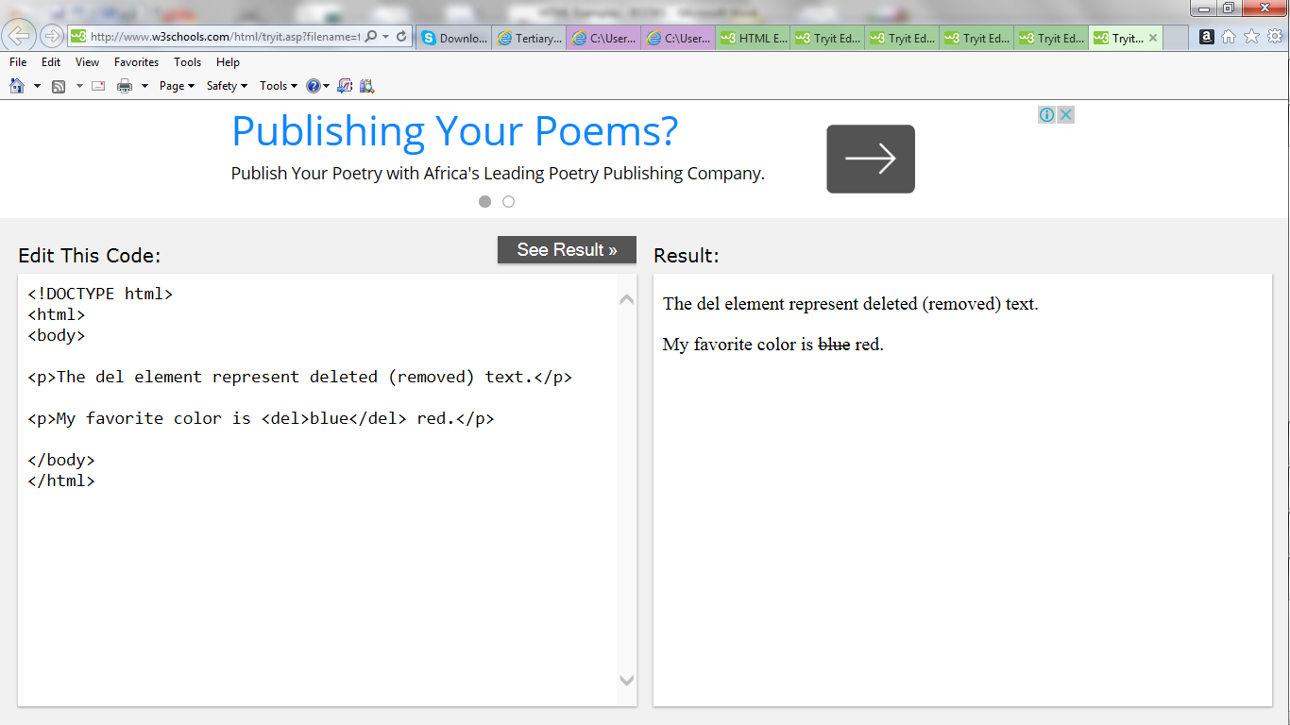

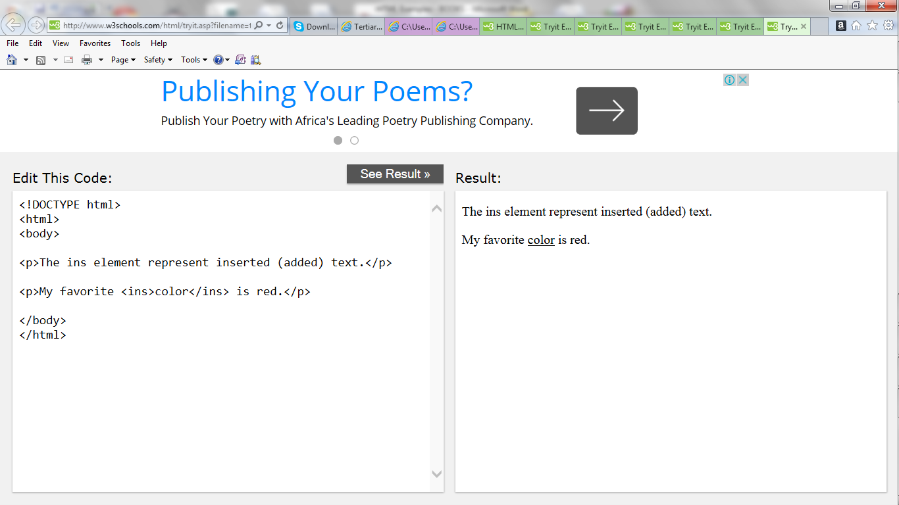

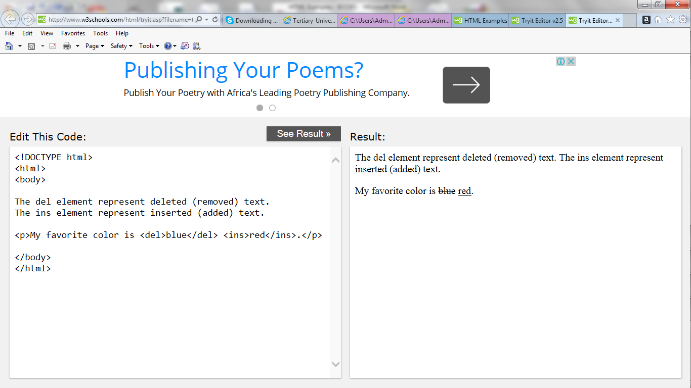

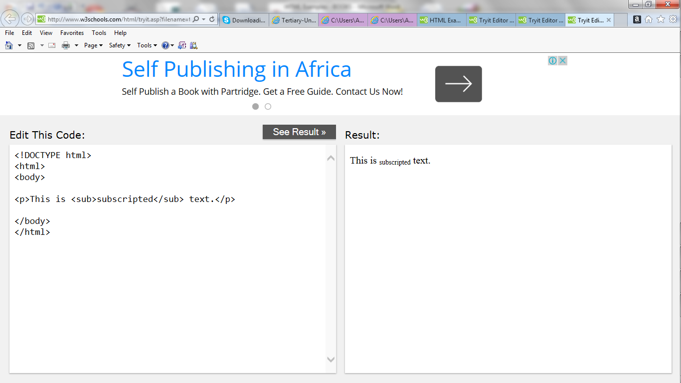

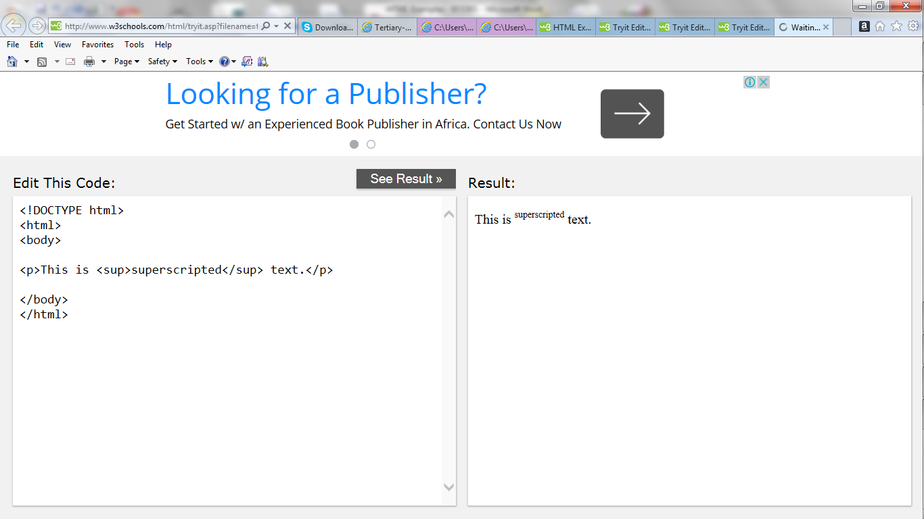

**HTML Quotations and Citations**

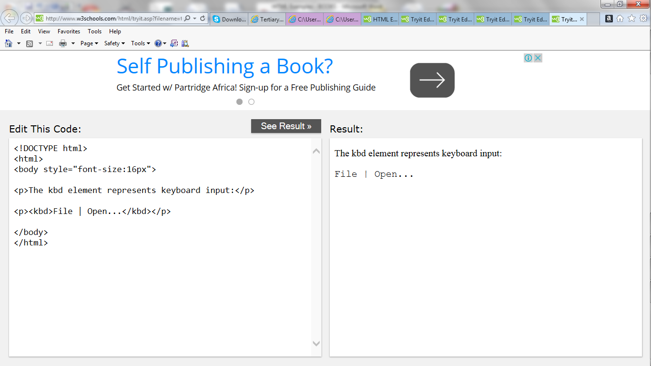

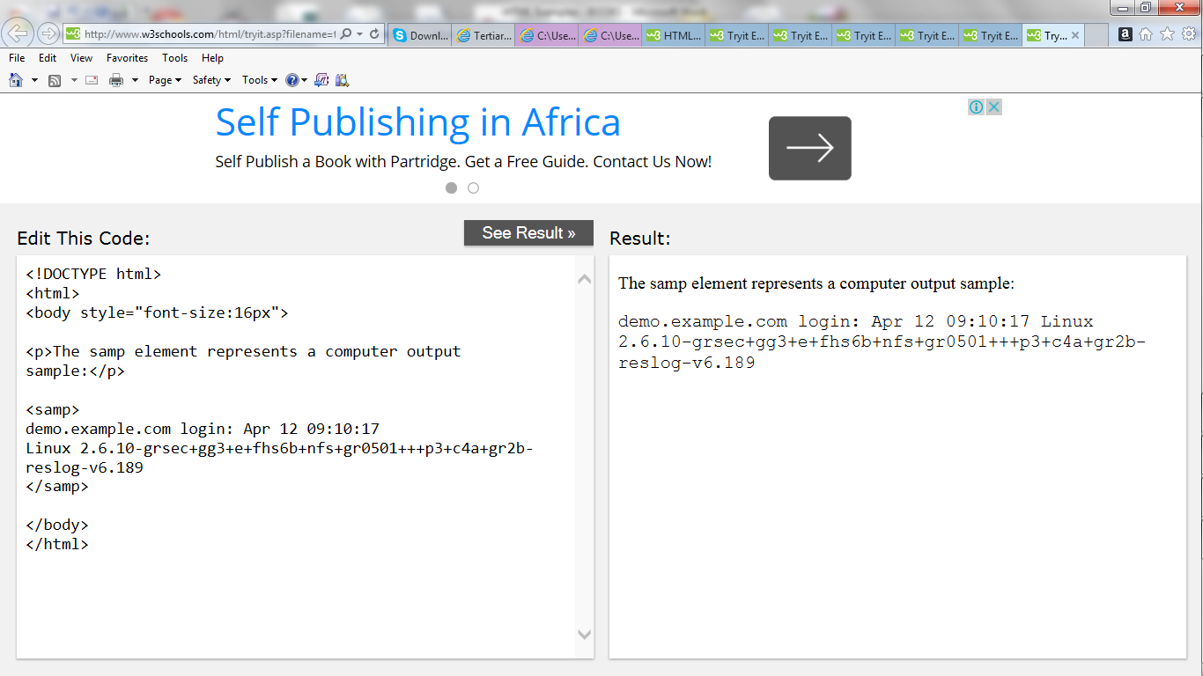

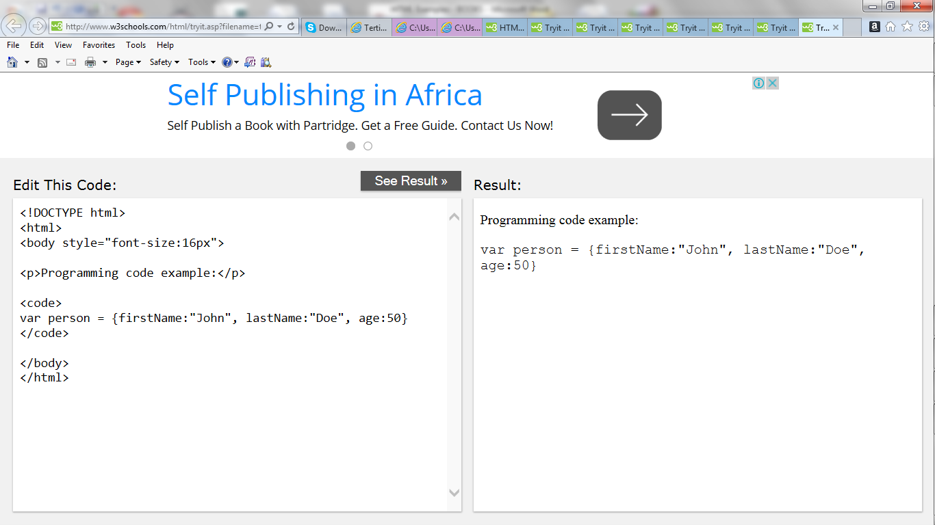

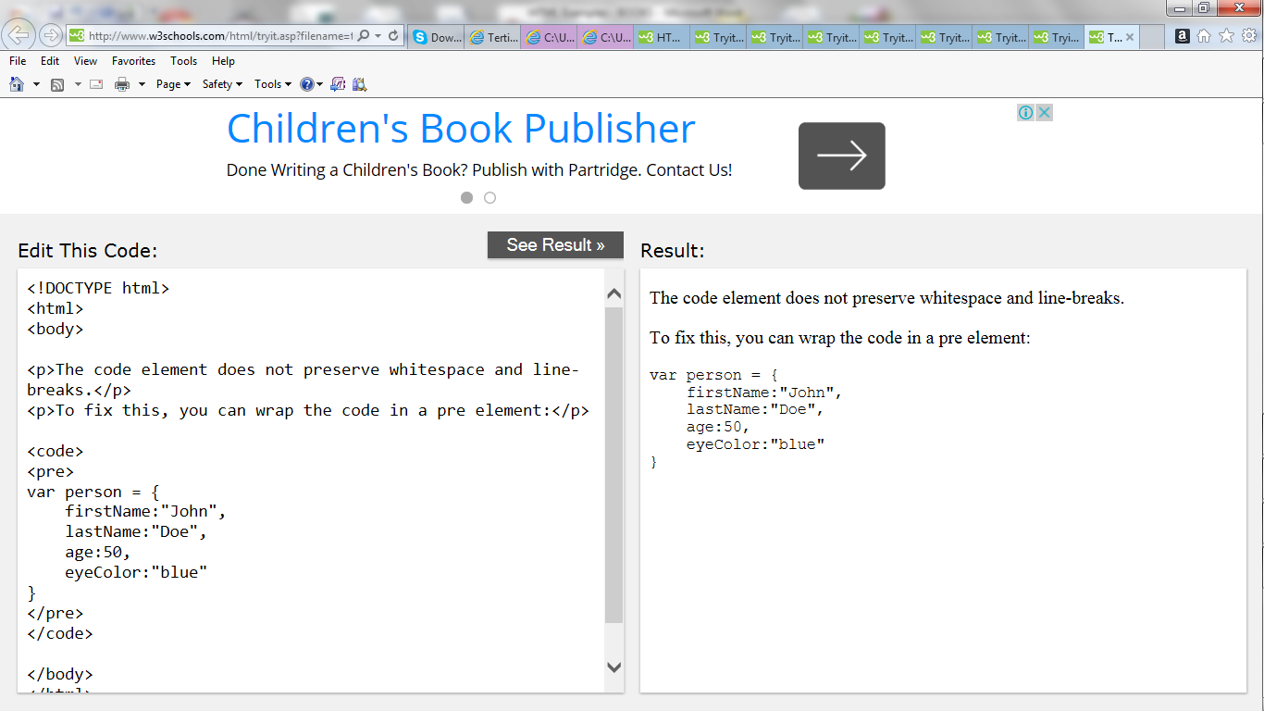

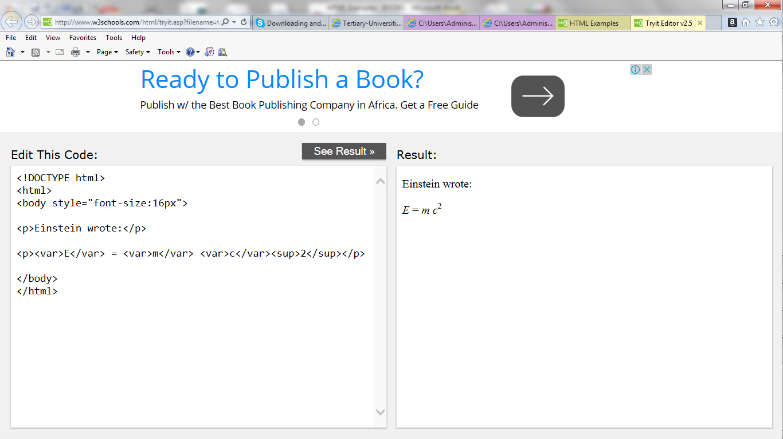

**HTML Comments**

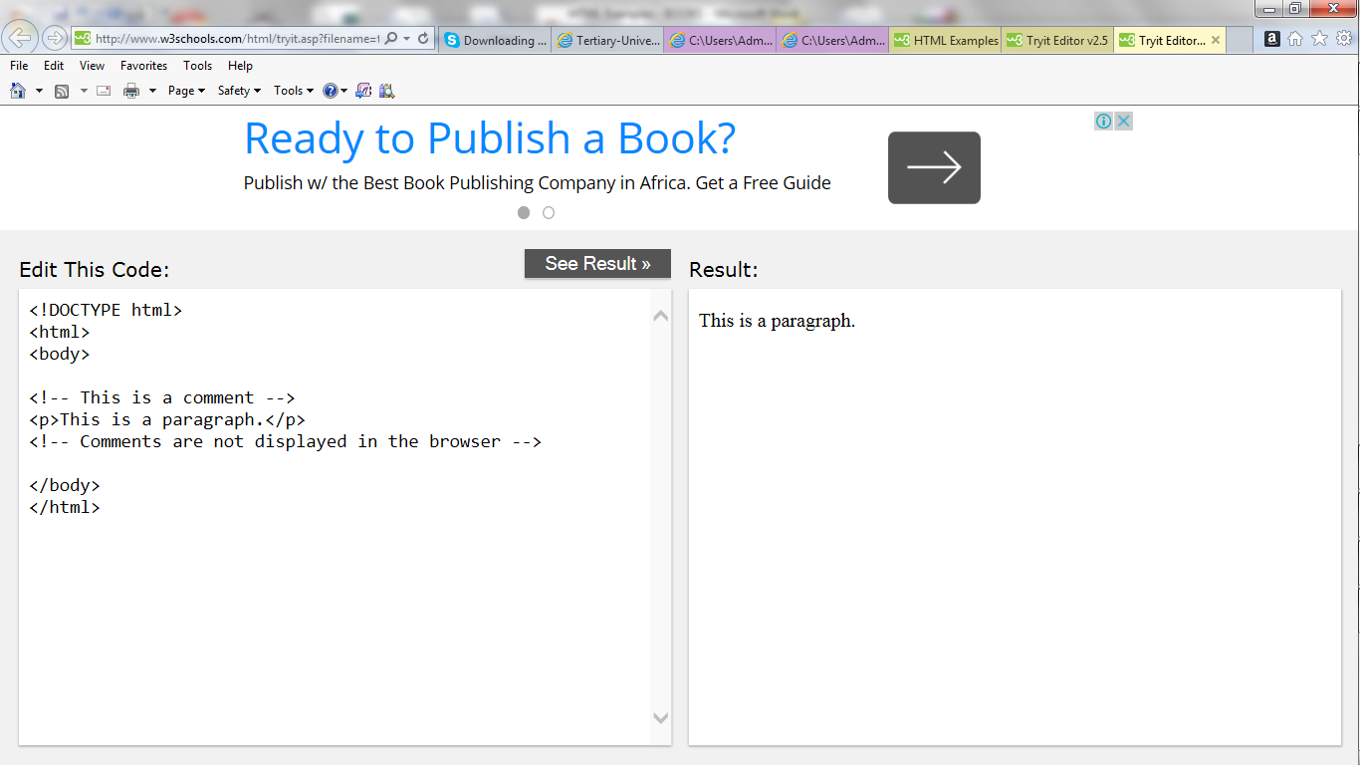

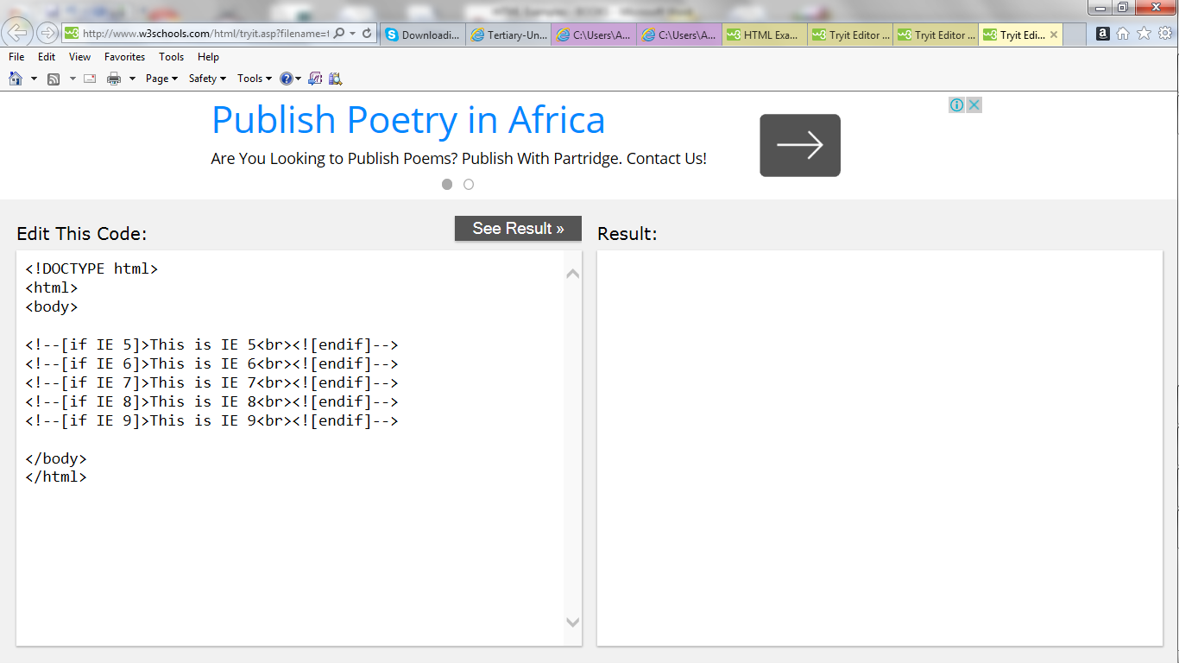

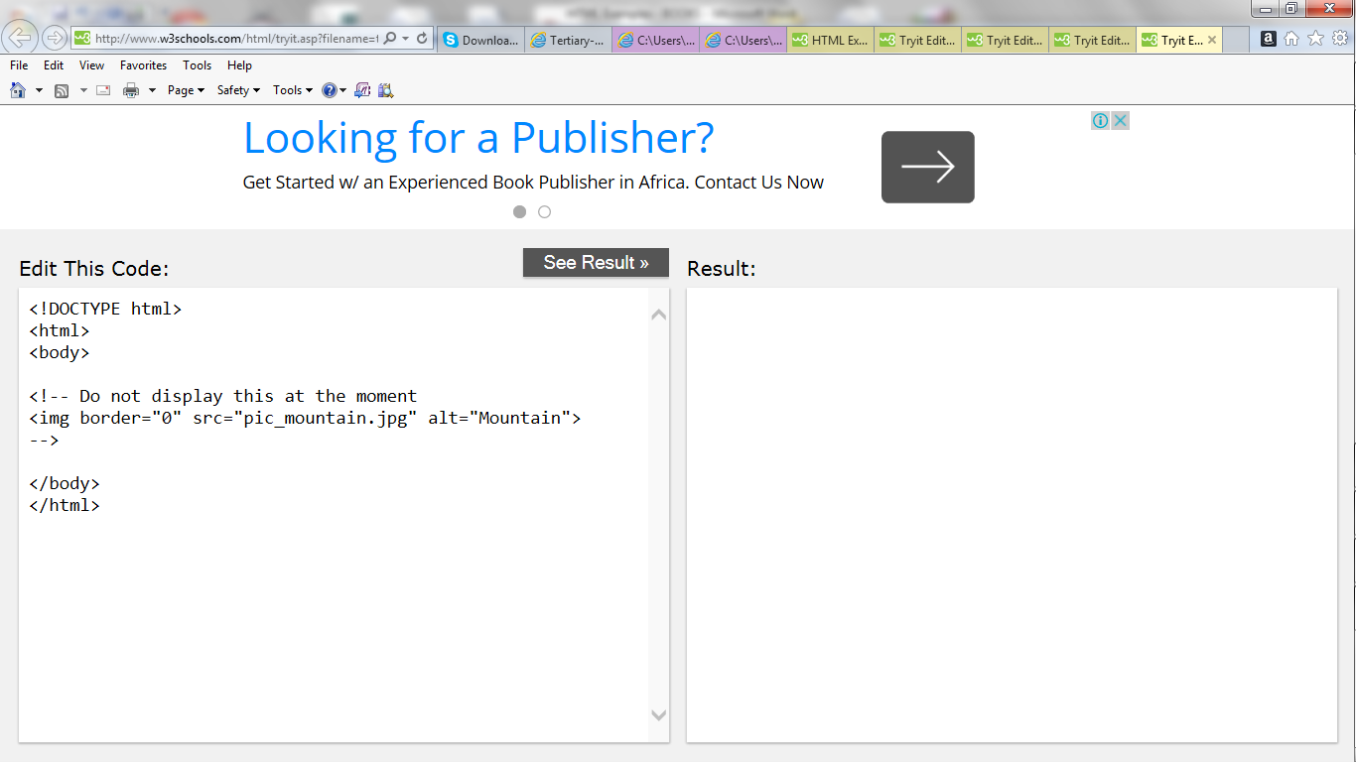

**HTML CSS**

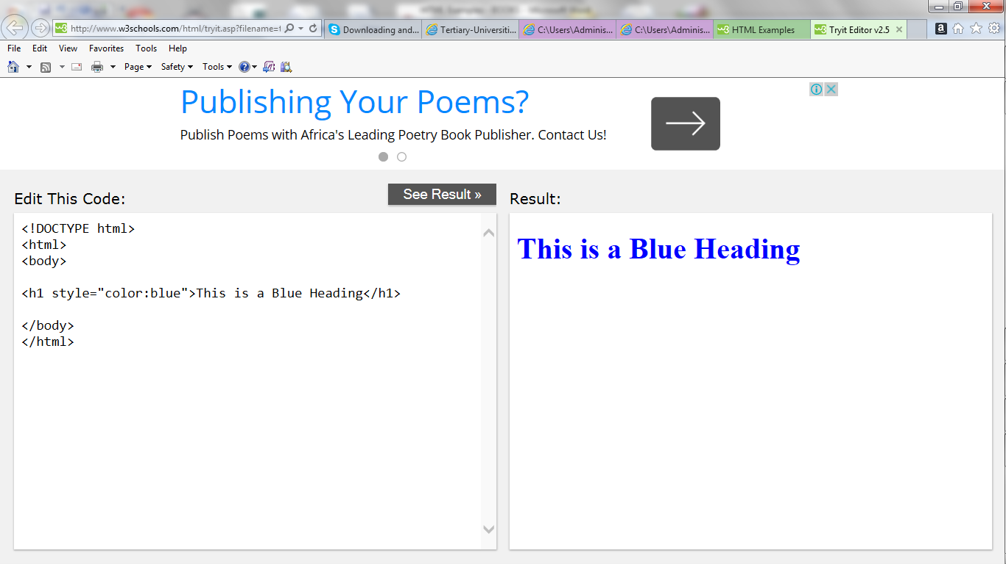

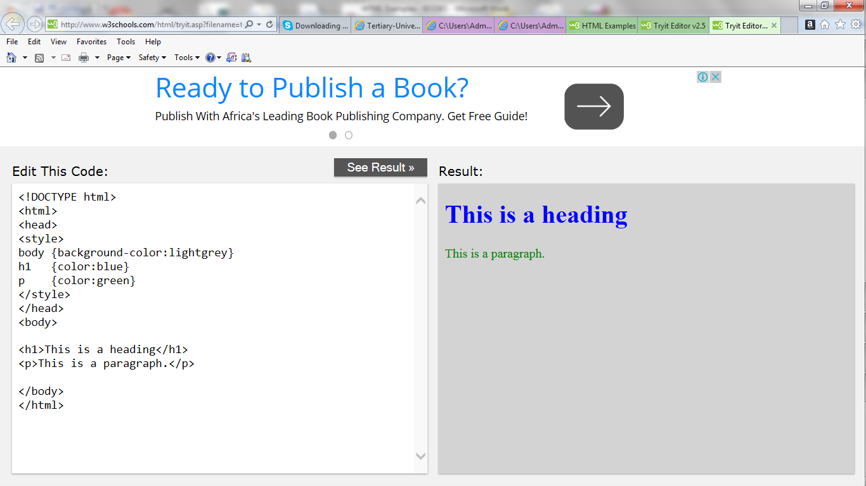

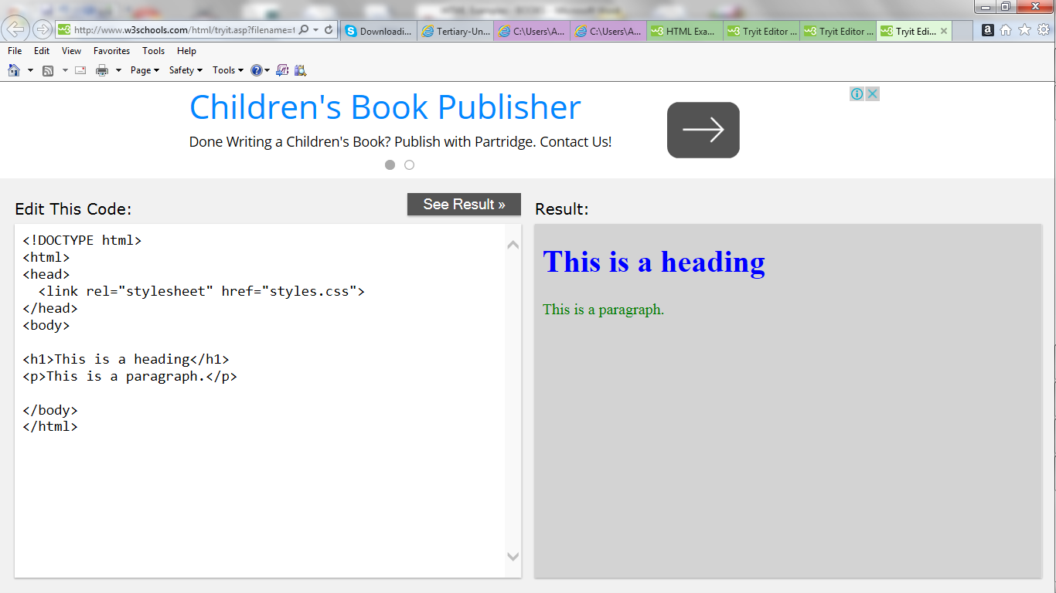

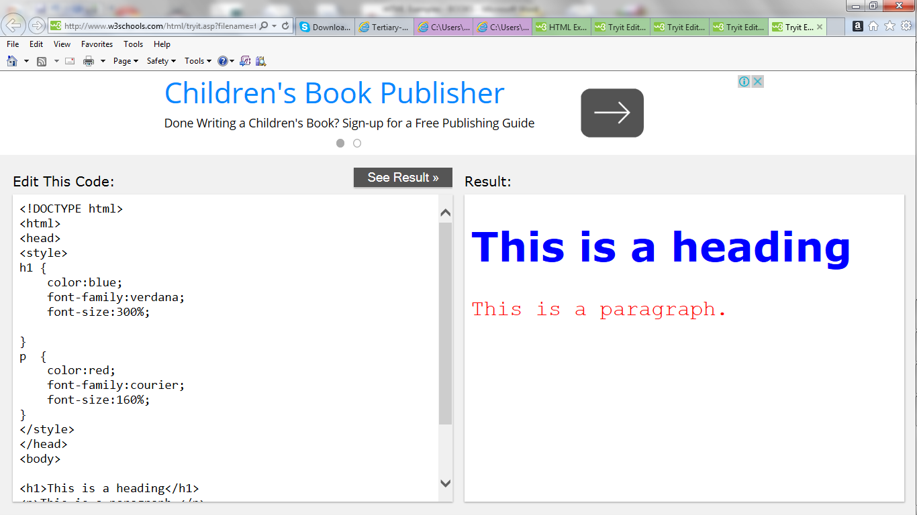

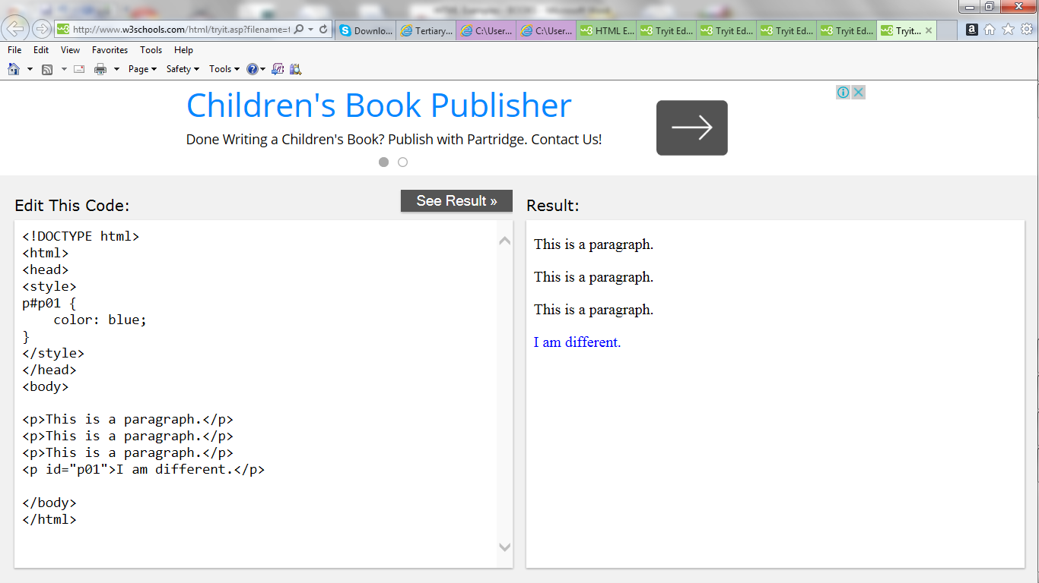

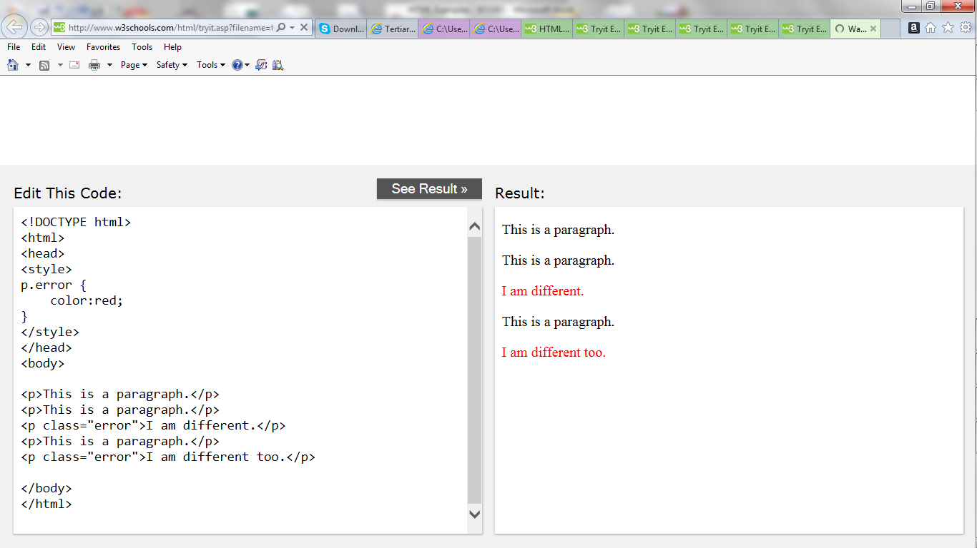

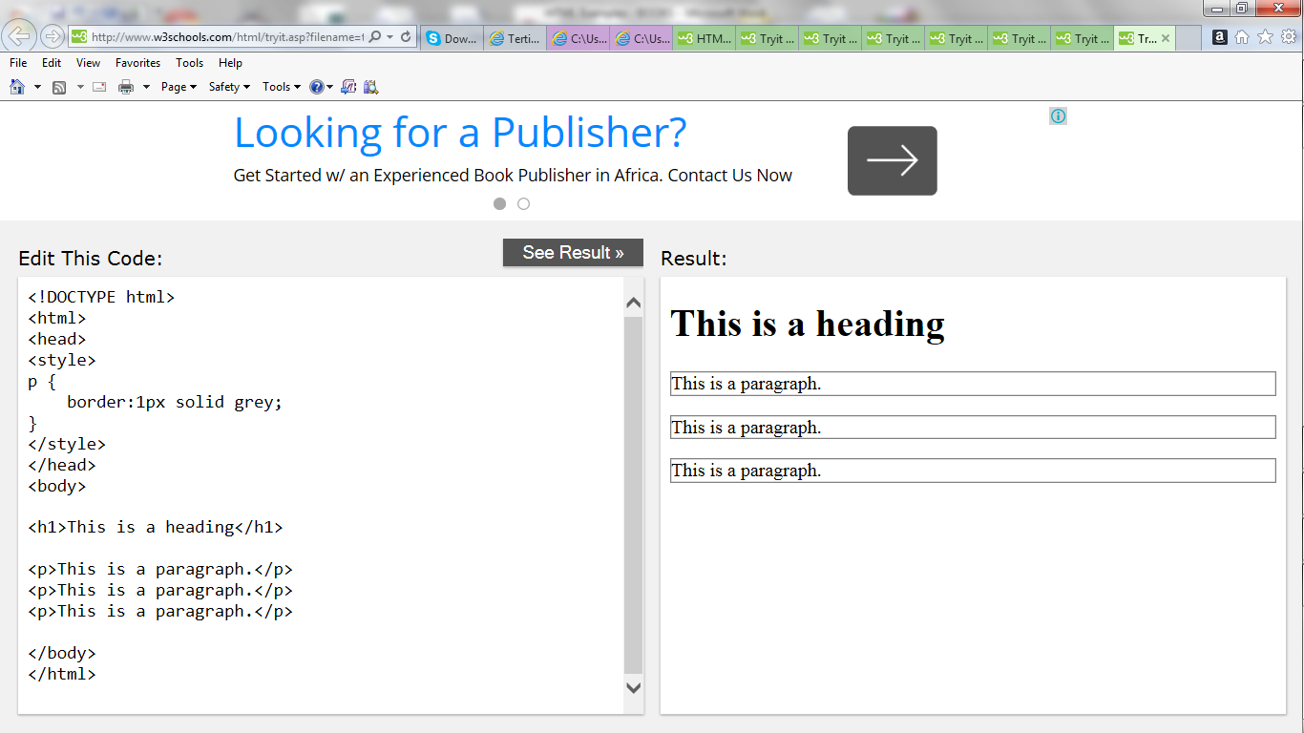

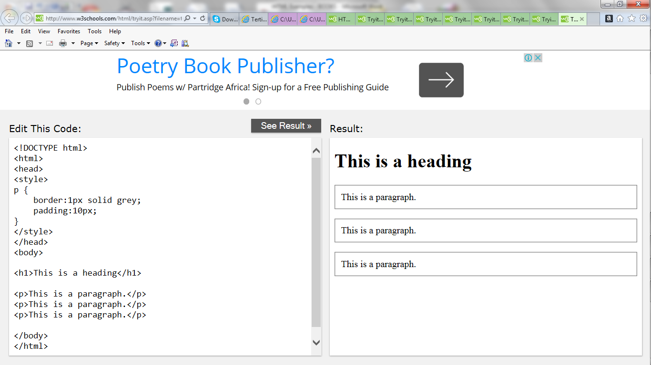

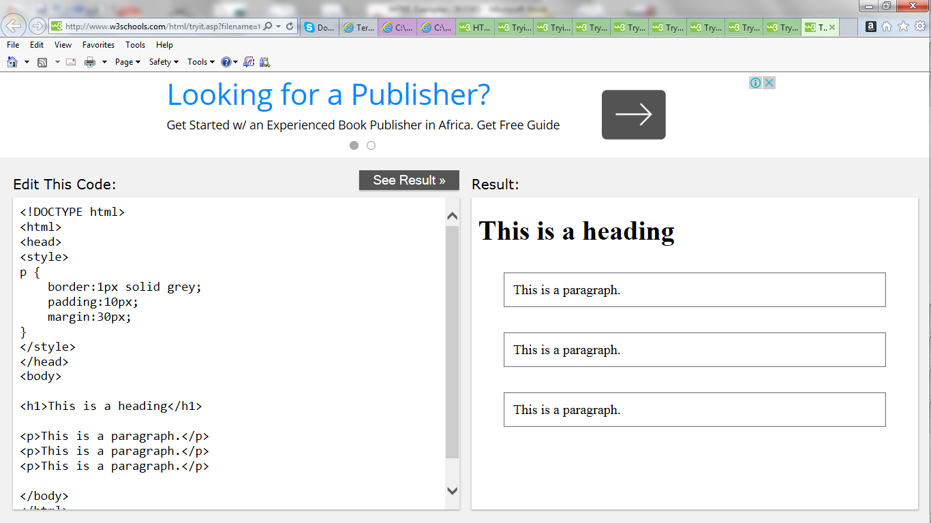

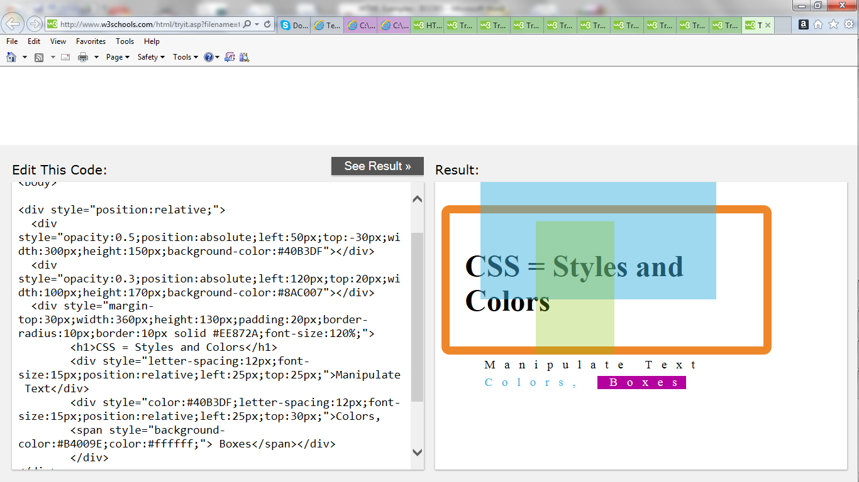

**HTML Links**

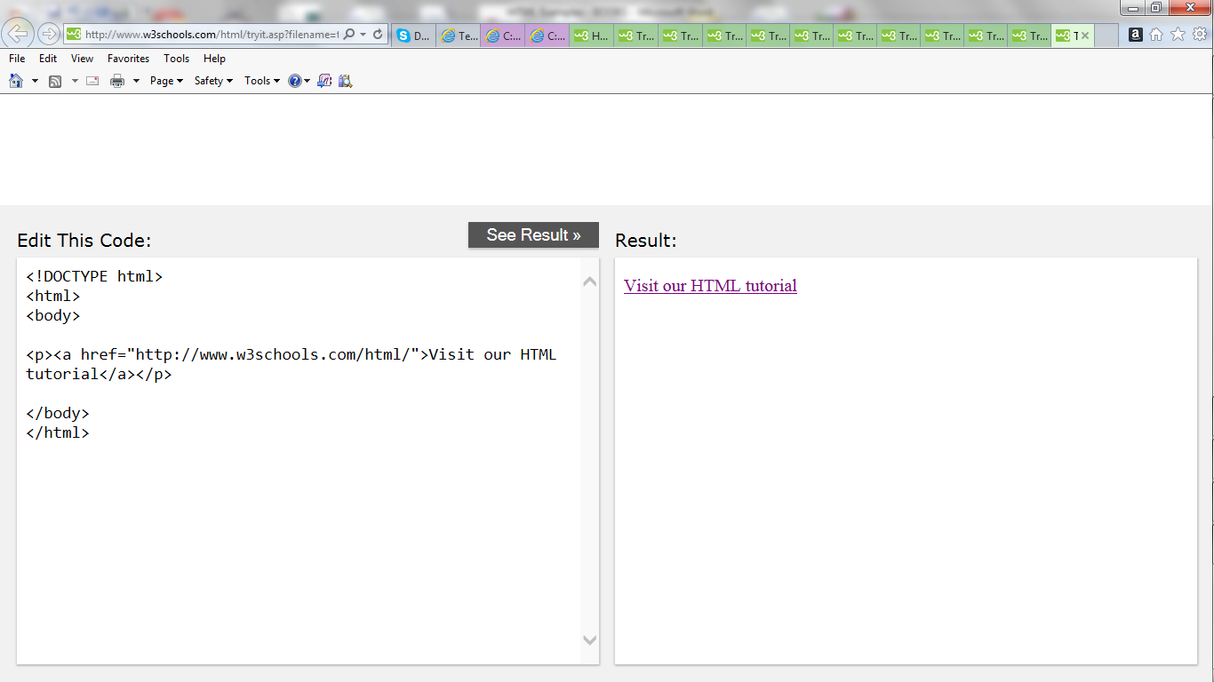

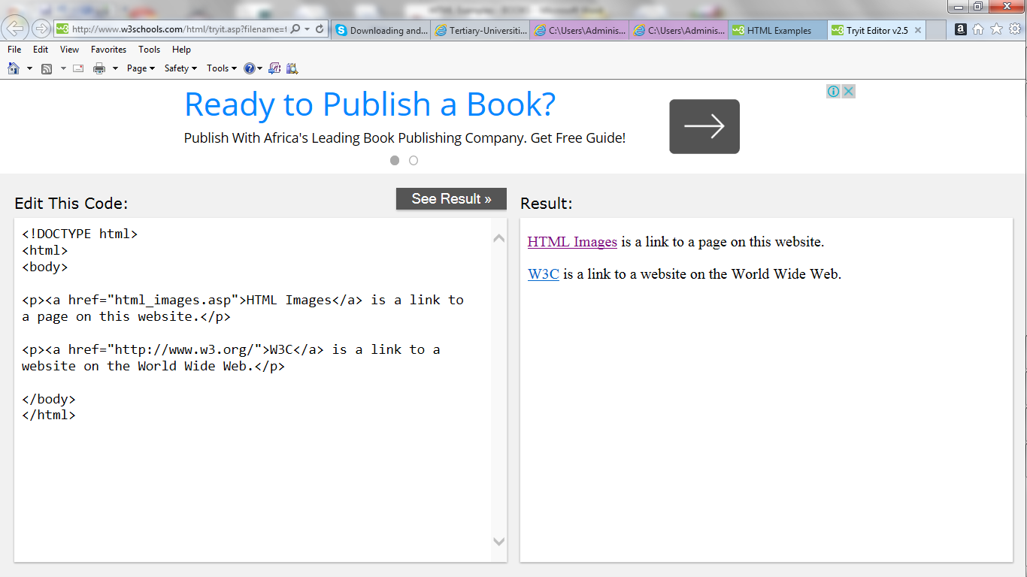

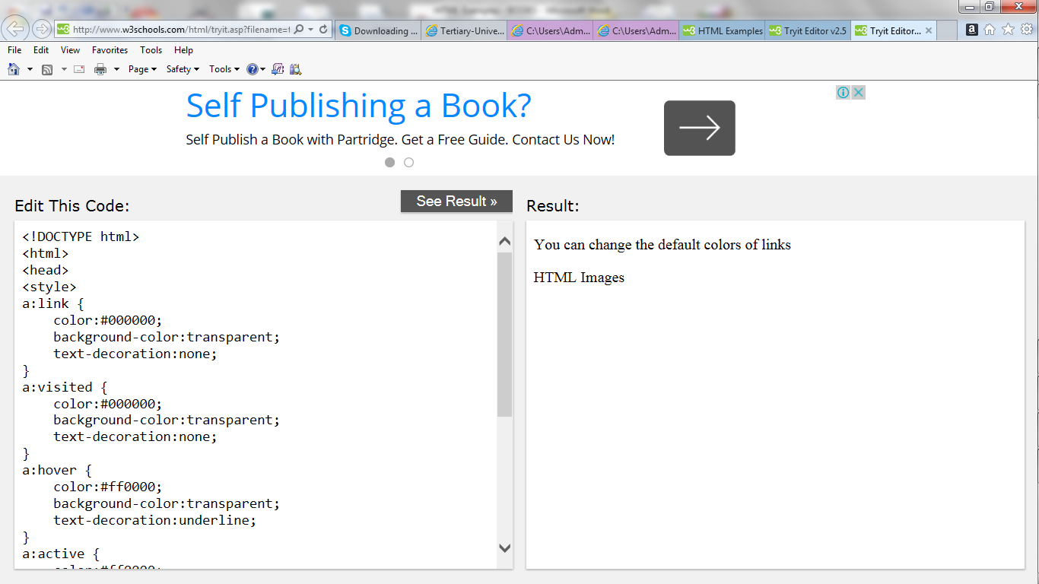

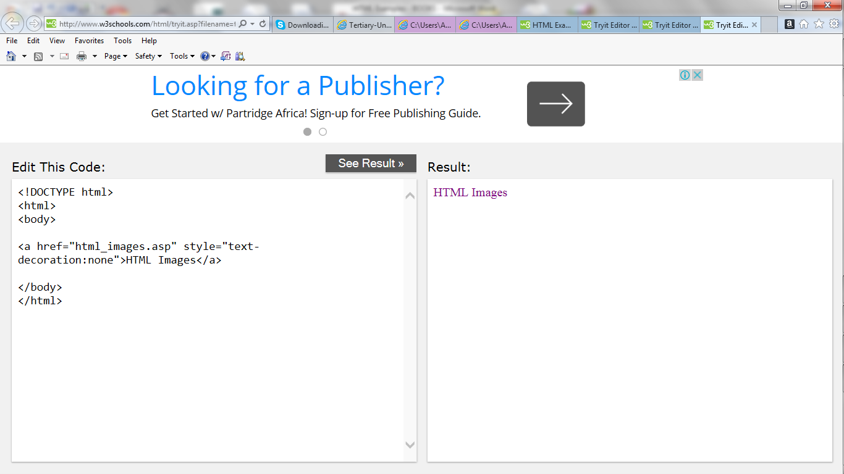

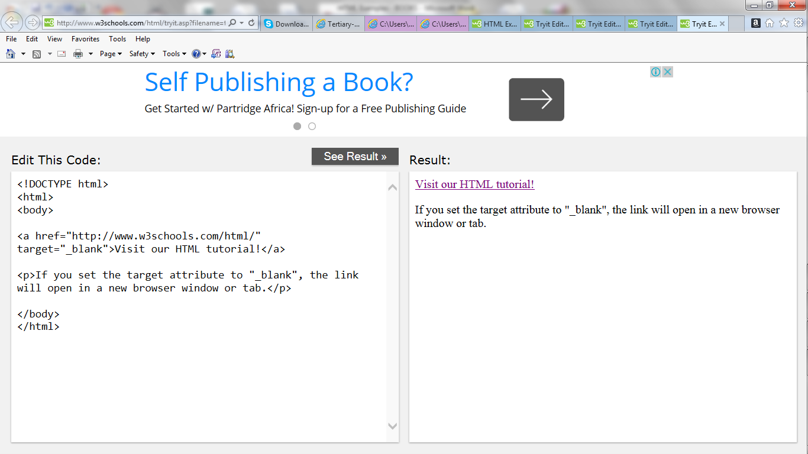

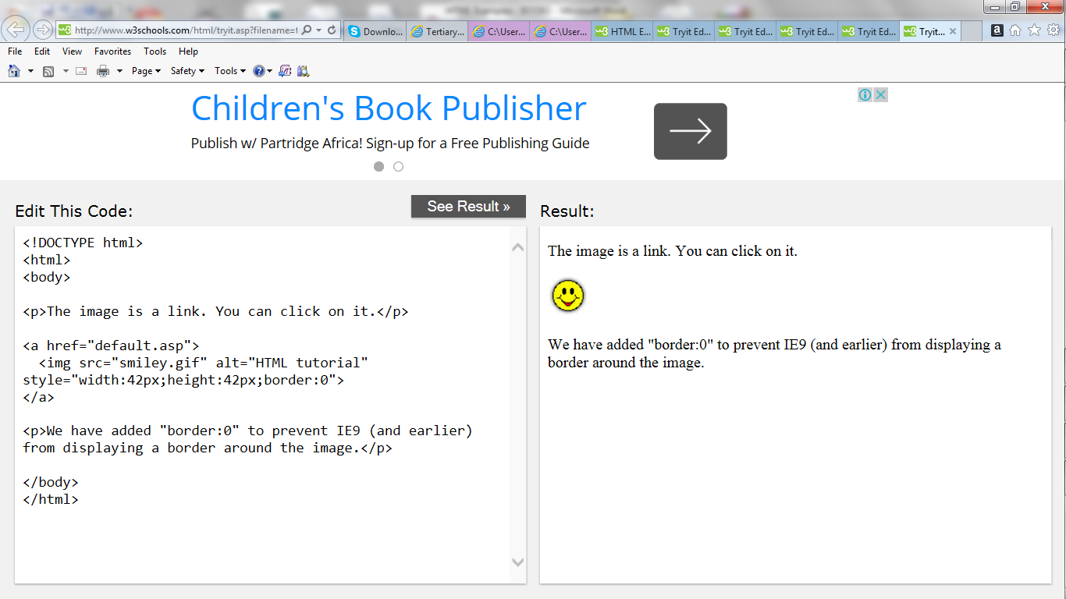

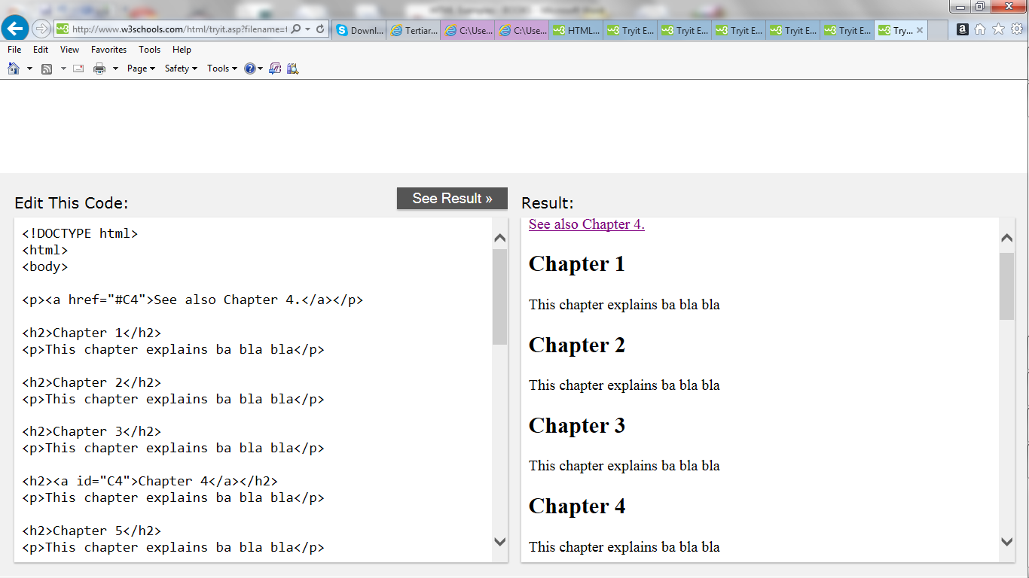

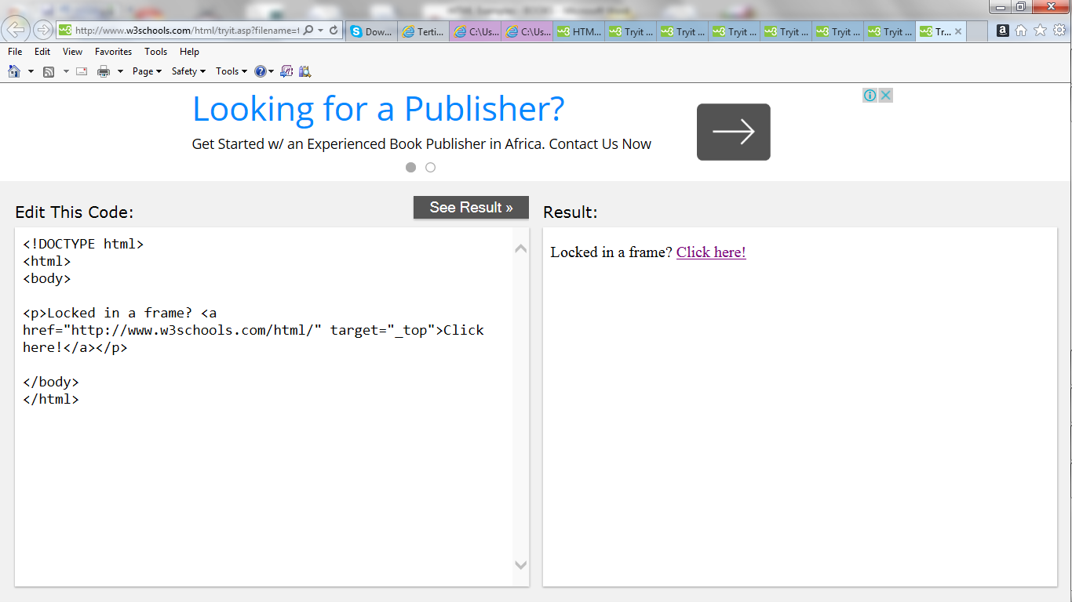

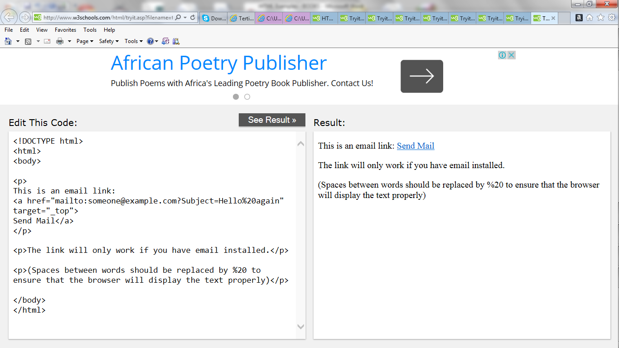

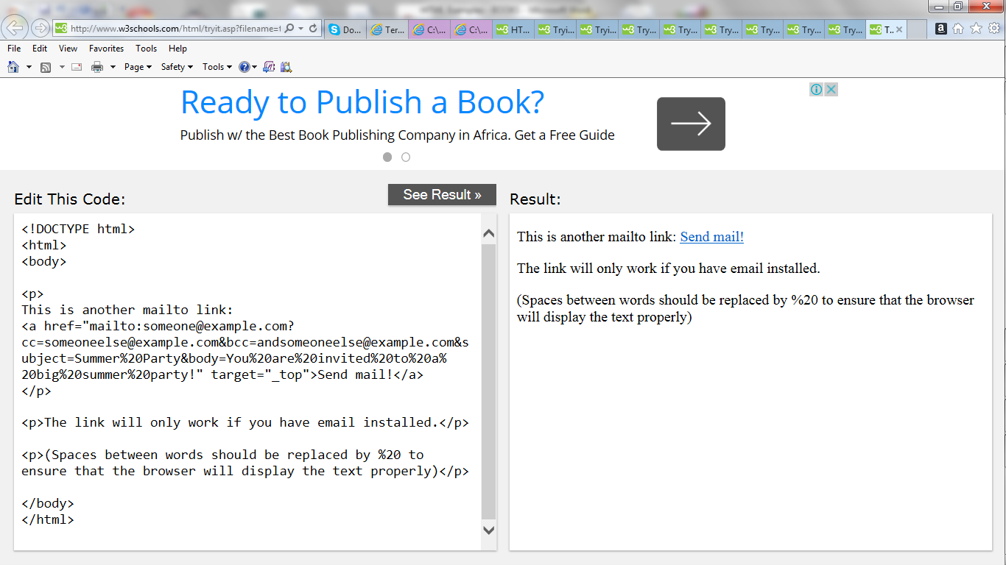

**HTML Images**

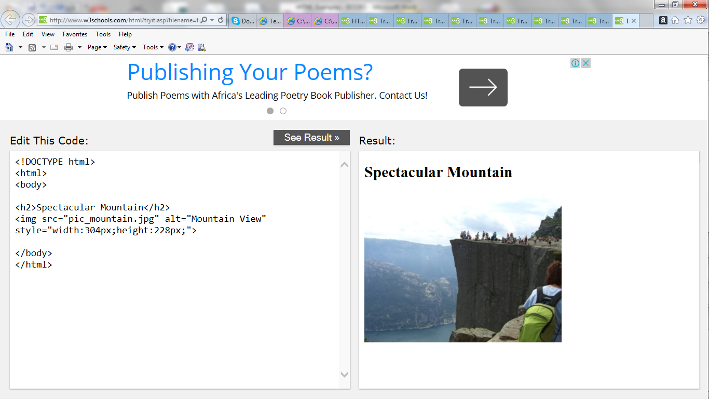

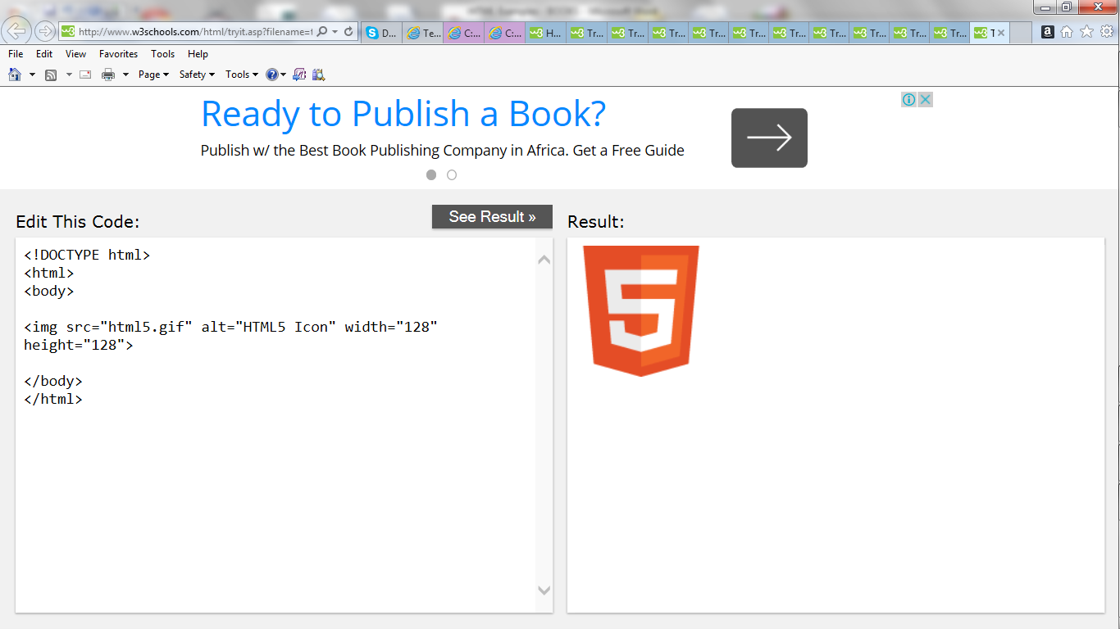

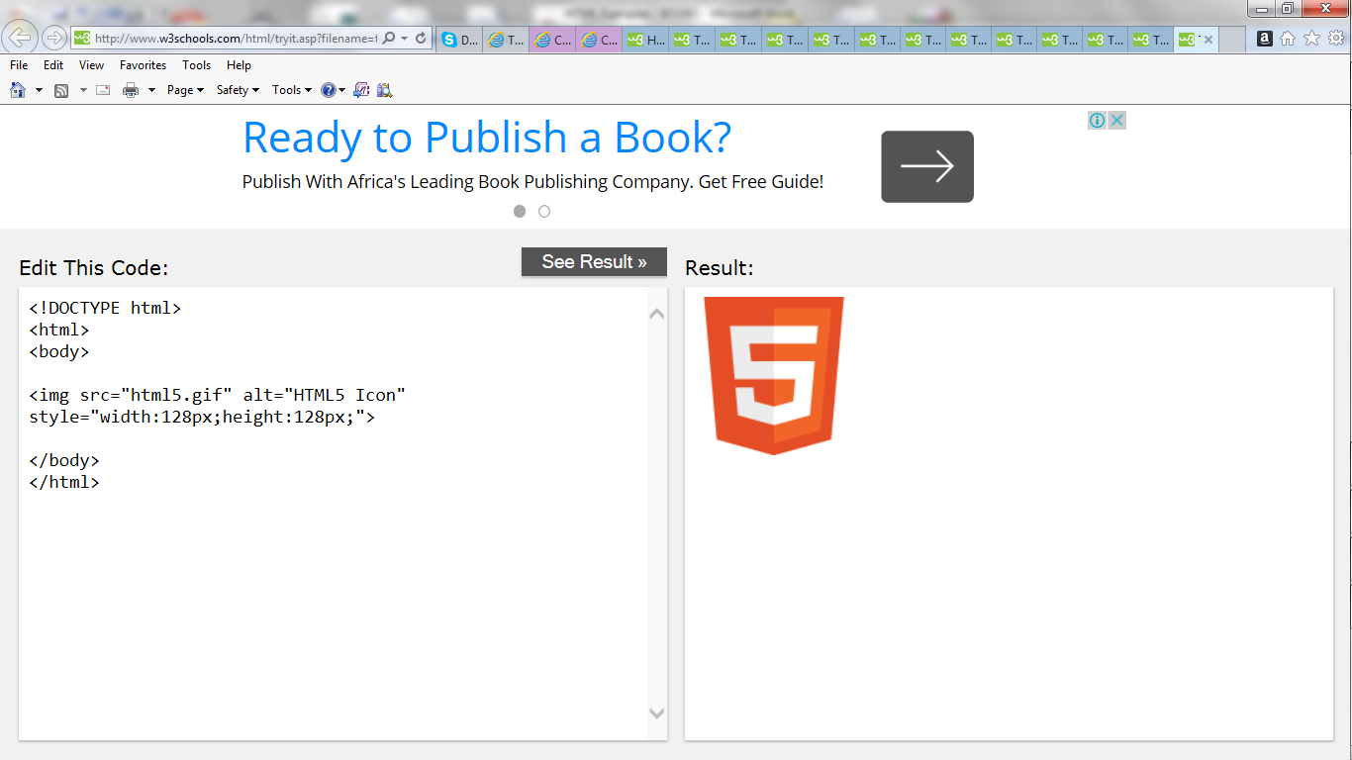  
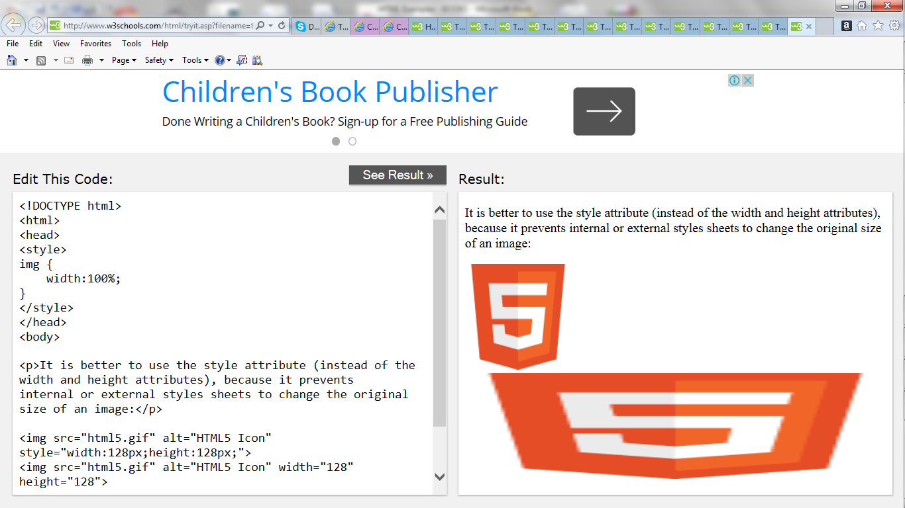

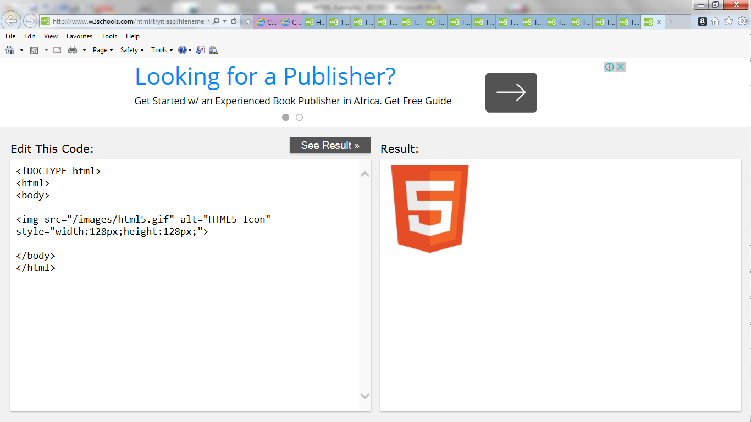

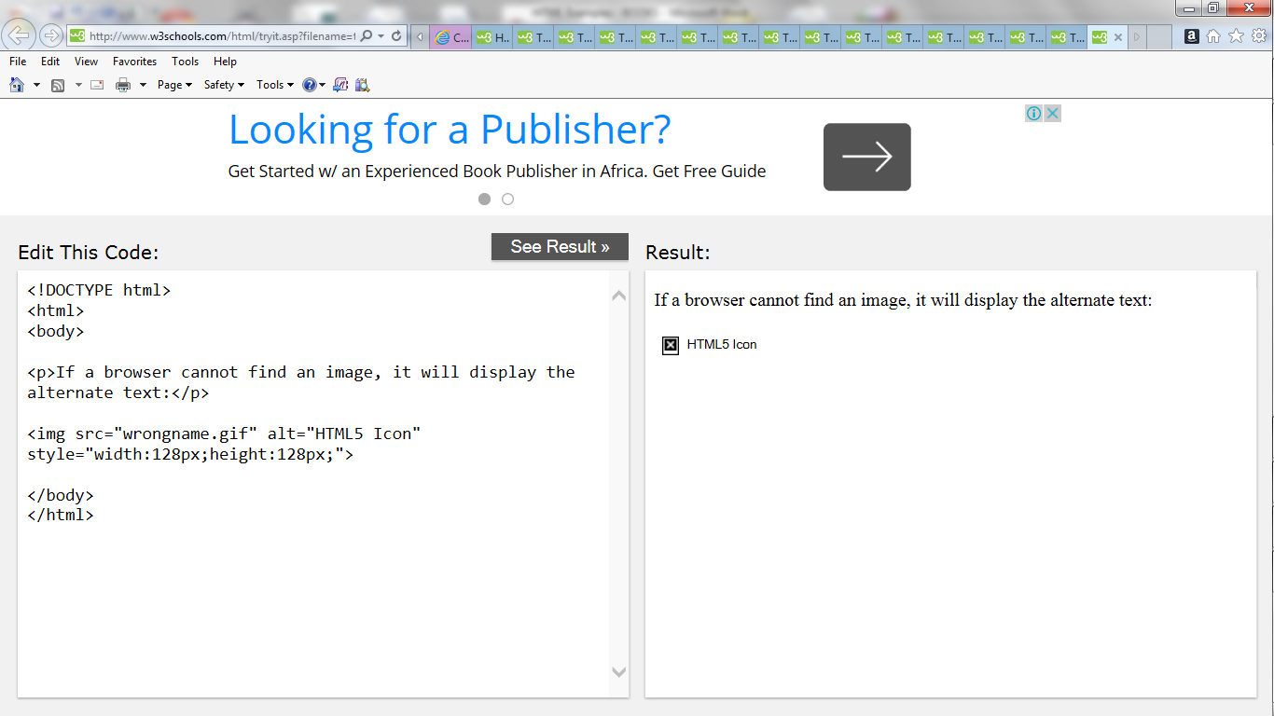

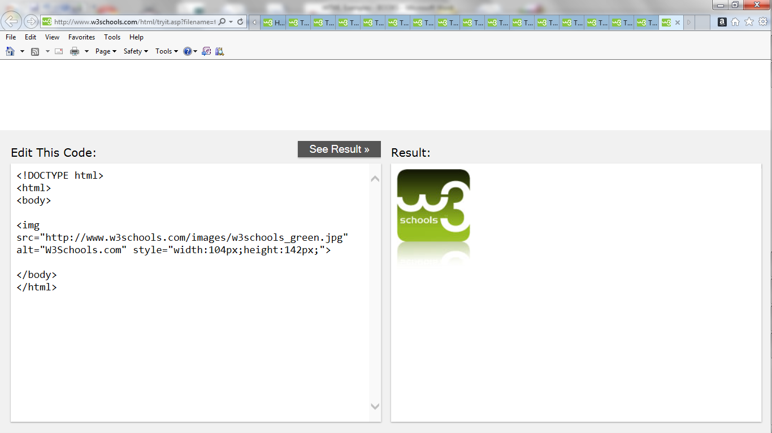

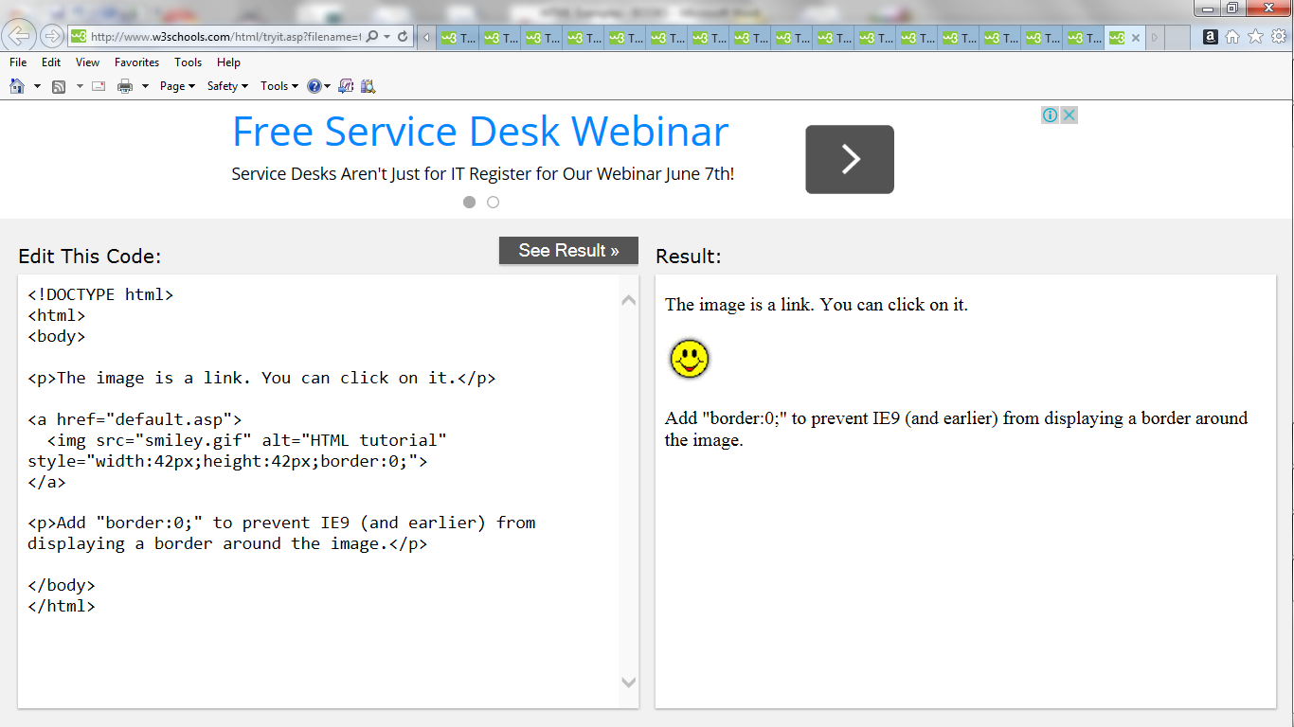

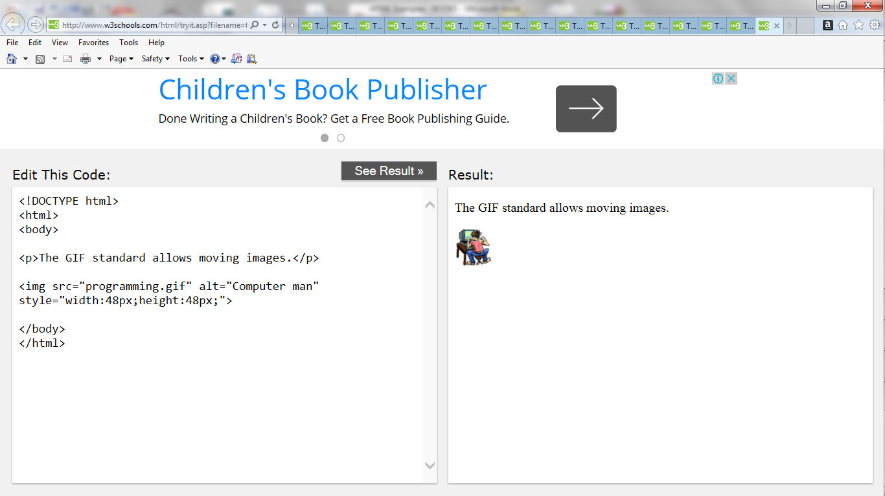

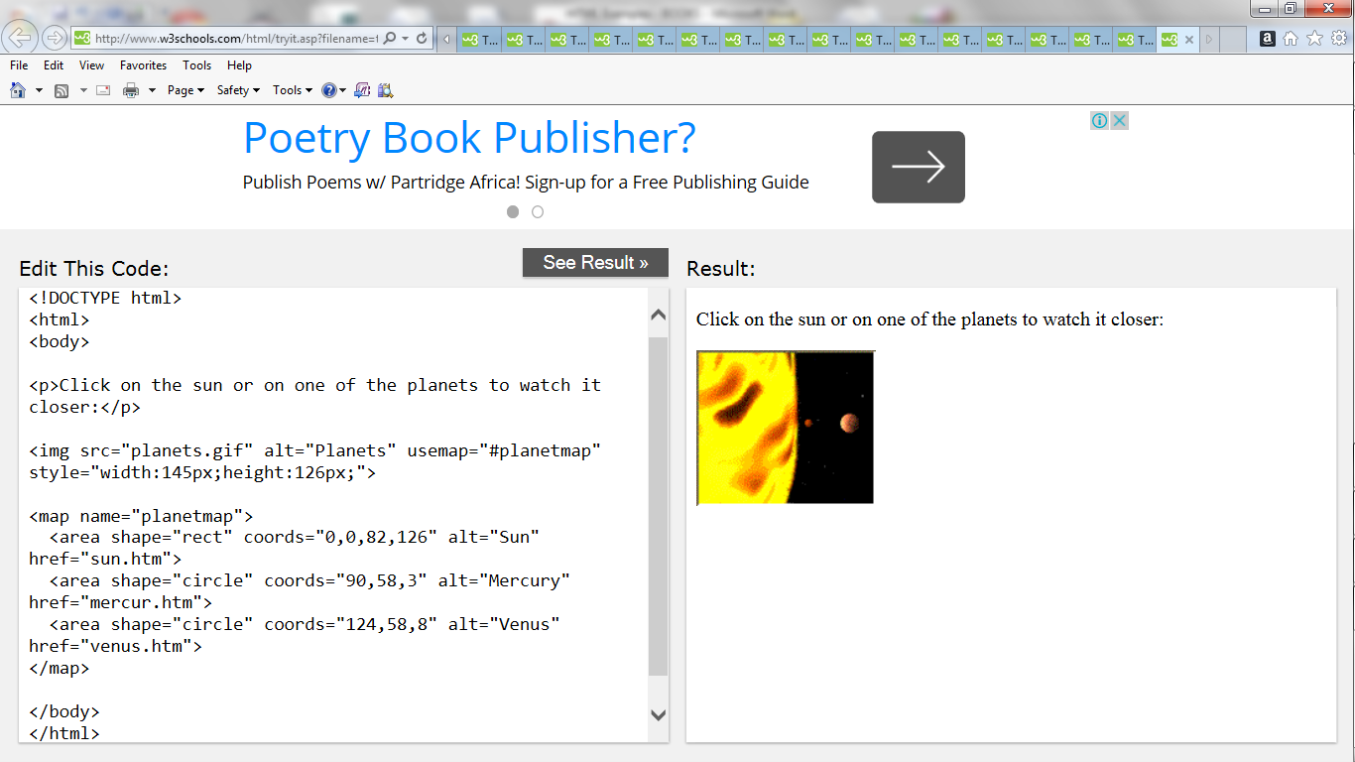

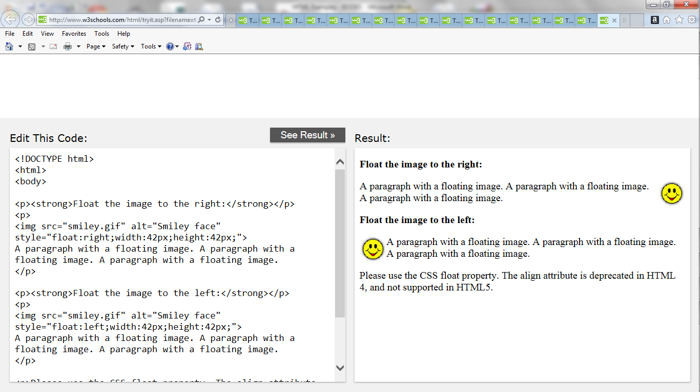

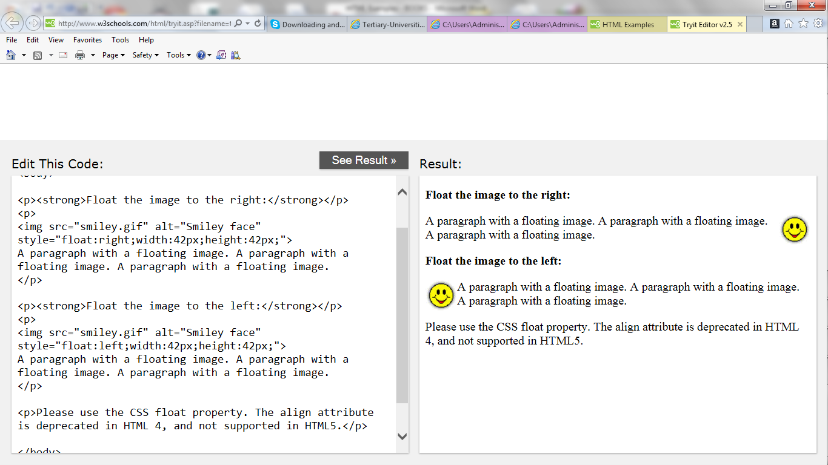

**HTML Tables**

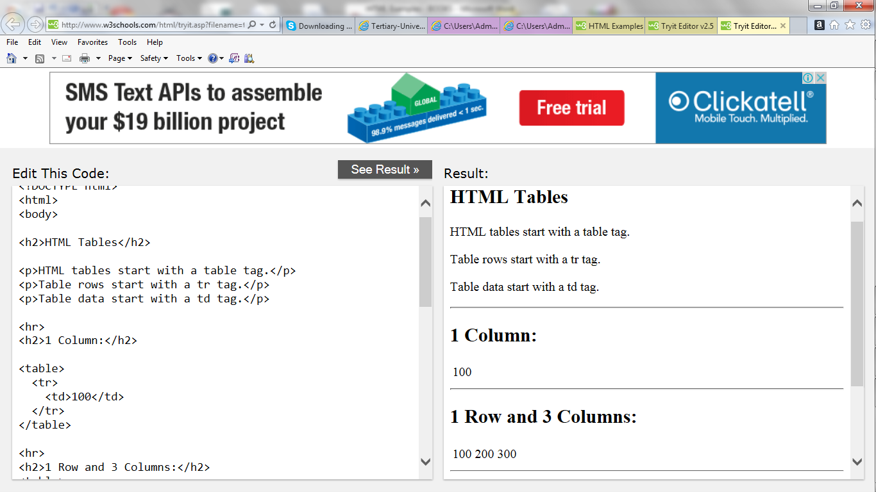

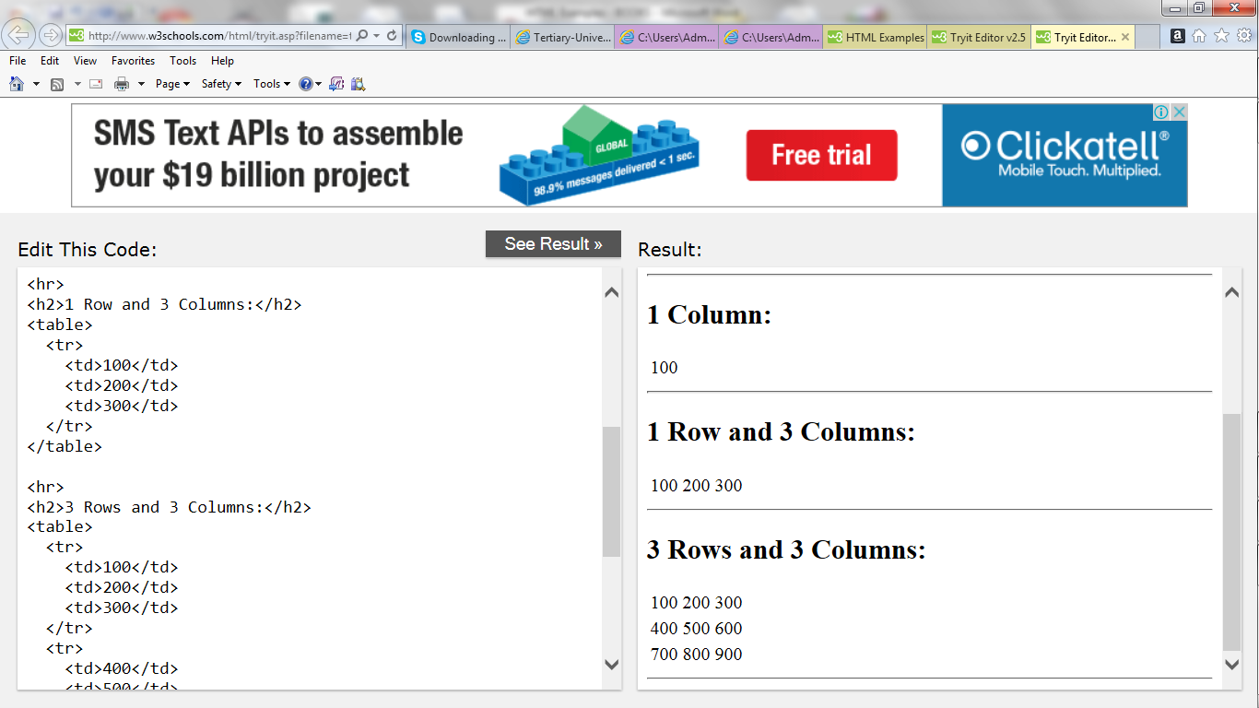

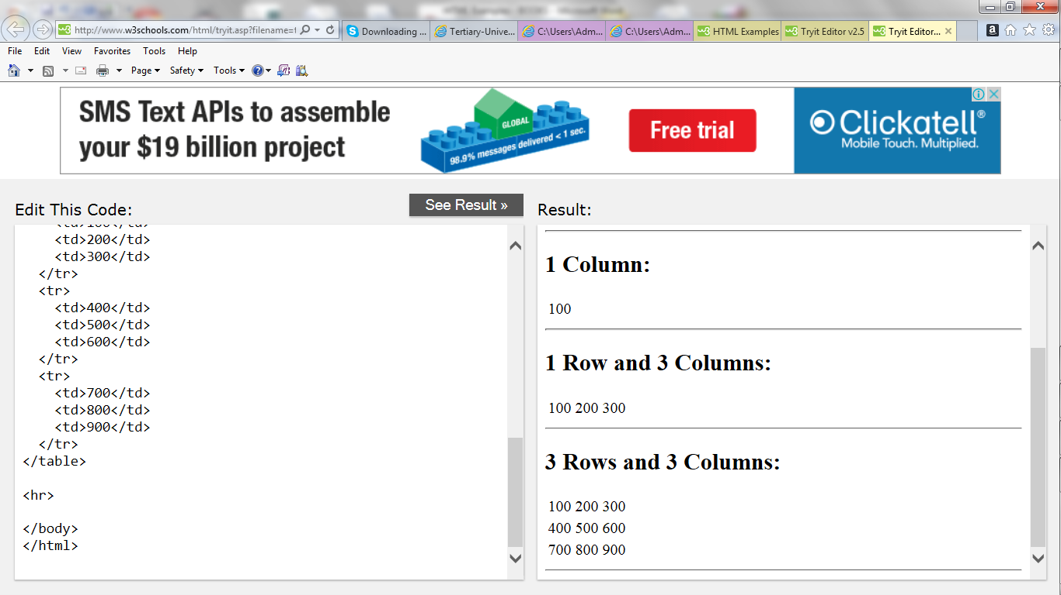

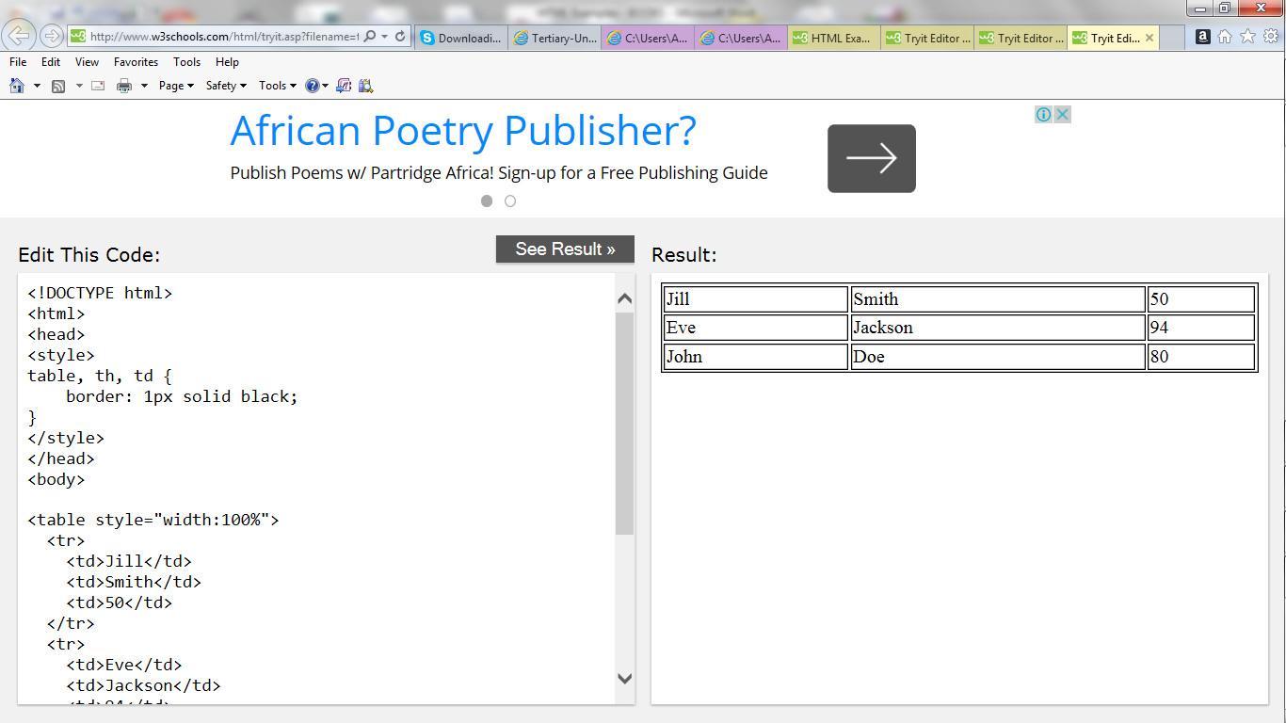

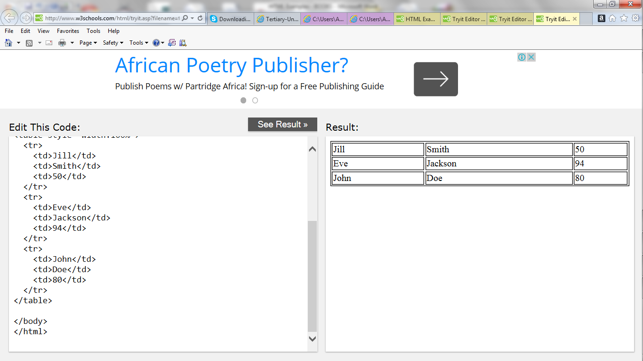

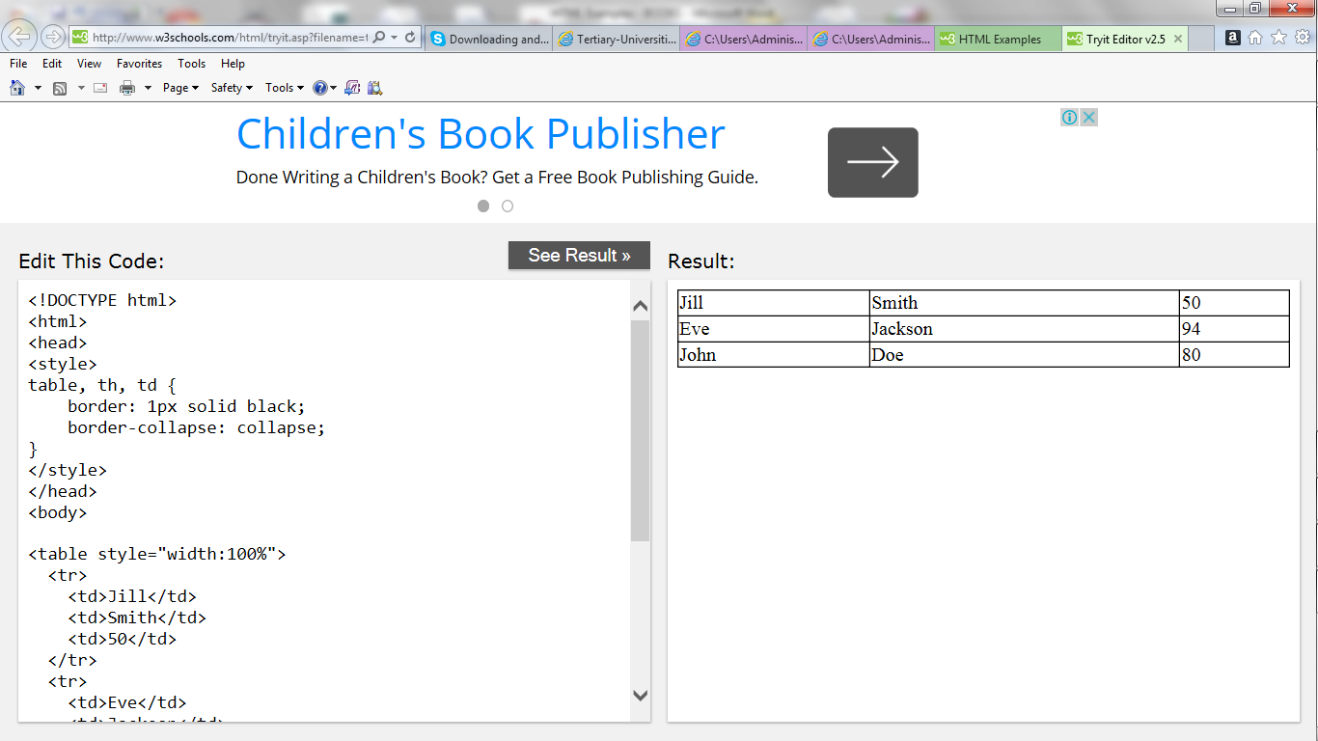

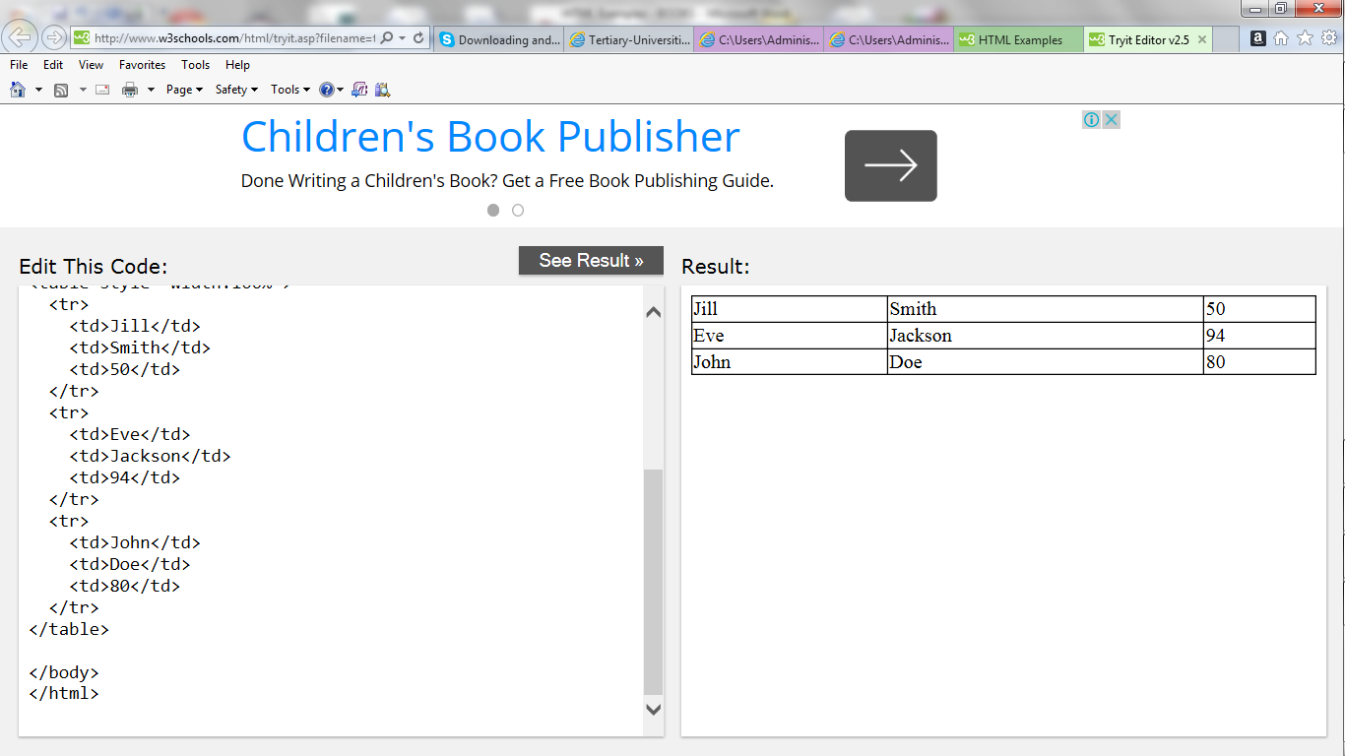

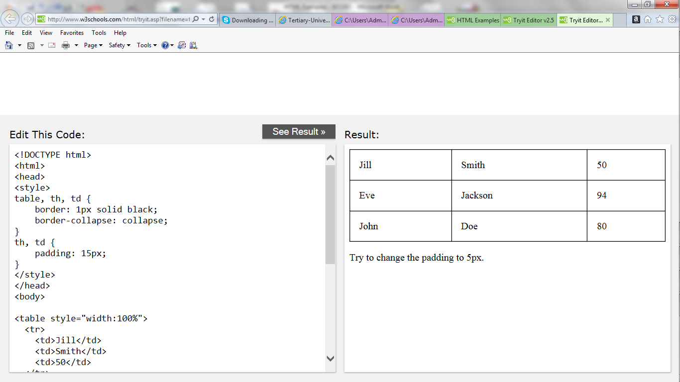

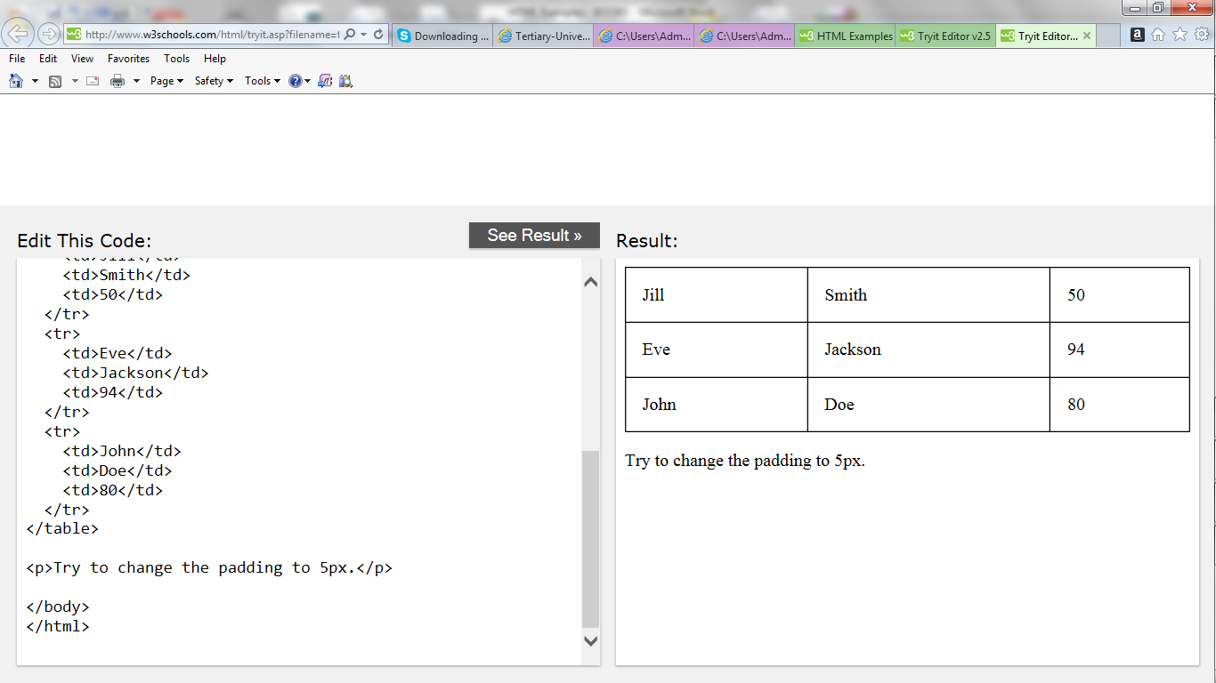

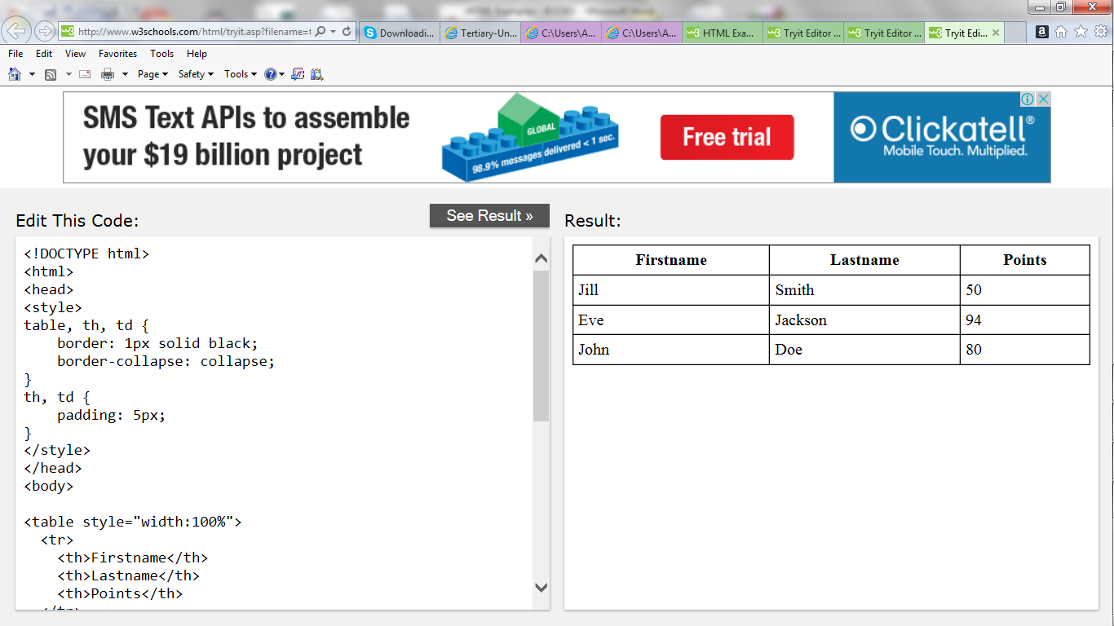

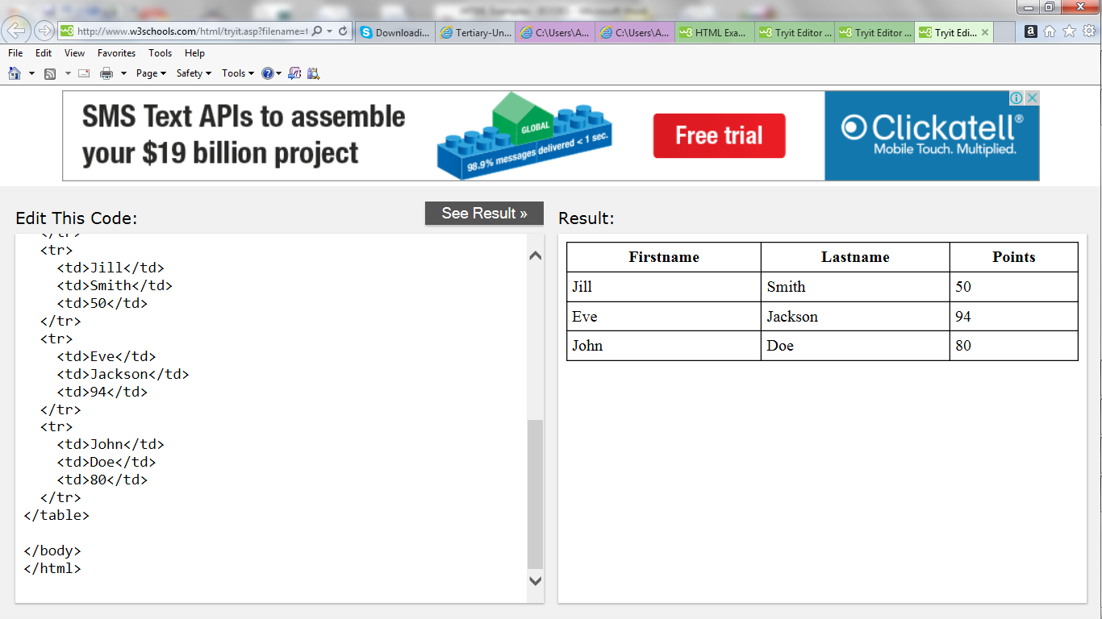

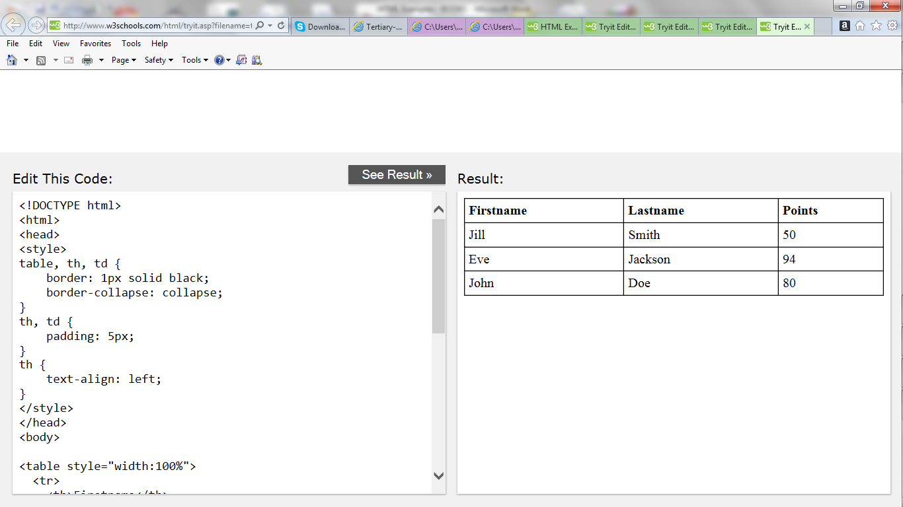

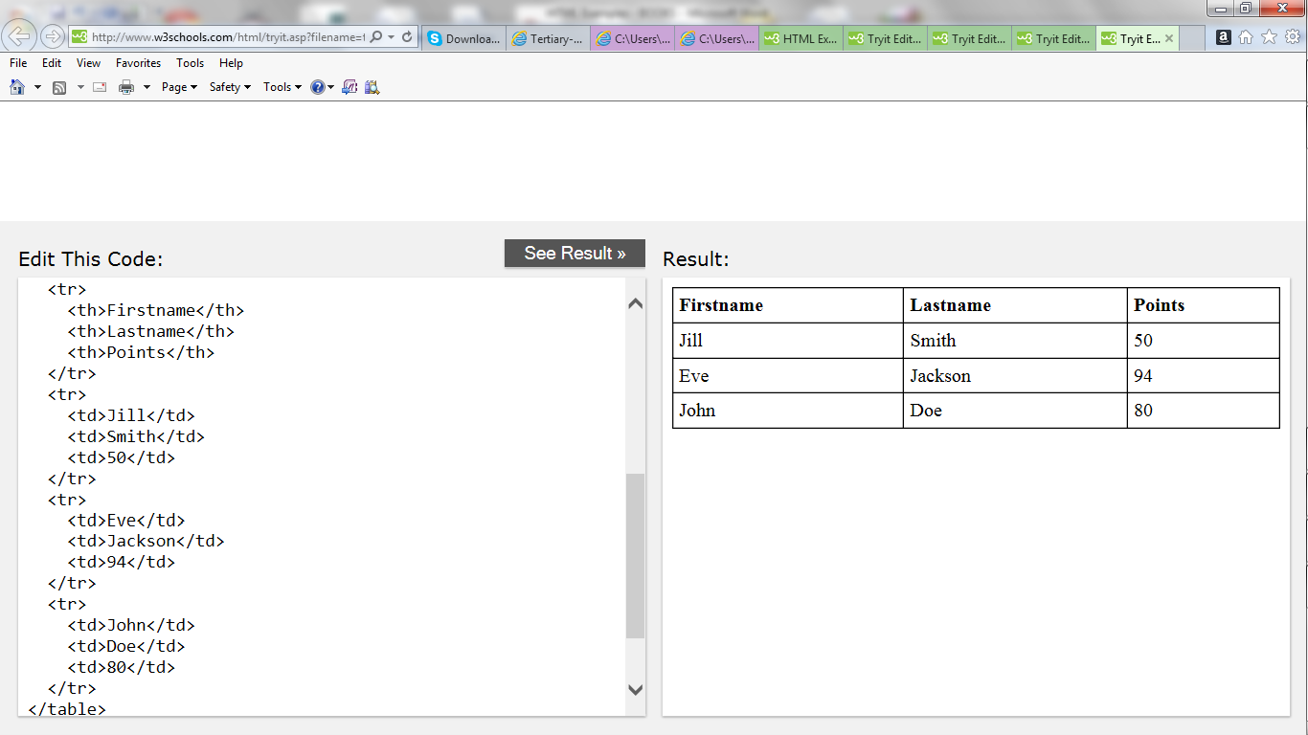

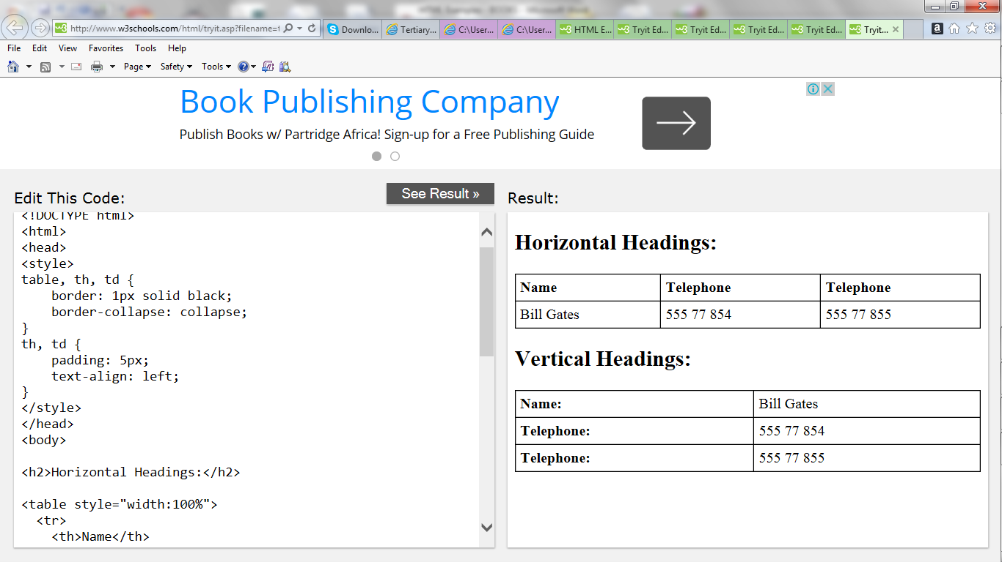

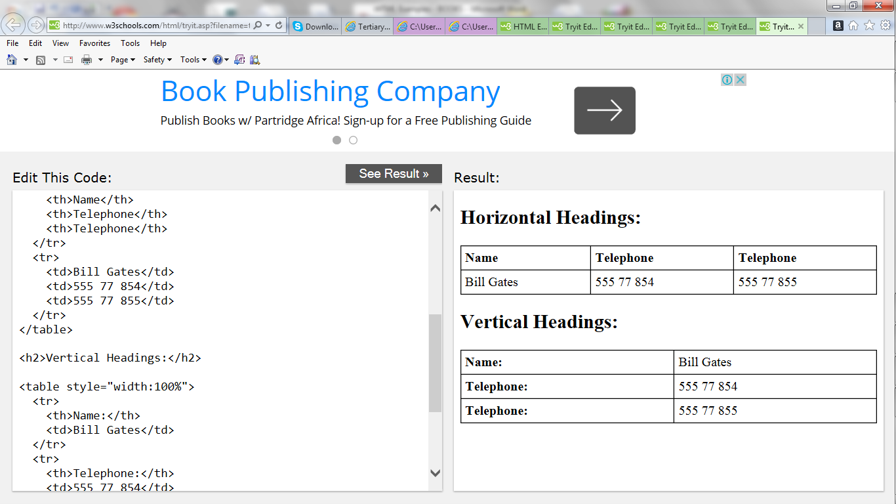

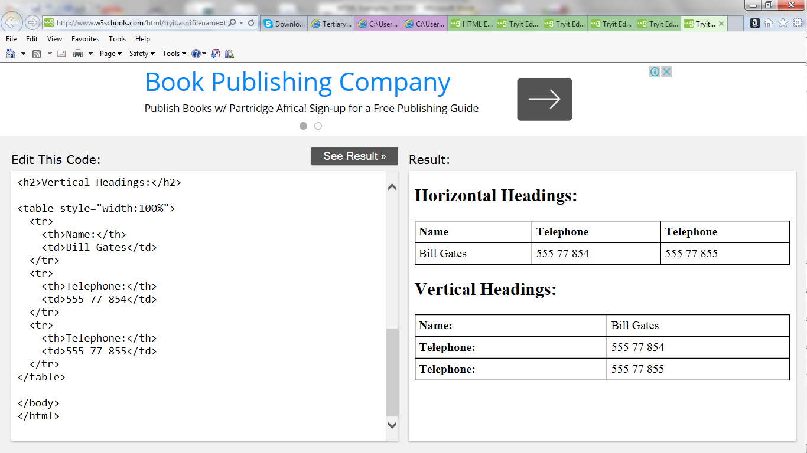

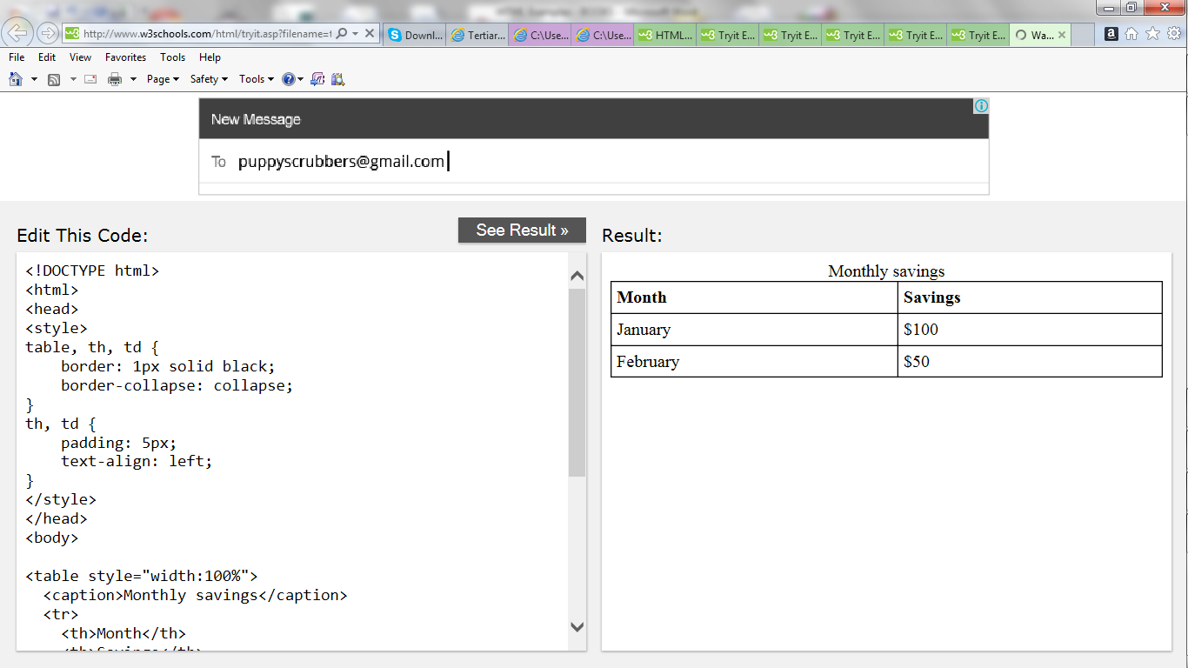

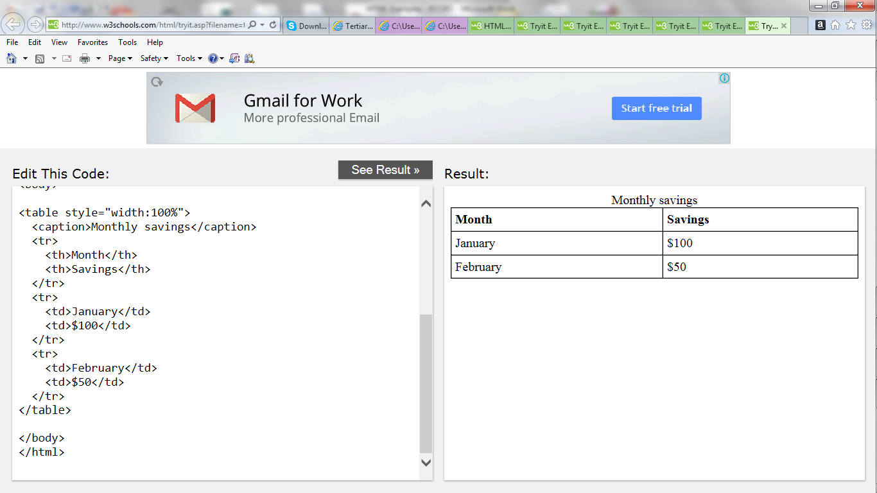

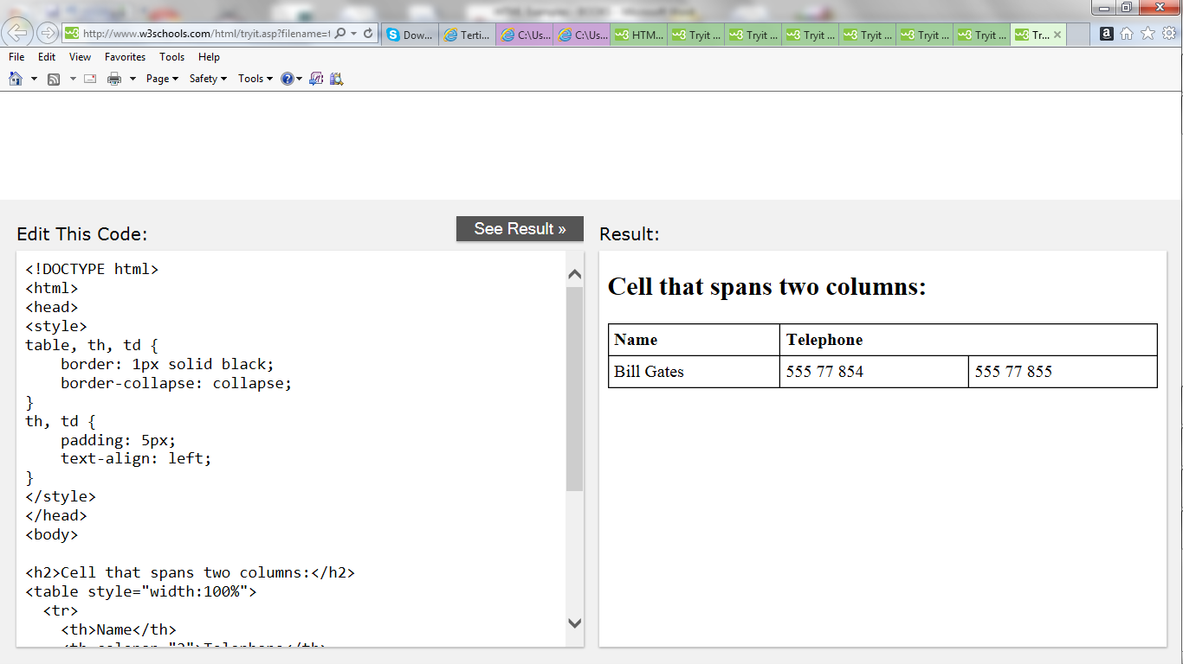

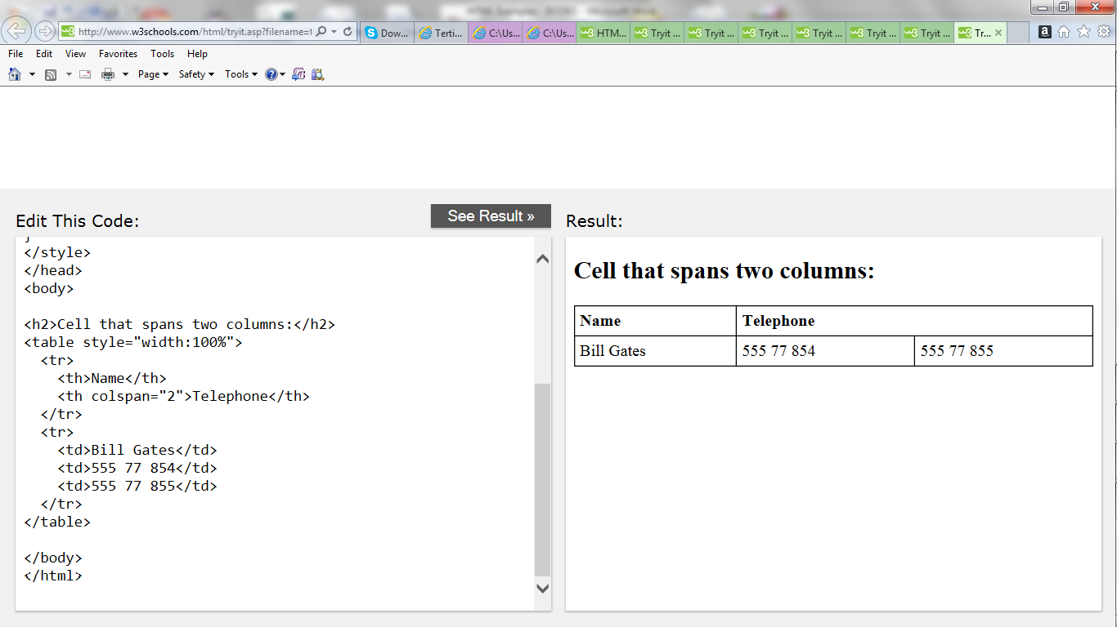

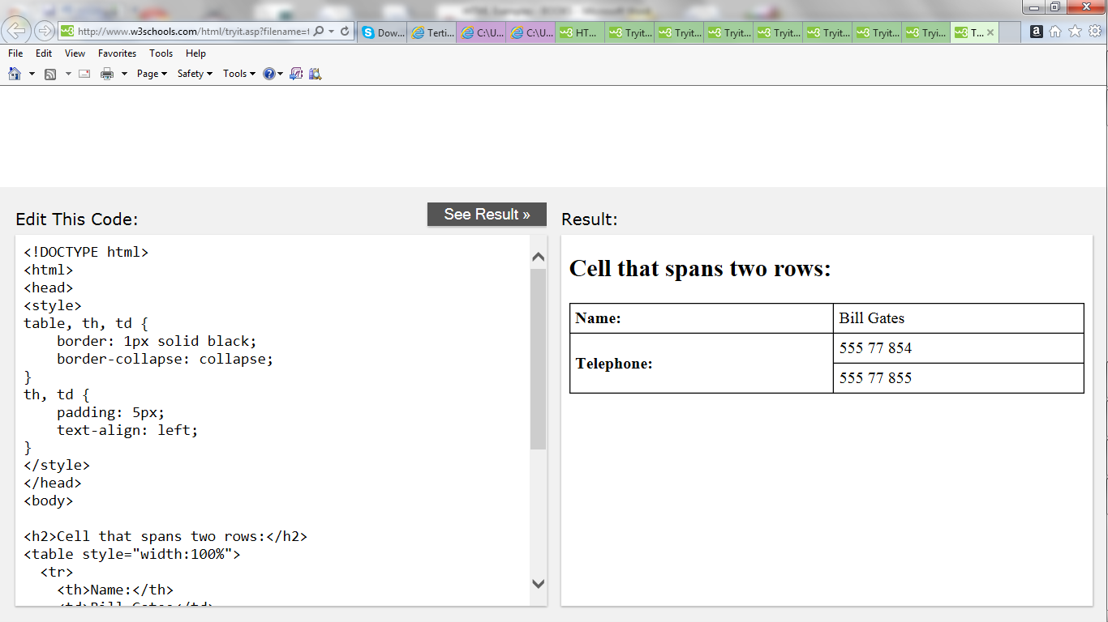

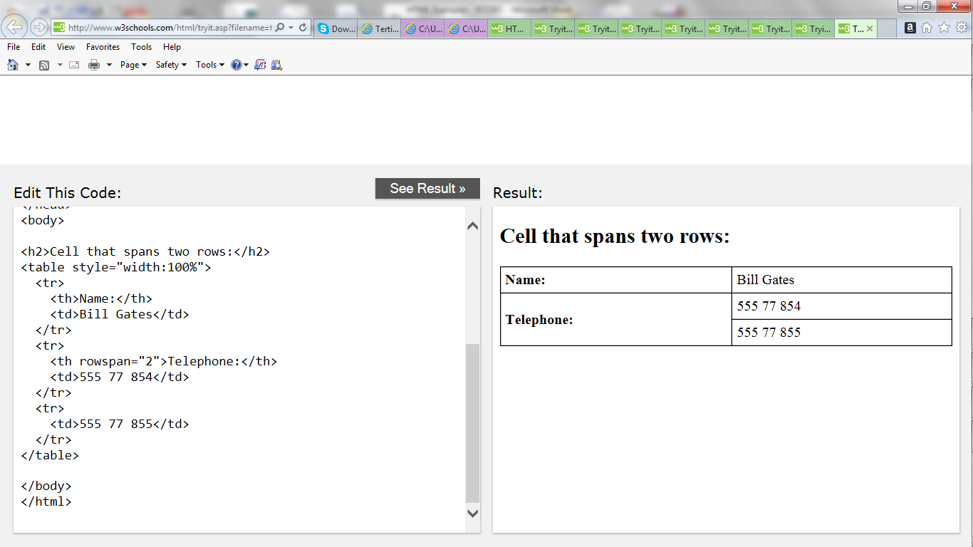

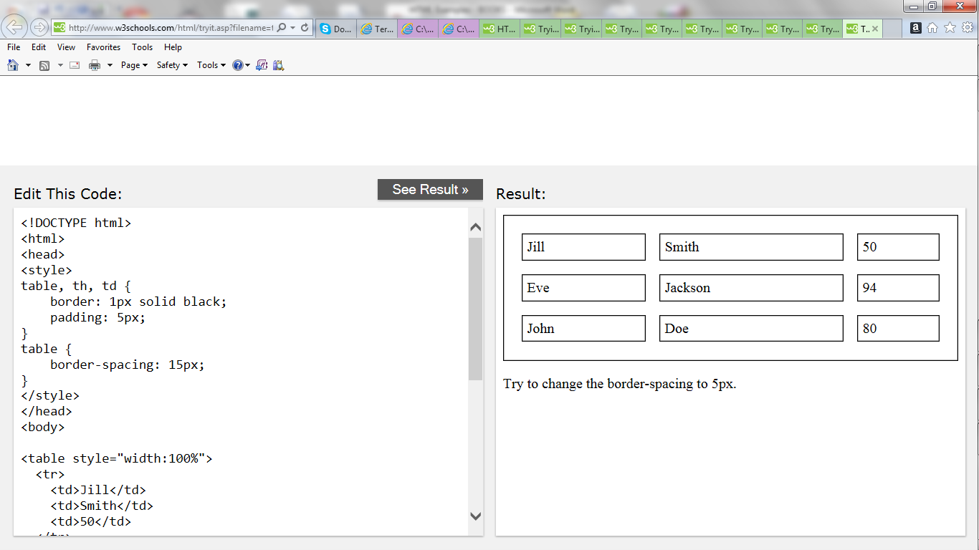

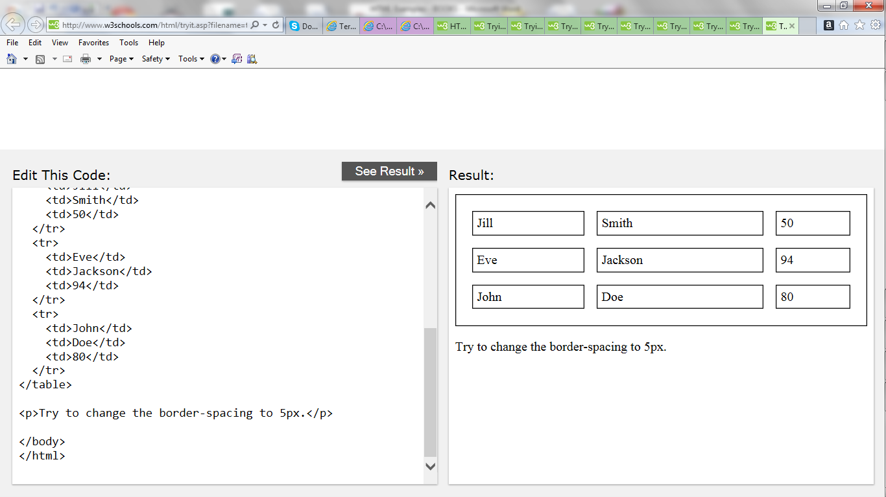

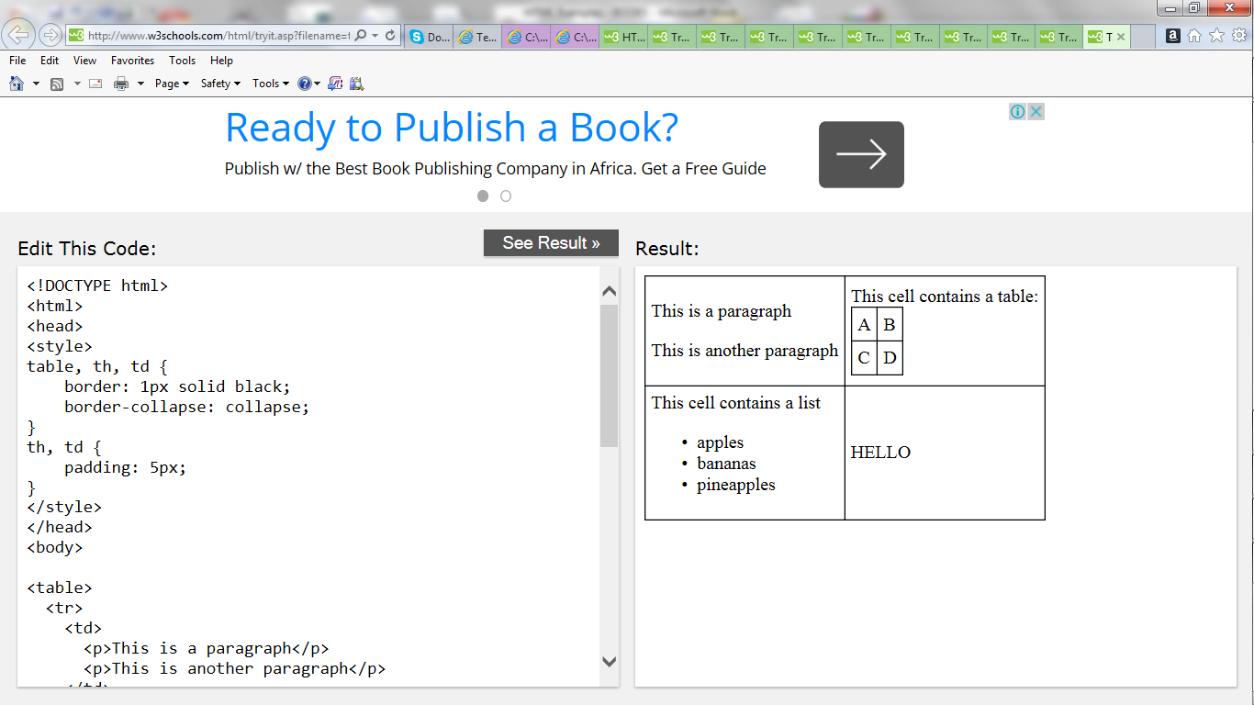

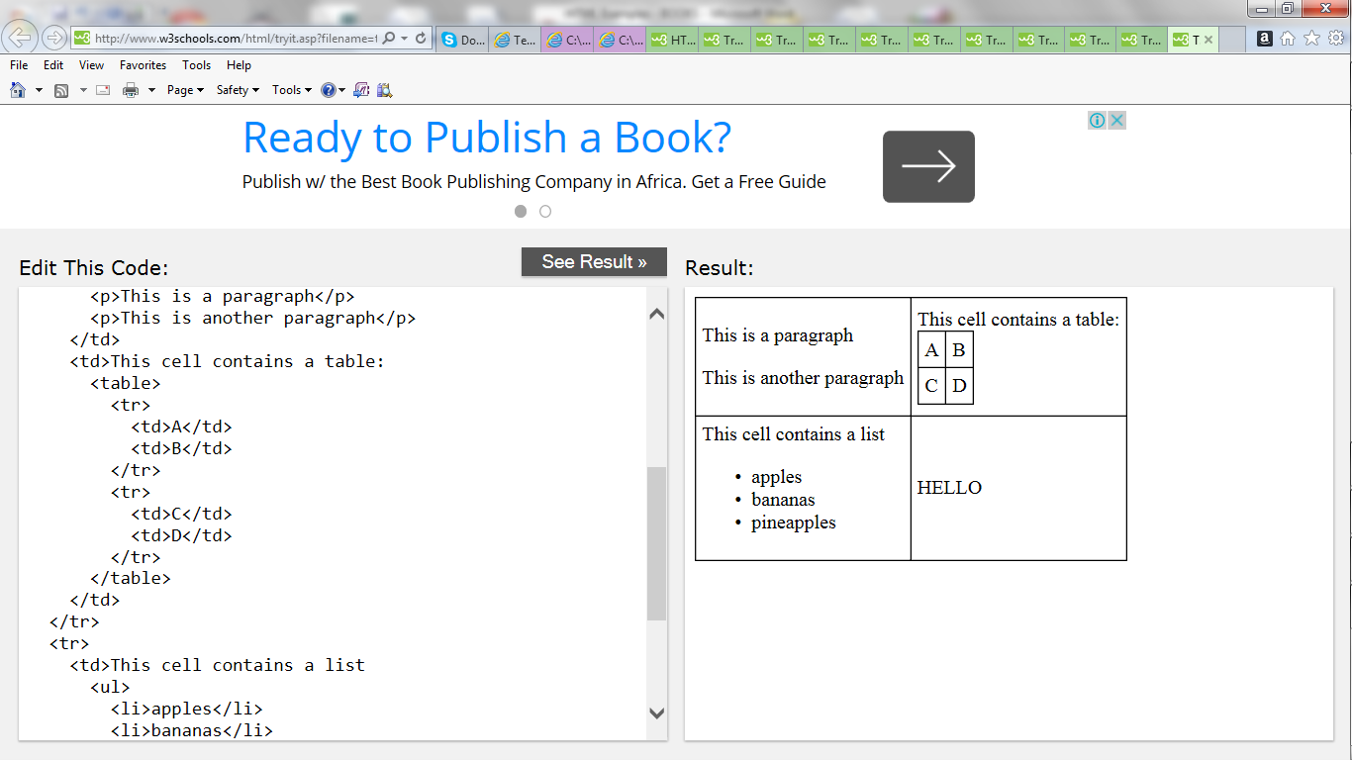

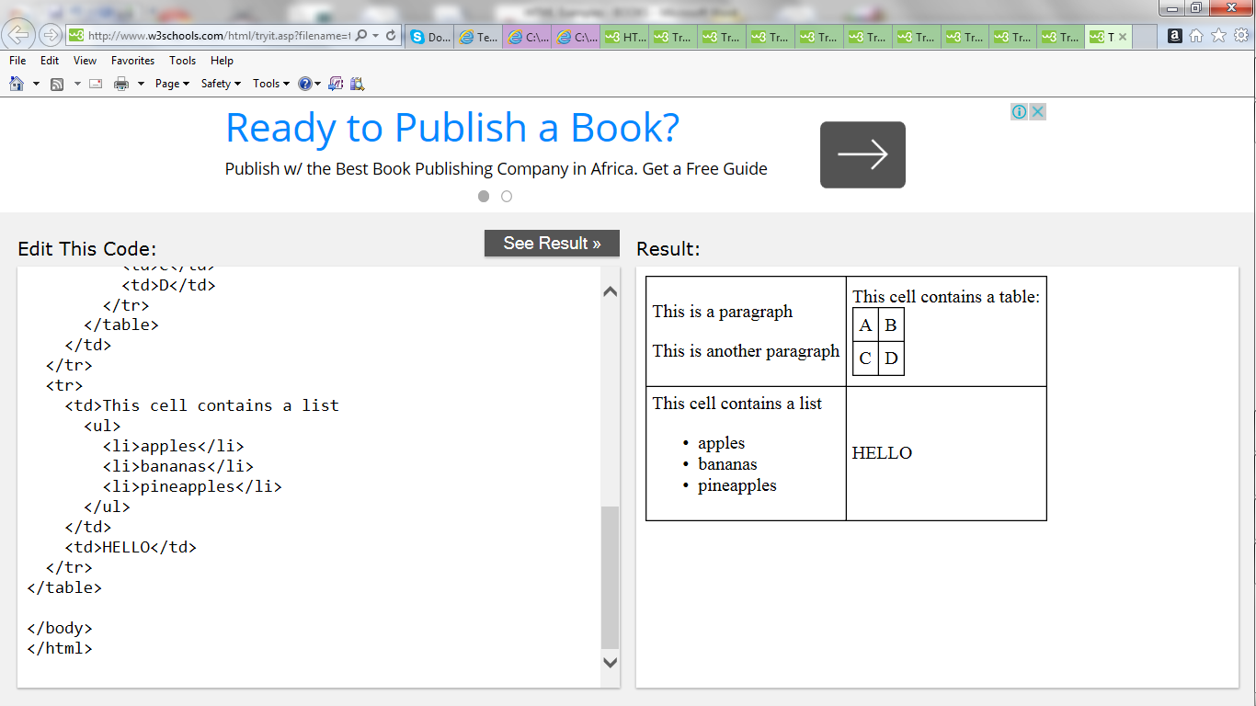

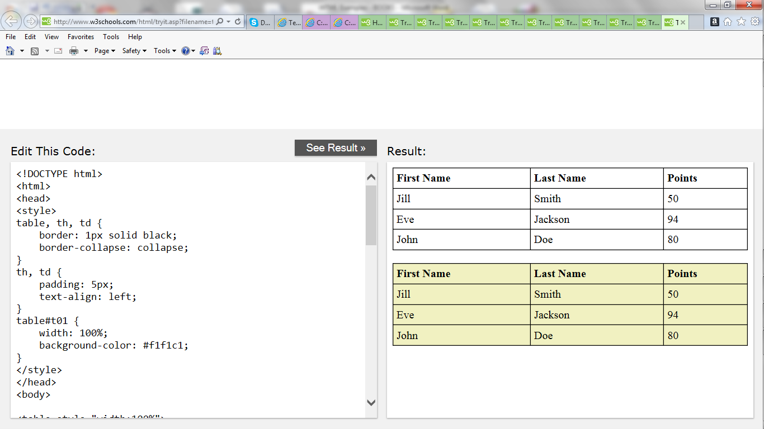

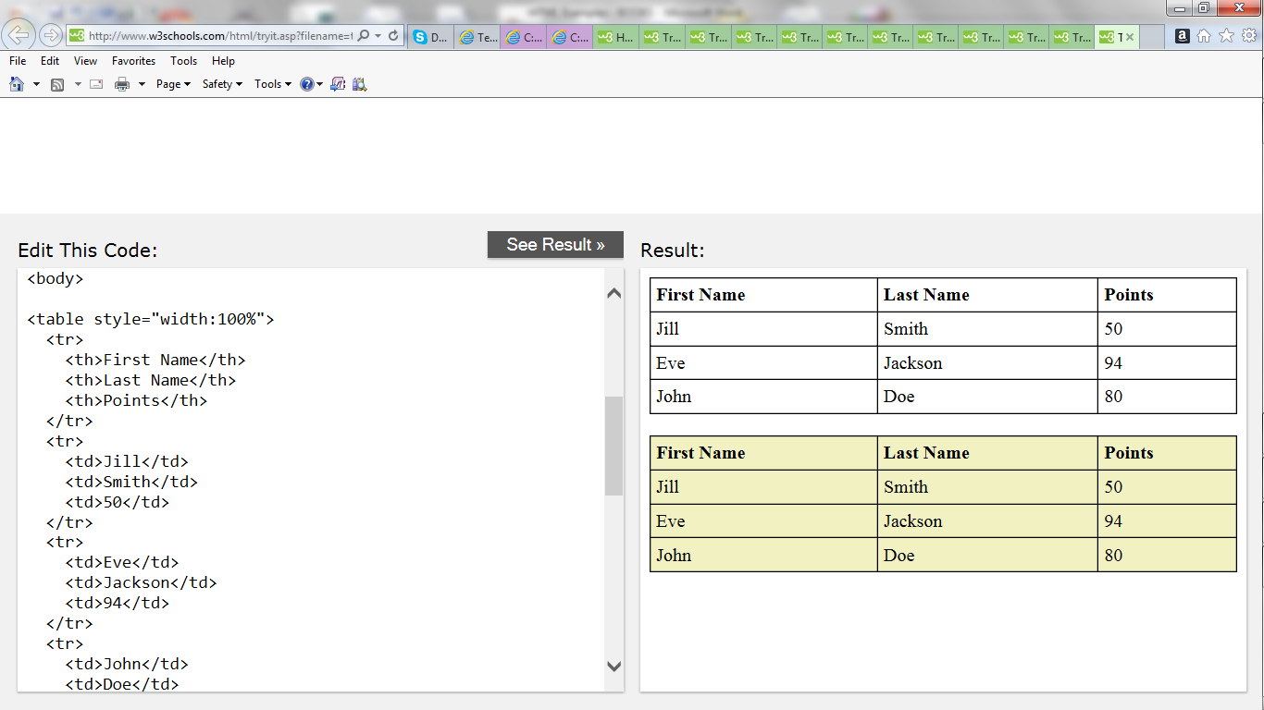

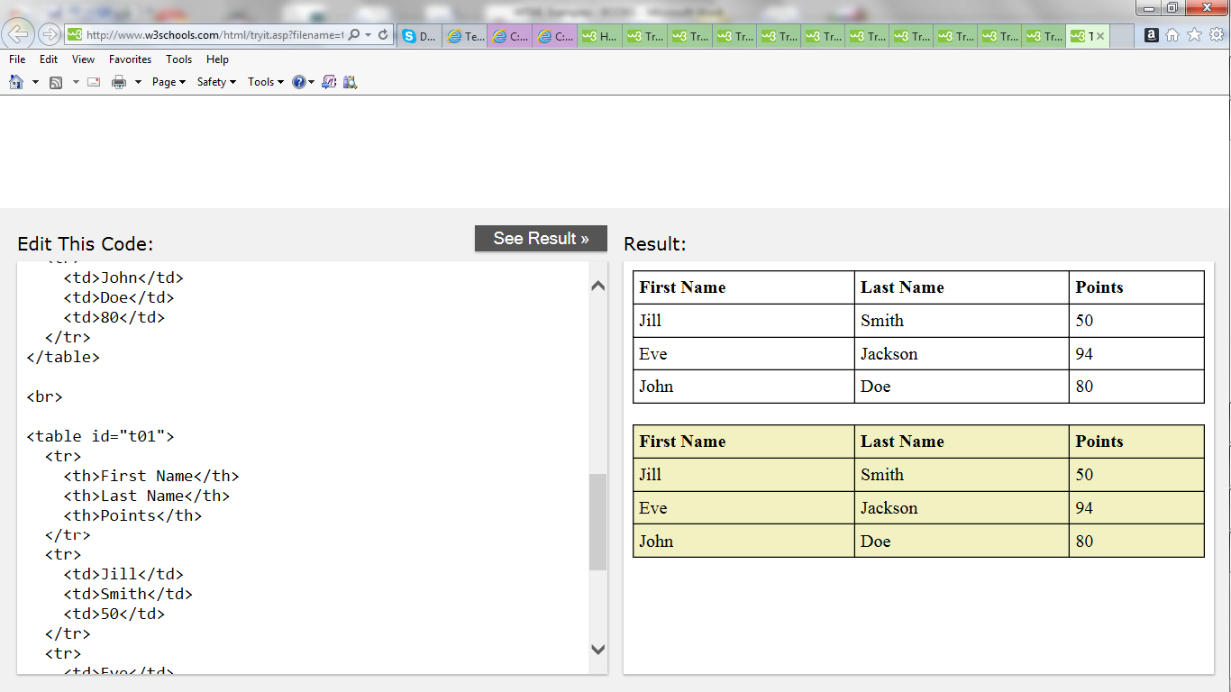

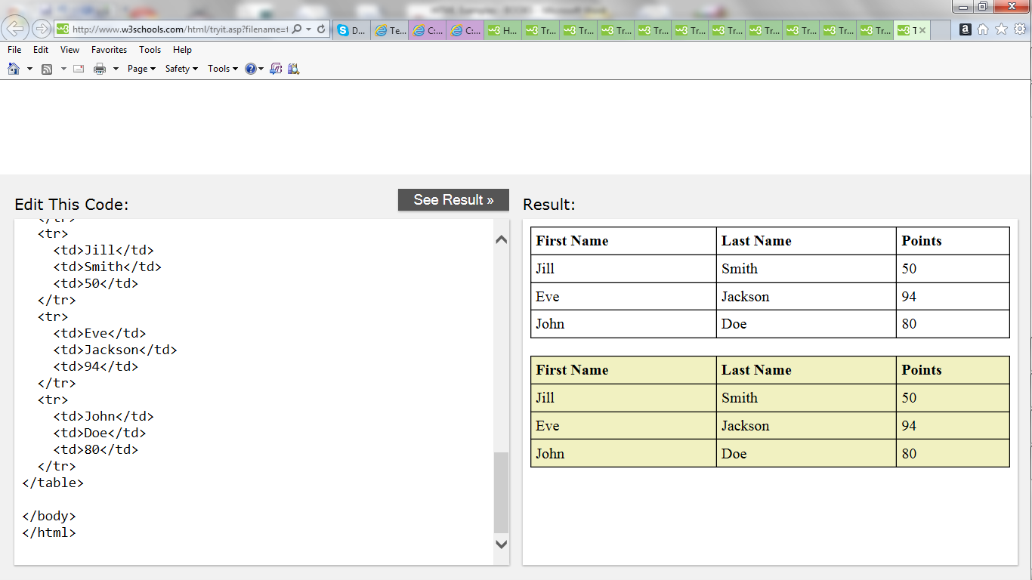

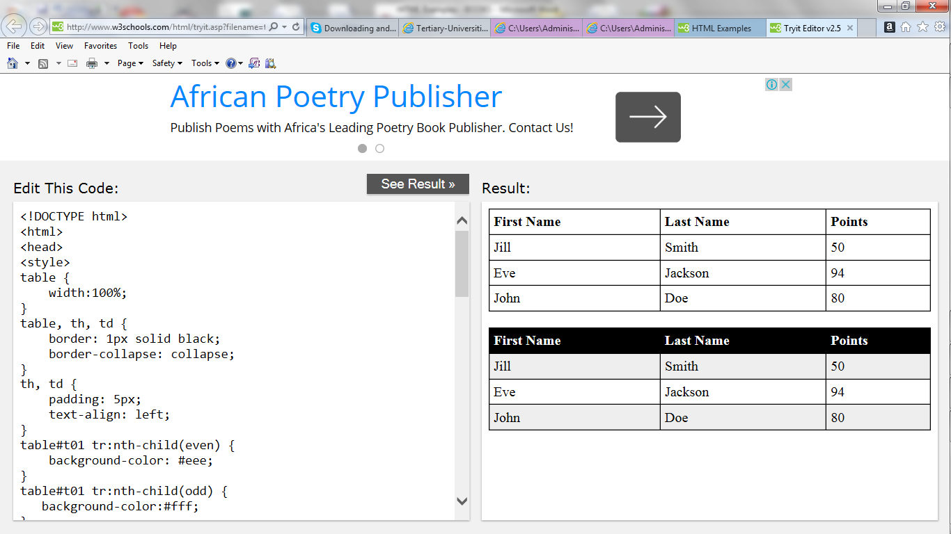

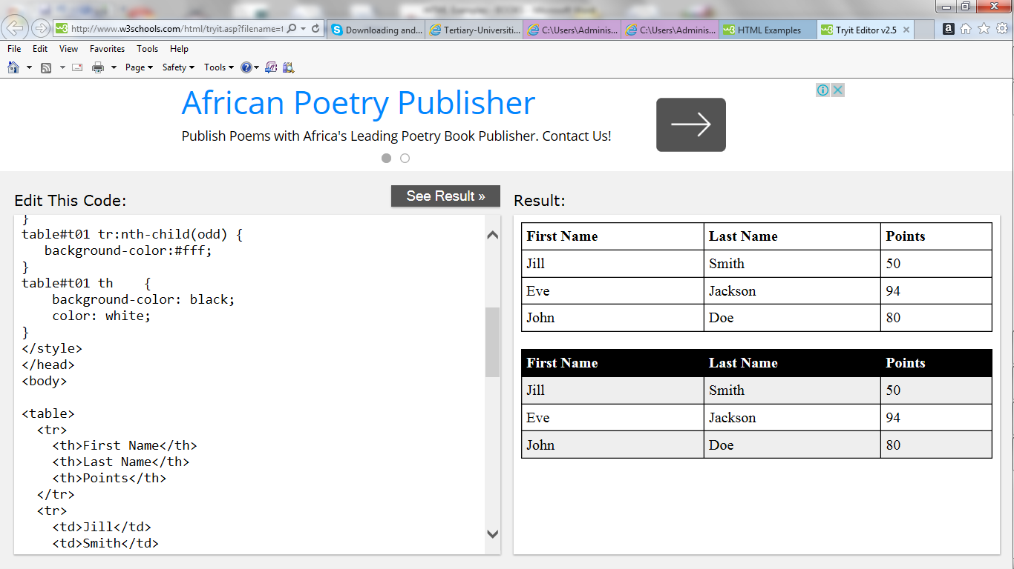

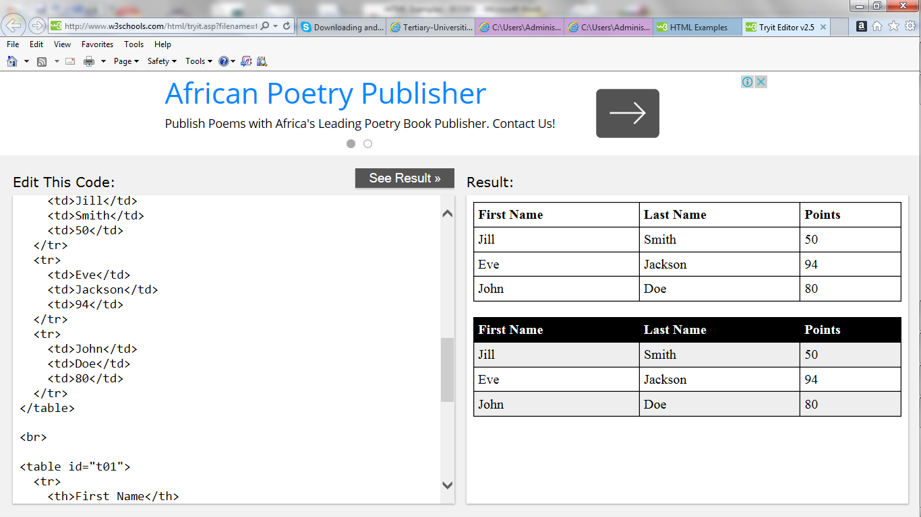

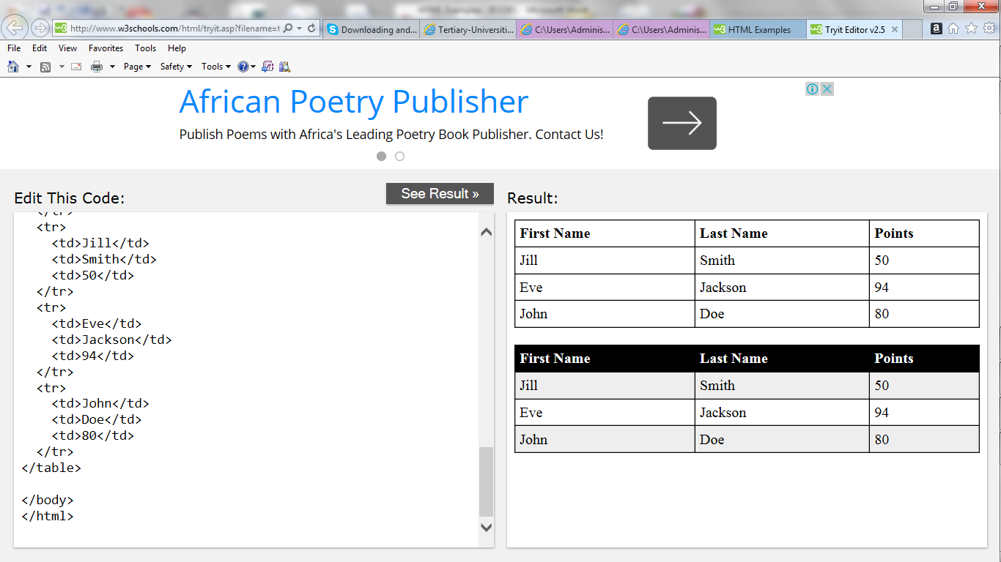

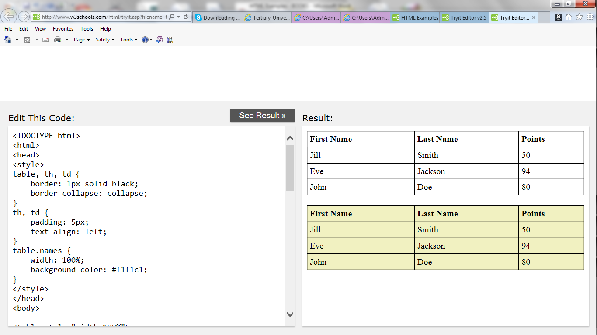

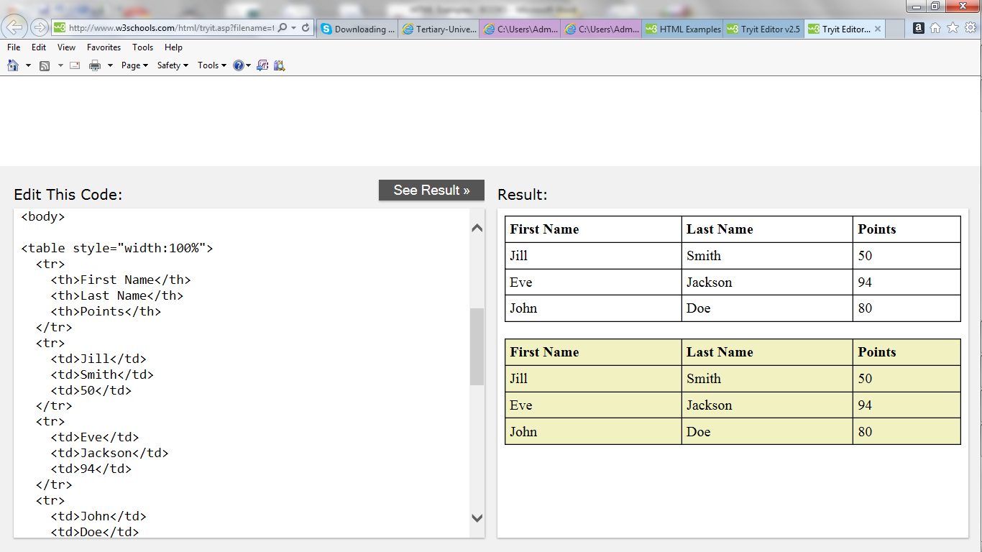

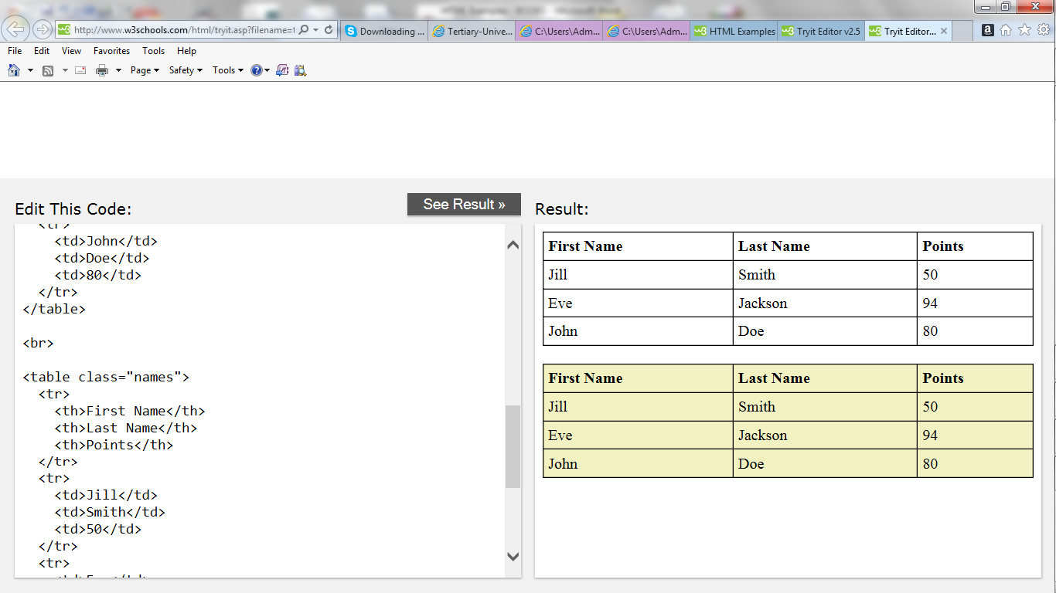

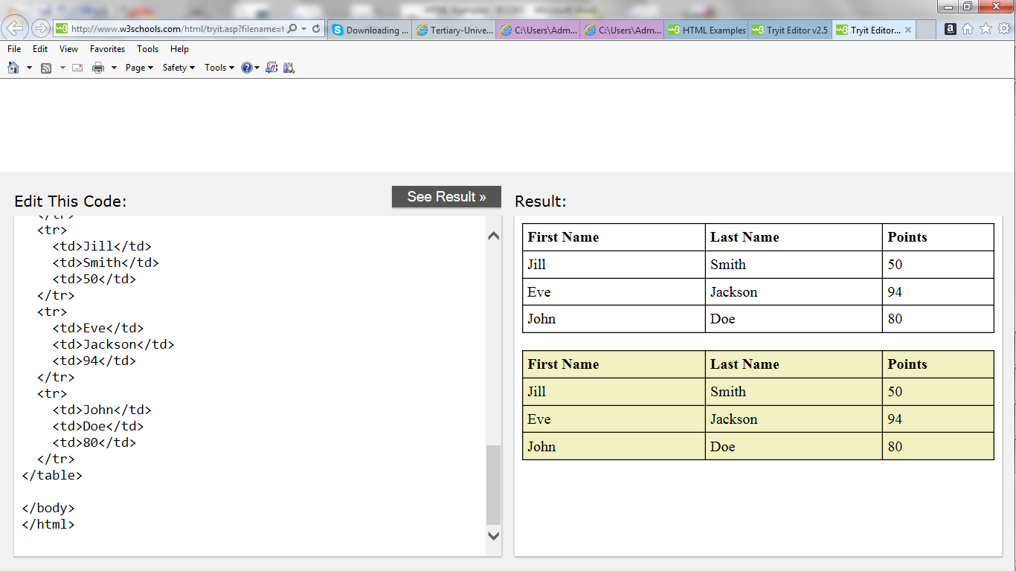

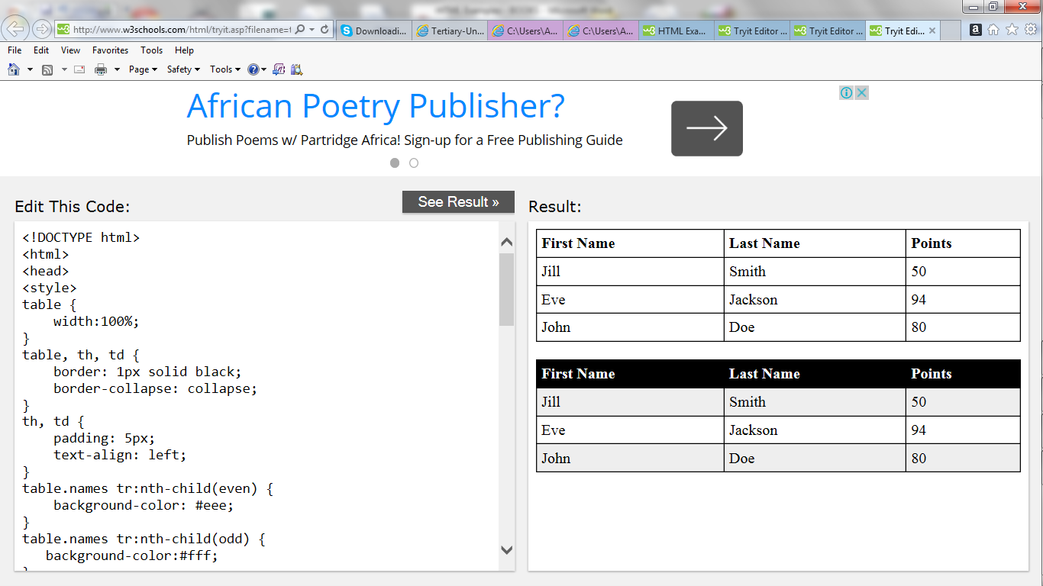

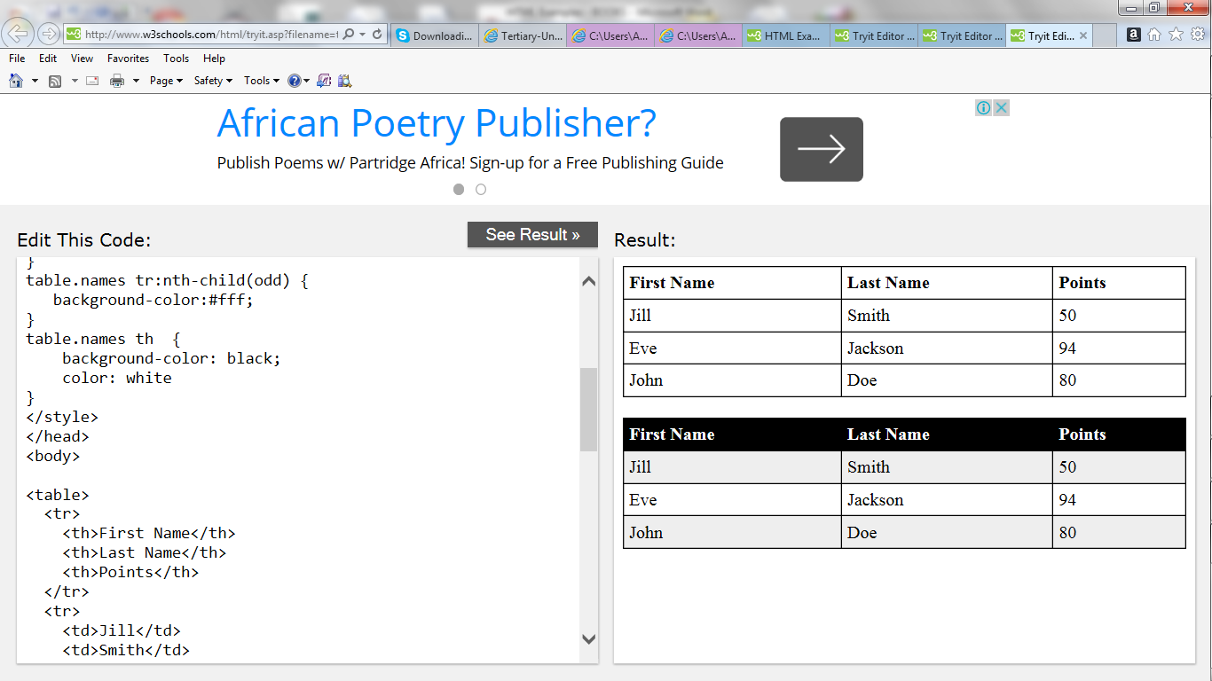

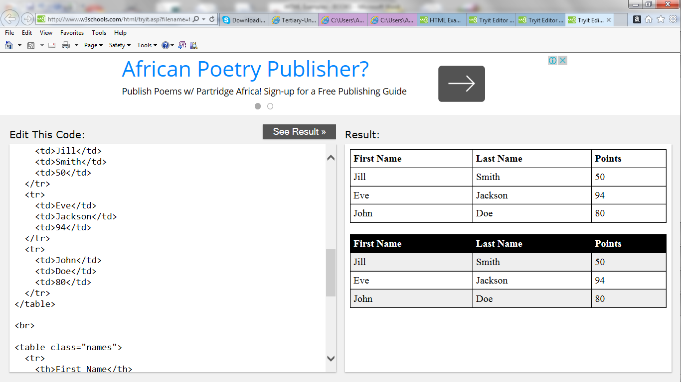

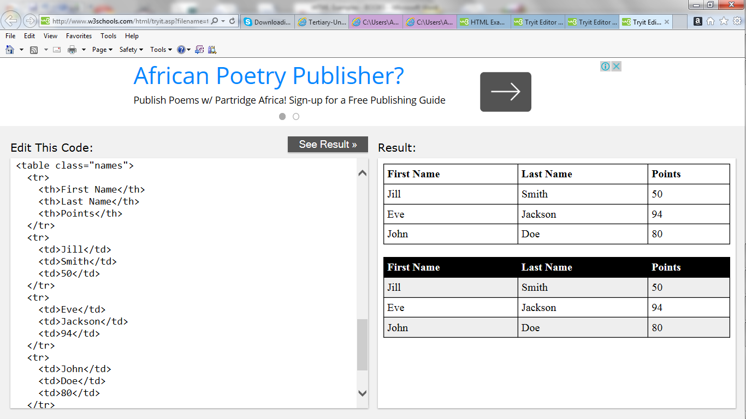

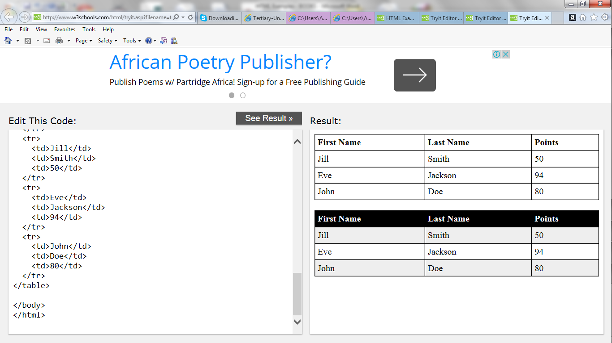

**HTML Lists**

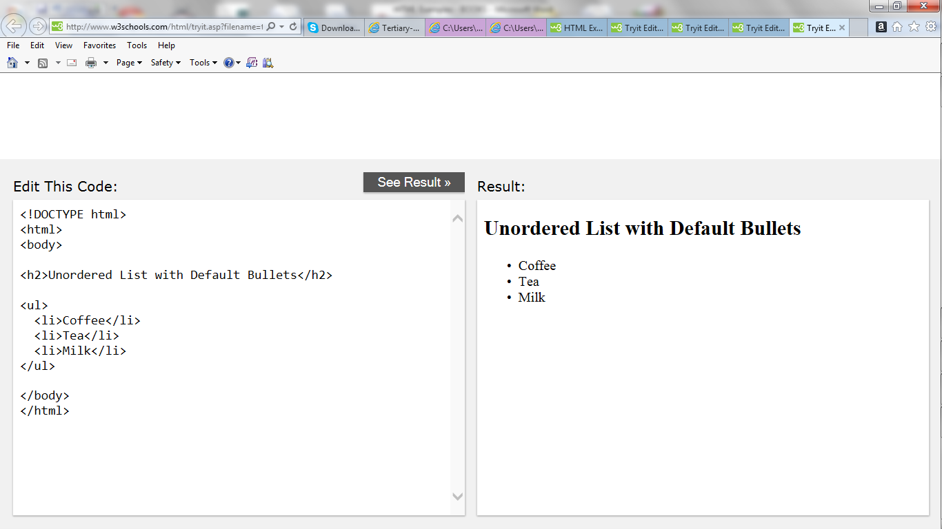

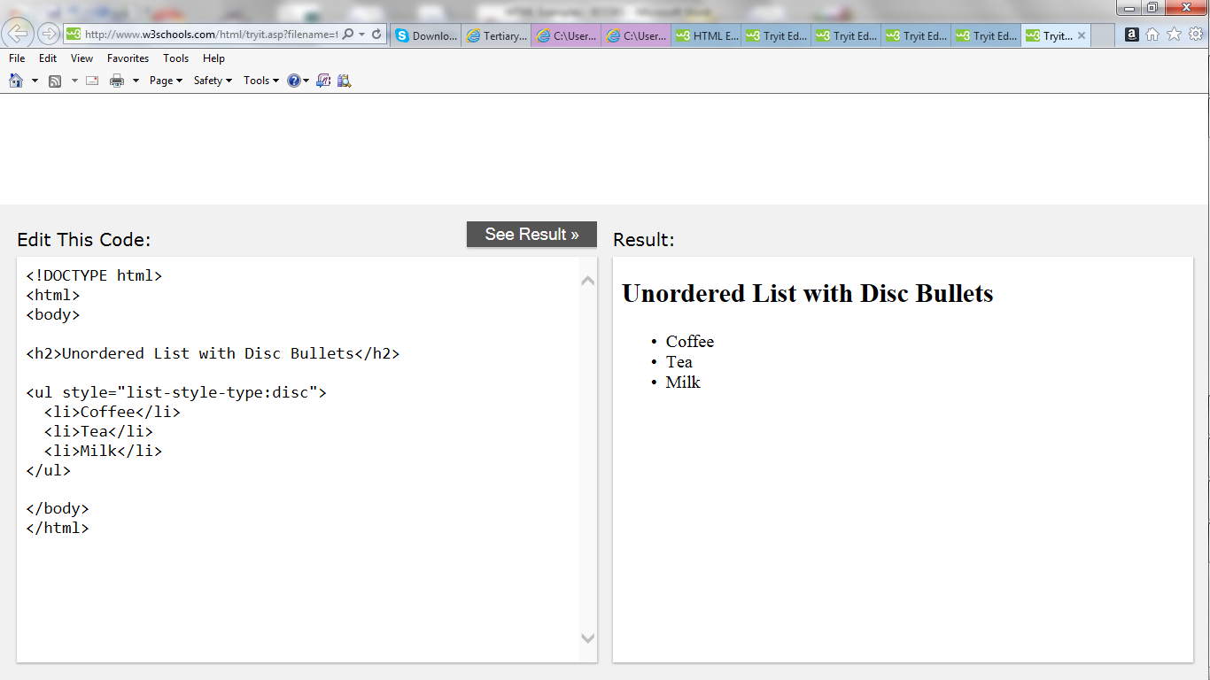

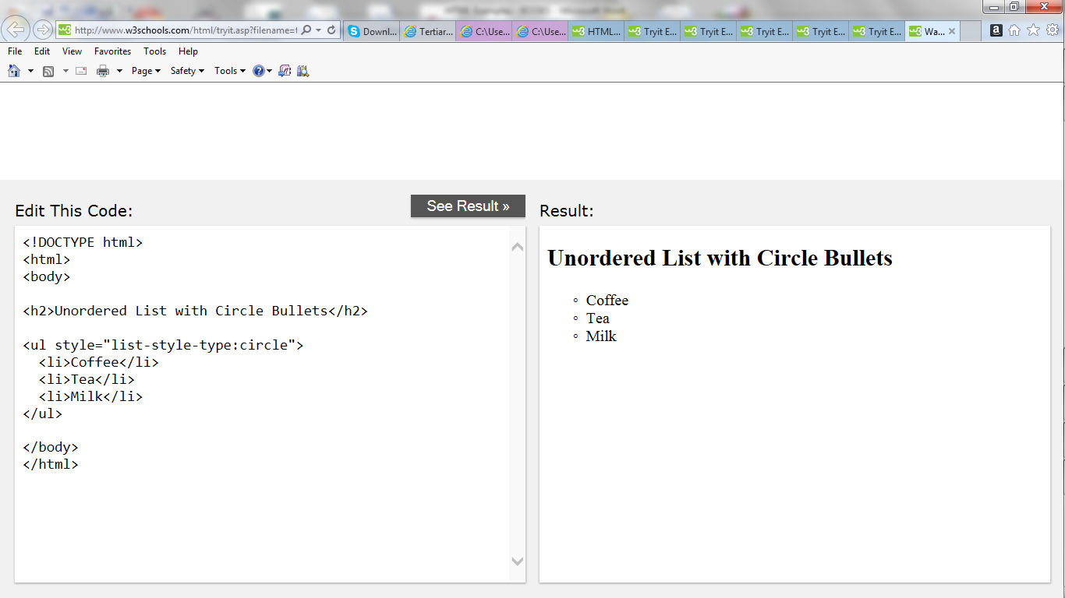

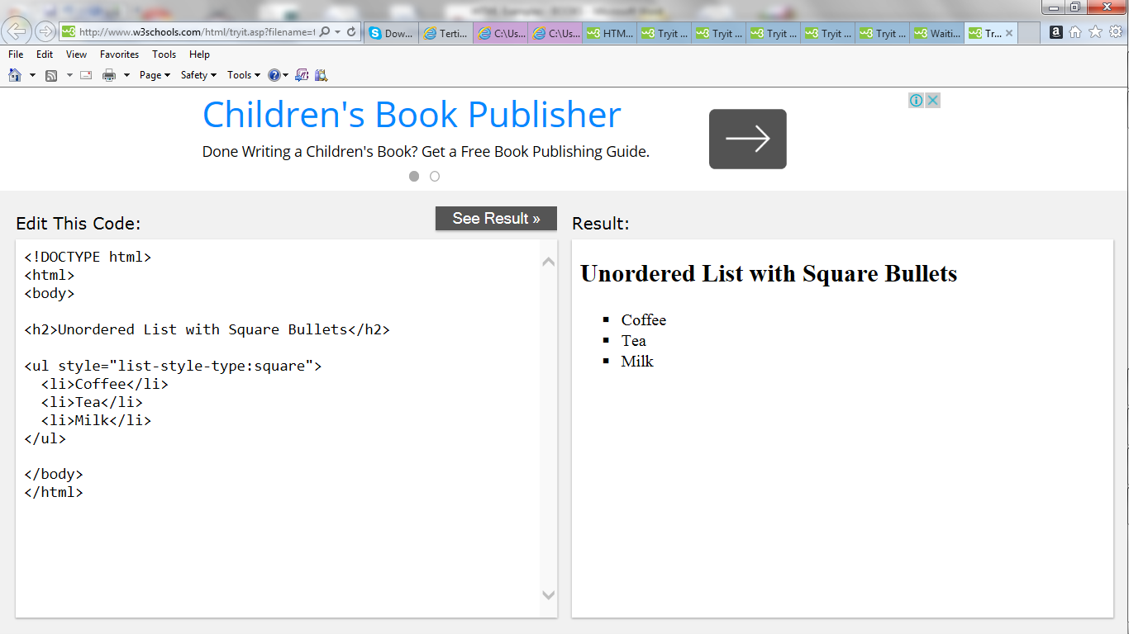

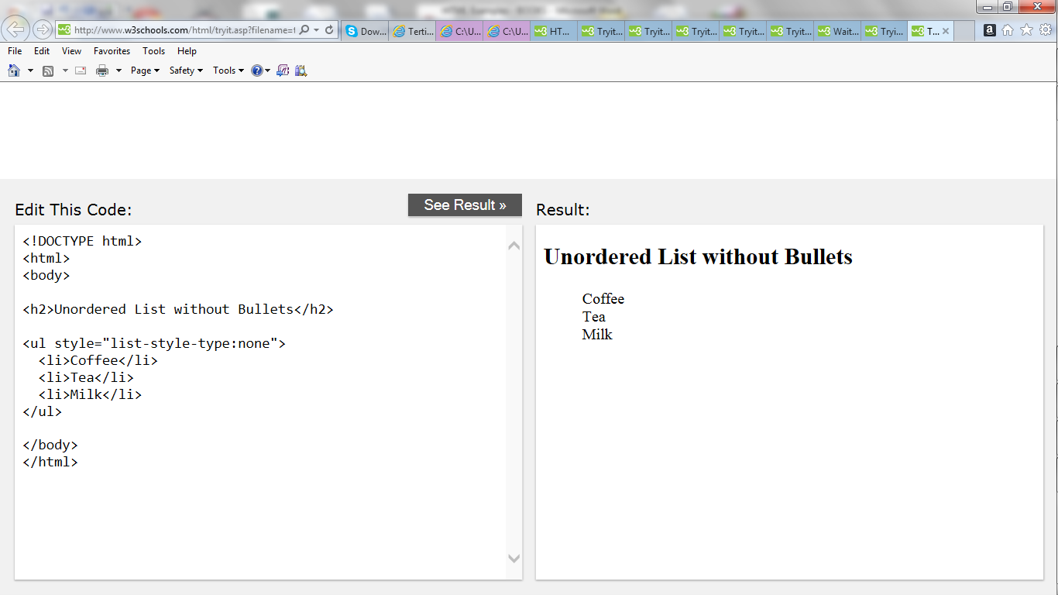

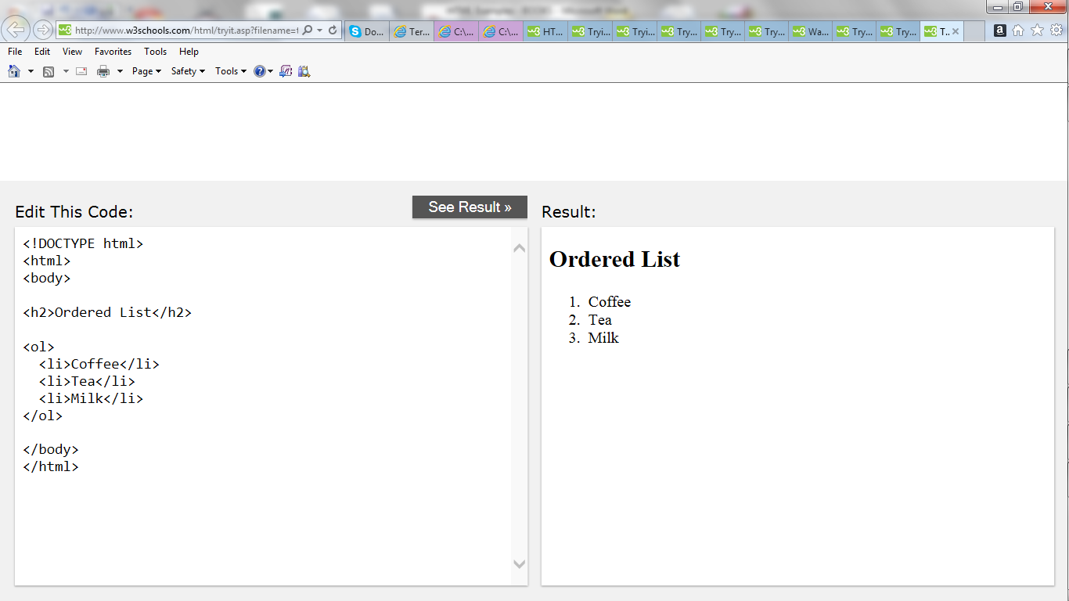

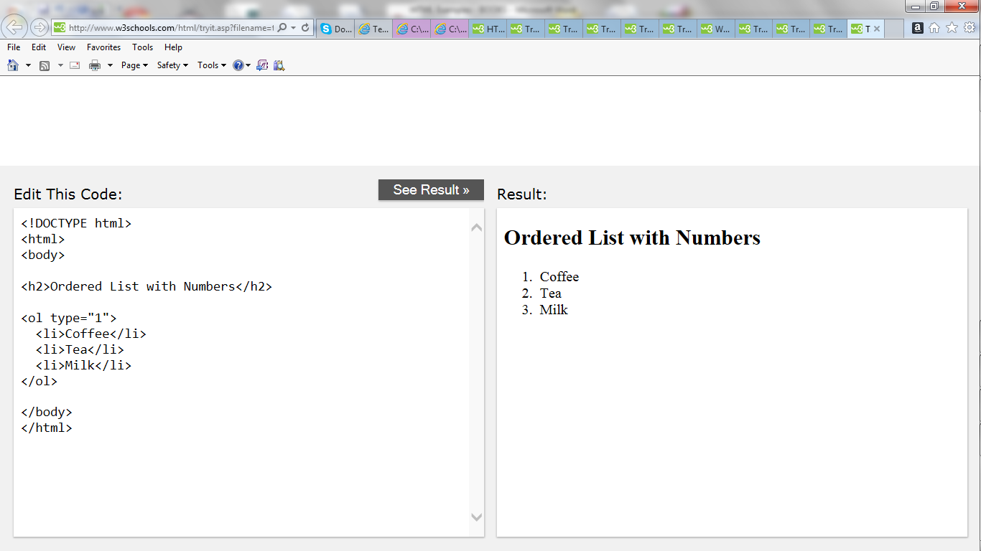

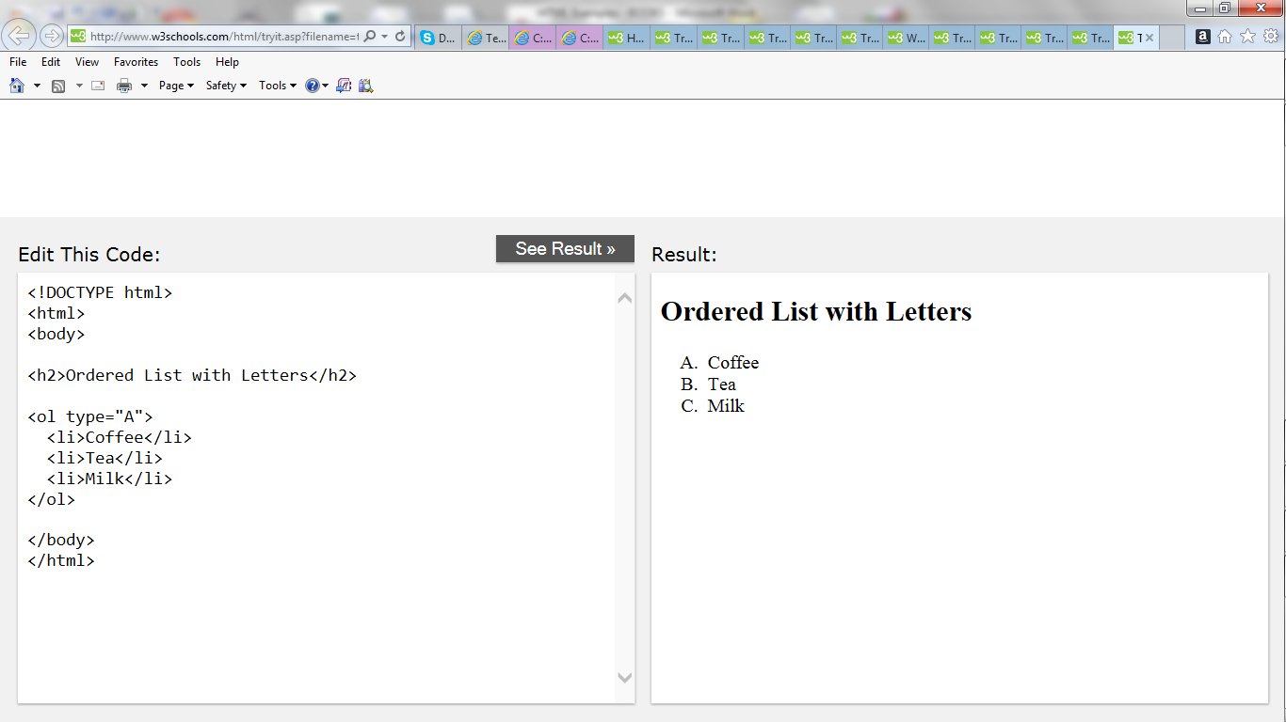

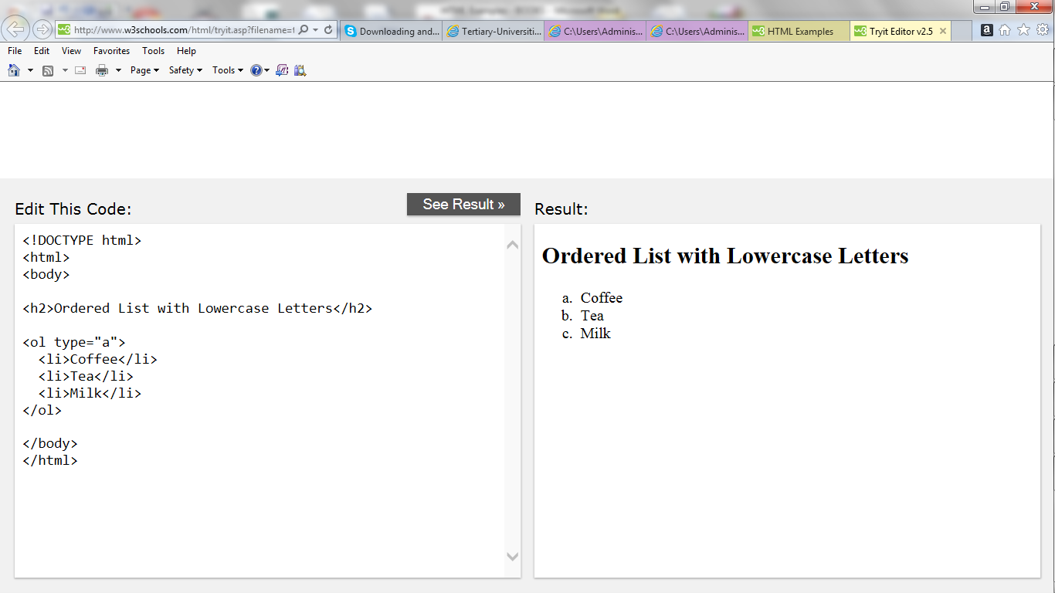

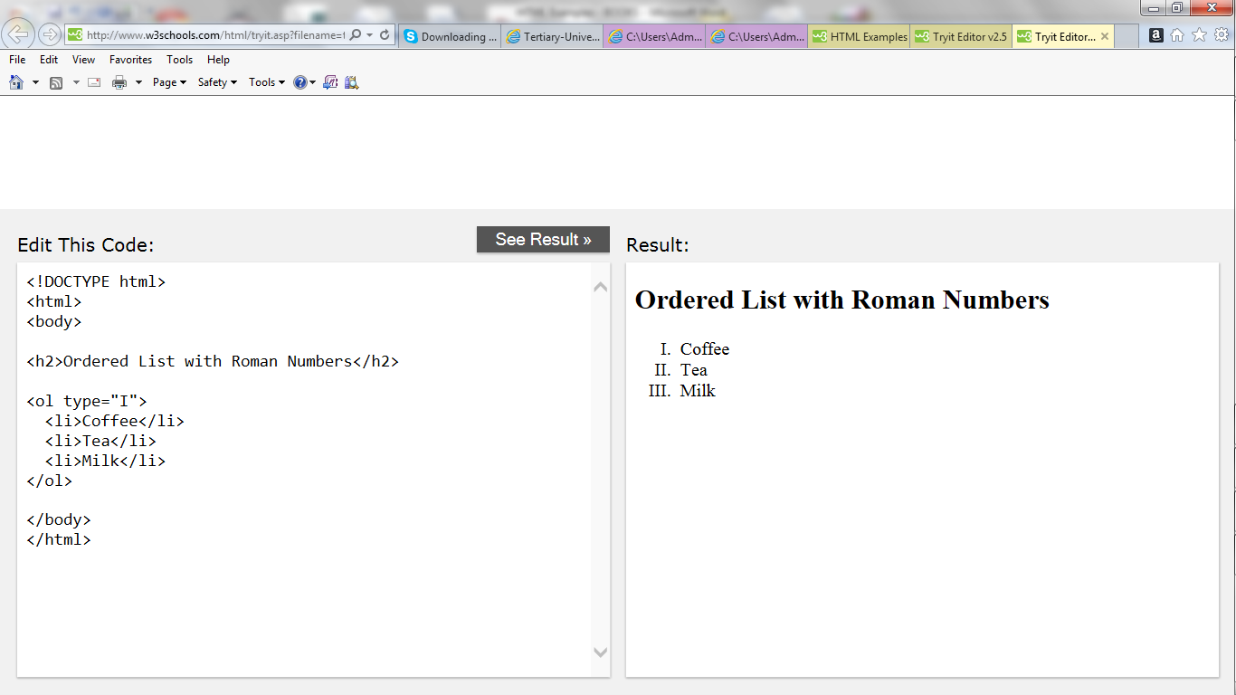

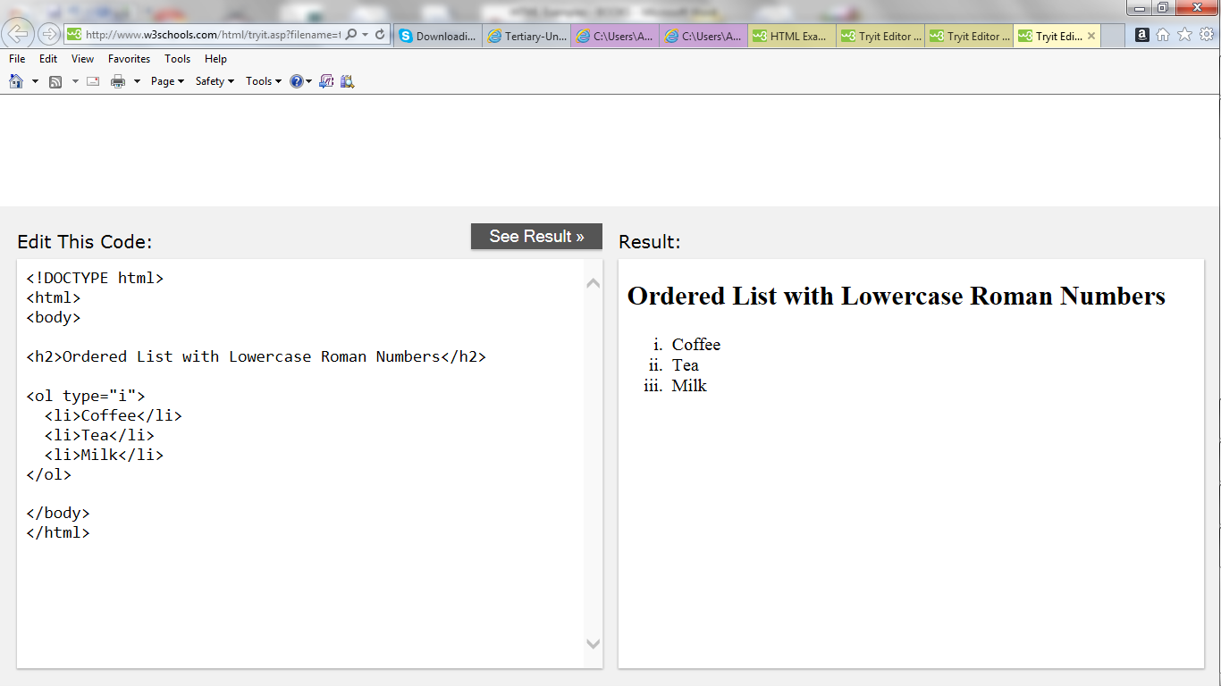

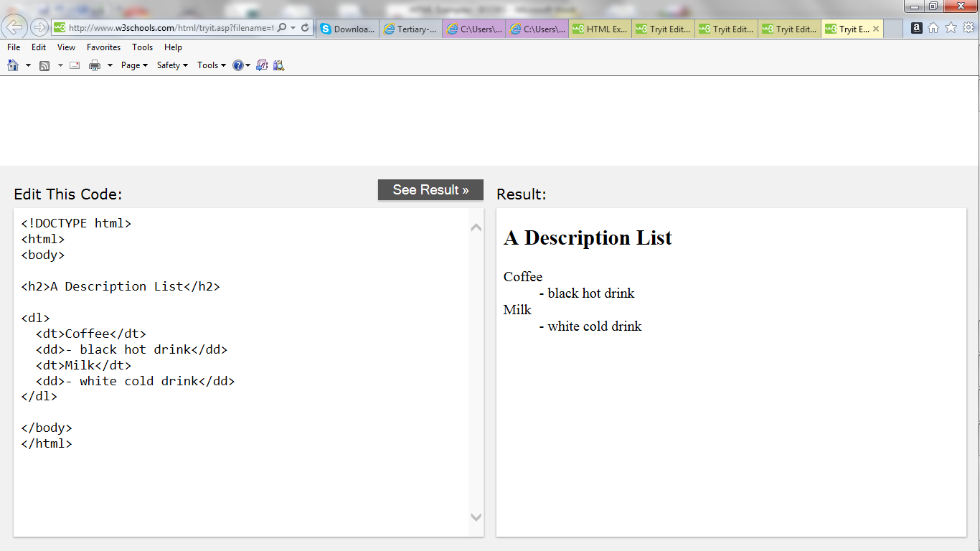

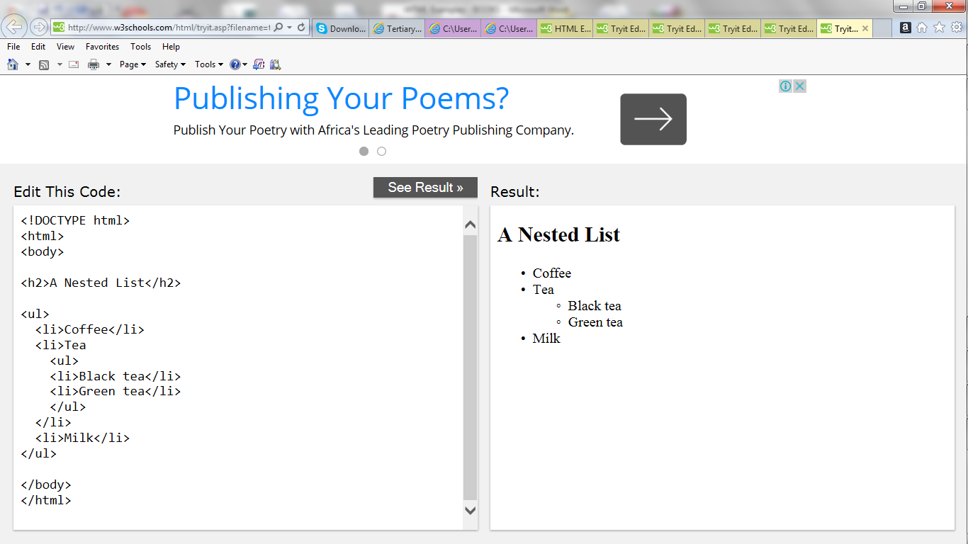

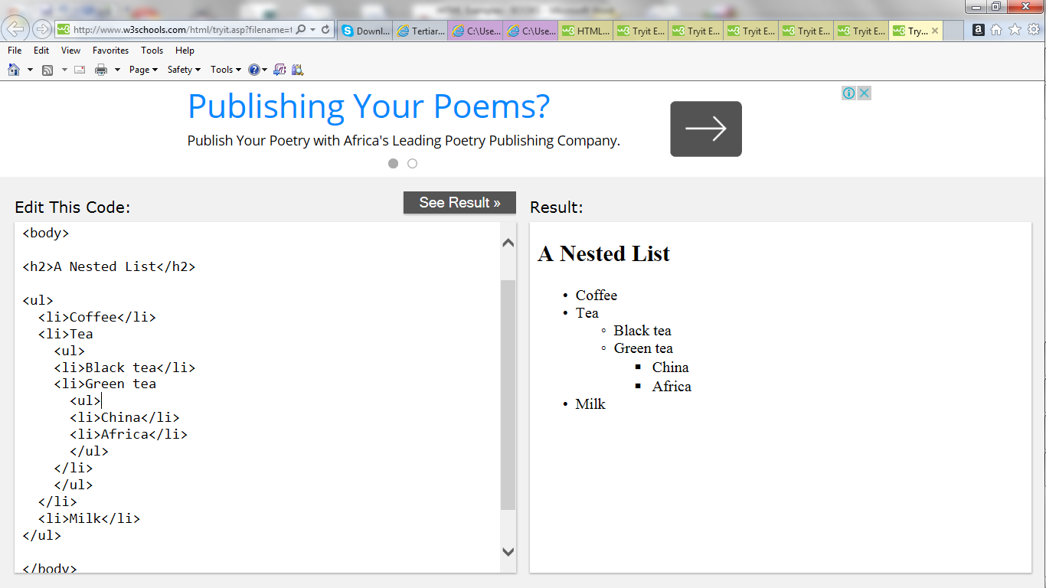

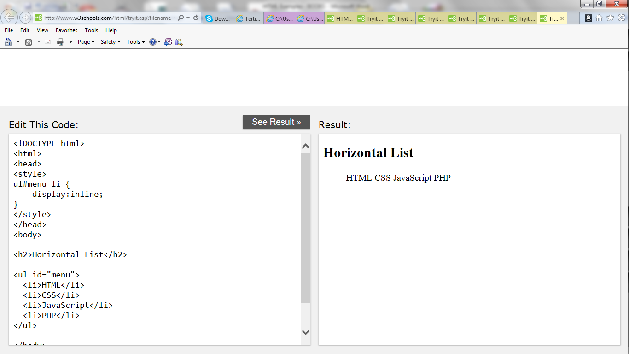

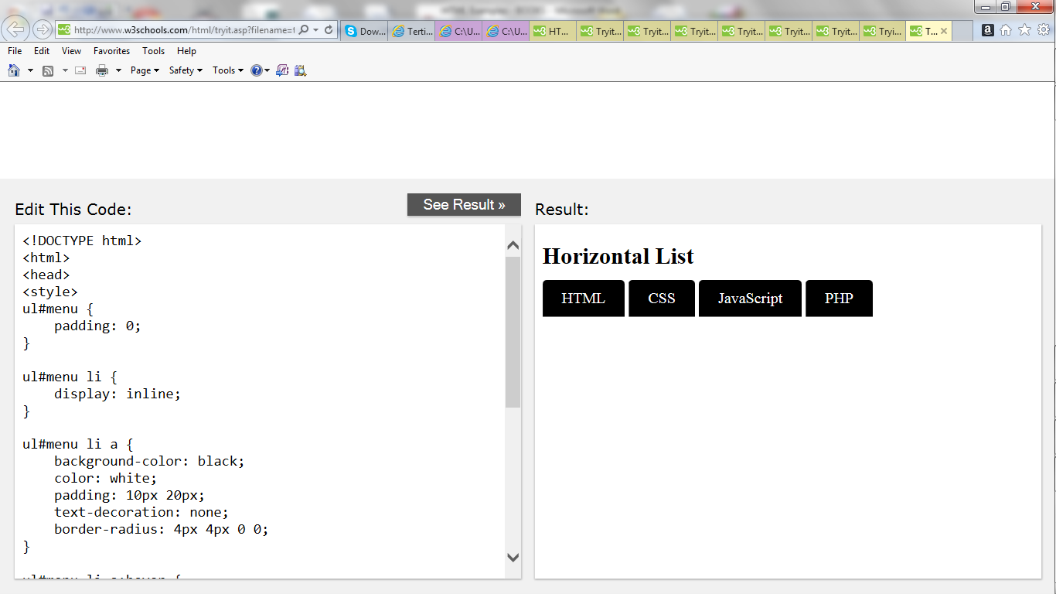



**HTML Block and inline elements**

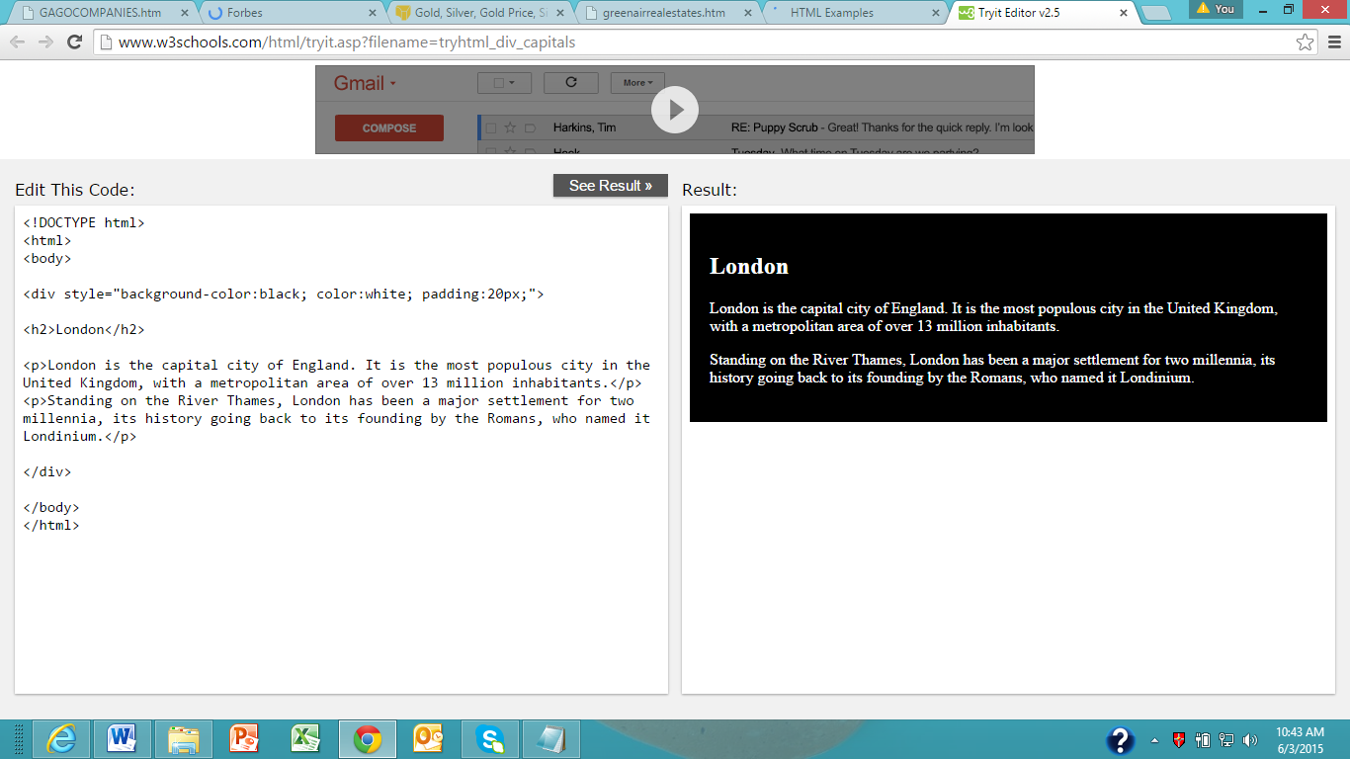

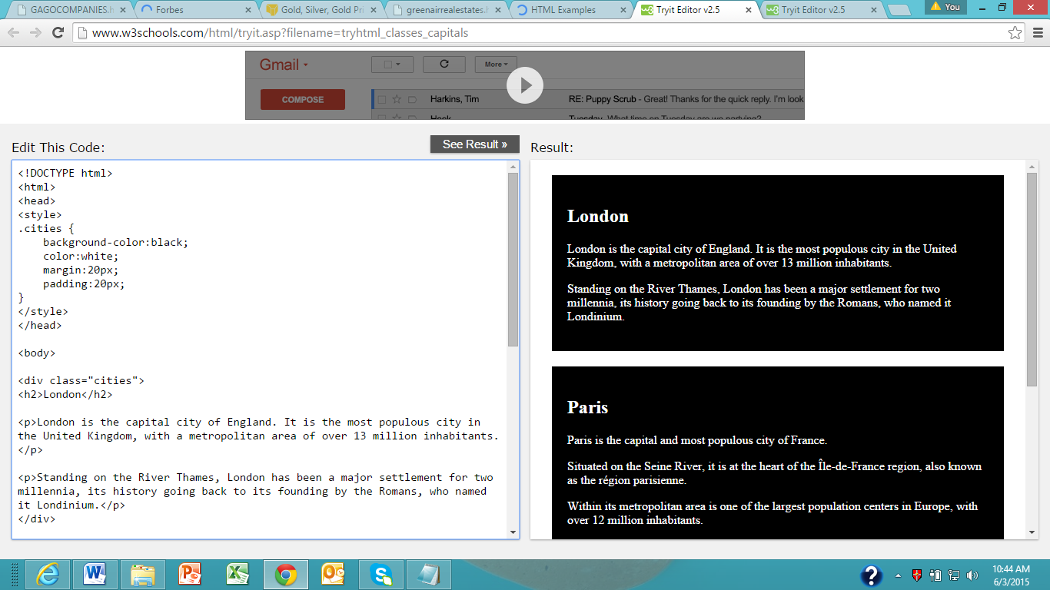

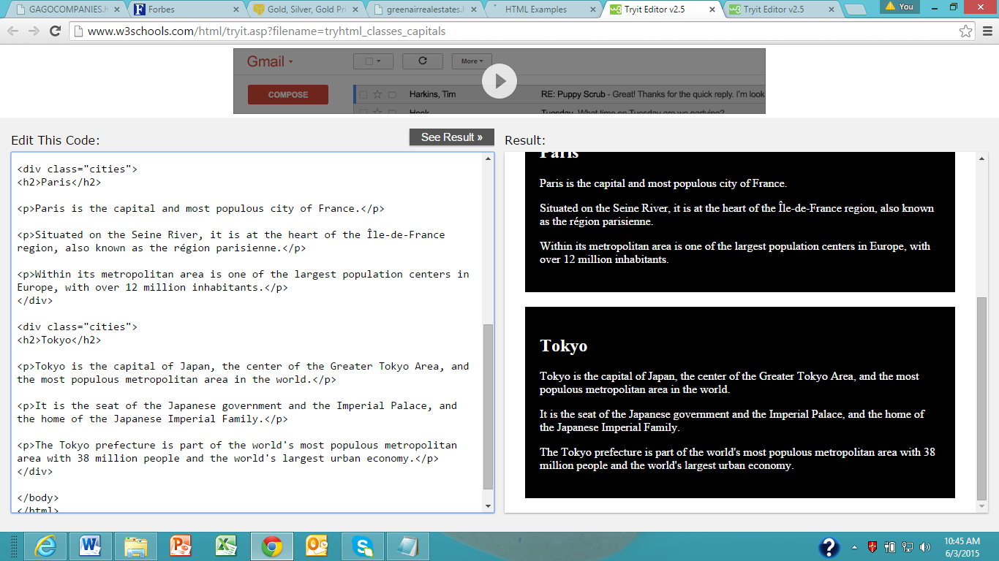

**HTML Classes**

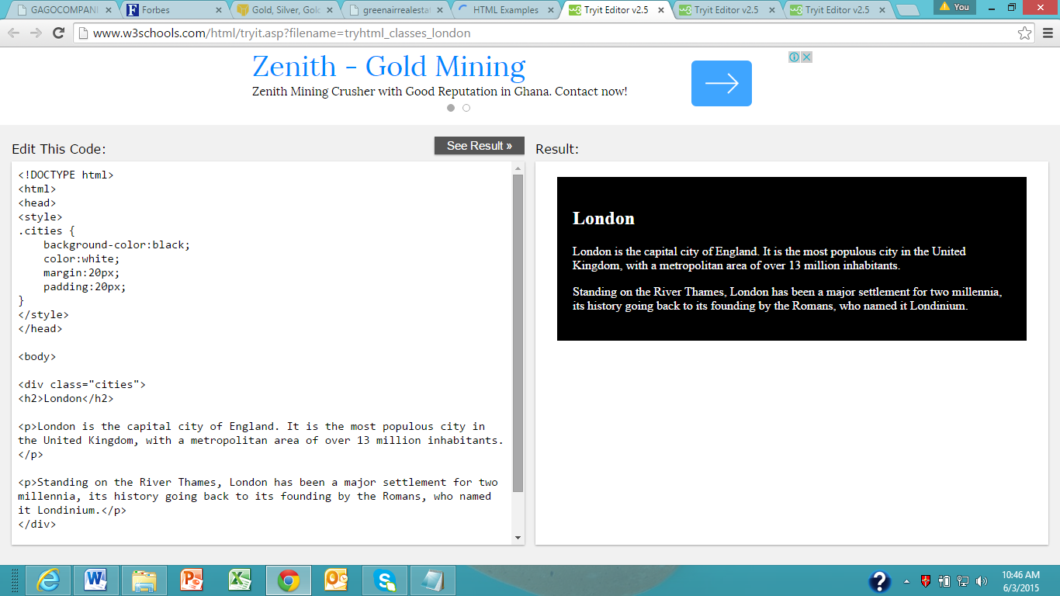

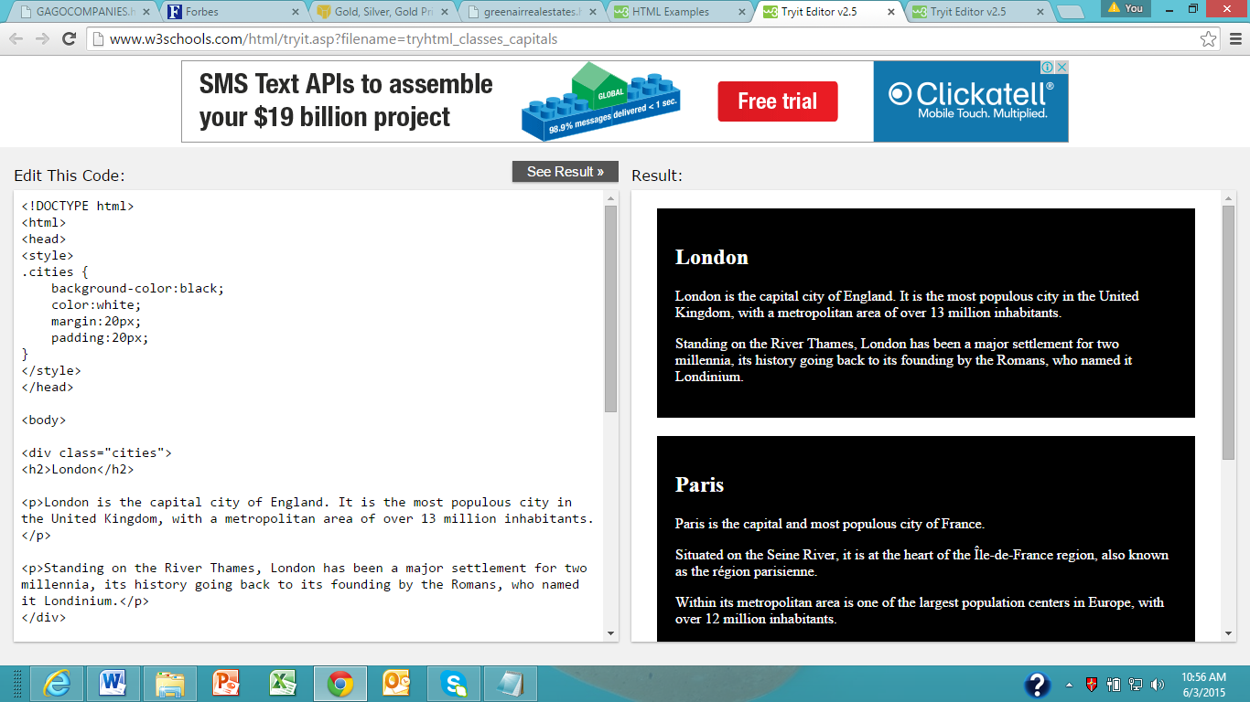

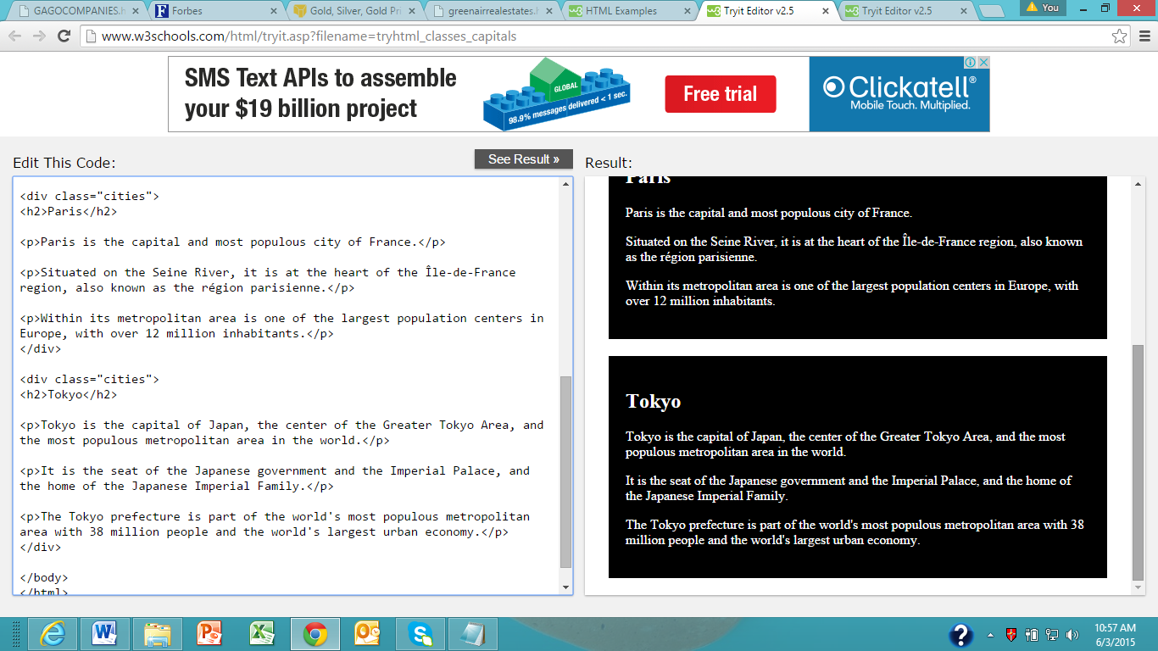

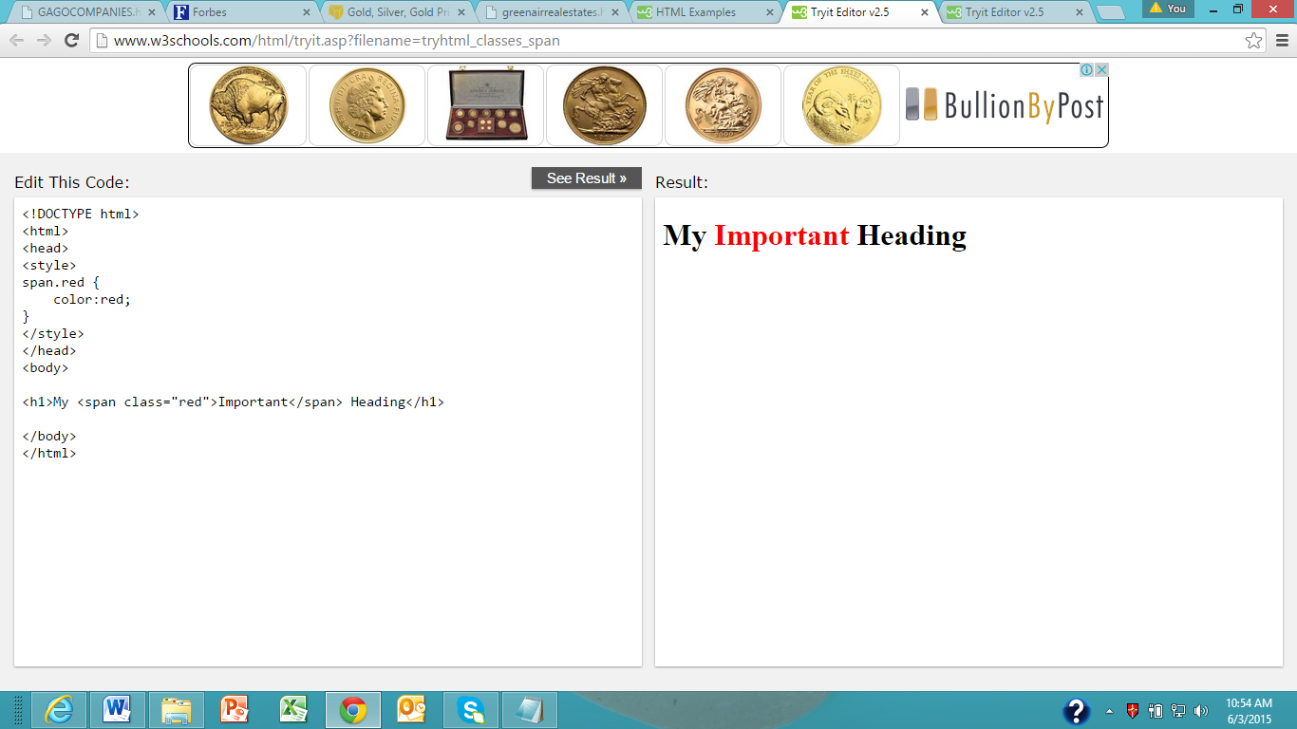

**HTML Layout**

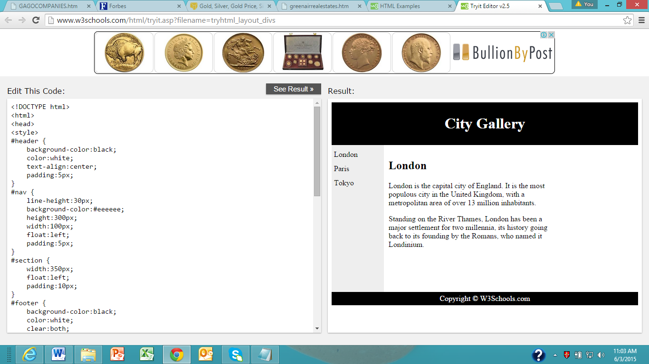

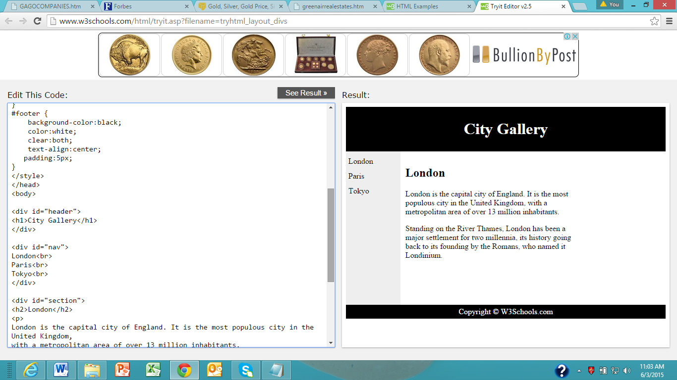

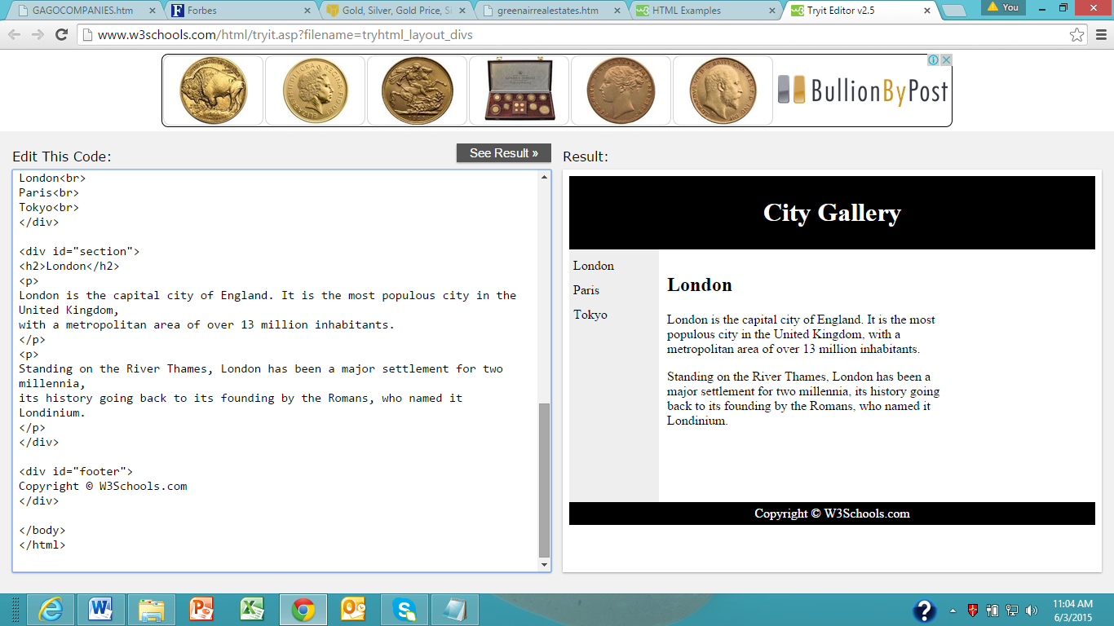

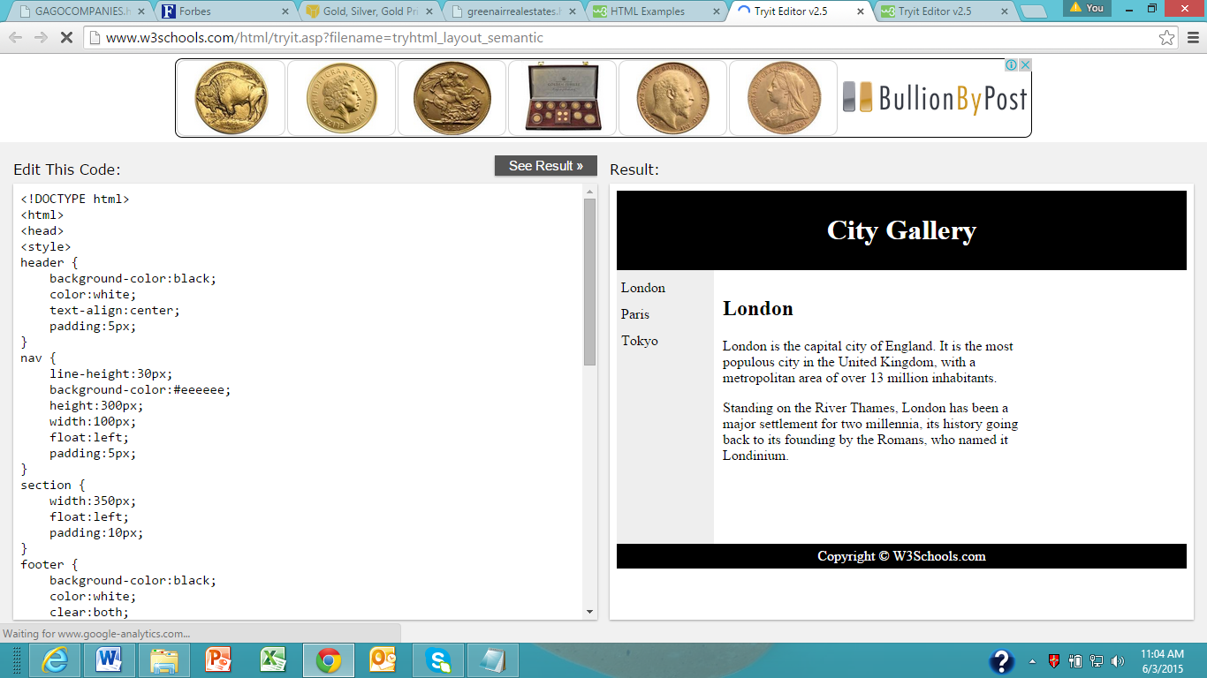

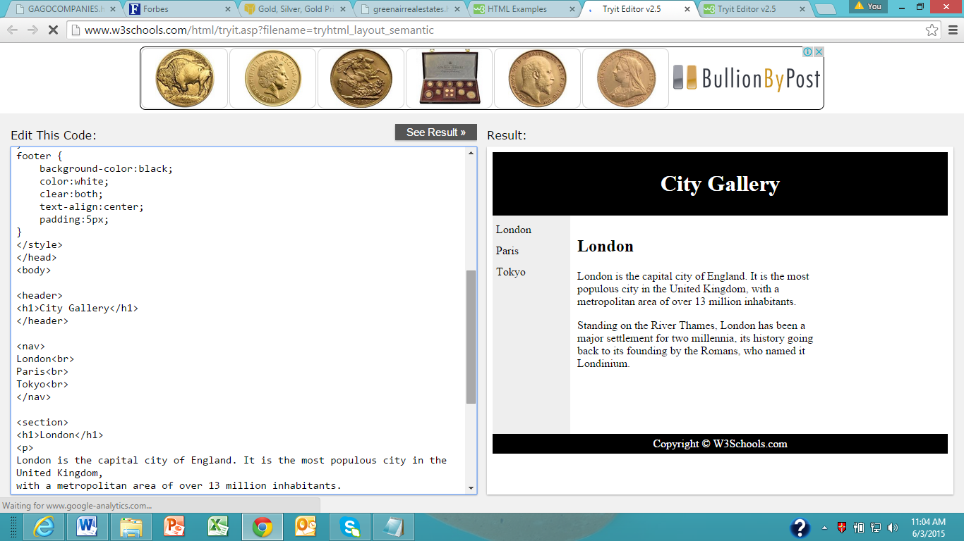

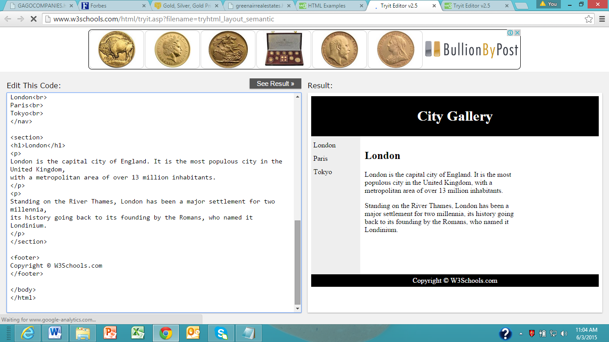

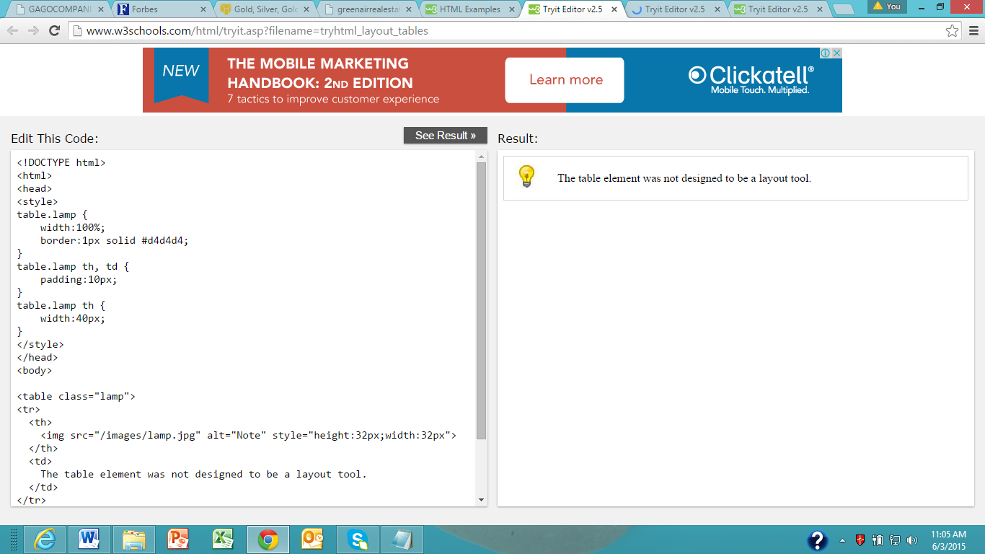

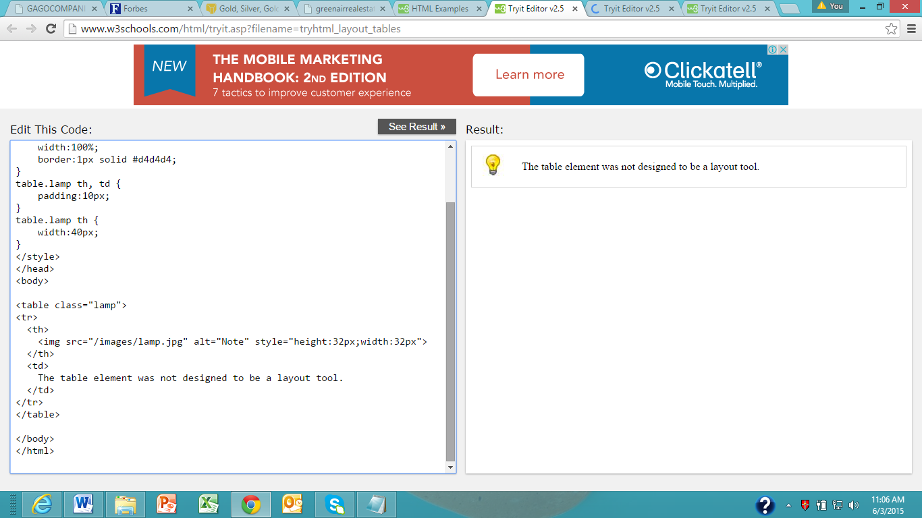

**HTML IFrame**

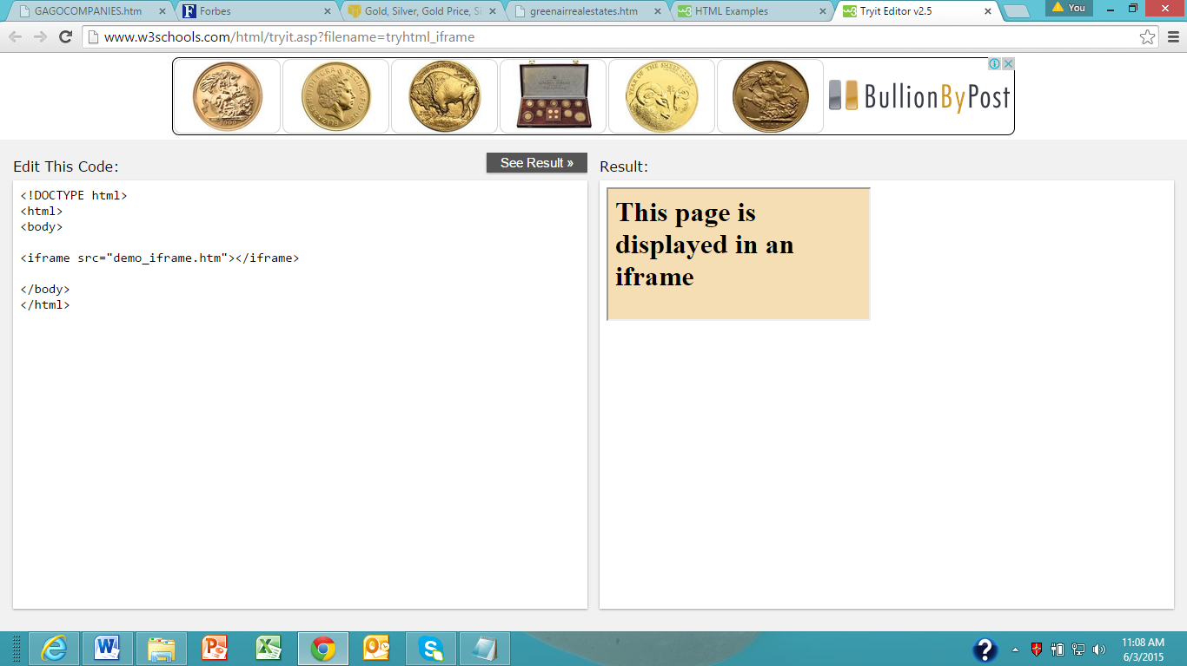

**HTML head Elements**

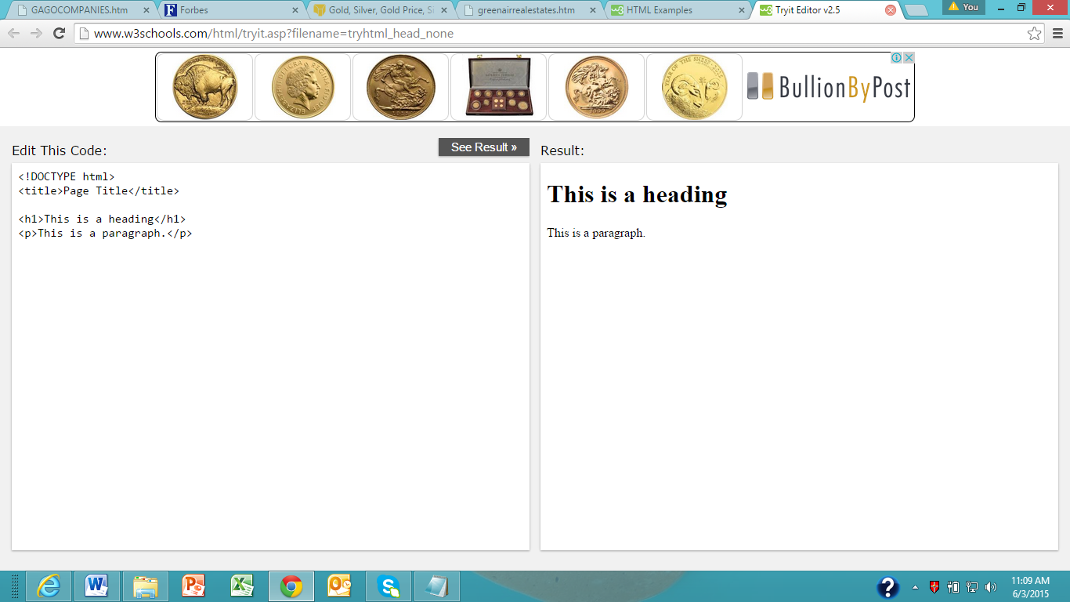

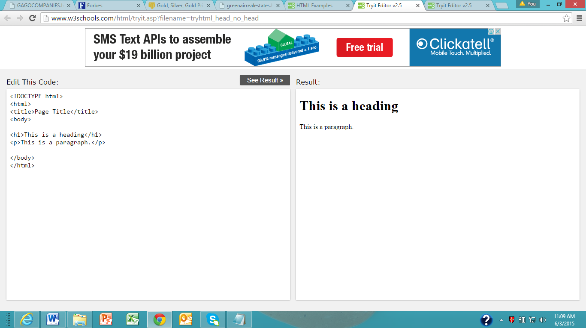

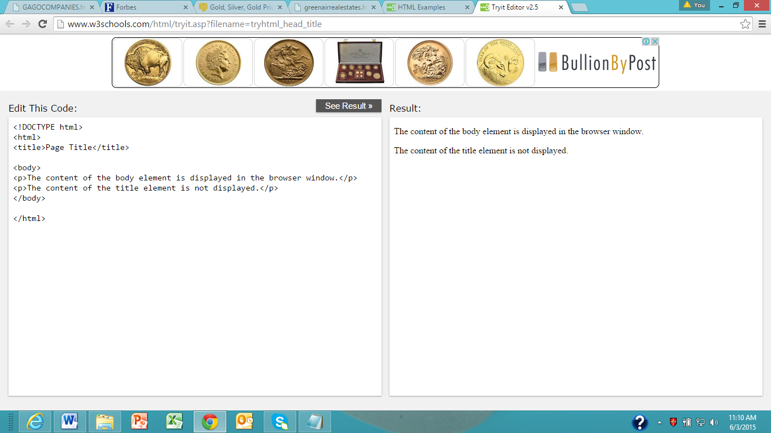

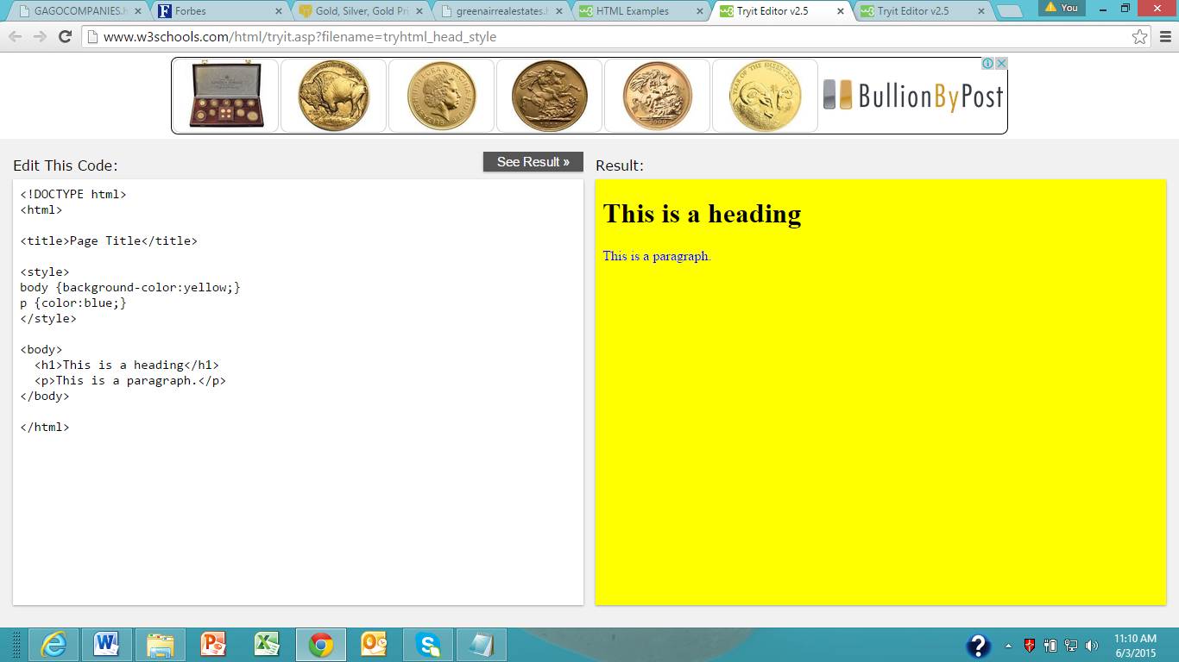

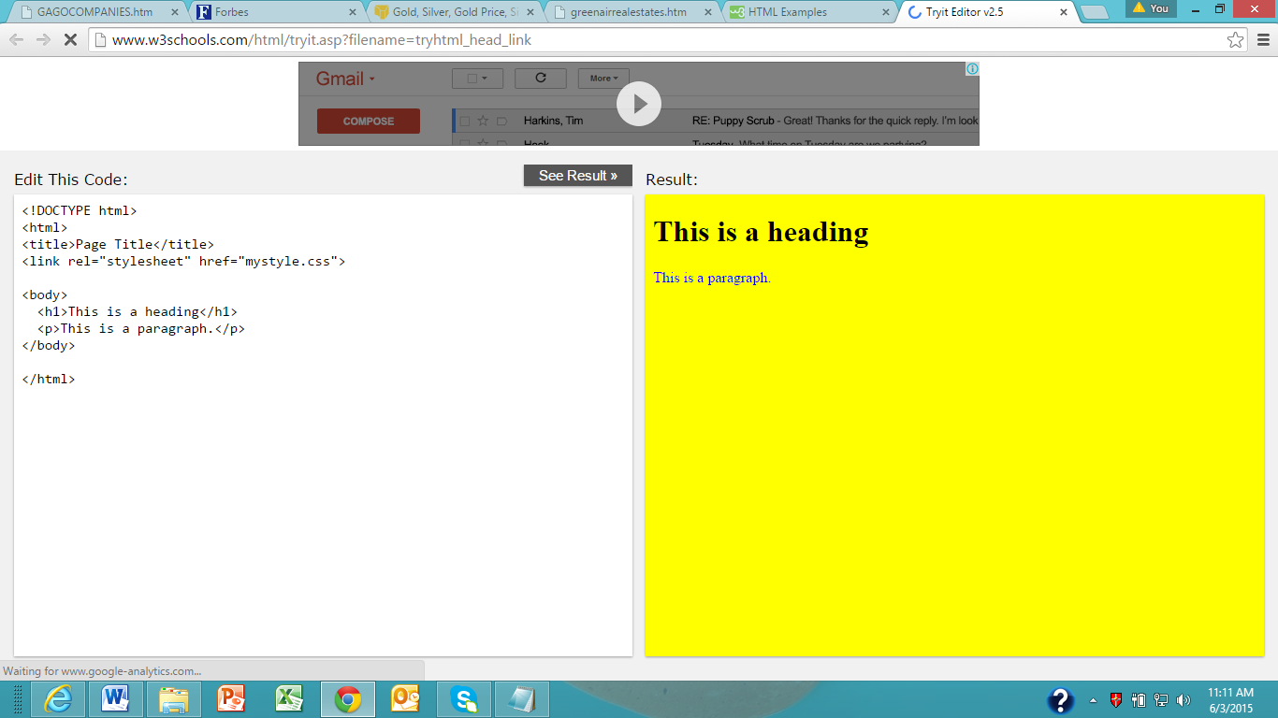

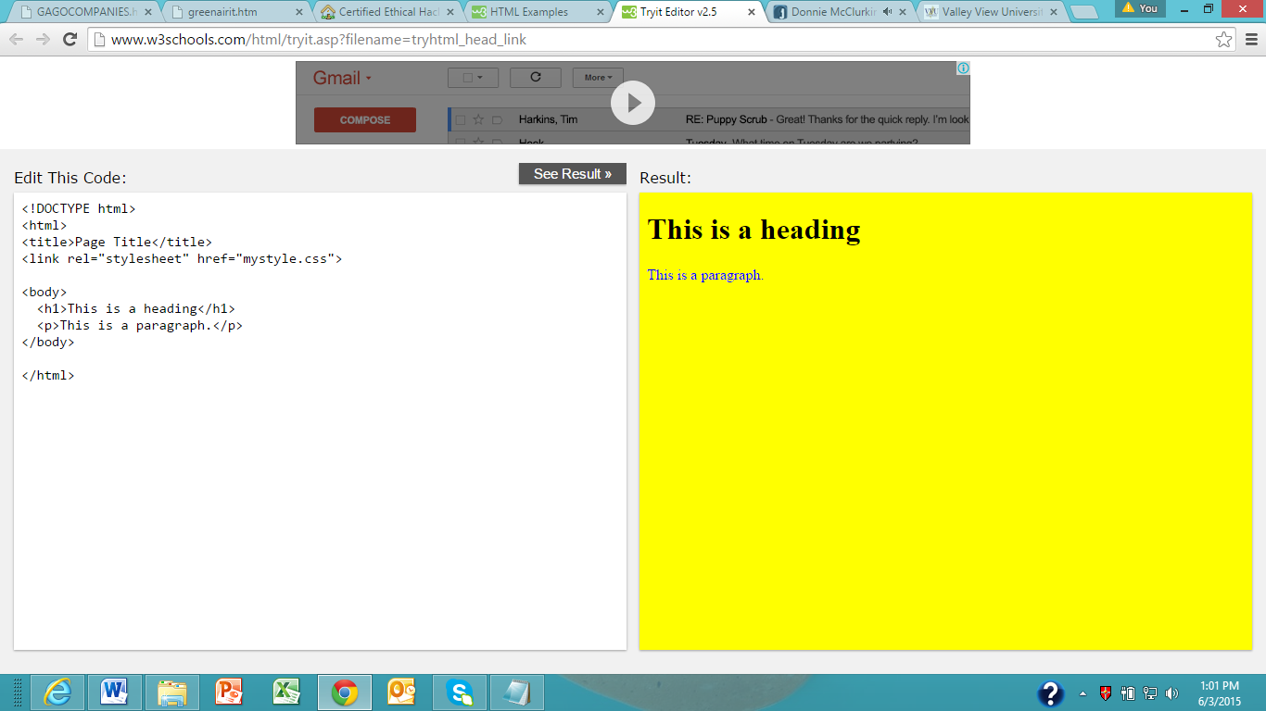

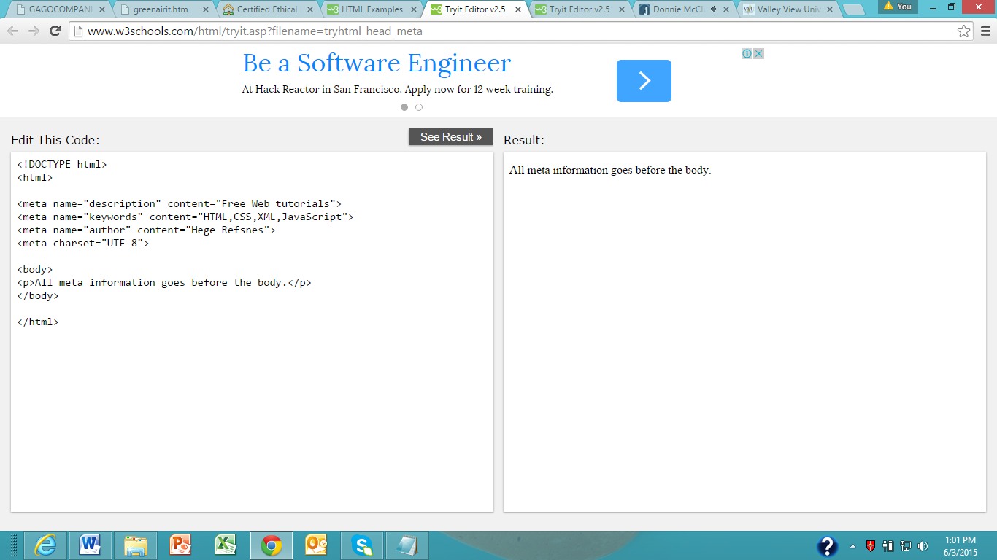

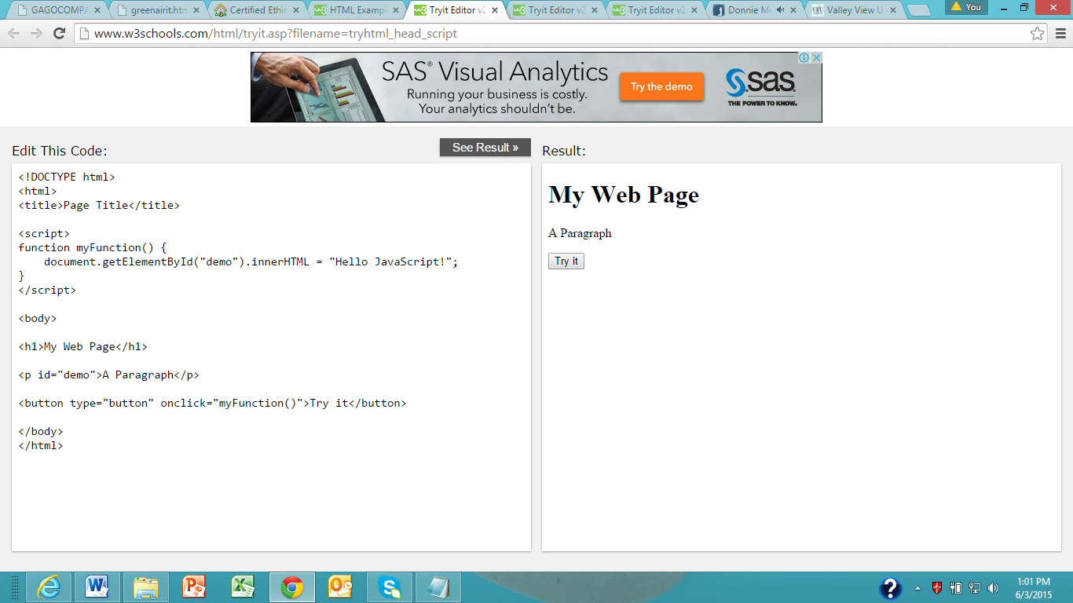

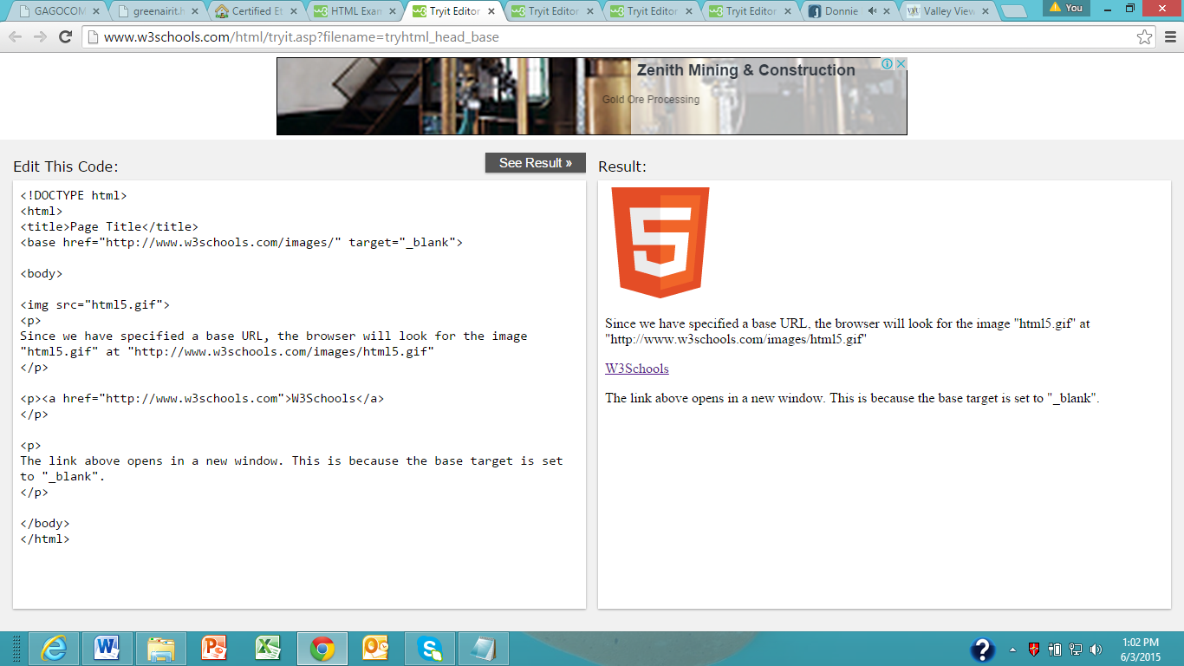

**HTML Scripts**

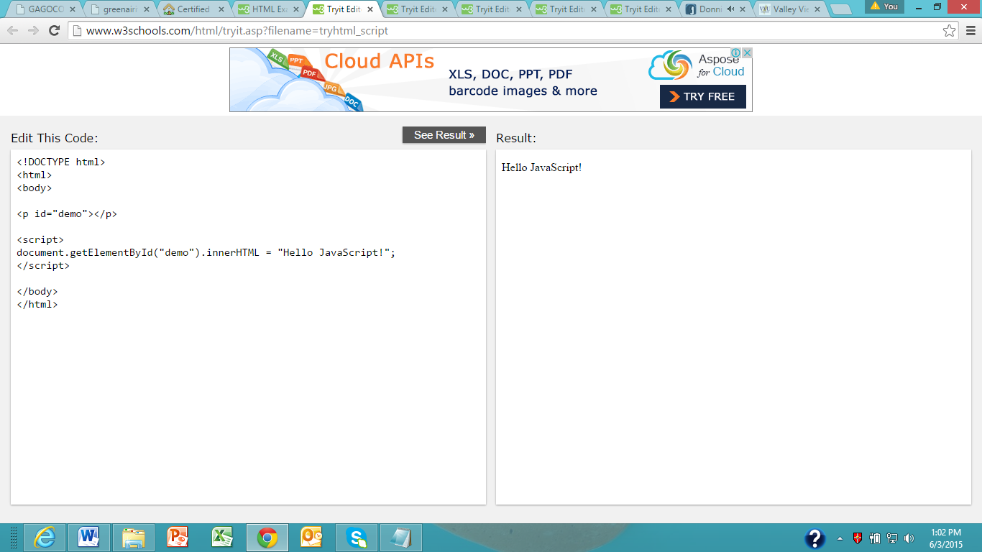

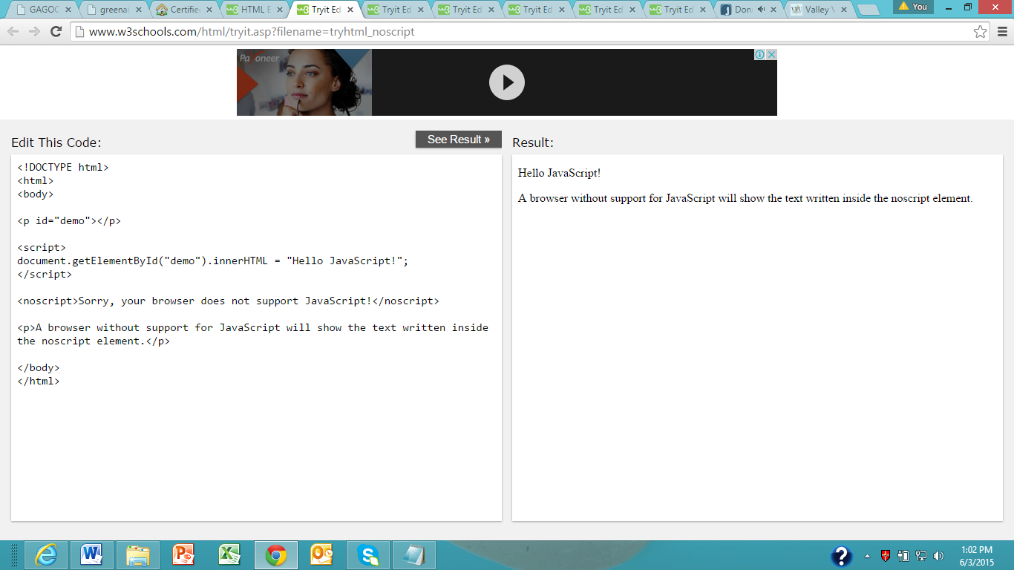

**HTML Forms**

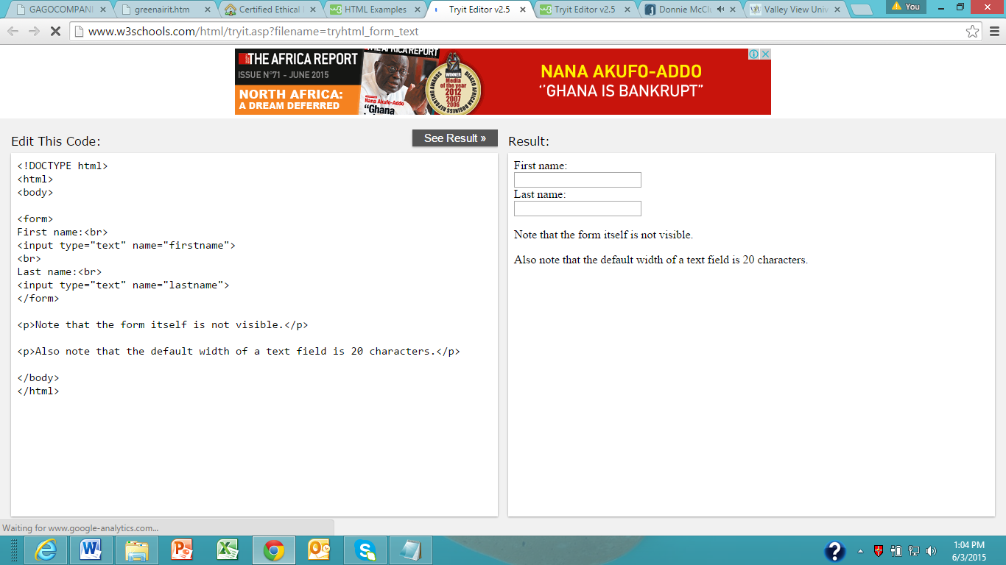

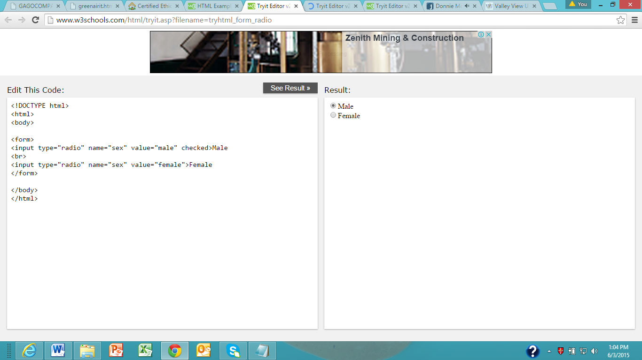

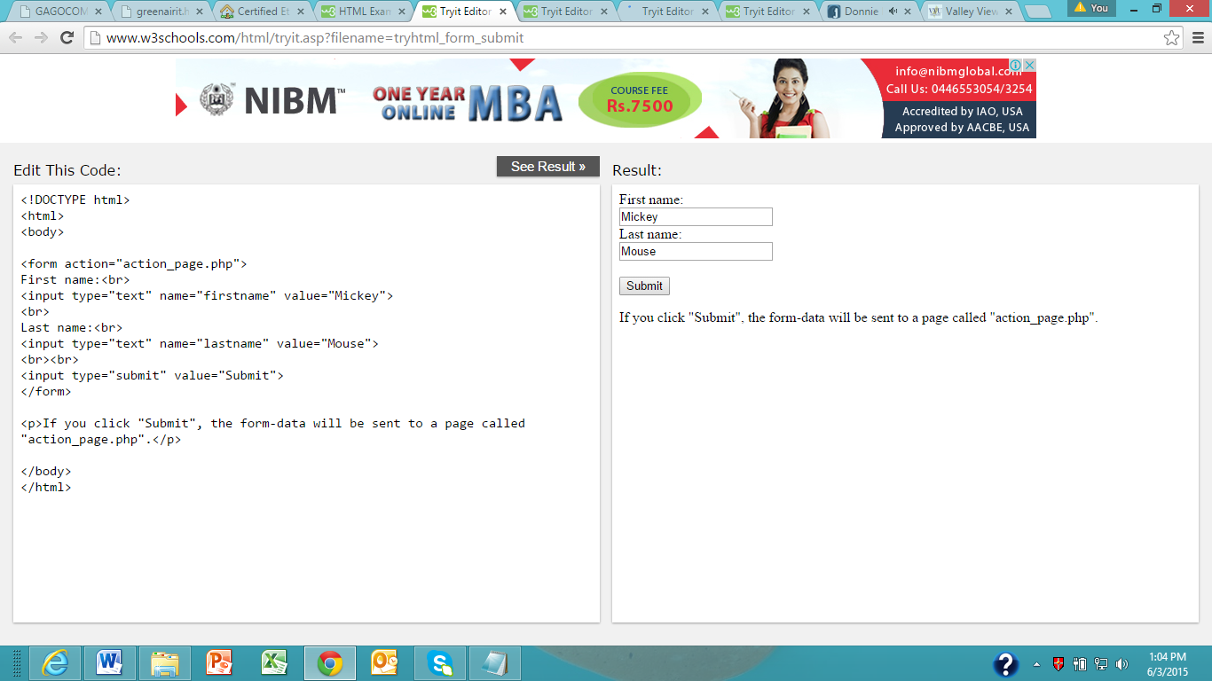

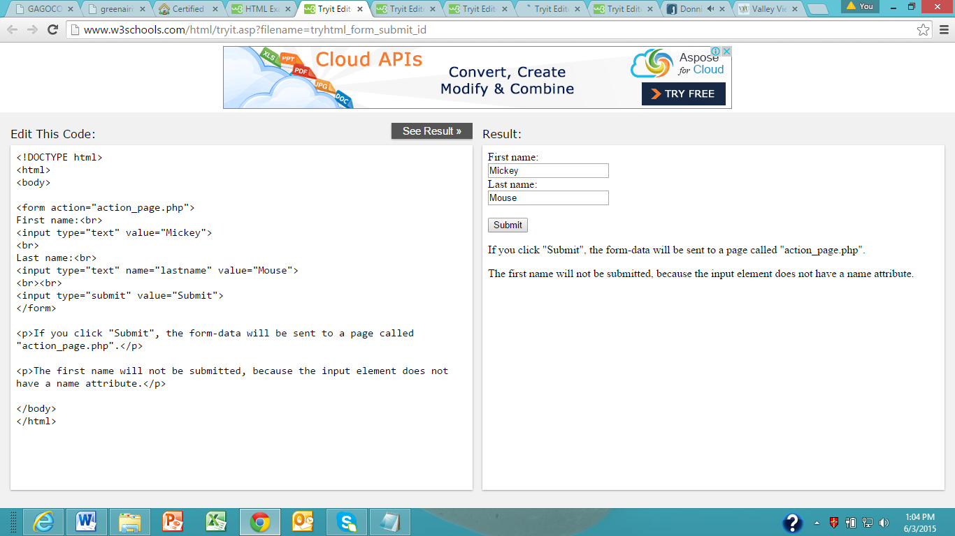

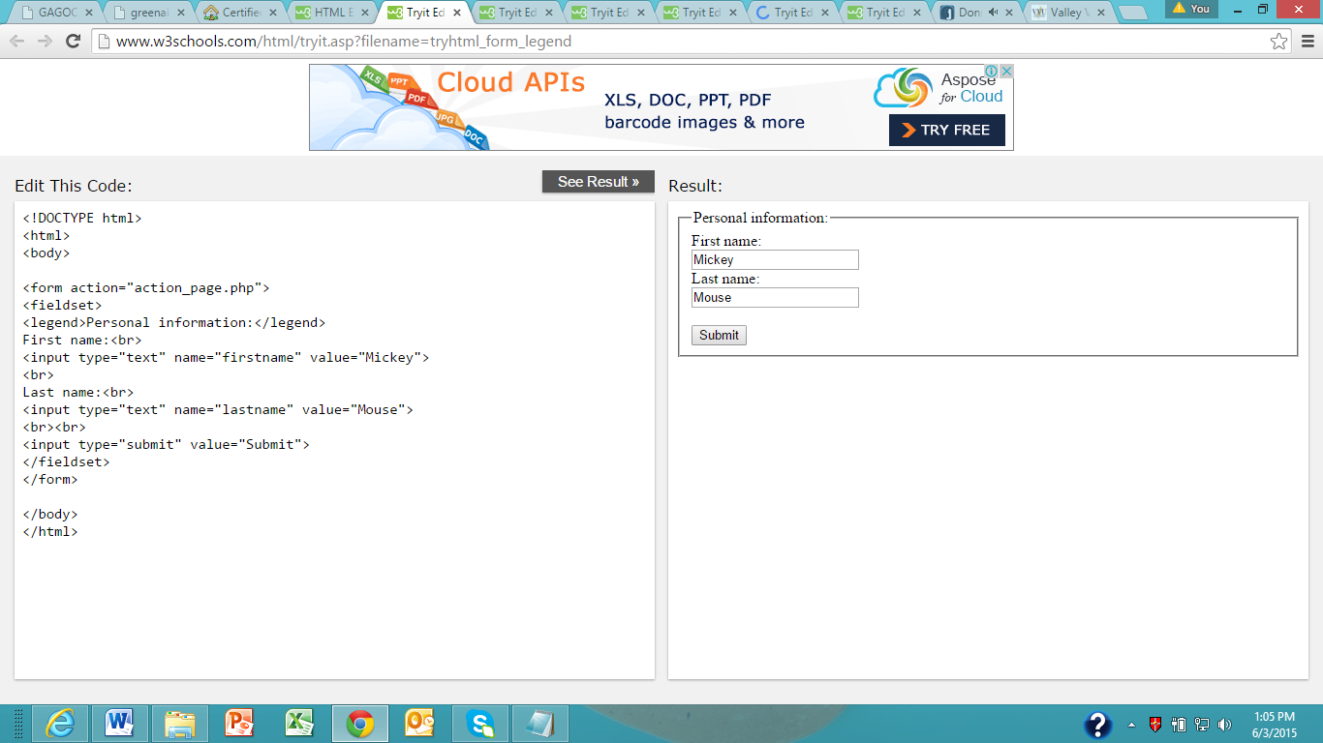

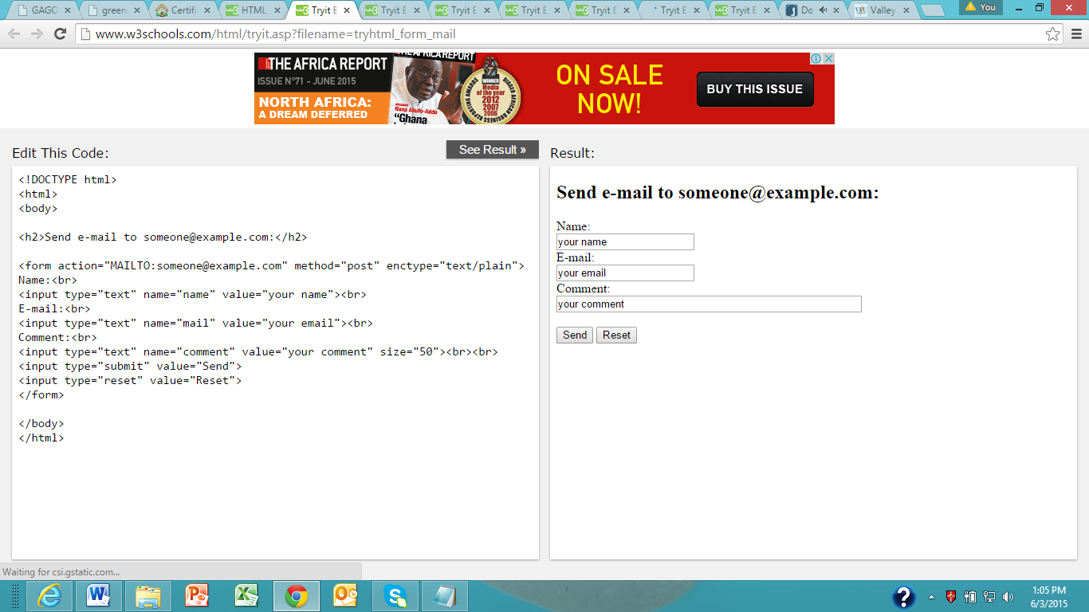

**HTML Form Elements**

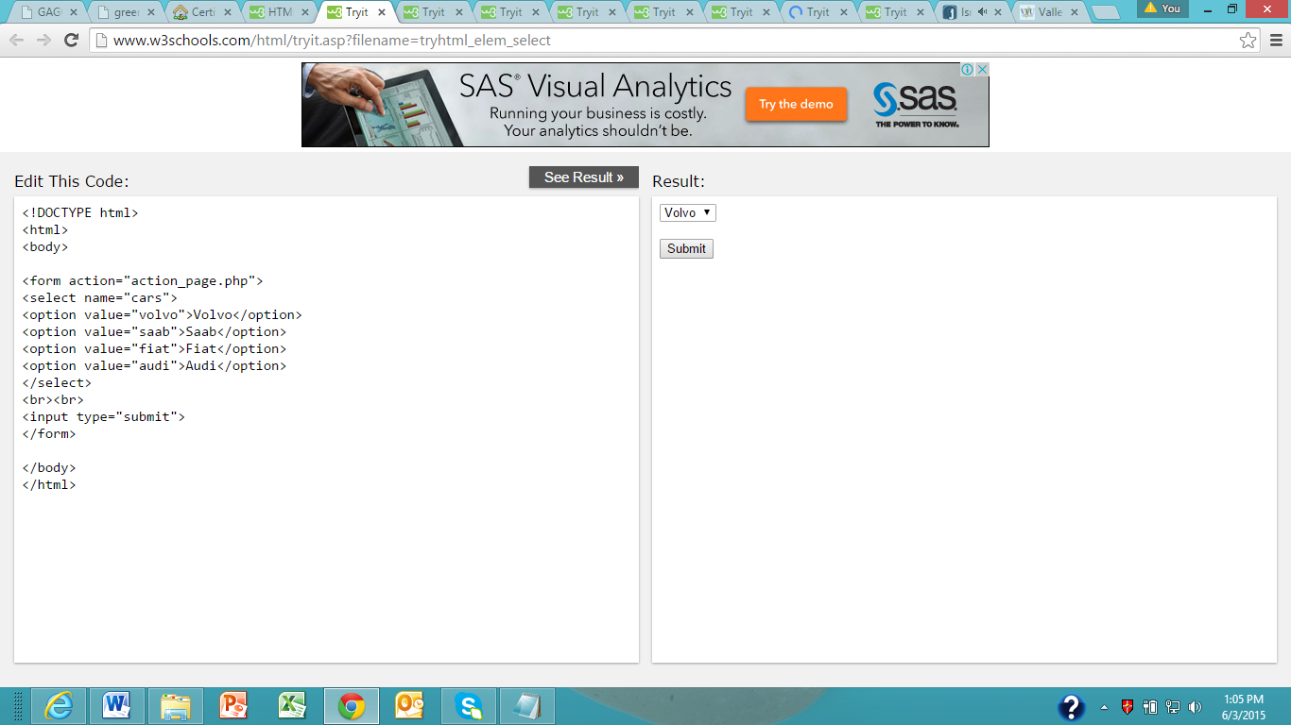

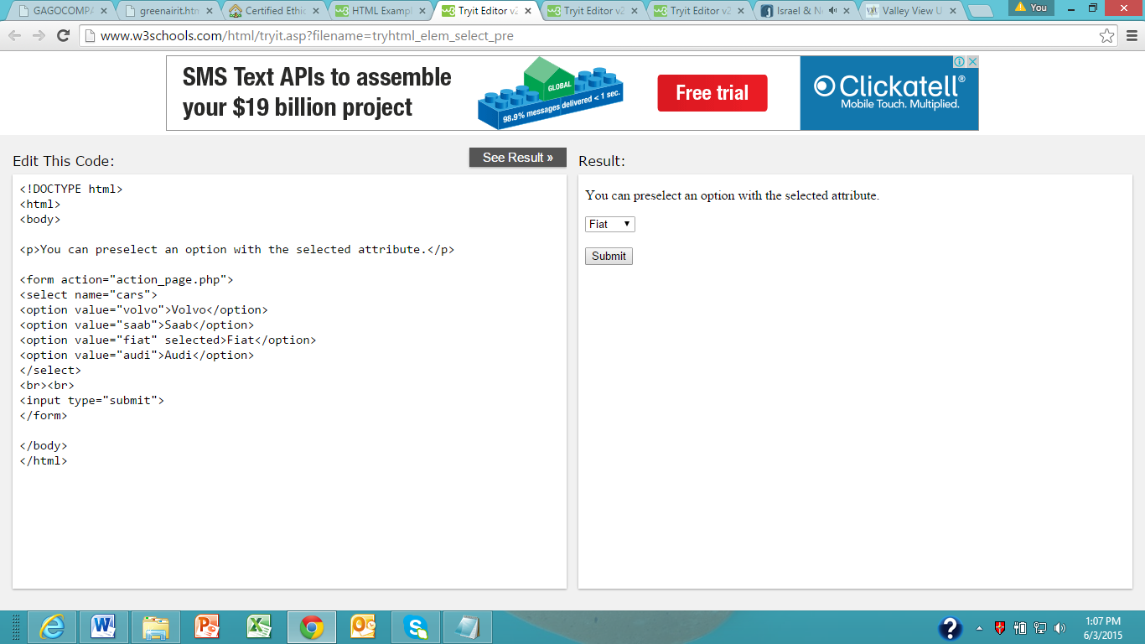

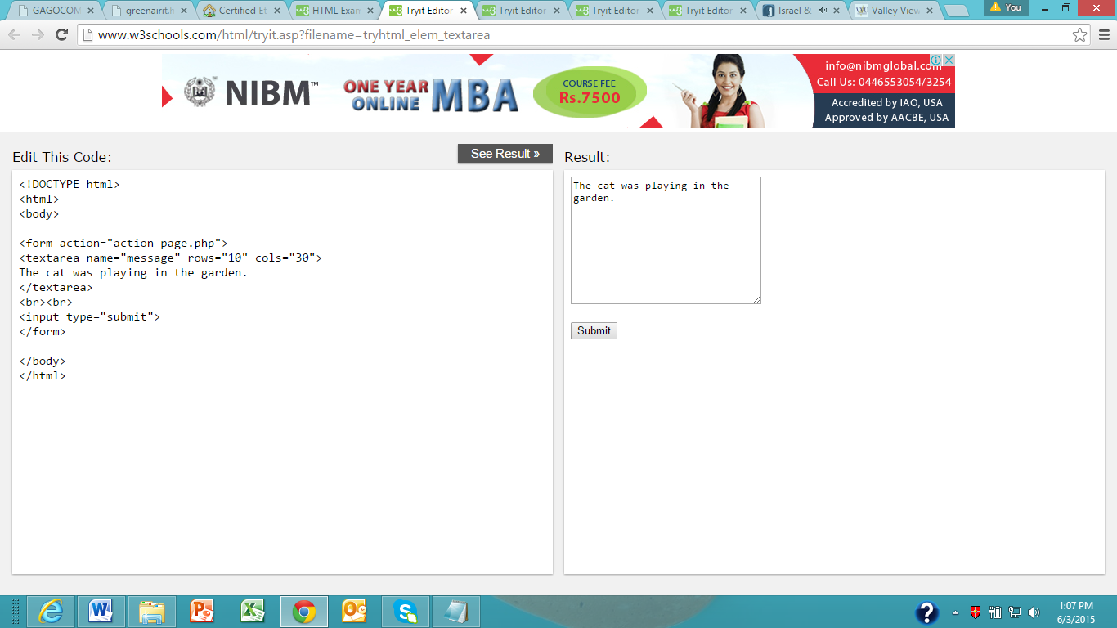

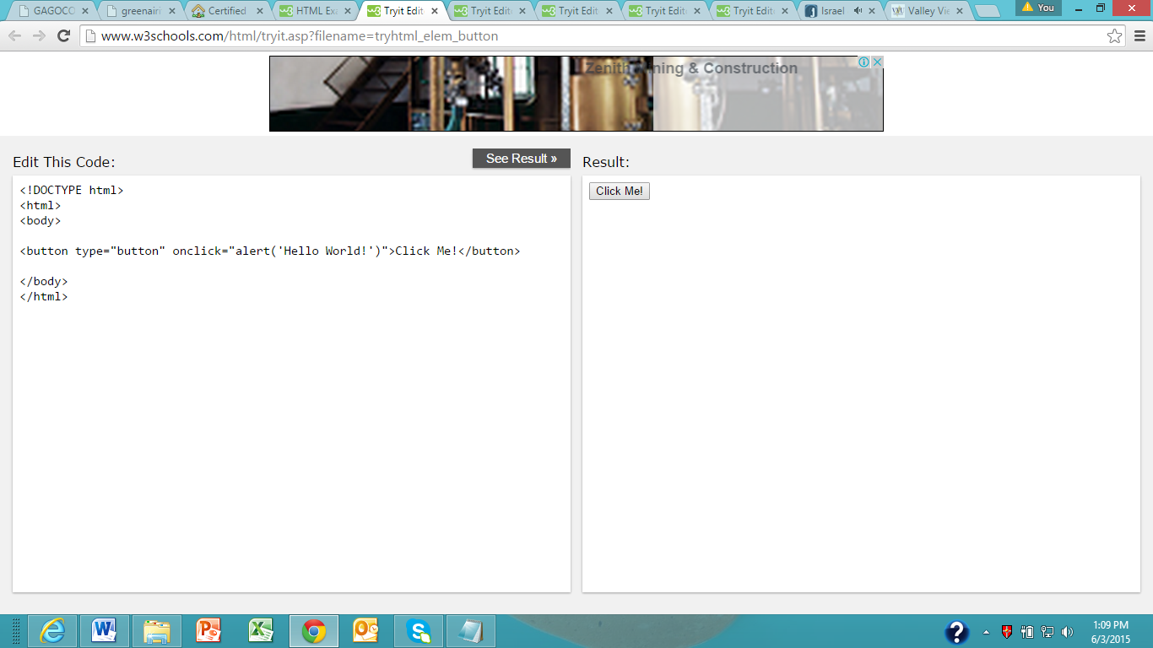

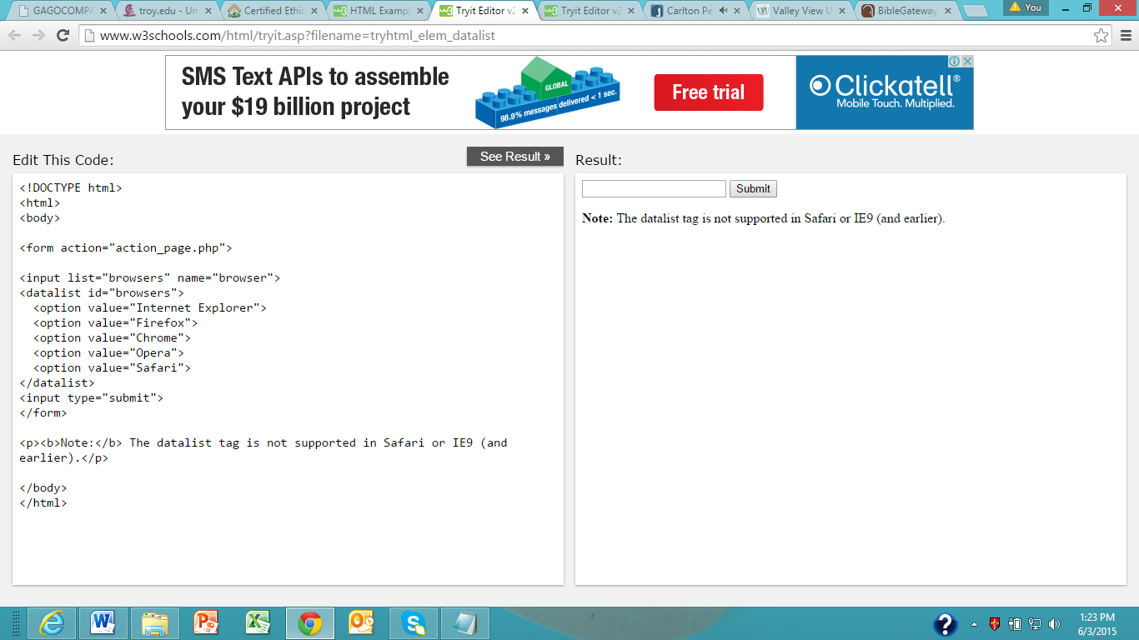

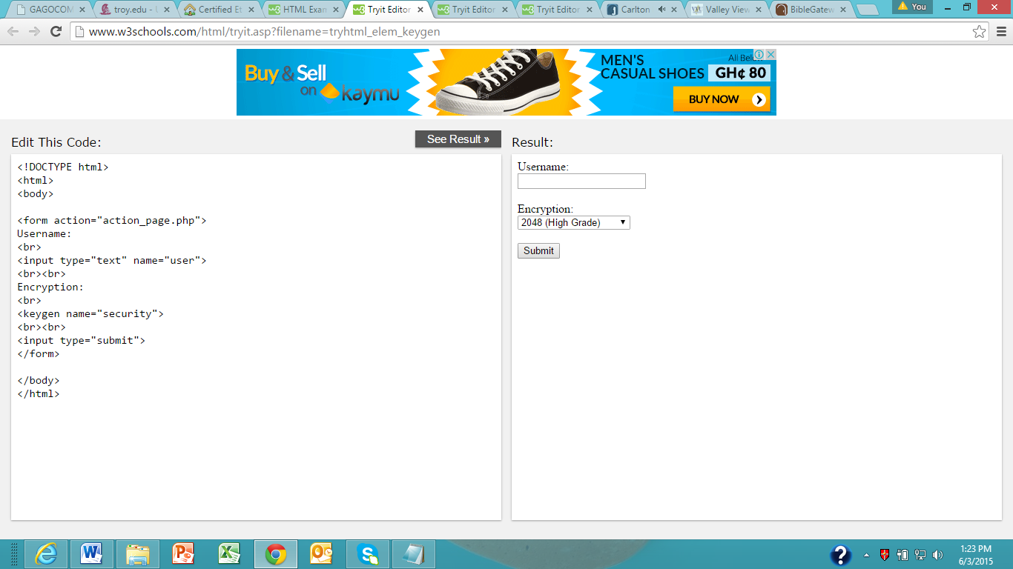

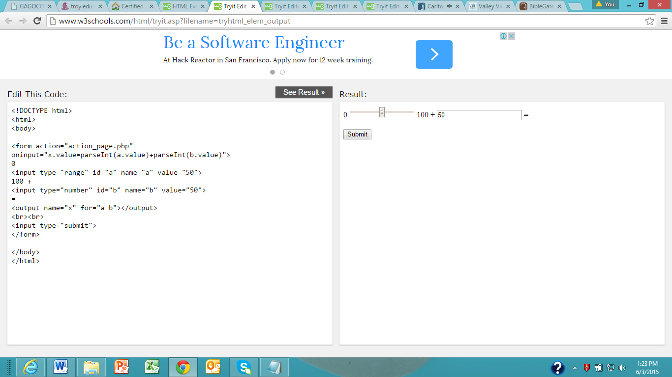

**HTML Input Types**

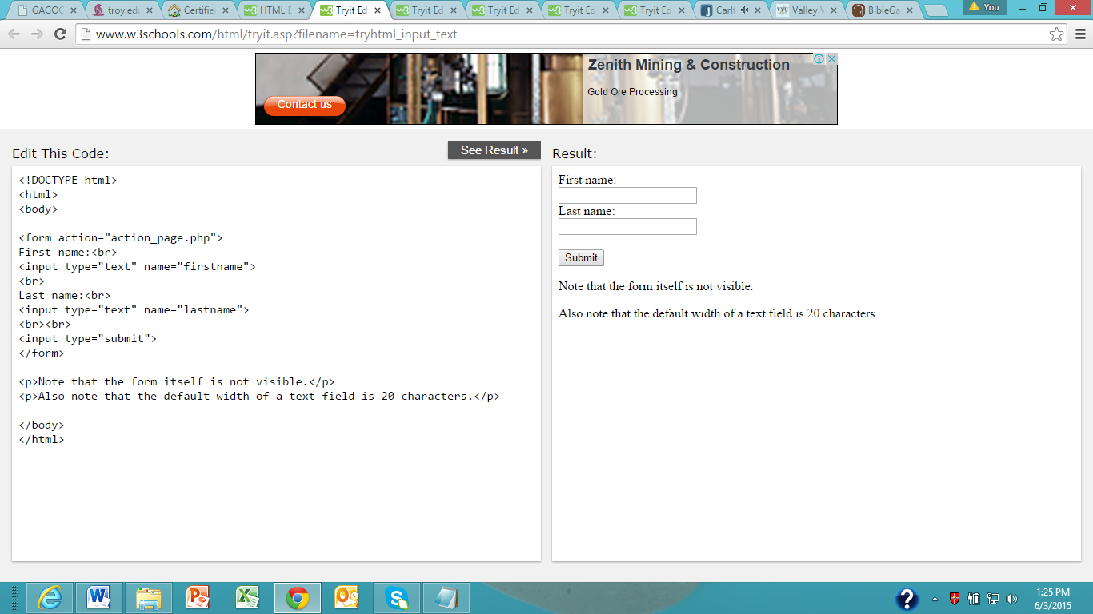

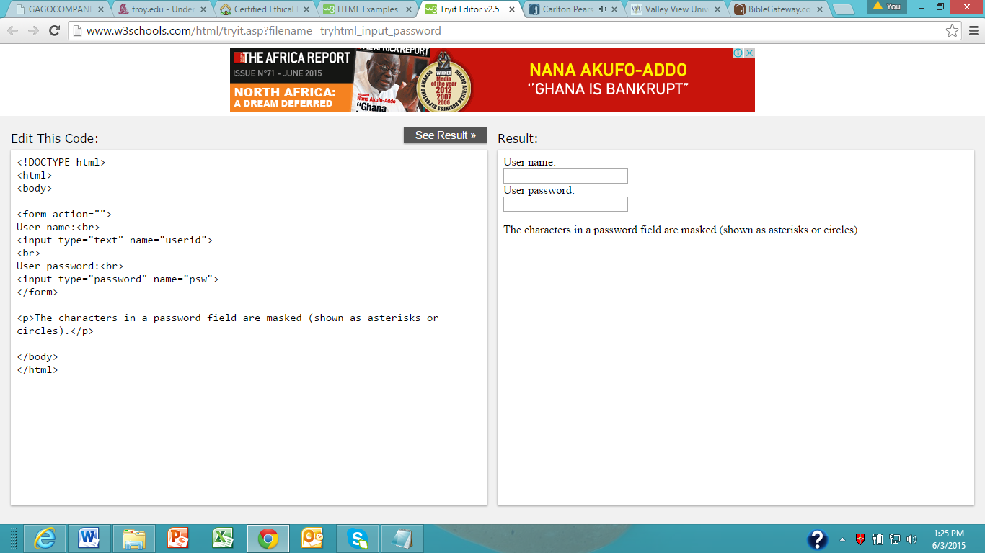

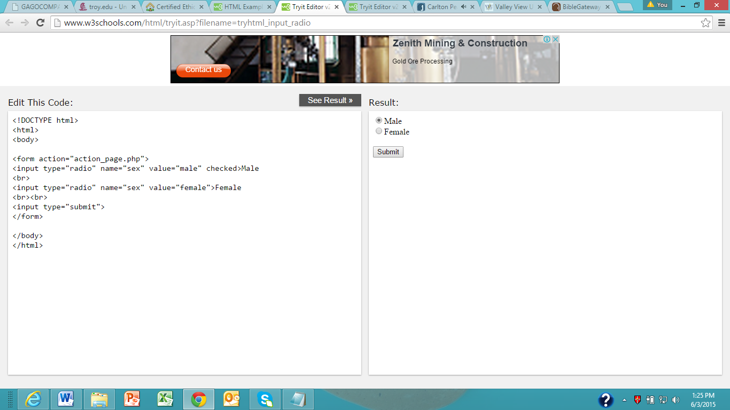

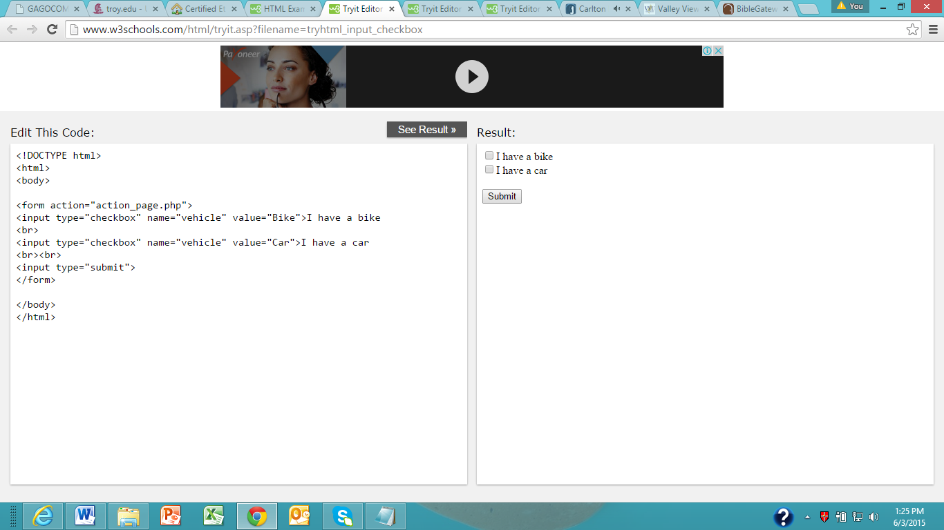

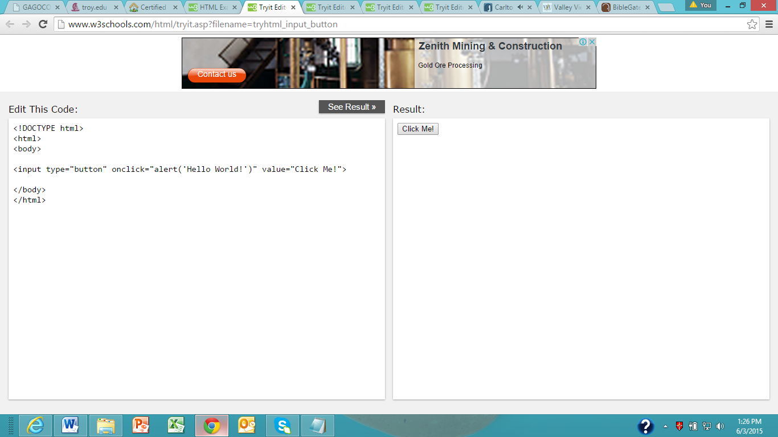

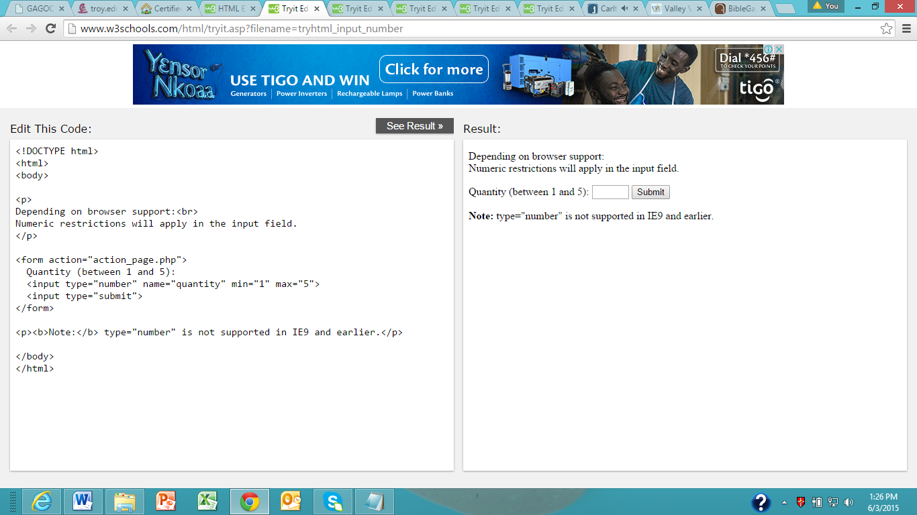

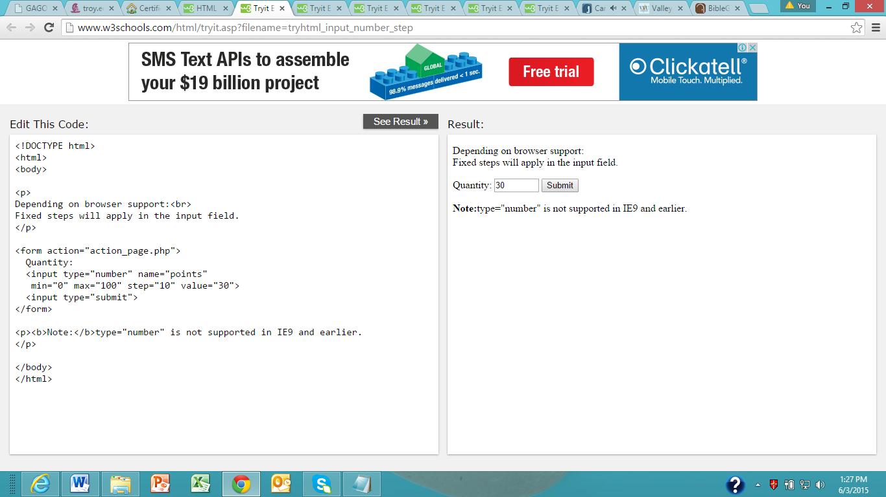

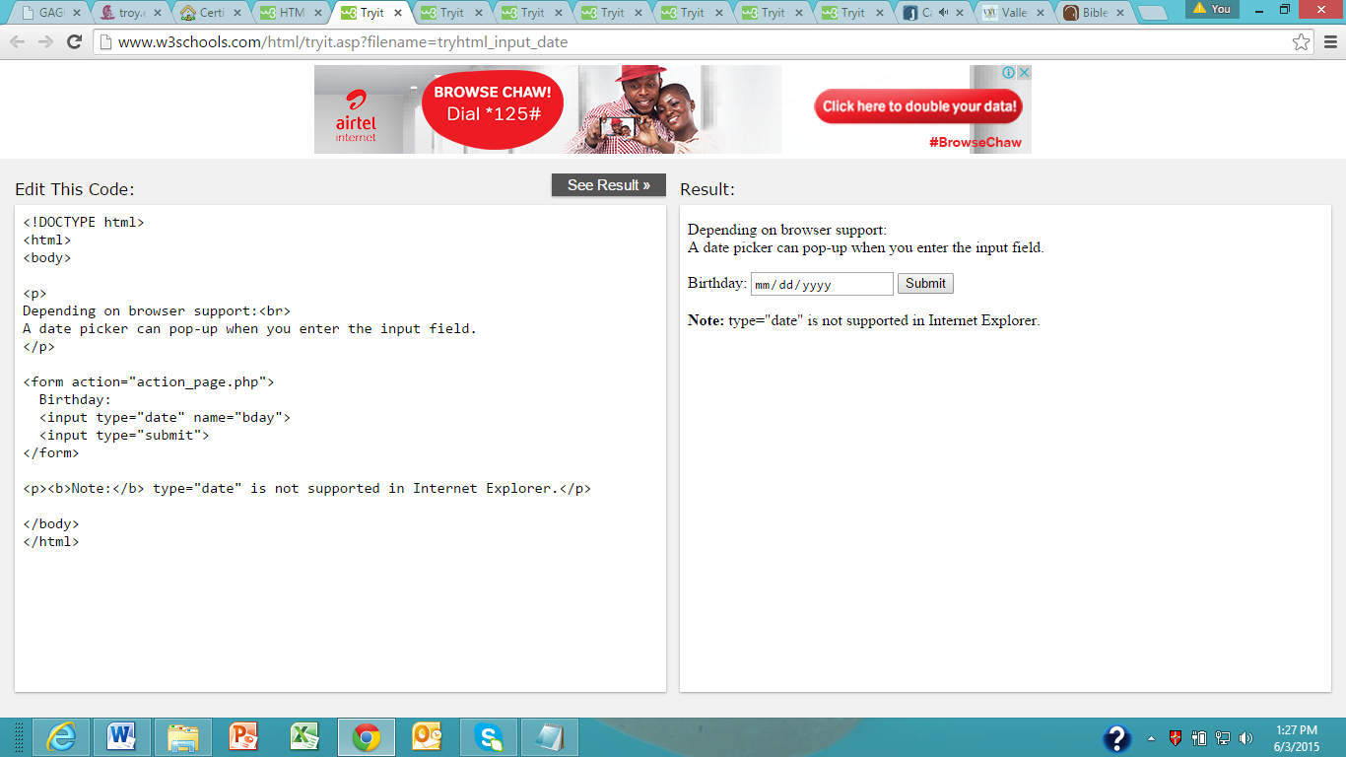

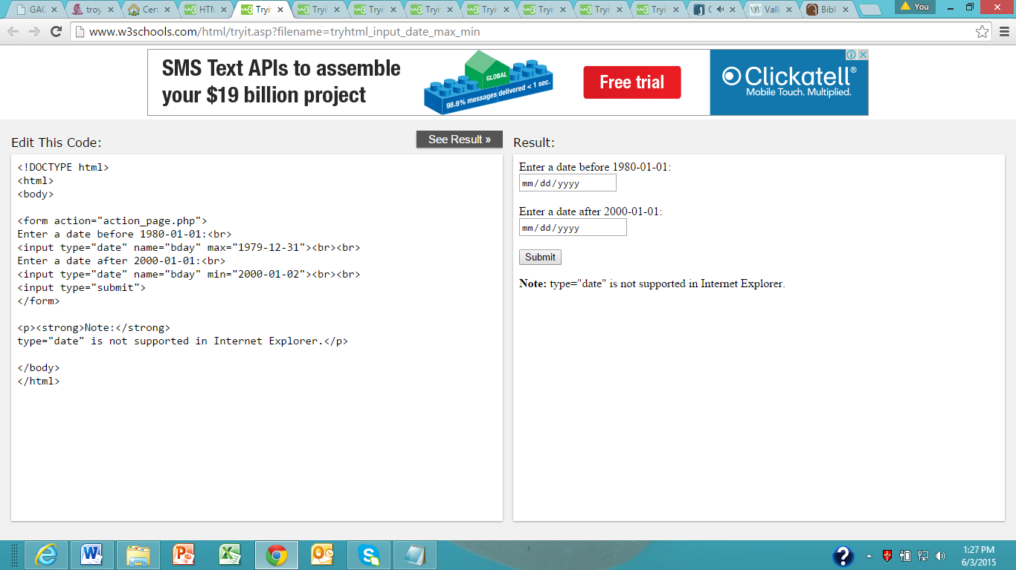

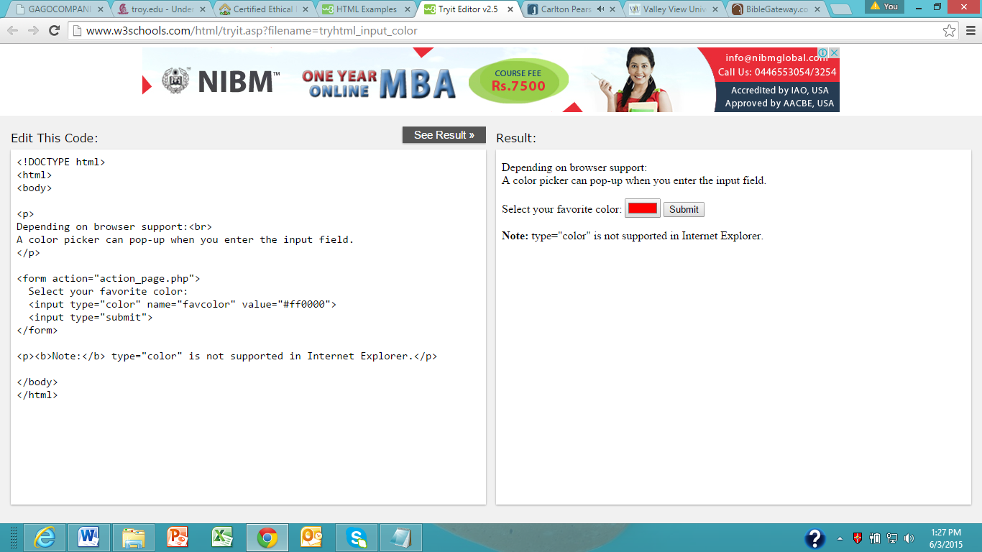

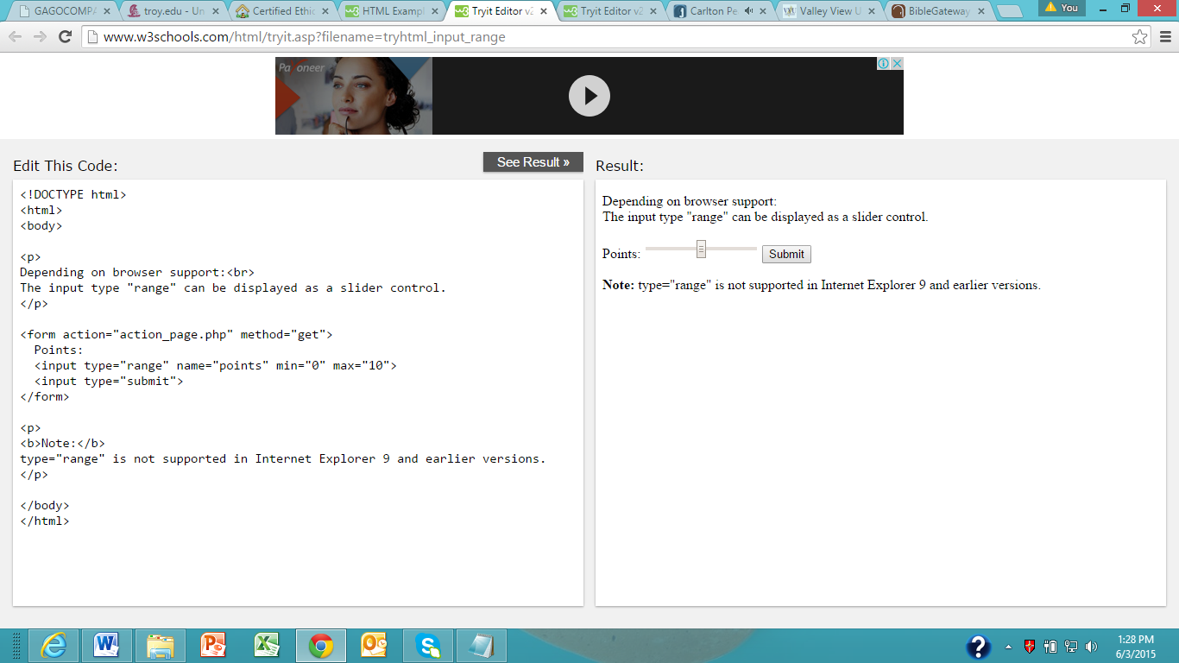

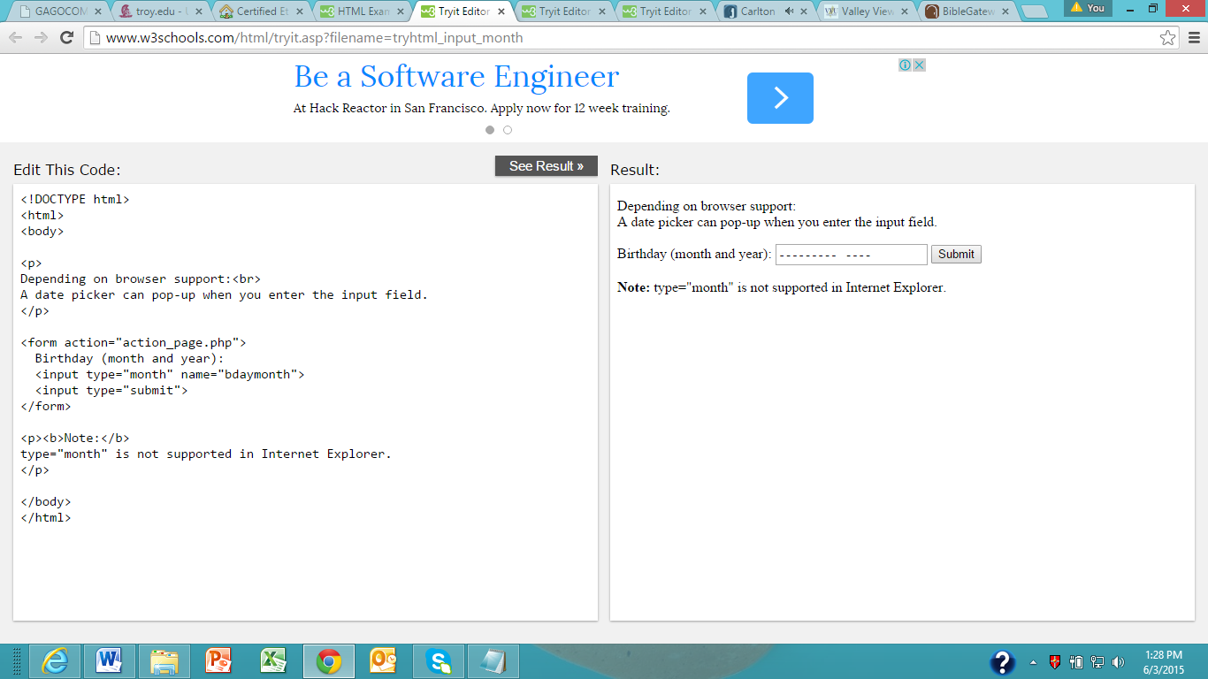

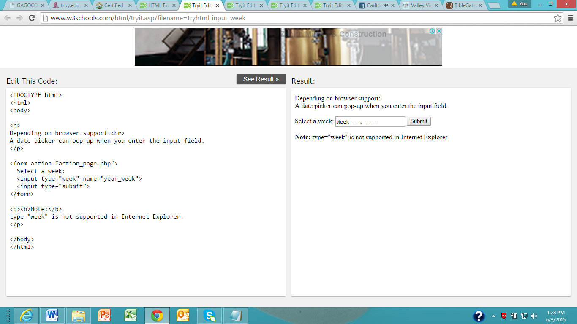

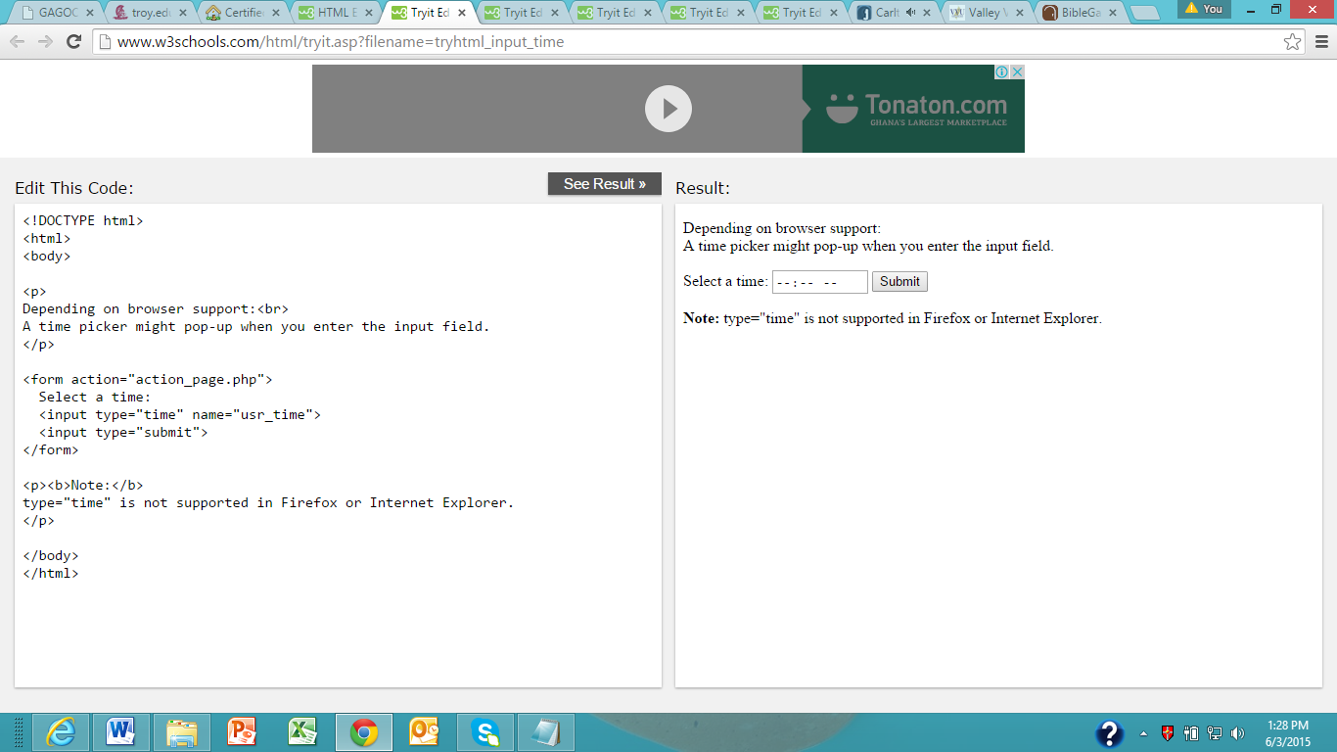

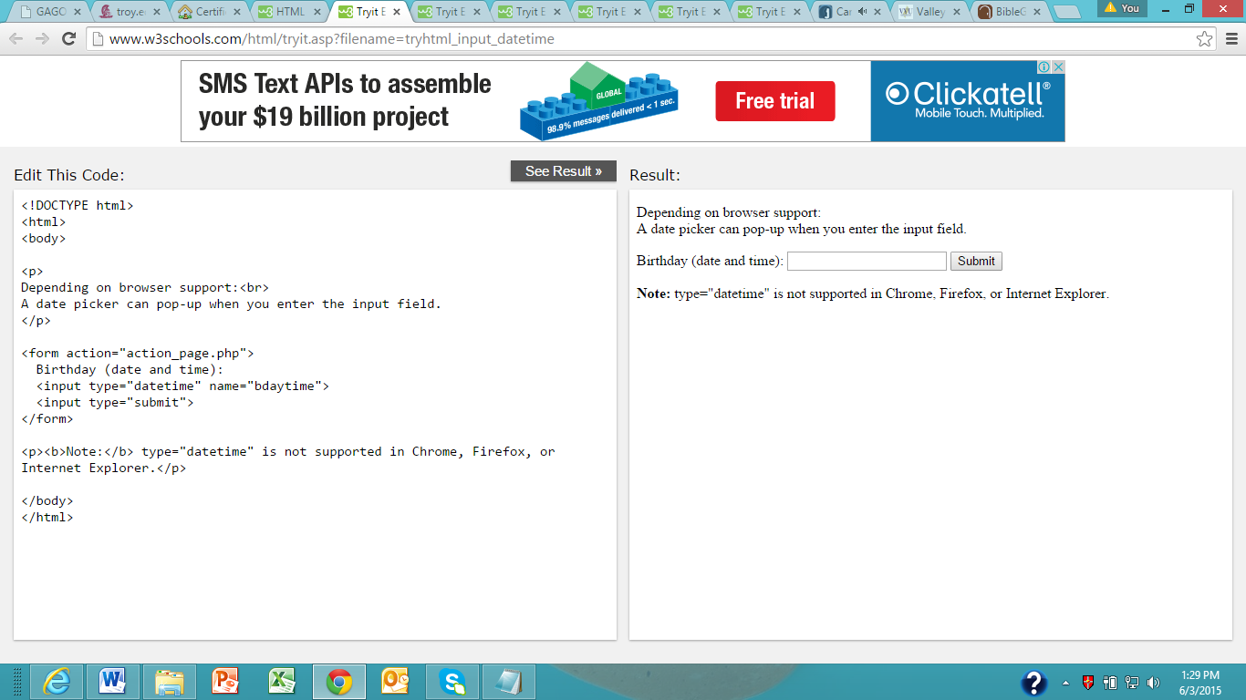

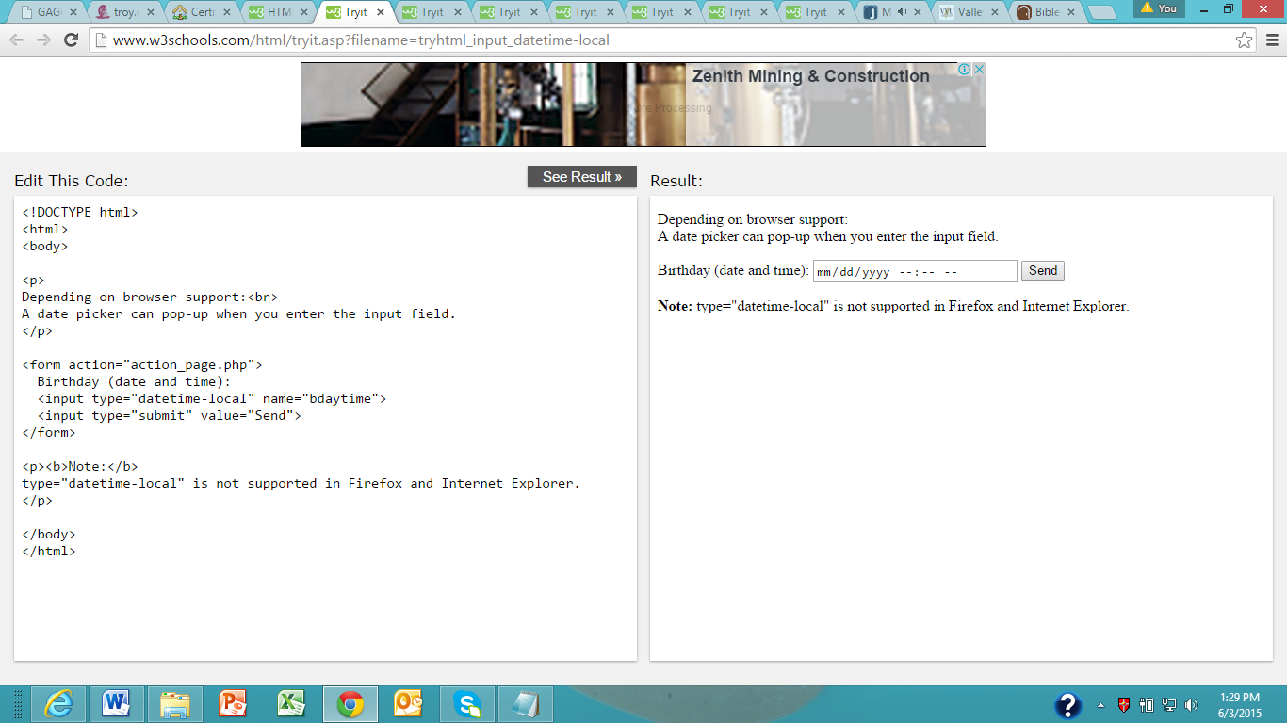

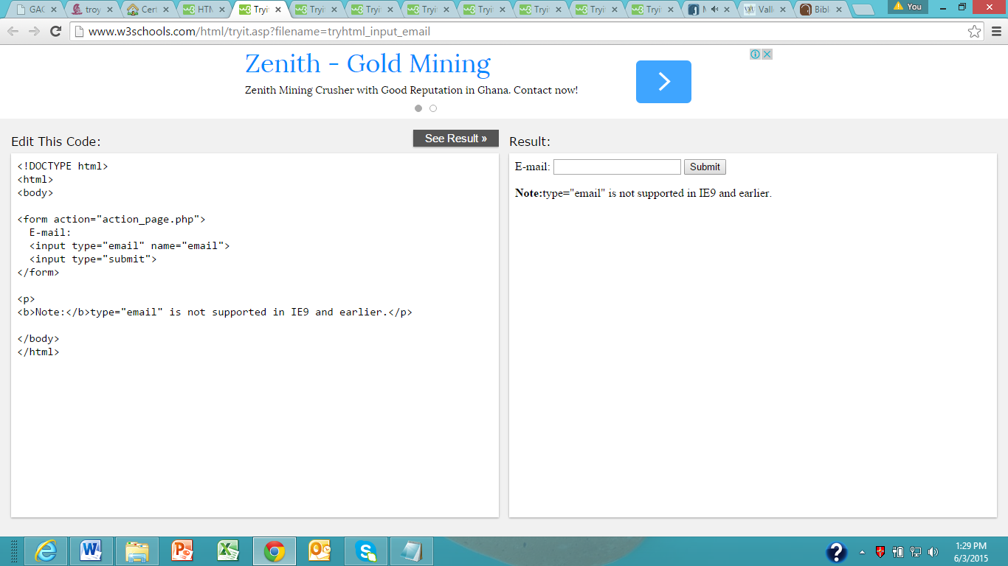

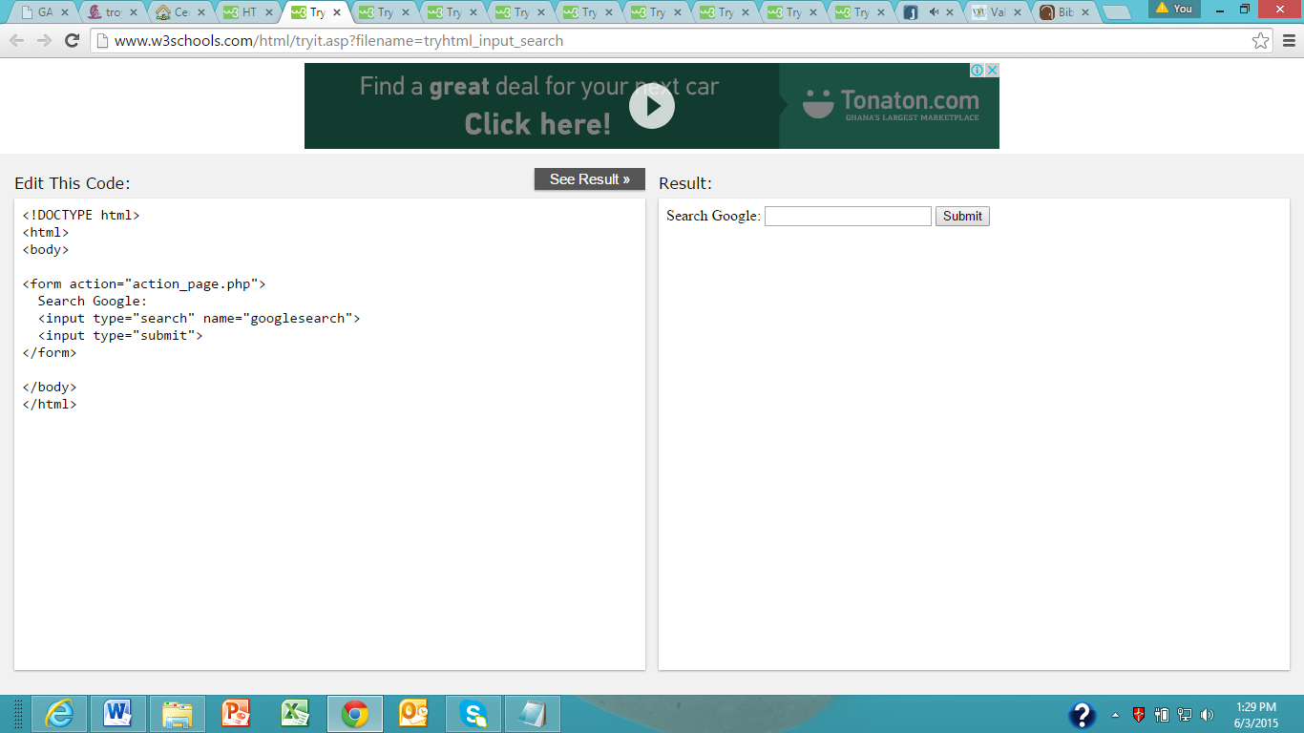

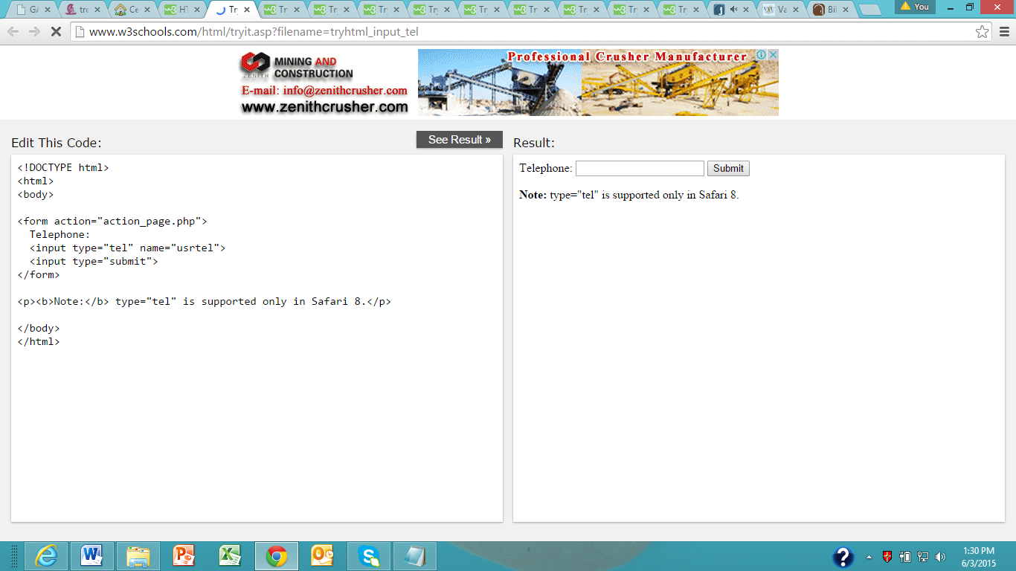

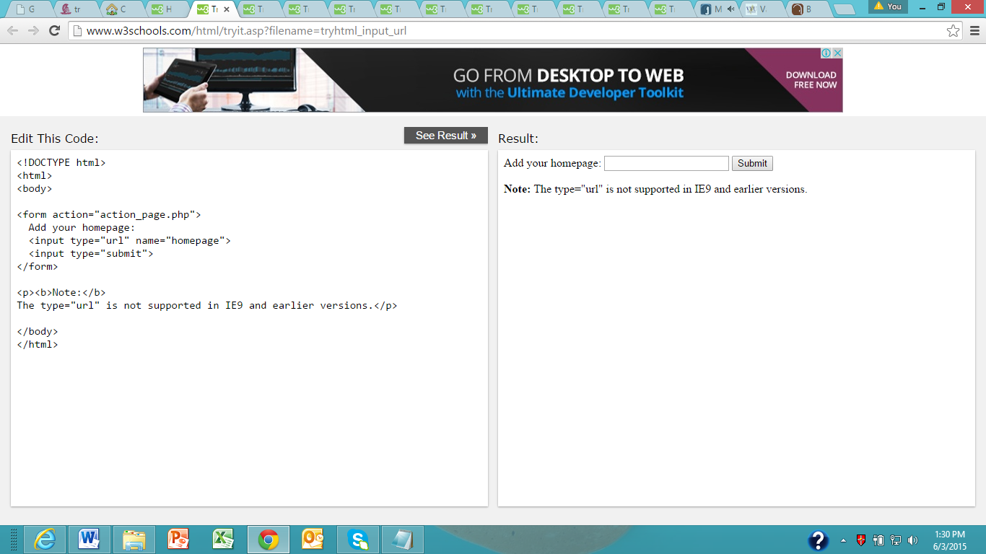

**HTML Input Attributes**

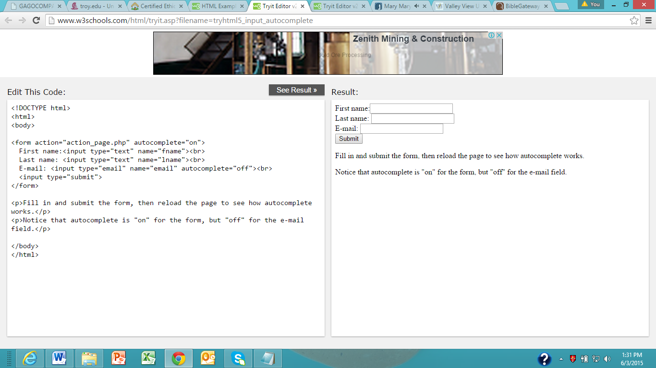

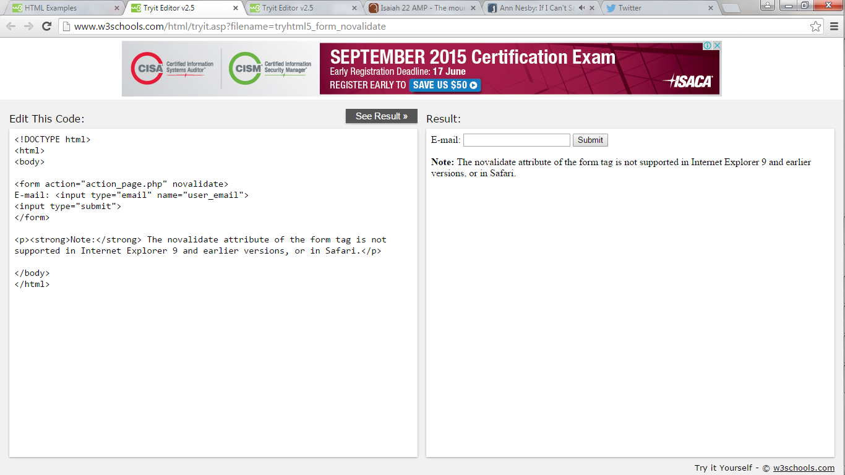

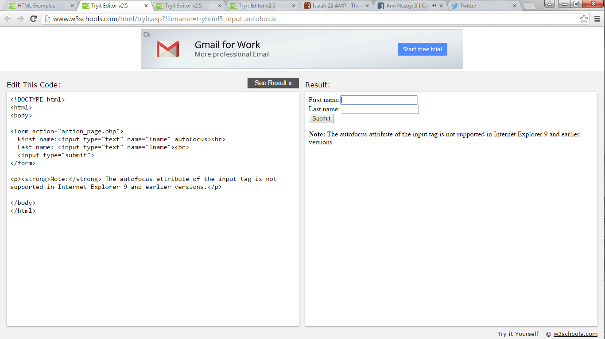

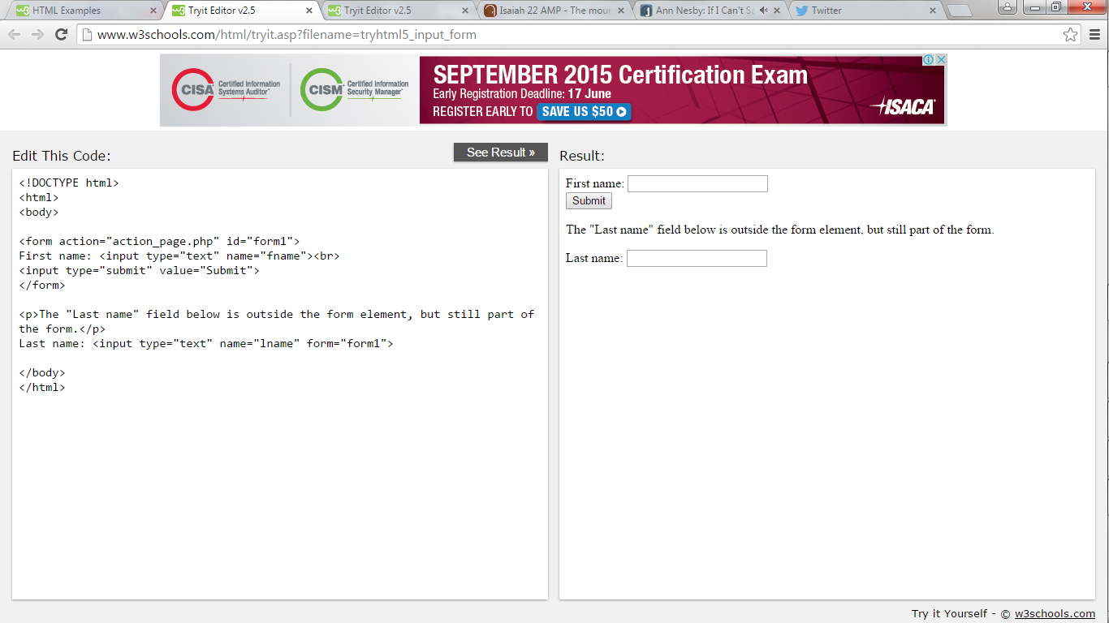

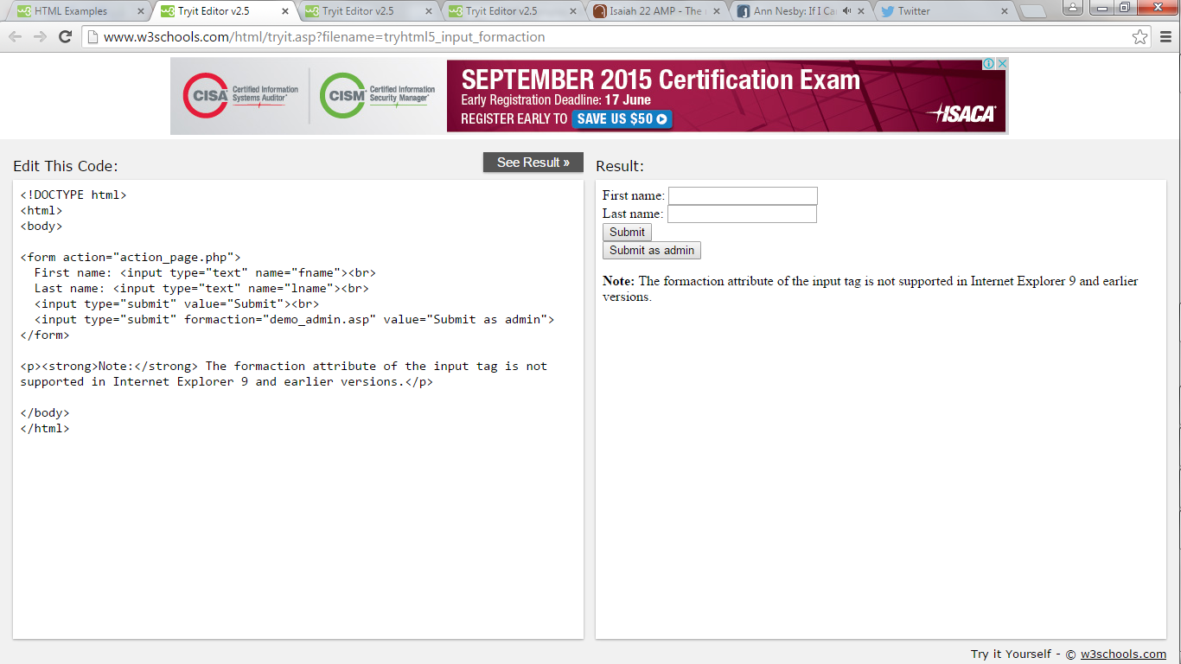

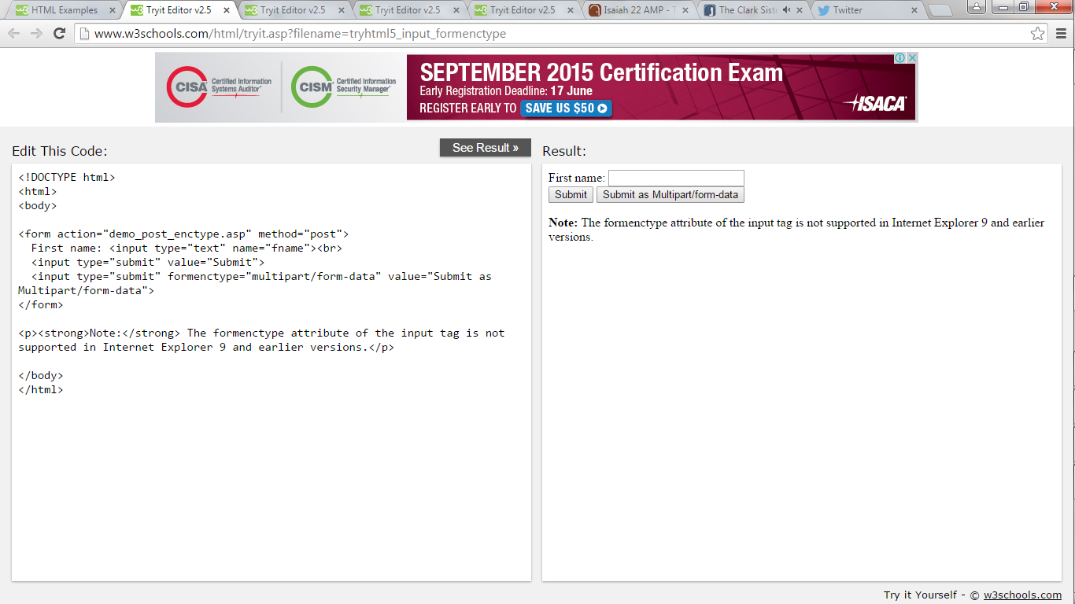

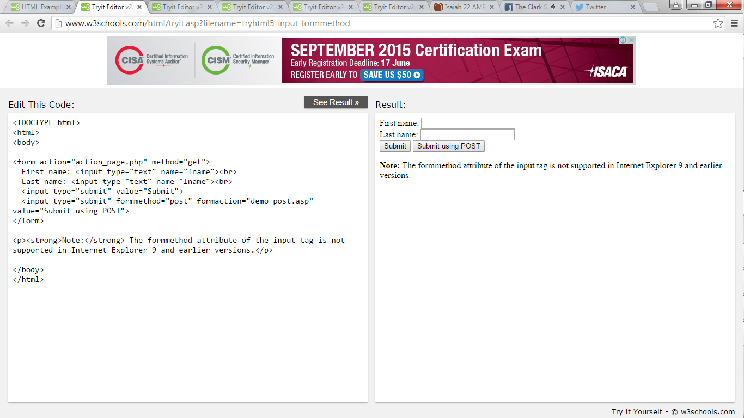

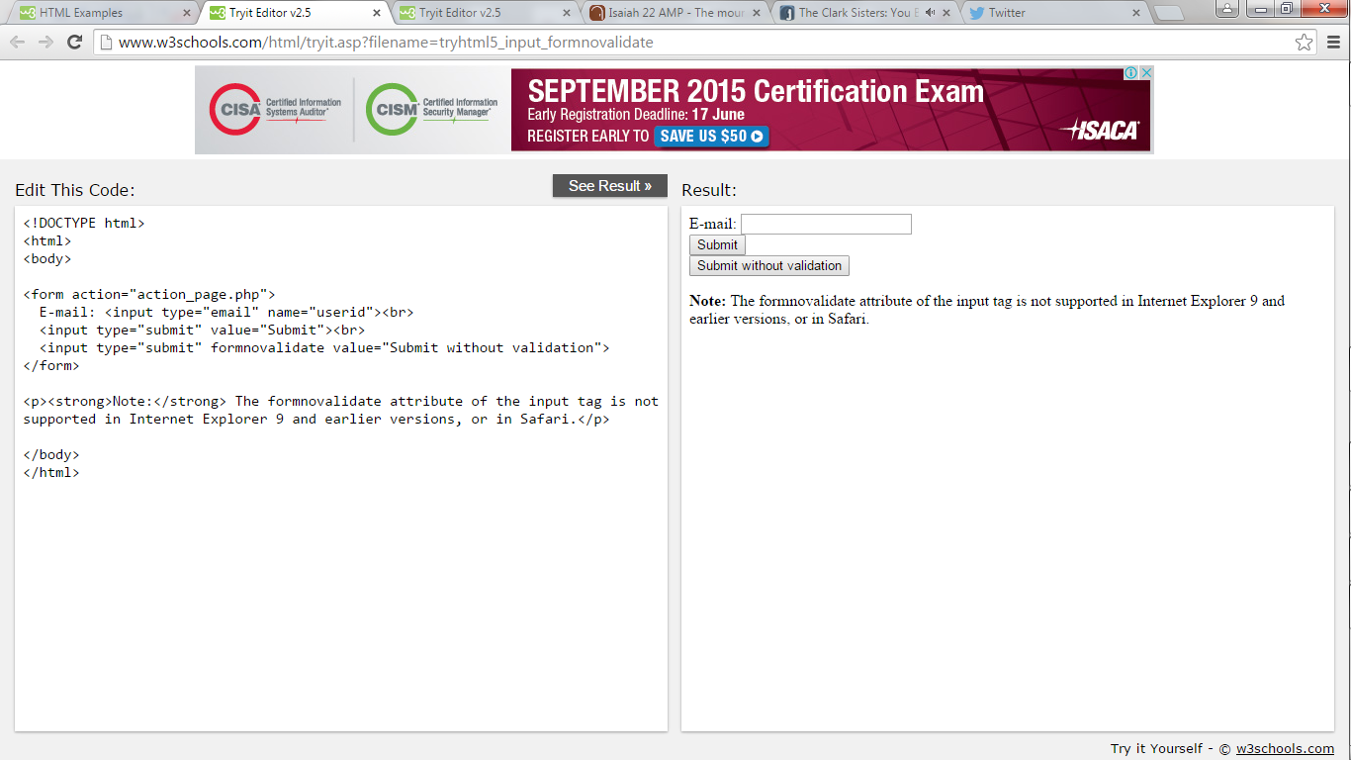

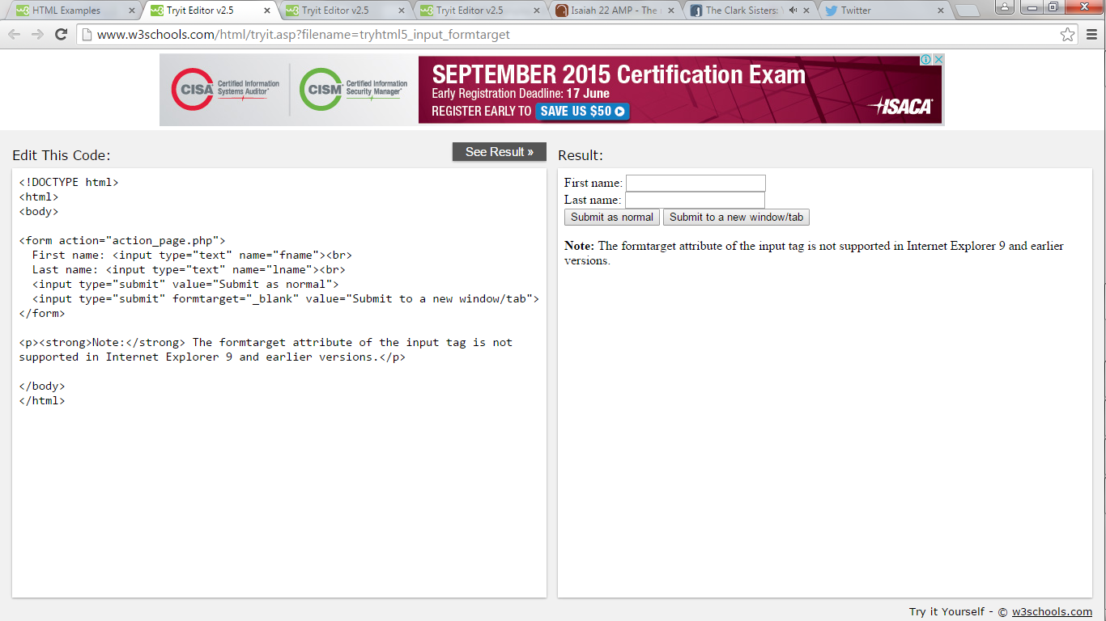

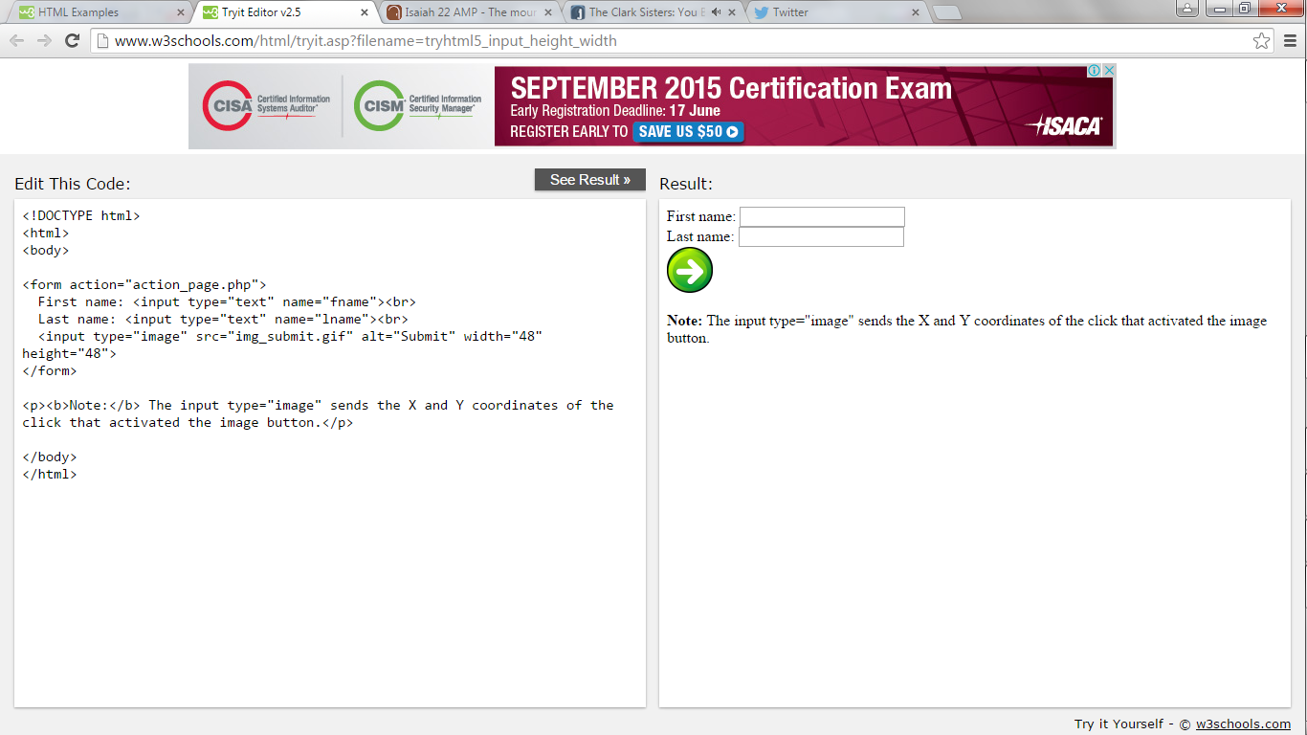

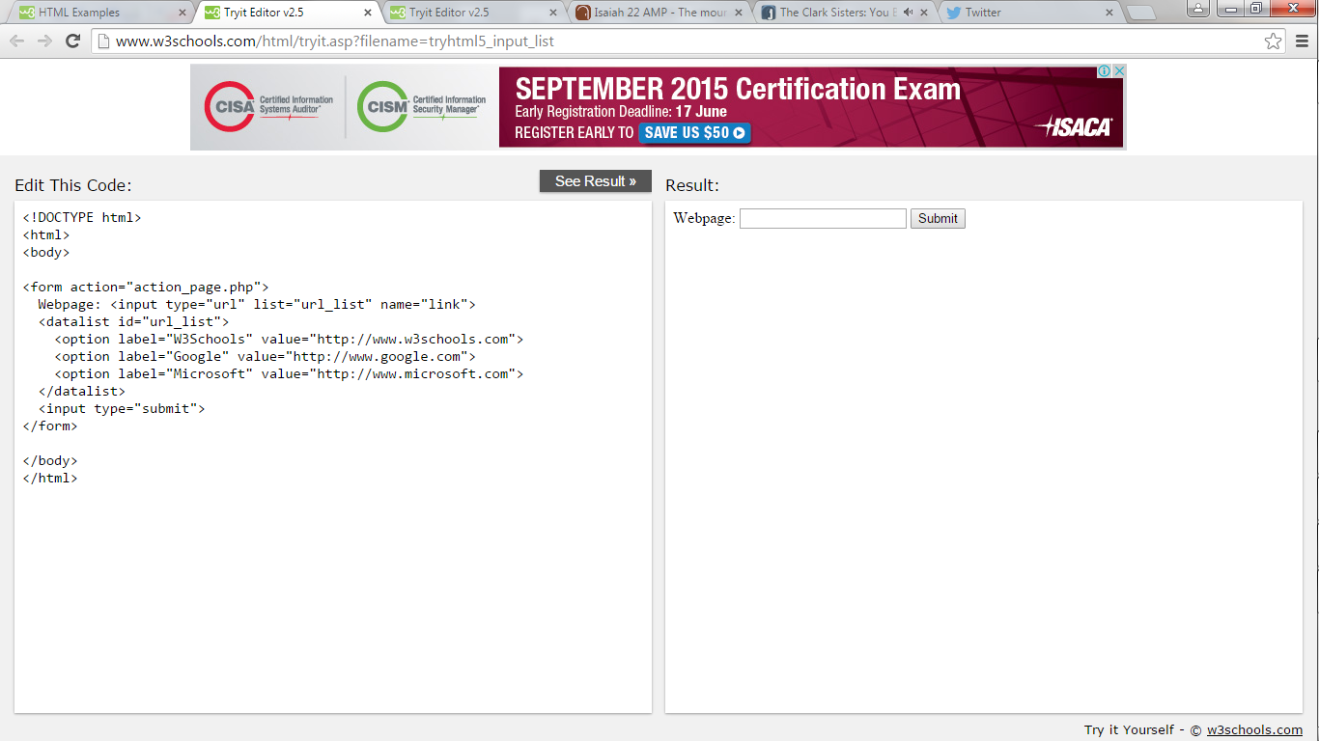

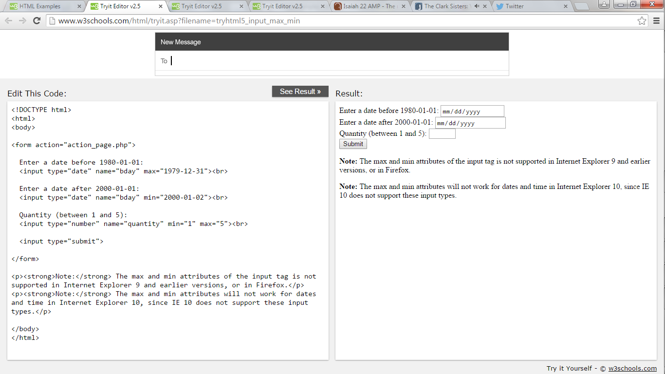

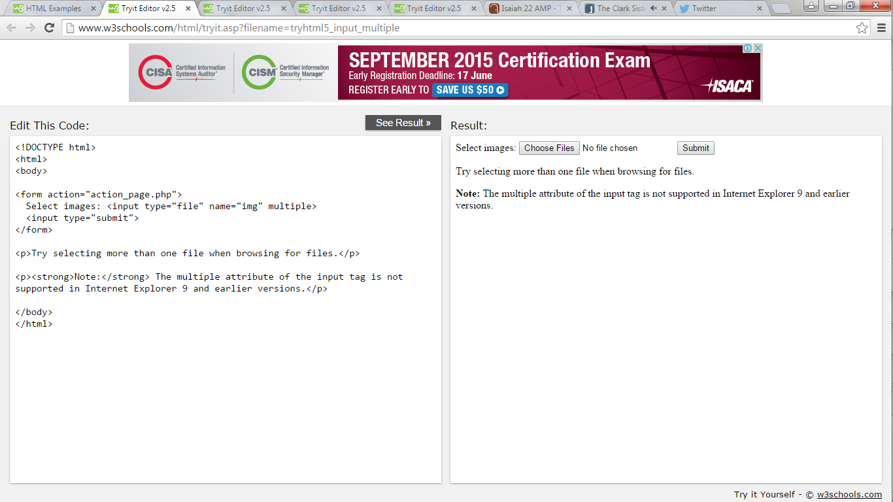

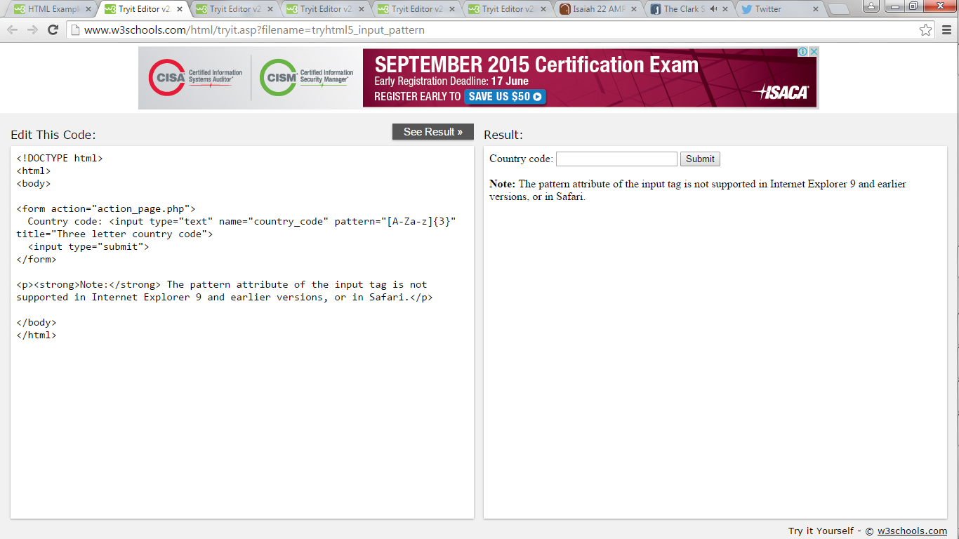

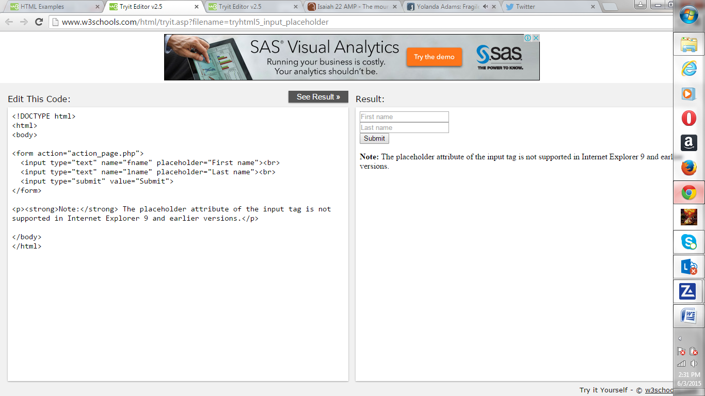

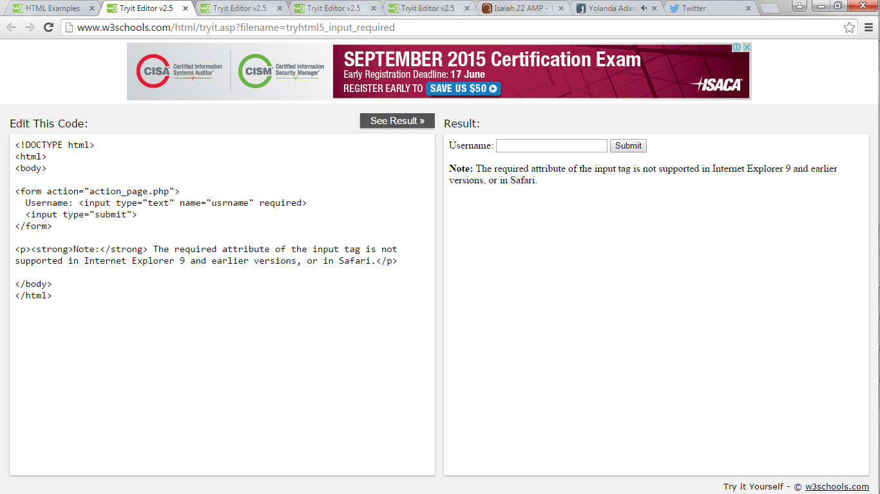

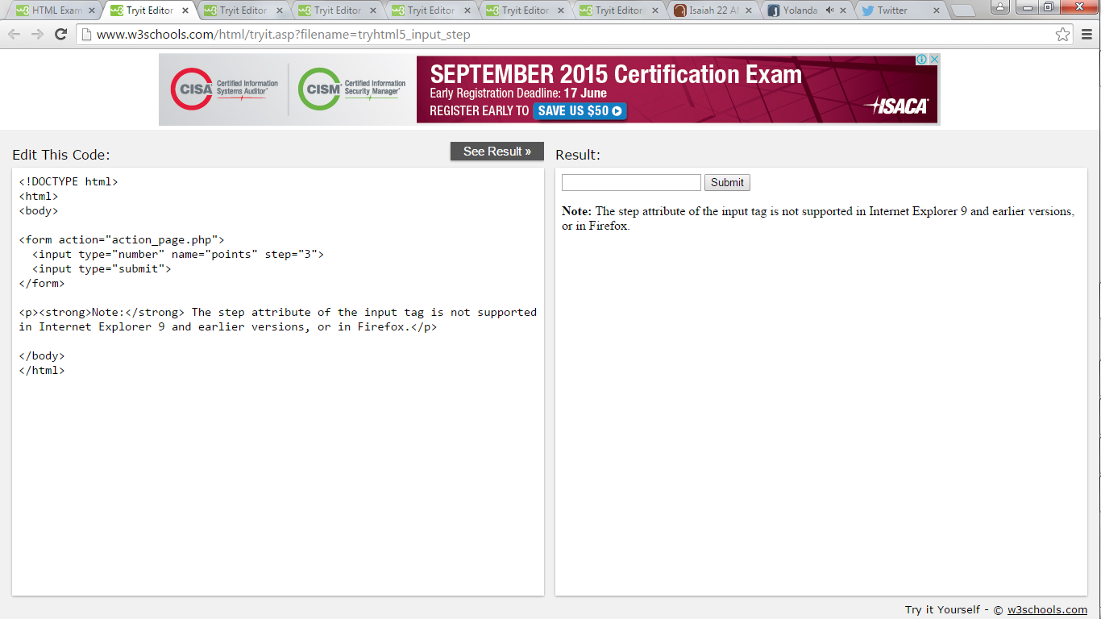

**HTML5 Canvas**

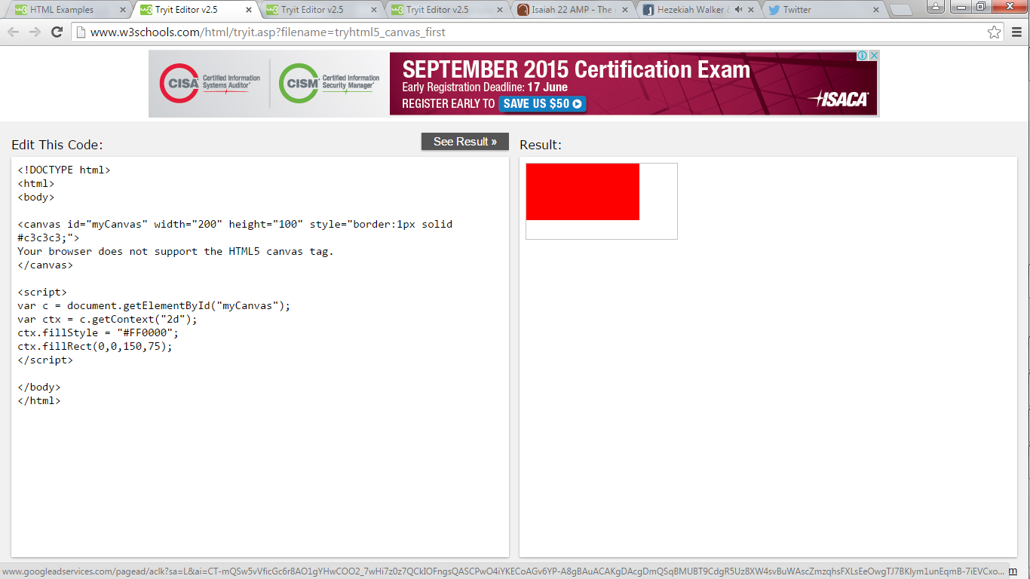

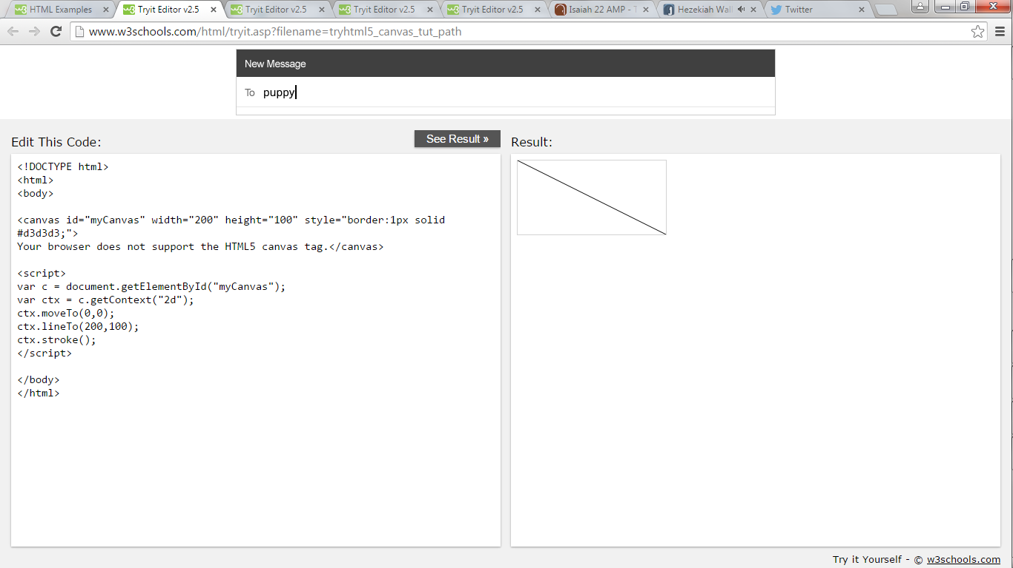

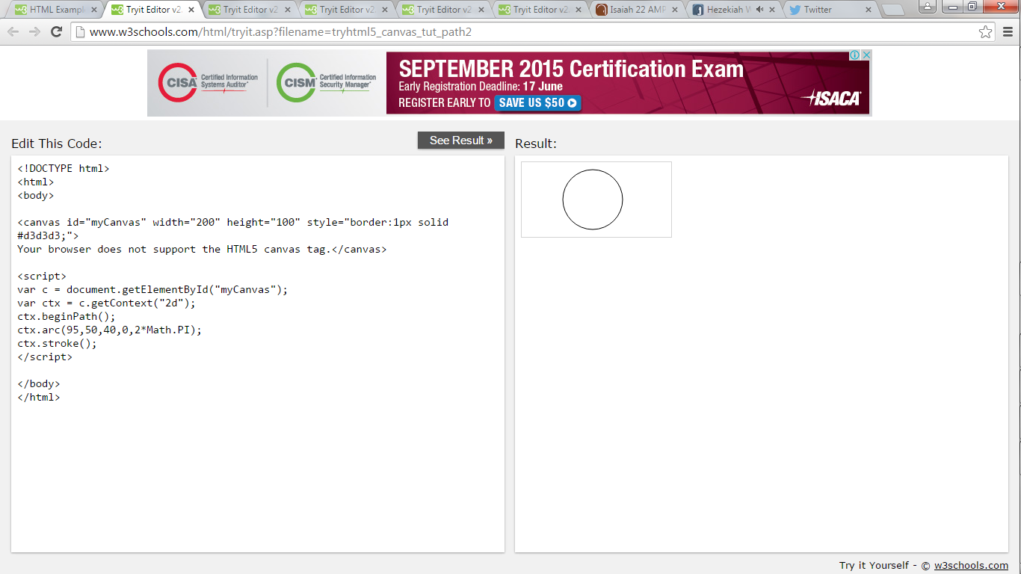

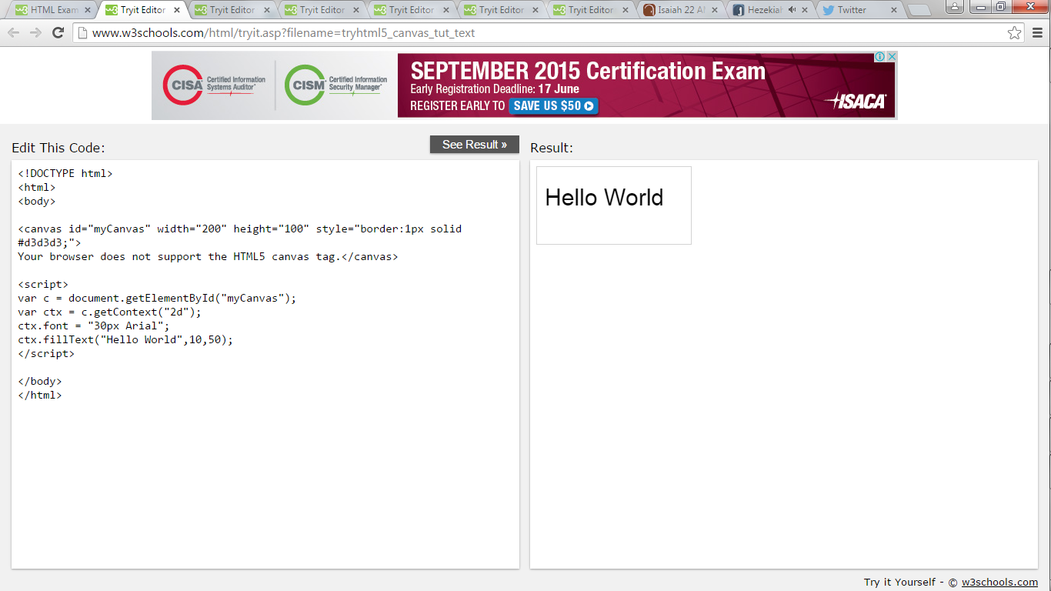

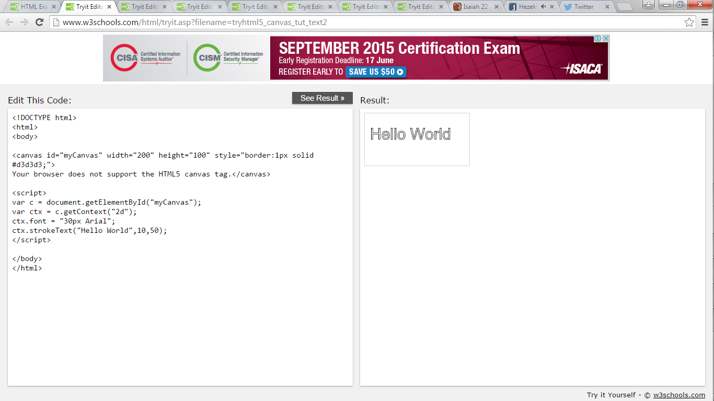

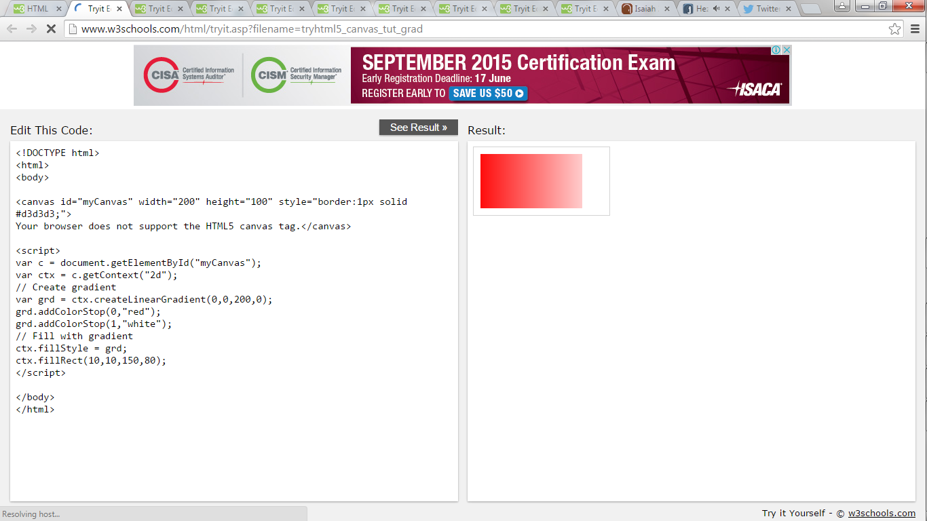

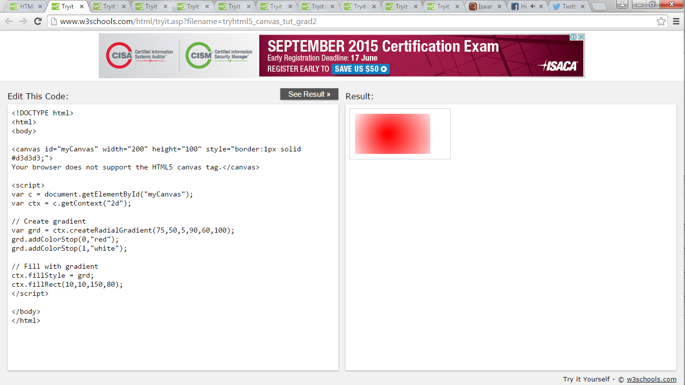

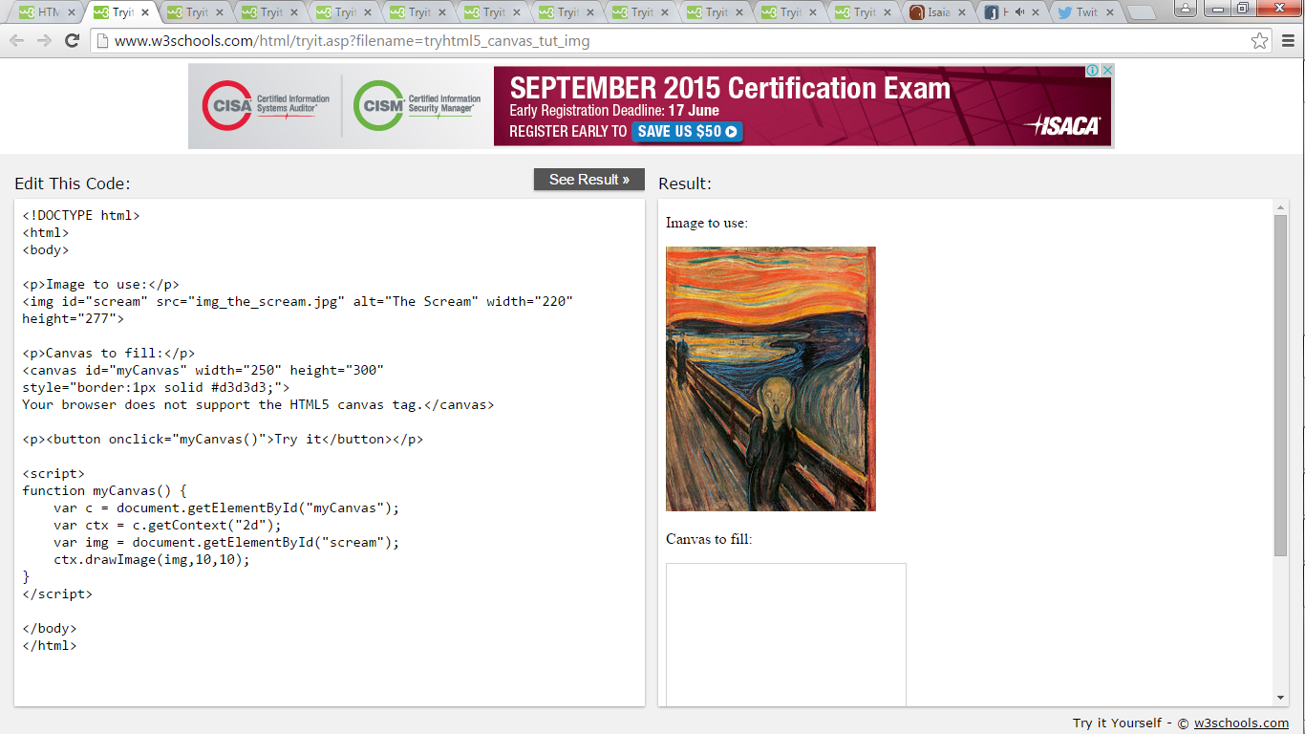

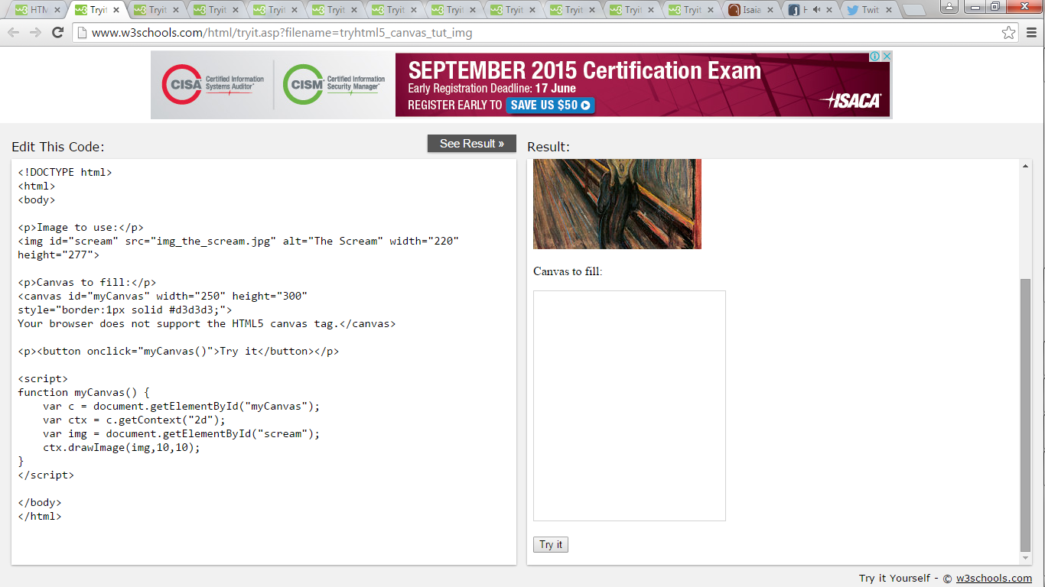

**HTML5 SVG**

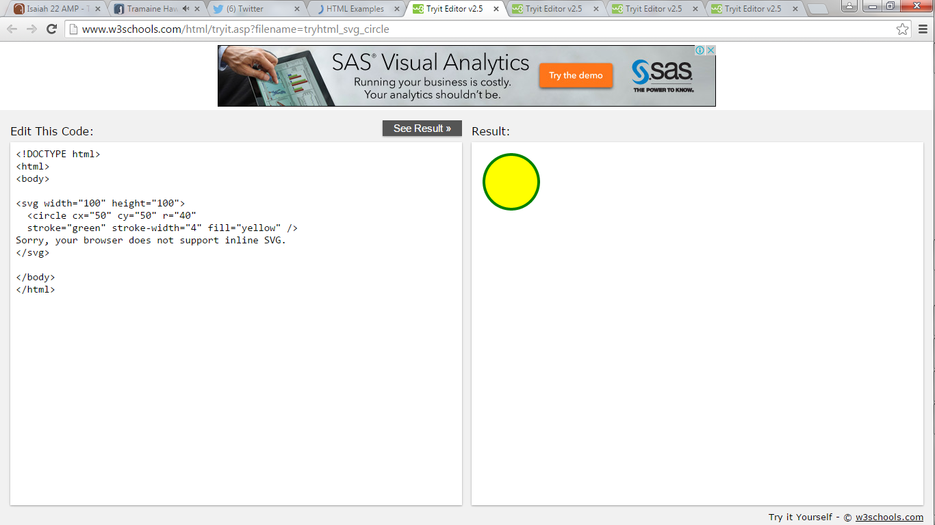

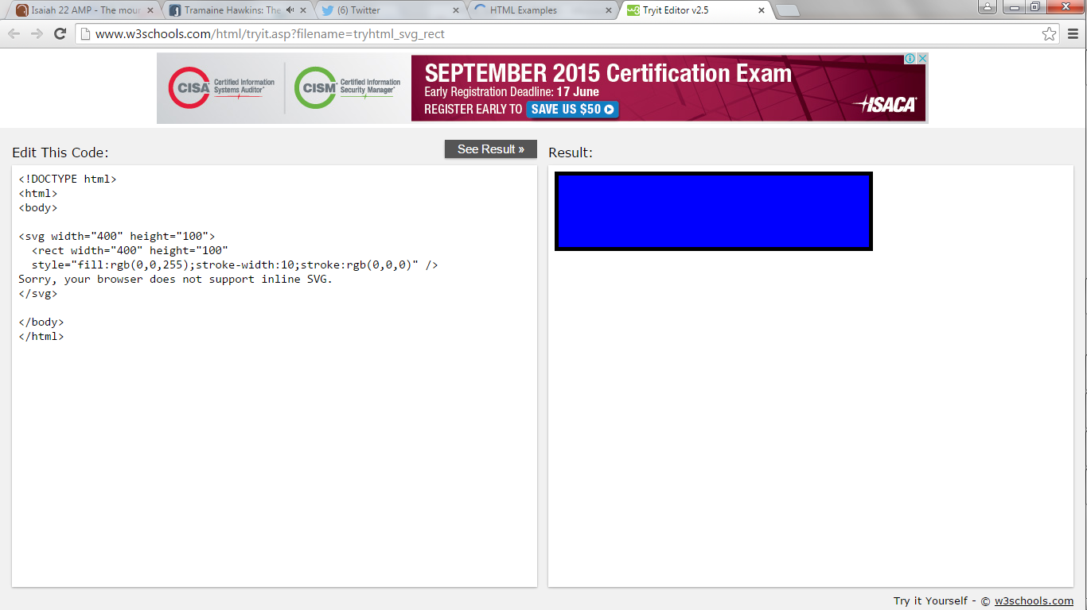

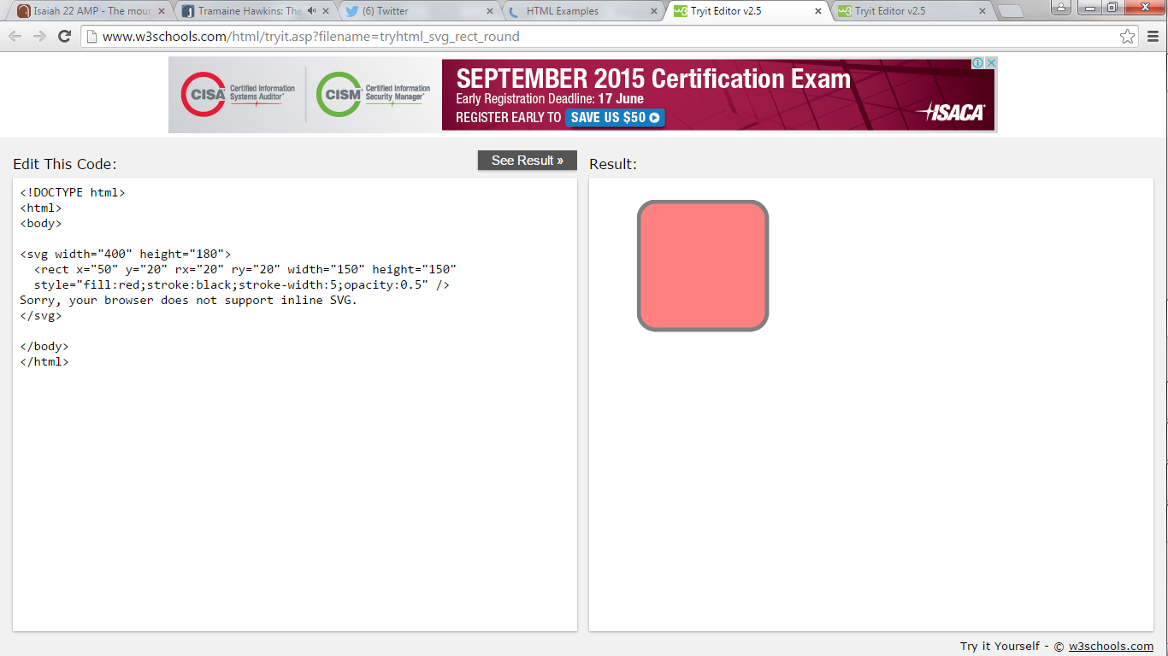

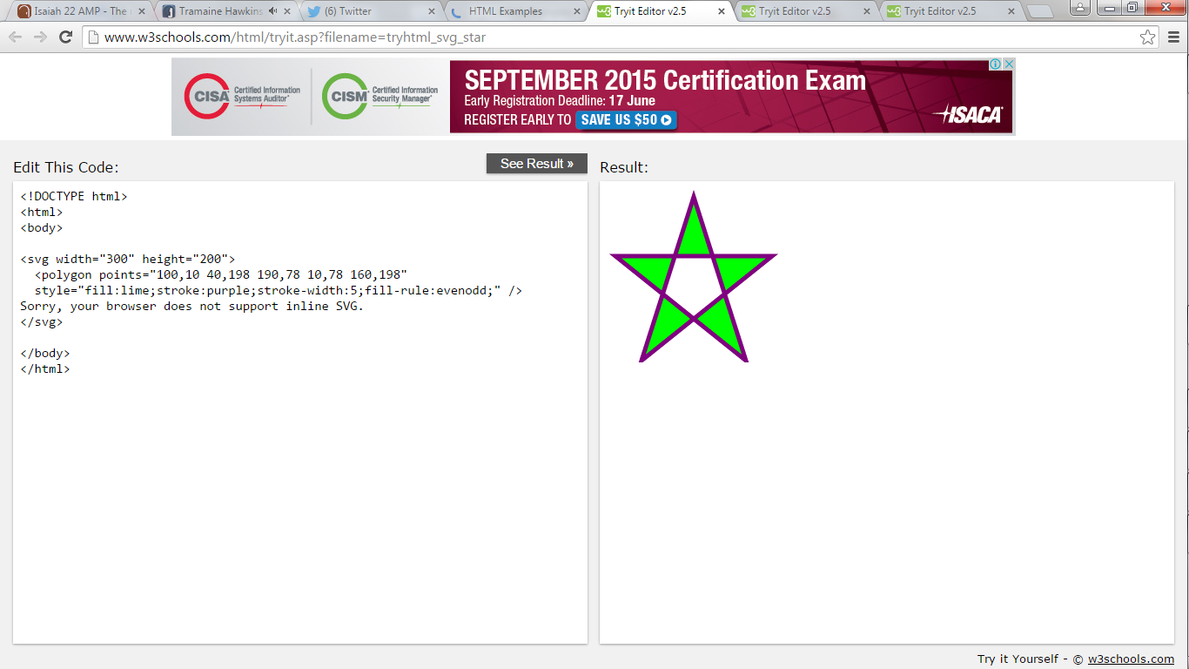

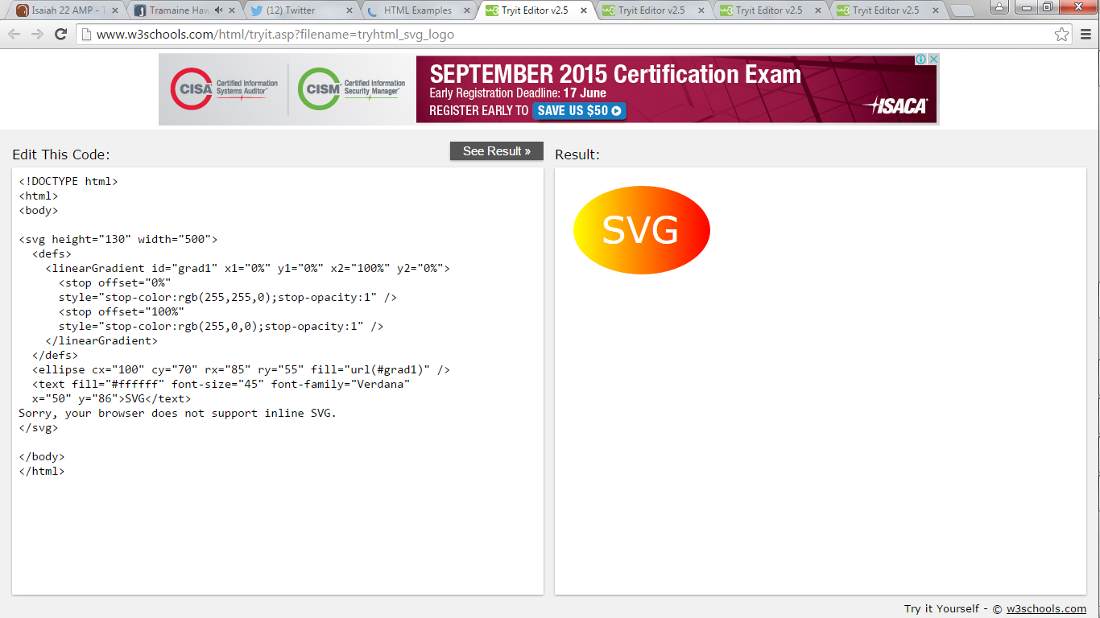

**HTML5 Media**

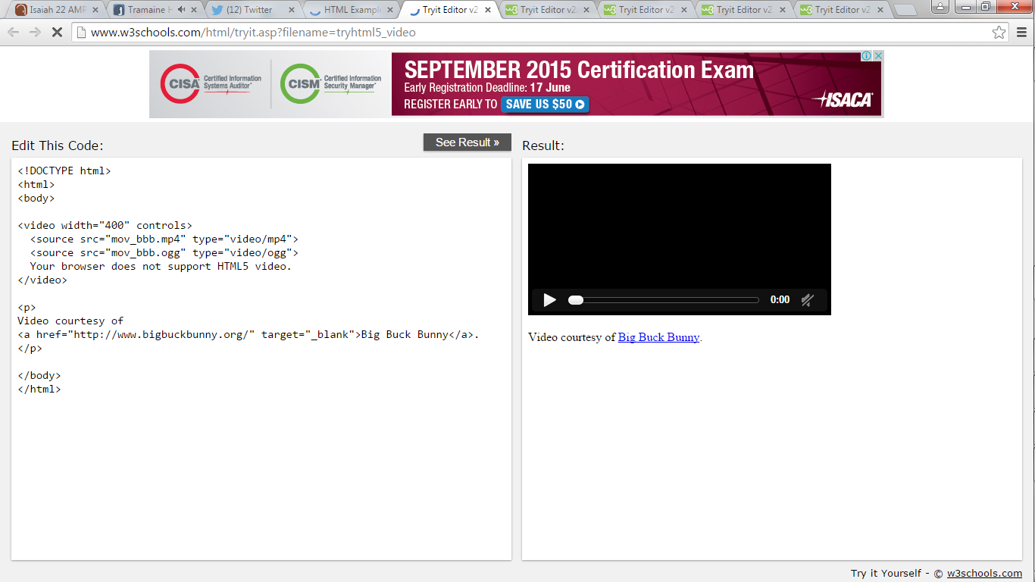

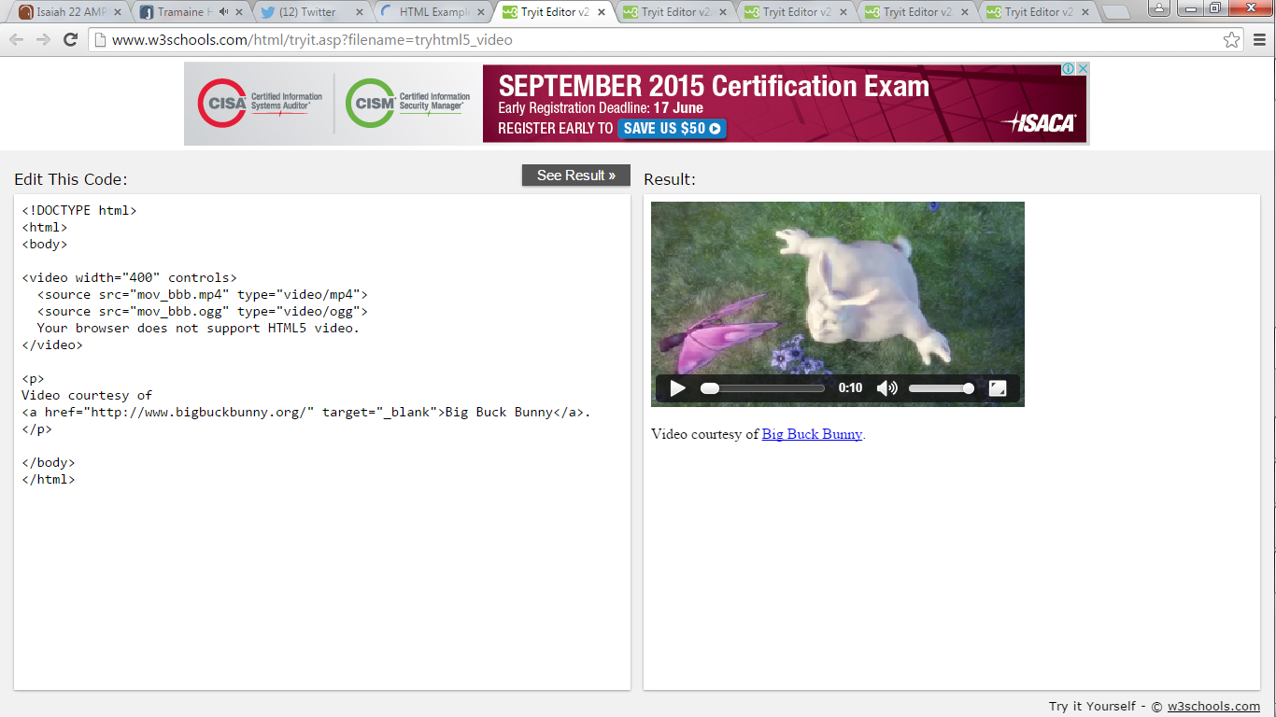

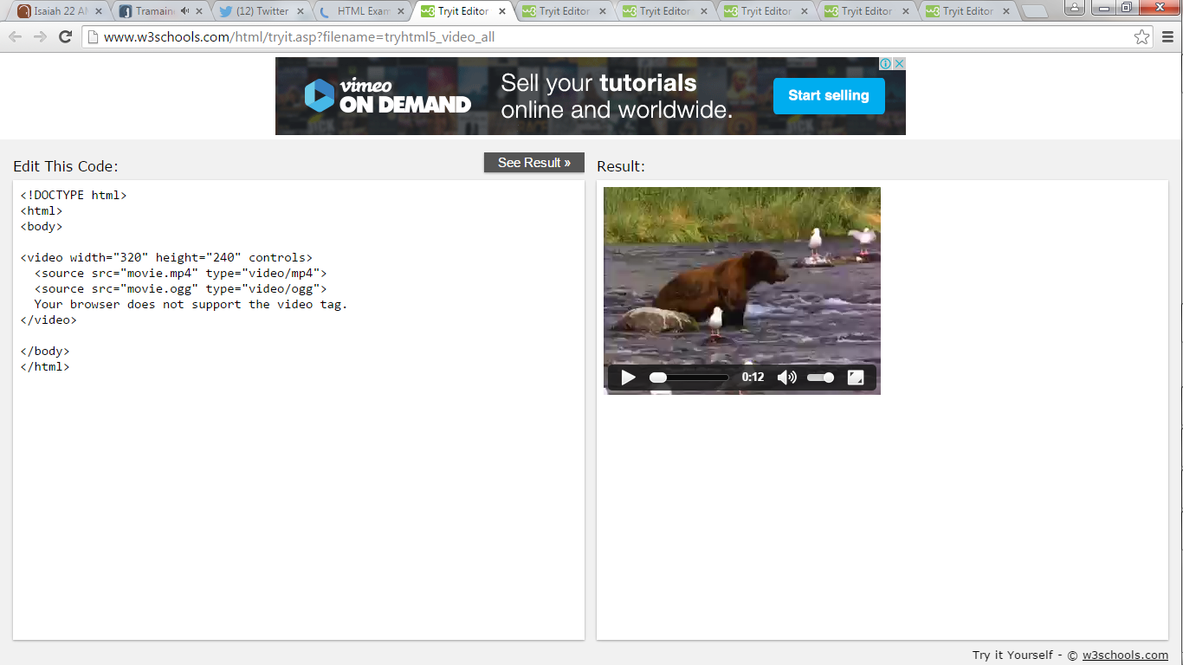

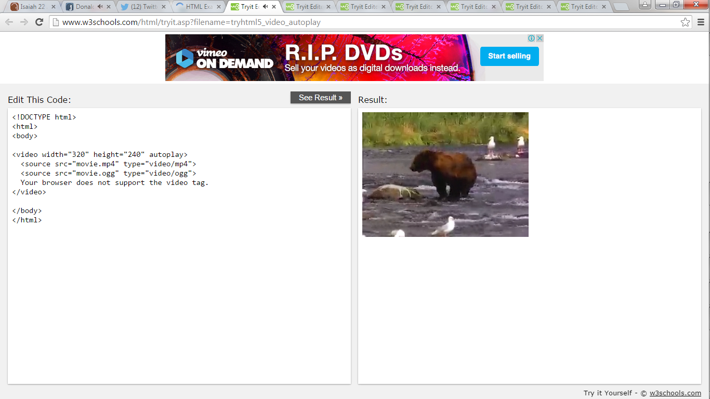

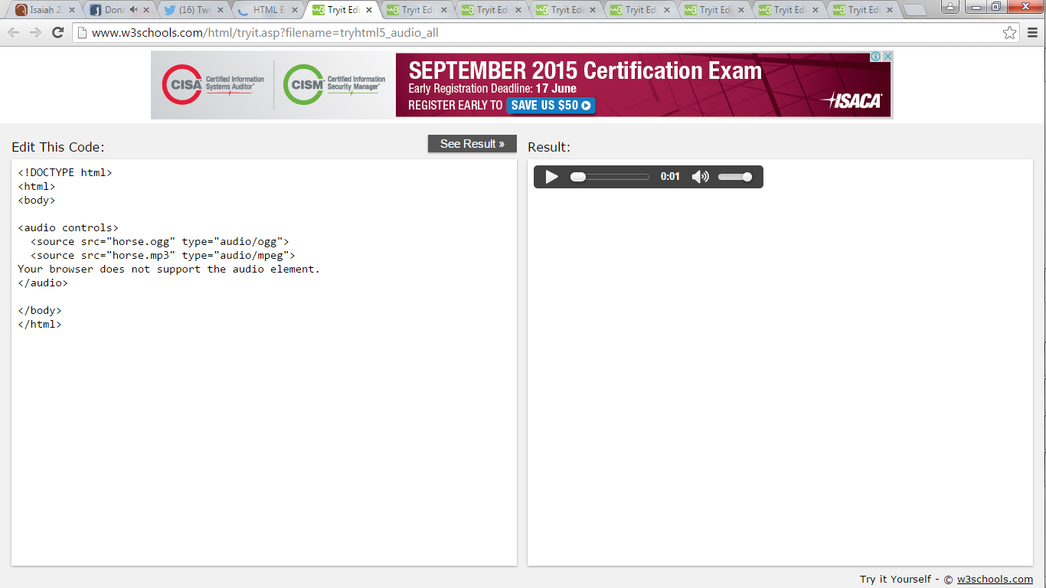

**HTML5 Geolocation**

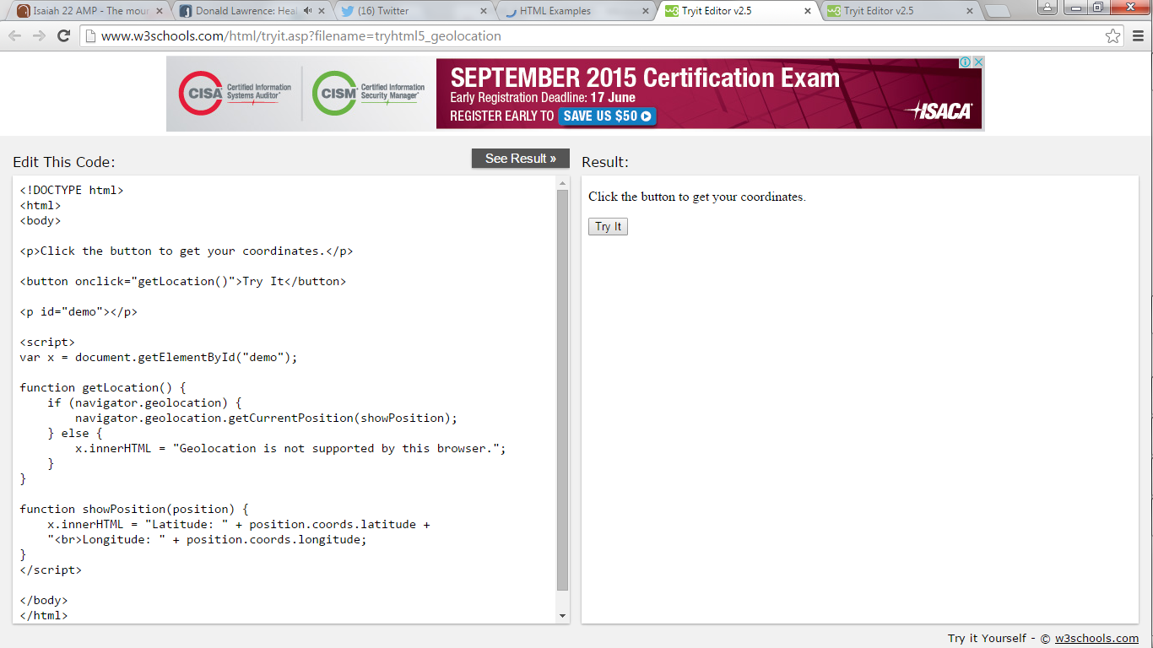

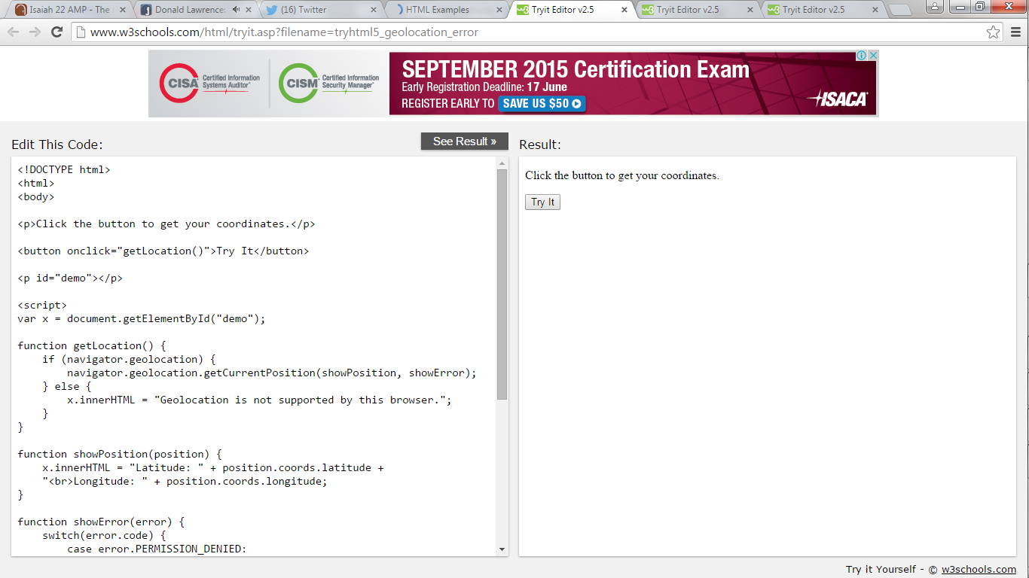

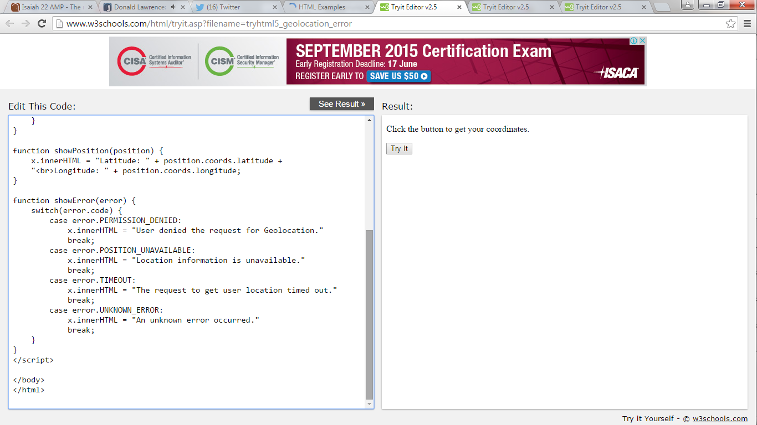

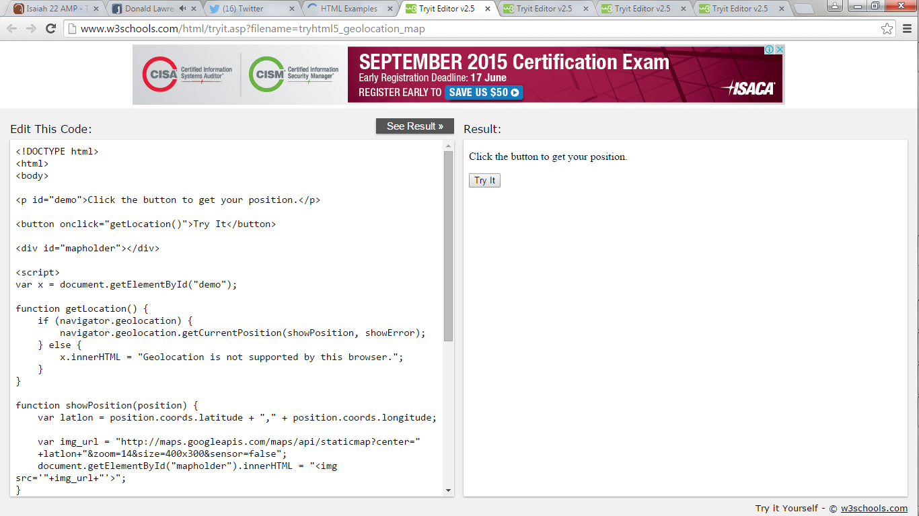

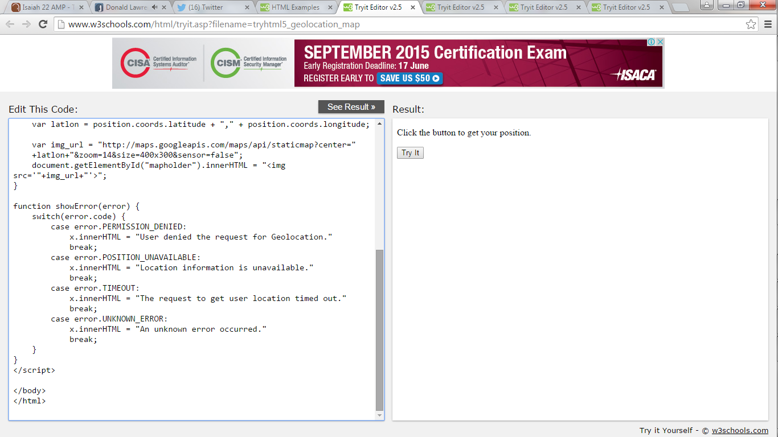

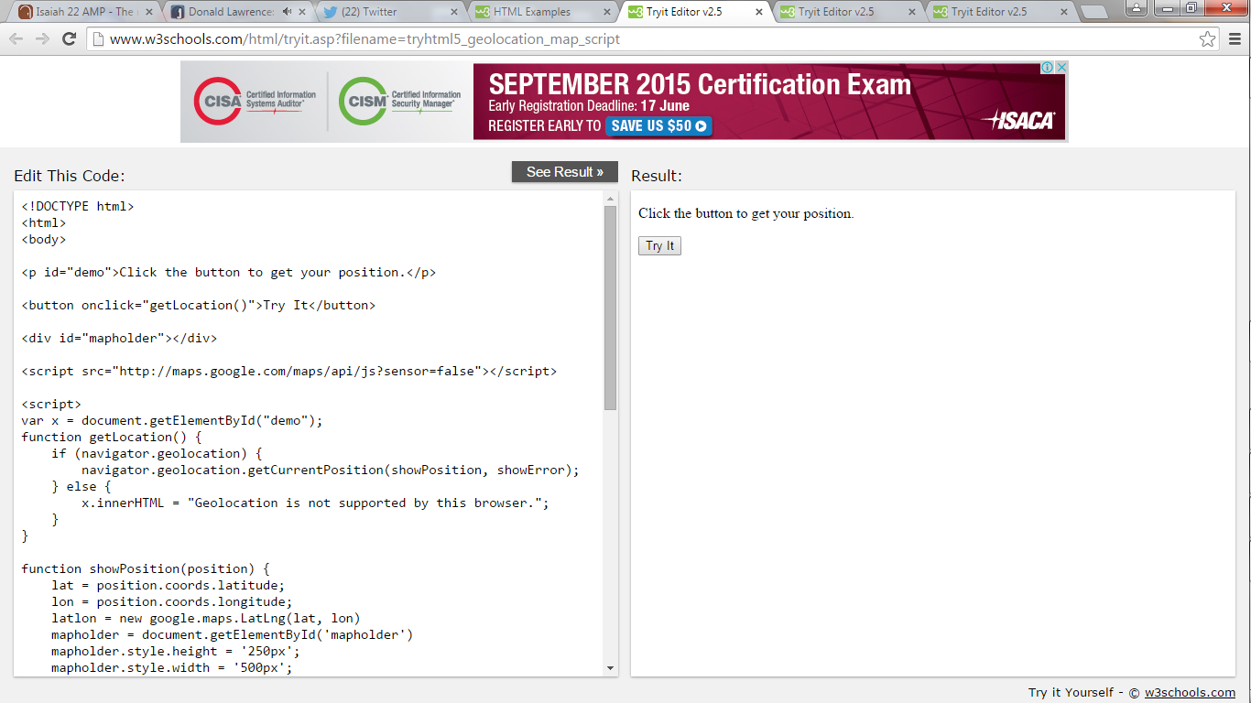

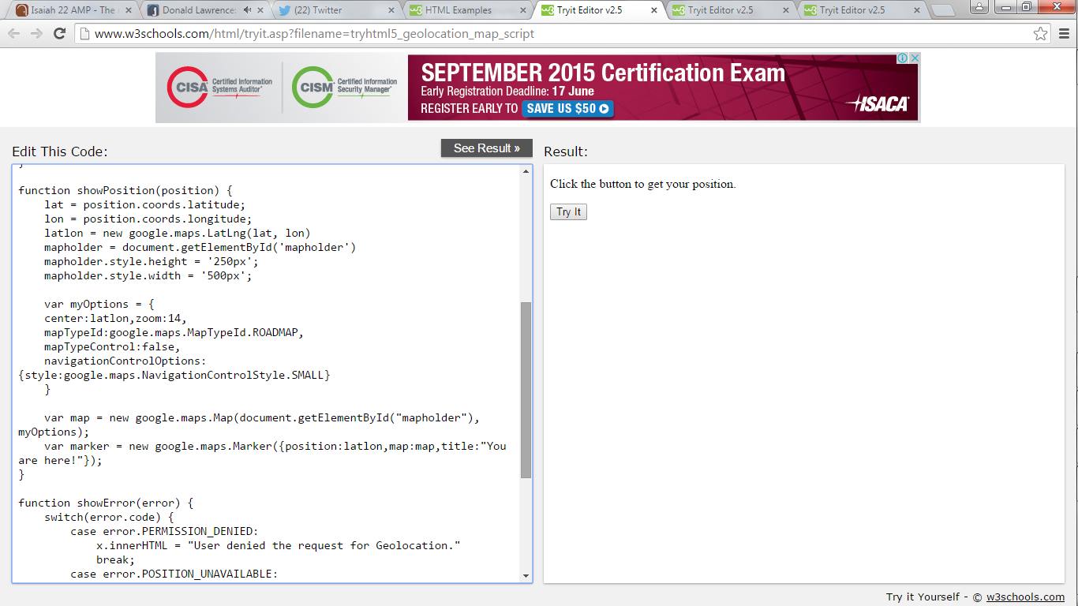

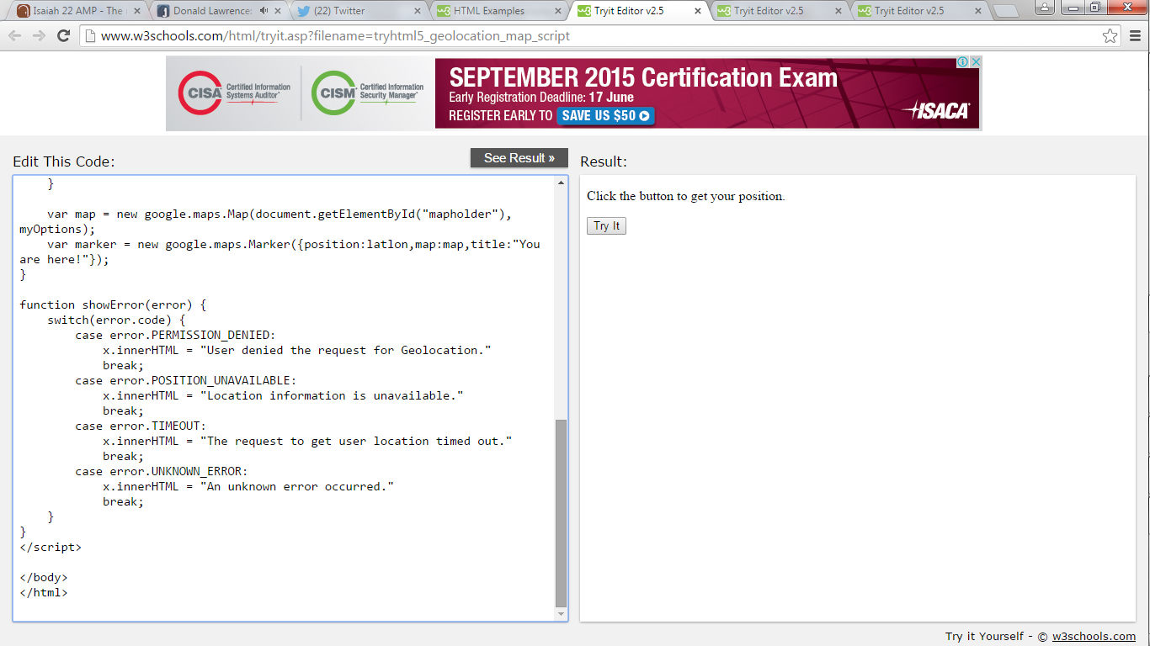

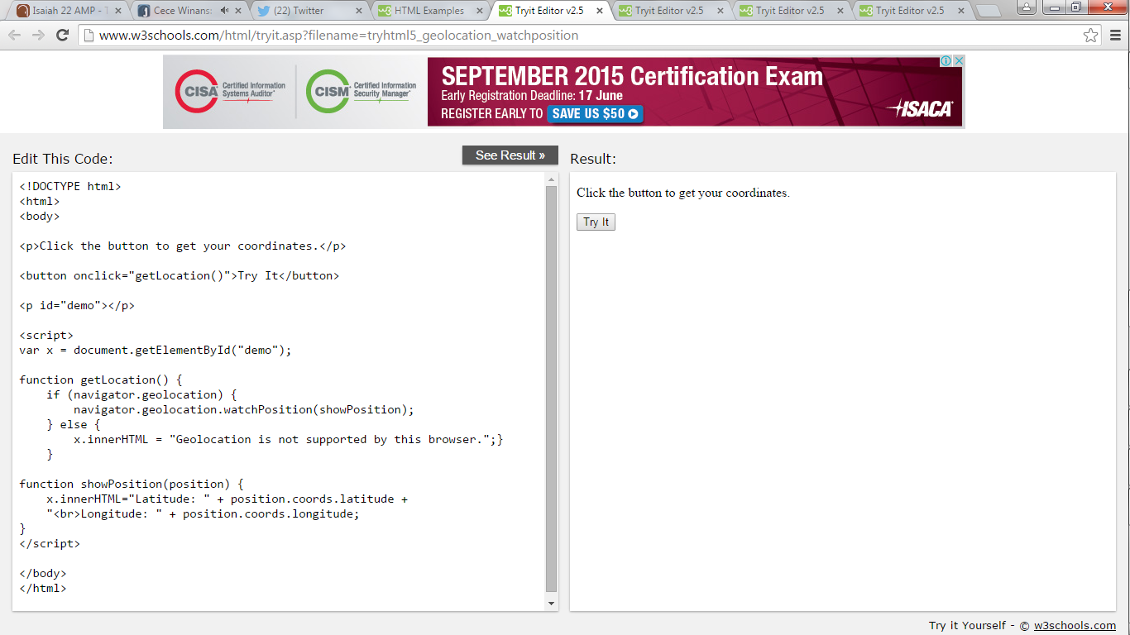

**HTML5 Local Storage**

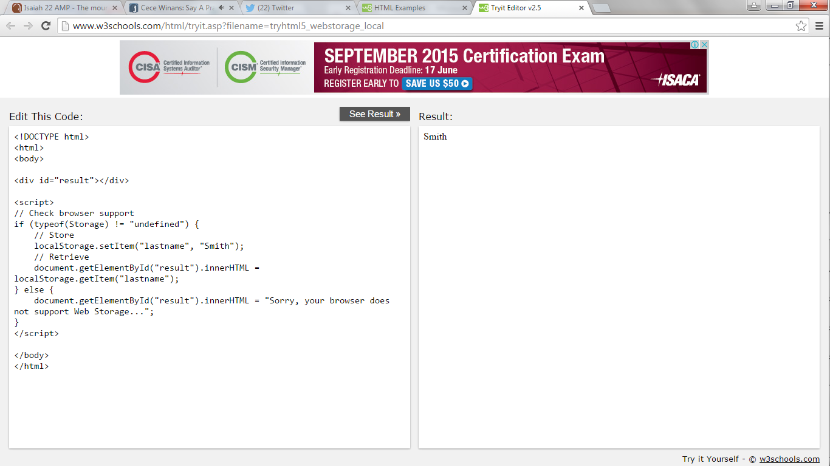

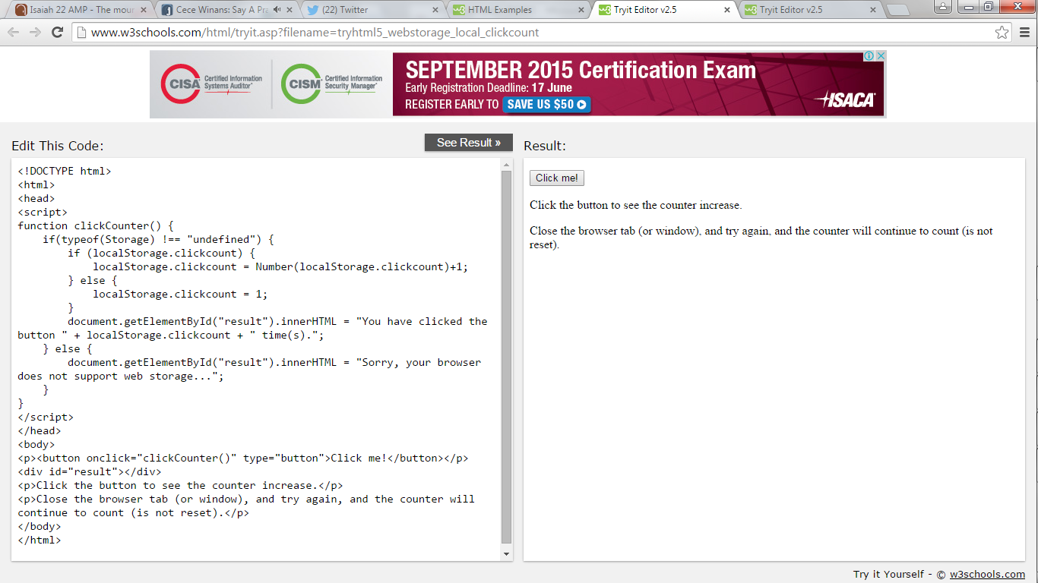

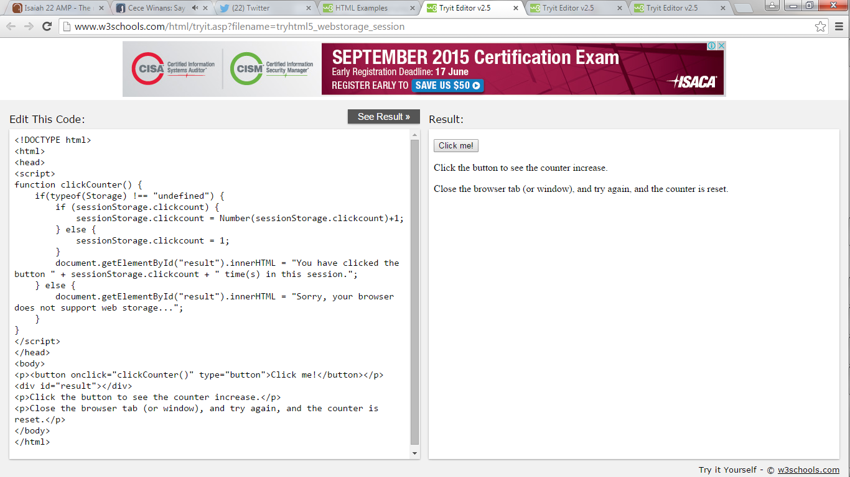

**More HTML5 Examples**

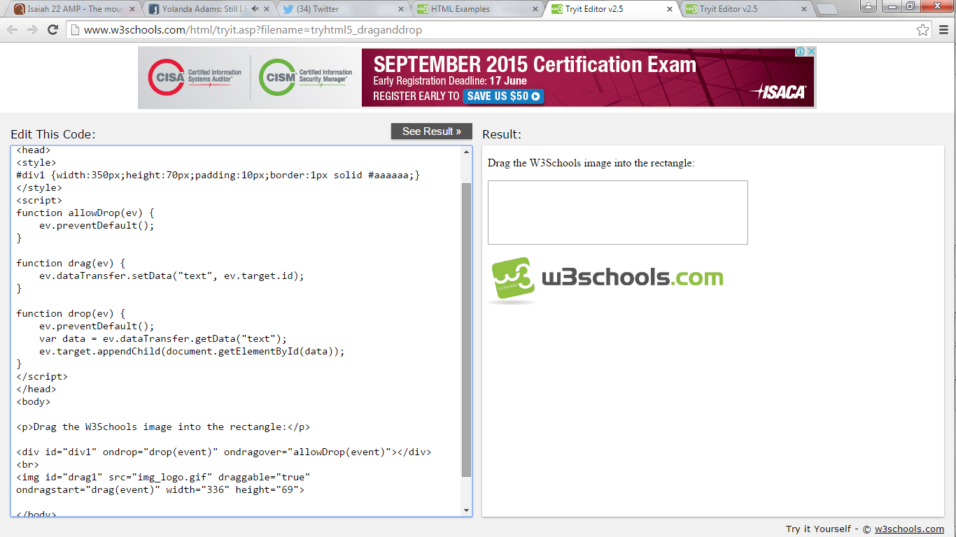

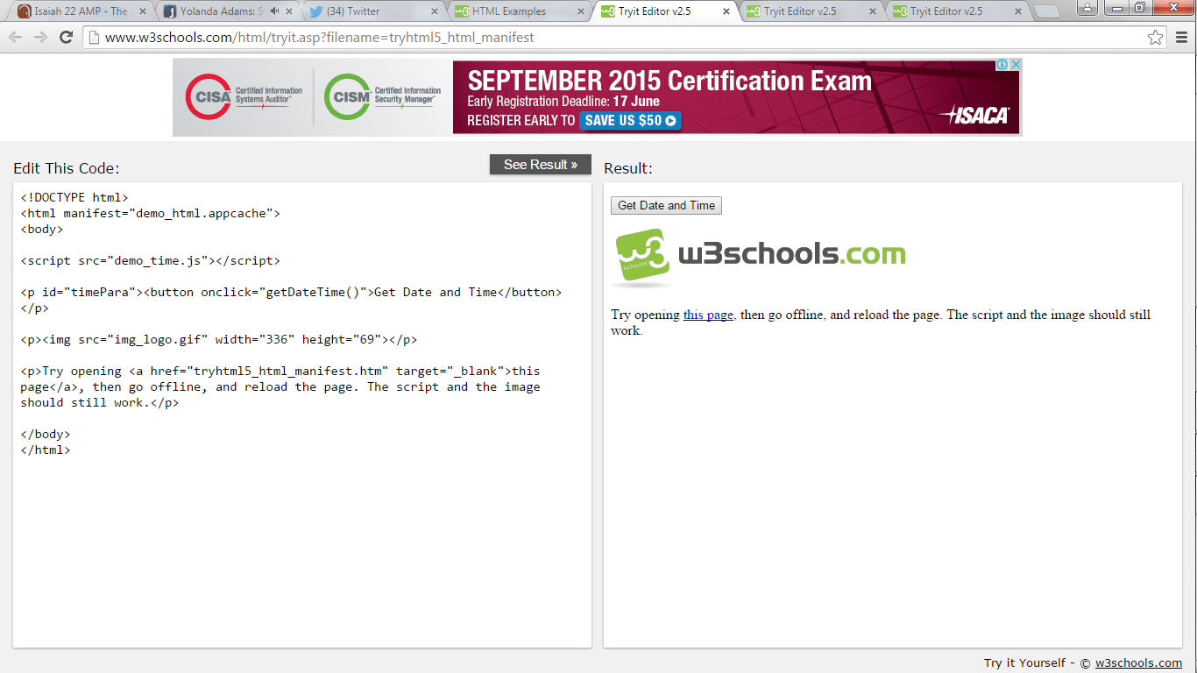

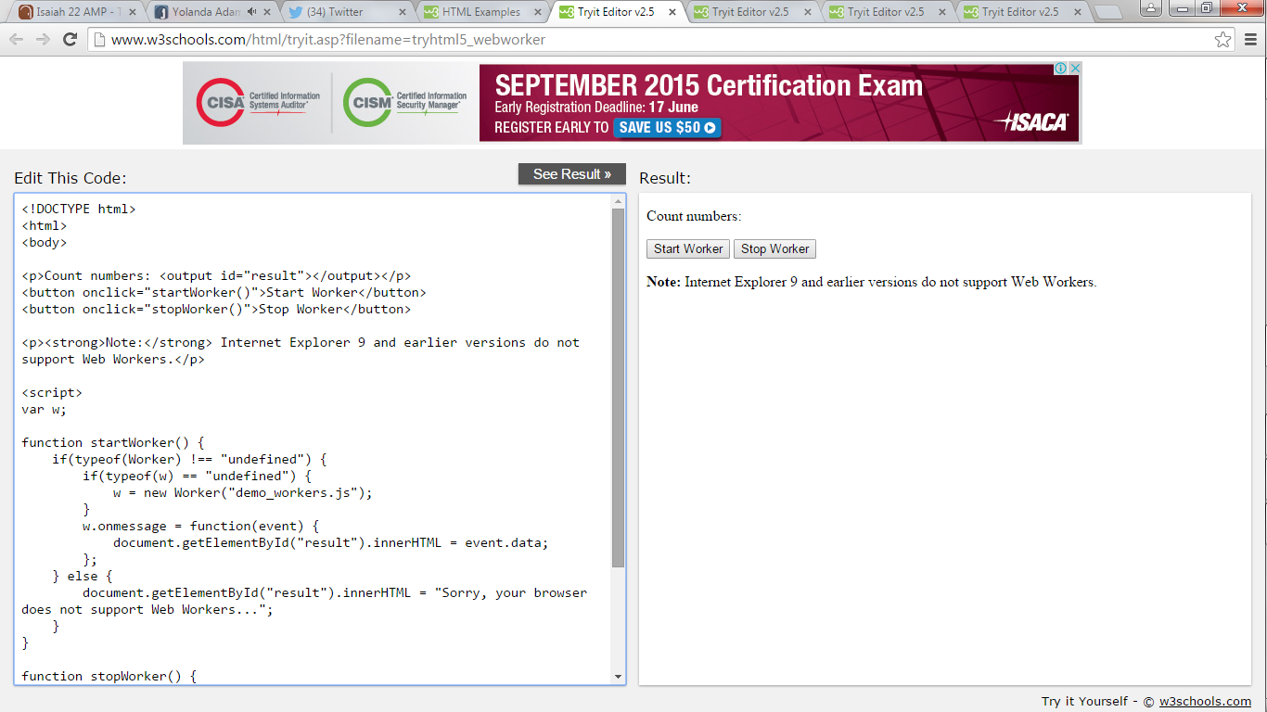

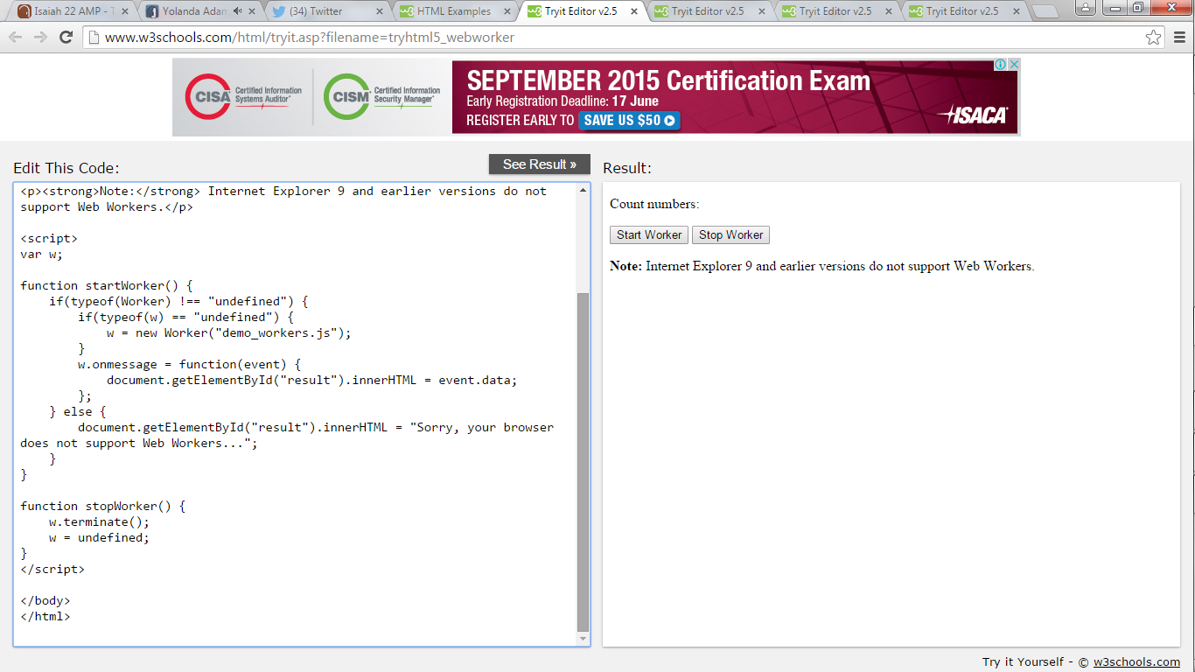

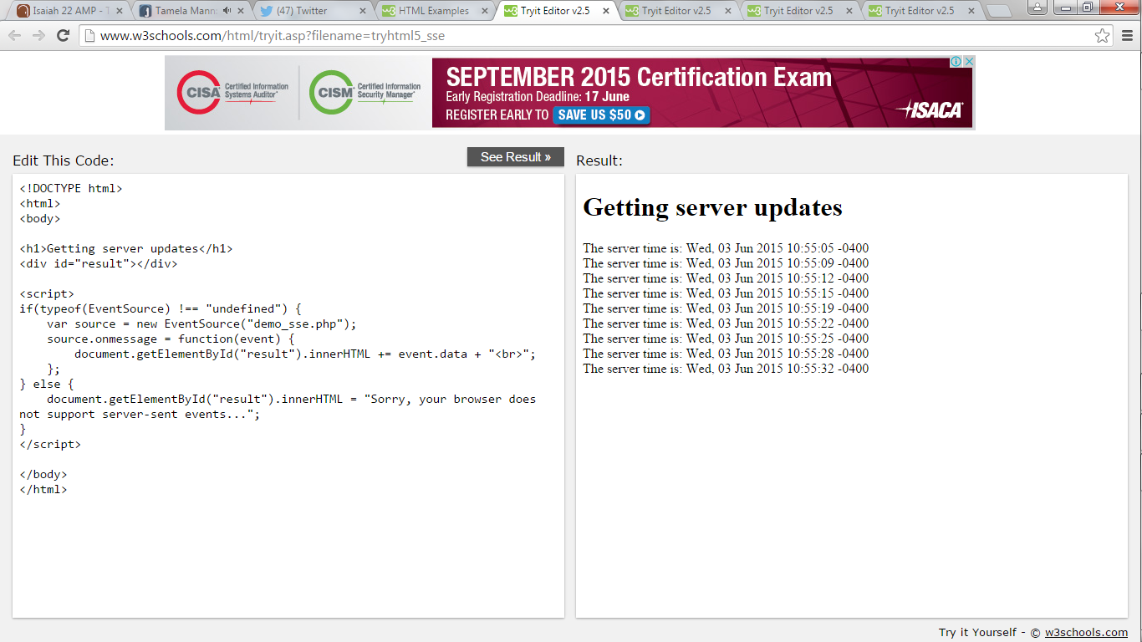

* [HTML](http://www.w3schools.com/html/default.asp)
* [CSS](http://www.w3schools.com/css/default.asp)
* [JAVASCRIPT](http://www.w3schools.com/js/default.asp)
* [SQL](http://www.w3schools.com/sql/default.asp)
* [PHP](http://www.w3schools.com/php/default.asp)
* [jQUERY](http://www.w3schools.com/jquery/default.asp)
* [BOOTSTRAP](http://www.w3schools.com/bootstrap/default.asp)
* [ANGULAR](http://www.w3schools.com/angular/default.asp)
* [TUTORIALS](http://www.w3schools.com/quiztest/result.asp)
* [REFERENCES](http://www.w3schools.com/quiztest/result.asp)
* [EXAMPLES](http://www.w3schools.com/quiztest/result.asp)
* [FORUM](http://www.w3schools.com/forum/default.asp)

## **W3Schools Quizzes**

[Quiz HTML](http://www.w3schools.com/quiztest/quiztest.asp?qtest=HTML)[Quiz HTML5](http://www.w3schools.com/quiztest/quiztest.asp?qtest=HTML5)[Quiz CSS](http://www.w3schools.com/quiztest/quiztest.asp?qtest=CSS)[Quiz JavaScript](http://www.w3schools.com/quiztest/quiztest.asp?qtest=JavaScript)[Quiz jQuery](http://www.w3schools.com/quiztest/quiztest.asp?qtest=jQuery)[Quiz PHP](http://www.w3schools.com/quiztest/quiztest.asp?qtest=PHP)[Quiz SQL](http://www.w3schools.com/quiztest/quiztest.asp?qtest=SQL)[Quiz XML](http://www.w3schools.com/quiztest/quiztest.asp?qtest=XML)[Quiz ASP](http://www.w3schools.com/quiztest/quiztest.asp?qtest=ASP)

# **W3Schools HTML Quiz**

Top of Form

|  |  |
| --- | --- |
| **HTML QUIZ** | **Points: 22 out of 25** |

**1. What does HTML stand for?**

**You answered:**

Hyper Text Markup Language

 Correct Answer!

**2. Who is making the Web standards?**

**You answered:**

The World Wide Web Consortium

 Correct Answer!

**3. Choose the correct HTML element for the largest heading:**

**You answered:**

<h1>

 Correct Answer!

**4. What is the correct HTML element for inserting a line break?**

**You answered:**

<br>

 Correct Answer!

**5. What is the correct HTML for adding a background color?**

**You answered:**

<body style="background-color:yellow;">

 Correct Answer!

**6. Choose the correct HTML element to define important text**

**You answered:**

<strong>

 Correct Answer!

**7. Choose the correct HTML element to define emphasized text**

**You answered:**

<em>

 Correct Answer!

**8. What is the correct HTML for creating a hyperlink?**

**You answered:**

<a href="http://www.w3schools.com">W3Schools</a>

 Correct Answer!

**9. Which character is used to indicate an end tag?**

**You answered:**

/

 Correct Answer!

**10. How can you open a link in a new tab/browser window?**

**You answered:**

<a href="url" target="_blank">

 Correct Answer!

**11. Which of these elements are all <table> elements?**

**You answered:**

<table><tr><td>

 Correct Answer!

**12. Inline elements are normally displayed without starting a new line.**

**You answered:**

True

 Correct Answer!

**13. How can you make a numbered list?**

**You answered:**

<ol>

 Correct Answer!

**14. How can you make a bulleted list?**

**You answered:**

<ol>

 Wrong Answer!

**15. What is the correct HTML for making a checkbox?**

**You answered:**

<input type="checkbox">

 Correct Answer!

**16. What is the correct HTML for making a text input field?**

**You answered:**

<input type="text">

 Correct Answer!

**17. What is the correct HTML for making a drop-down list?**

**You answered:**

<select>

 Correct Answer!

**18. What is the correct HTML for making a text area?**

**You answered:**

<input type="textbox">

 Wrong Answer!

**19. What is the correct HTML for inserting an image?**

**You answered:**

<img src="image.gif" alt="MyImage">

 Correct Answer!

**20. What is the correct HTML for inserting a background image?**

**You answered:**

<body style="background-image:url(background.gif)">

 Correct Answer!

**21. An <iframe> is used to display a web page within a web page.**

**You answered:**

True

 Correct Answer!

**22. HTML comments start with <!-- and end with -->**

**You answered:**

False

 Wrong Answer!

**23. Block elements are normally displayed without starting a new line.**

**You answered:**

False

 Correct Answer!

**24. Which HTML element defines the title of a document?**

**You answered:**

<title>

 Correct Answer!

**25. Which HTML attribute specifies an alternate text for an image, if the image cannot be displayed?**

**You answered:**

alt

 Correct Answer!

|  |  |
| --- | --- |
| **By W3Schools** | **Time spent: 7:36** |

Bottom of Form

### **W3SCHOOLS EXAMS**

[HTML, CSS, JavaScript, PHP, jQuery, and XML Certifications](http://www.w3schools.com/cert/default.asp)

### **COLOR PICKER**

[](http://www.w3schools.com/tags/ref_colorpicker.asp)

### **SHARE THIS PAGE**

[REPORT ERROR](http://www.w3schools.com/quiztest/result.asp)

[PRINT PAGE](http://www.w3schools.com/quiztest/result.asp)

[FORUM](http://www.w3schools.com/forum/default.asp)

[ABOUT](http://www.w3schools.com/about/default.asp)

### **Top 10 Tutorials**

[HTML Tutorial](http://www.w3schools.com/html/default.asp)  
[CSS Tutorial](http://www.w3schools.com/css/default.asp)  
[JavaScript Tutorial](http://www.w3schools.com/js/default.asp)  
[SQL Tutorial](http://www.w3schools.com/sql/default.asp)  
[PHP Tutorial](http://www.w3schools.com/php/default.asp)  
[jQuery Tutorial](http://www.w3schools.com/jquery/default.asp)  
[Bootstrap Tutorial](http://www.w3schools.com/bootstrap/default.asp)  
[Angular Tutorial](http://www.w3schools.com/angular/default.asp)  
[ASP.NET Tutorial](http://www.w3schools.com/aspnet/default.asp)  
[XML Tutorial](http://www.w3schools.com/xml/default.asp)

### **Top 10 References**

[HTML Reference](http://www.w3schools.com/tags/default.asp)  
[CSS Reference](http://www.w3schools.com/cssref/default.asp)  
[JavaScript Reference](http://www.w3schools.com/jsref/default.asp)  
[Browser Statistics](http://www.w3schools.com/browsers/default.asp)  
[HTML DOM](http://www.w3schools.com/jsref/dom_obj_document.asp)  
[PHP Reference](http://www.w3schools.com/php/php_ref_array.asp)  
[jQuery Reference](http://www.w3schools.com/jquery/jquery_ref_selectors.asp)  
[HTML Colors](http://www.w3schools.com/tags/ref_colornames.asp)  
[HTML Character Sets](http://www.w3schools.com/charsets/default.asp)  
[XML DOM](http://www.w3schools.com/dom/dom_nodetype.asp)

### **Top 10 Examples**

[HTML Examples](http://www.w3schools.com/html/html_examples.asp)  
[CSS Examples](http://www.w3schools.com/css/css_examples.asp)  
[JavaScript Examples](http://www.w3schools.com/js/js_examples.asp)  
[HTML DOM Examples](http://www.w3schools.com/js/js_dom_examples.asp)  
[PHP Examples](http://www.w3schools.com/php/php_examples.asp)  
[jQuery Examples](http://www.w3schools.com/jquery/jquery_examples.asp)  
[XML Examples](http://www.w3schools.com/xml/xml_examples.asp)  
[XML DOM Examples](http://www.w3schools.com/dom/dom_examples.asp)  
[ASP Examples](http://www.w3schools.com/asp/asp_examples.asp)  
[SVG Examples](http://www.w3schools.com/svg/svg_examples.asp)

### **Web Certificates**

[HTML Certificate](http://www.w3schools.com/cert/default.asp)  
[HTML5 Certificate](http://www.w3schools.com/cert/default.asp)  
[CSS Certificate](http://www.w3schools.com/cert/default.asp)  
[JavaScript Certificate](http://www.w3schools.com/cert/default.asp)  
[jQuery Certificate](http://www.w3schools.com/cert/default.asp)  
[PHP Certificate](http://www.w3schools.com/cert/default.asp)  
[XML Certificate](http://www.w3schools.com/cert/default.asp)

W3Schools is optimized for learning, testing, and training. Examples might be simplified to improve reading and basic understanding. Tutorials, references, and examples are constantly reviewed to avoid errors, but we cannot warrant full correctness of all content. While using this site, you agree to have read and accepted our [terms of use](http://www.w3schools.com/about/about_copyright.asp), [cookie and privacy policy](http://www.w3schools.com/about/about_privacy.asp).[Copyright 1999-2015](http://www.w3schools.com/about/about_copyright.asp) by Refsnes Data. All Rights Reserved.  
  
[](http://www.w3schools.com/)